Mineral Titles Act 2010
NOTICE OF LAND CEASING TO BE A MINERAL TITLE AREA
Title Type and Number: | Mineral Claim (Northern) 3753
Area ceased on: | 30 January 2023
Area: | 35.00 Hectare
Locality: | WINGATE MOUNTAINS
Name of Applicants(s)Holder(s): | 100% CHIN The Estate of Ernest Sue Wah
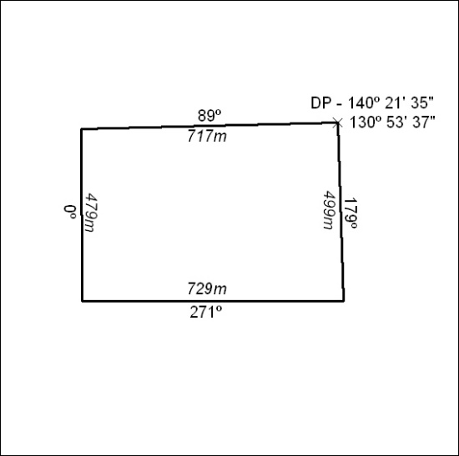

031/23

