Mineral Titles Act 2010
NOTICE OF LAND CEASING TO BE A MINERAL TITLE APPLICATION AREA
Title Type and Number: | Exploration Licence 32184
Area Ceased on: | 10 January 2023
Area: | 245 Blocks, 815.76 km²
Locality: | WINGATE MOUNTAINS
Name of Applicant(s)/Holder(s): | 100% HARKISS MINERAL DISCOVERY PTY LTD [ACN. 603 435 856]
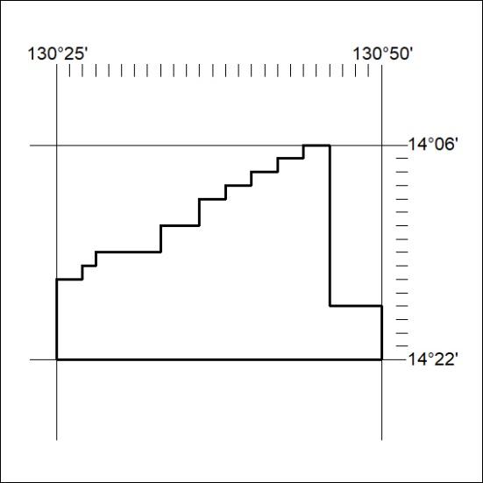

013/23

Mineral Titles Act 2010
NOTICE OF LAND CEASING TO BE A MINERAL TITLE APPLICATION AREA
Title Type and Number: | Exploration Licence 32185
Area Ceased on: | 10 January 2023
Area: | 236 Blocks, 770.43 km²
Locality: | WINGATE MOUNTAINS
Name of Applicant(s)/Holder(s): | 100% HARKISS MINERAL DISCOVERY PTY LTD [ACN. 603 435 856]
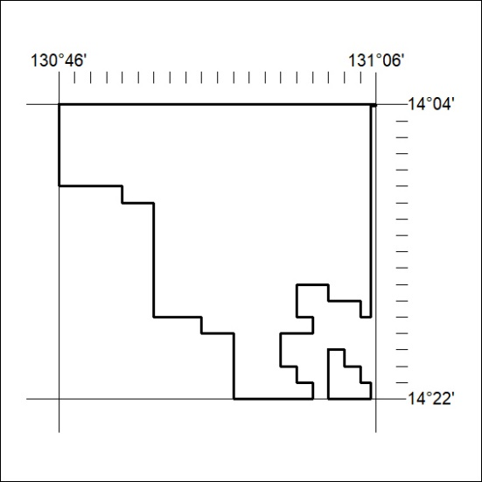

014/23

