Mineral Titles Act 2010
NOTICE OF LAND CEASING TO BE A MINERAL TITLE AREA
Title Type and Number: | Exploration Licence 32087
Area Ceased on: | 16 December 2022
Area: | 2 Blocks, 6.68 km²
Locality: | BATCHELOR
Name of Applicant(s)/Holder(s): | 100% TOTTEN Robert
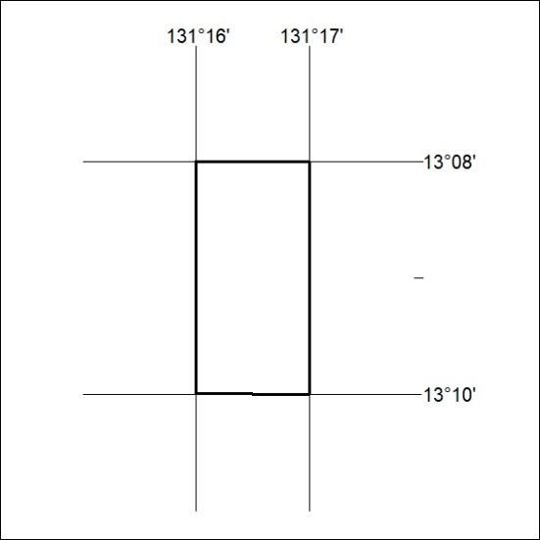

428/22

Mineral Titles Act 2010
NOTICE OF LAND CEASING TO BE A MINERAL TITLE AREA
Title Type and Number: | Extractive Mineral Exploration Licence 32375
Area Ceased on: | 15 December 2022
Area: | 4 Blocks, 13.35 km²
Locality: | PINE CREEK
Name of Applicant(s)/Holder(s): | 100% MOUSELLIS Pothitos
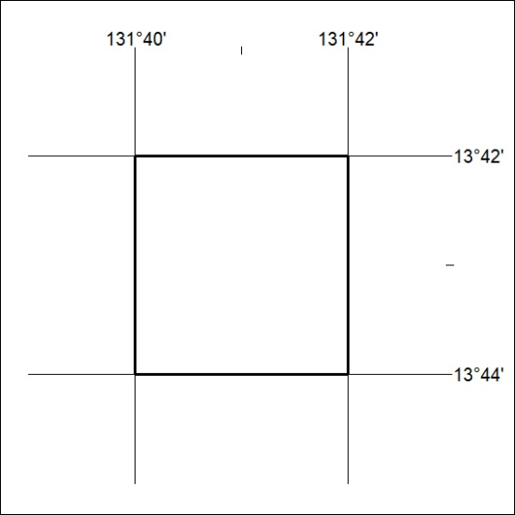

429/22
Mineral Titles Act 2010
NOTICE OF LAND CEASING TO BE A MINERAL TITLE AREA
Title Type and Number: | Extractive Mineral Exploration Licence 32376
Area Ceased on: | 15 December 2022
Area: | 3 Blocks, 10.01 km²
Locality: | PINE CREEK
Name of Applicant(s)/Holder(s): | 100% MOUSELLIS Pothitos
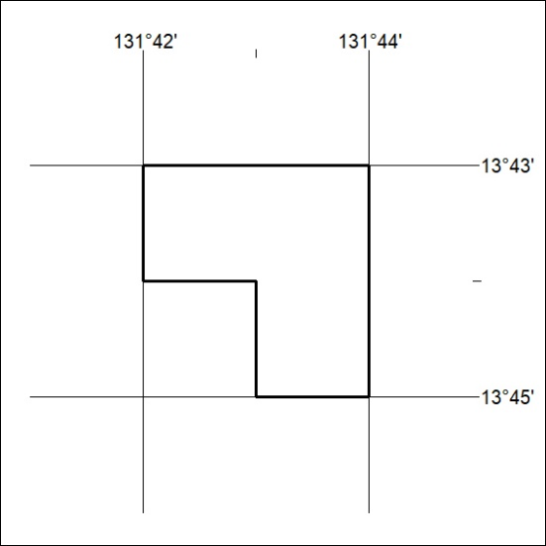

430/22

