Mineral Titles Act 2010
NOTICE OF LAND CEASING TO BE A MINERAL TITLE APPLICATION AREA
Title Type and Number: | Exploration Licence 33112
Area Ceased on: | 12 December 2022
Area: | 14 Blocks, 26.36 km²
Locality: | KATHERINE
Name of Applicant(s)/Holder(s): | 100% NT MINING OPERATIONS PTY LTD* [ACN. 136 525 990]
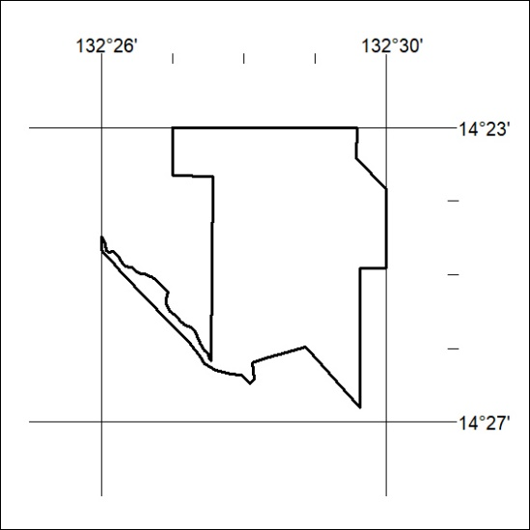

425/22

Mineral Titles Act
NOTICE OF GRANT OF A MINERAL TITLE
Title Type and Number: | Exploration Licence 33204
Granted: | 13 December 2022, for a period of 6 Years
Area: | 226 Blocks, 714.66 km²
Locality: | NARWIETOOMA
Name of Holder/s: | 100% URO CORPORATION PTY LTD [ACN. 653 927 998]
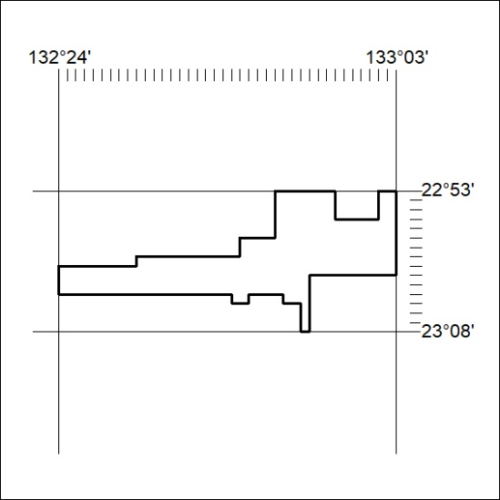
Area granted is indicated above. The titleholder is not permitted to exercise occupational rights on any land that is subject to a development title, or an application for a development title. Any land the subject of a Reserved Land gazettal under the Mineral Titles Act and all land vested in the Commonwealth of Australia is also excluded by description but not excised from the grant area.

426/22

