Mineral Titles Act
NOTICE OF GRANT OF A MINERAL TITLE
Title Type and Number: | Exploration Licence 32748
Granted: | 09 December 2022, for a period of 6 Years
Area: | 250 Blocks, 825.83 km²
Locality: | MARYFIELD
Name of Holder/s: | 100% FIDDLER'S CREEK MINING COMPANY PTY LTD * [ACN. 099 215 648]
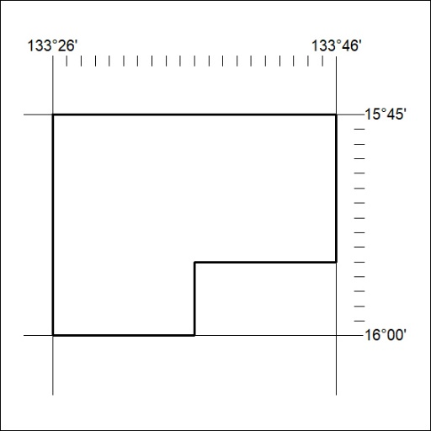
Area granted is indicated above. The titleholder is not permitted to exercise occupational rights on any land that is subject to a development title, or an application for a development title. Any land the subject of a Reserved Land gazettal under the Mineral Titles Act and all land vested in the Commonwealth of Australia is also excluded by description but not excised from the grant area.

423/22

Mineral Titles Act
NOTICE OF GRANT OF A MINERAL TITLE
Title Type and Number: | Exploration Licence 32751
Granted: | 09 December 2022, for a period of 6 Years
Area: | 227 Blocks, 748.83 km²
Locality: | DALY WATERS
Name of Holder/s: | 100% FIDDLER'S CREEK MINING COMPANY PTY LTD * [ACN. 099 215 648]
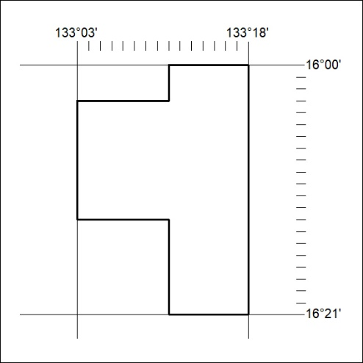
Area granted is indicated above. The titleholder is not permitted to exercise occupational rights on any land that is subject to a development title, or an application for a development title. Any land the subject of a Reserved Land gazettal under the Mineral Titles Act and all land vested in the Commonwealth of Australia is also excluded by description but not excised from the grant area.

424/22

