Mineral Titles Act 2010
NOTICE OF LAND CEASING TO BE A MINERAL TITLE APPLICATION AREA
Title Type and Number: | Exploration Licence 33052
Area Ceased on: | 26 July 2022
Area: | 199 Blocks, 630.94 km²
Locality: | DOREEN
Name of Applicant(s)/Holder(s): | 100% DRILLABIT PTY LTD [ACN. 166 230 664]
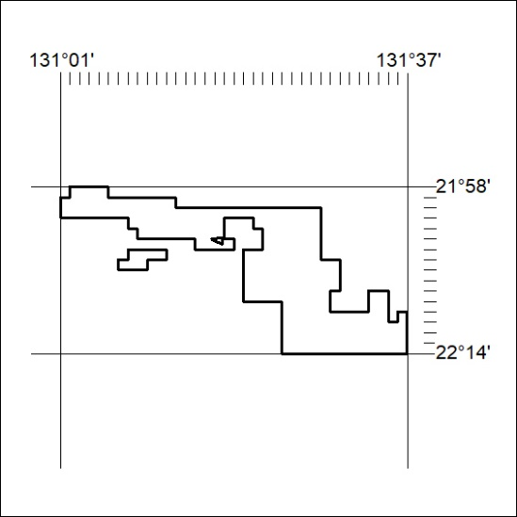

260/22

