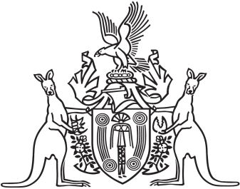
Northern Territory of Australia

Government Gazette
ISSN-0157-833X
No. S84 19 October 2018
Please note that Billeroy Road Community Centre having passed resolution to dissolve intends to transfer property of the association to other bodies with similar or charitable objectives being; Robertson Barracks Family Group, Larrakeyah Neighbourhood Centre, Network Tindal, Playgroup NT.

