Northern Territory of Australia

Government Gazette
ISSN-0157-8324
No. G40 3 October 2018

General information
The Gazette is published by the Office of the Parliamentary Counsel.
The Gazette will be published every Wednesday, with the closing date for notices being the previous Friday at 4.00 pm.
Notices not received by the closing time will be held over until the next issue.
Notices will not be published unless a Gazette notice request form together with a copy of the signed notice and a clean copy of the notice in Word or PDF is emailed to gazettes@nt.gov.au
Notices will be published in the next issue, unless urgent publication is requested.

Availability
The Gazette will be available online at 12 Noon on the day of publication at https://nt.gov.au/about-government/gazettes
Unauthorised versions of Northern Territory Acts and Subordinate legislation are available online at https://legislation.nt.gov.au/

Northern Territory of Australia
Mineral Titles Act
General Reservation of Land
(RL 31988)
I, Armando Valentino Padovan, Executive Director Mines, Department of Primary Industry and Resources, as the delegate of the Minister for Primary Industry and Resources:
(a) under section 113 of the Mineral Titles Act, reserve all the land in the locality of Bynoe that is shown within the thick black lines on the plan in the Schedule from the following activities:
(i) exploration for, and extraction of, minerals generally;
(ii) exploration for, and extraction of, extractive minerals; and
(b) give notice that:
(i) the reservation mentioned in paragraph (a) takes effect on the day this notice is published in the Gazette; and
(ii) the land mentioned in paragraph (a) is being reserved for a proposed prawn breeding facility area; and
(iii) a person is not entitled to apply for the grant of any mineral title in relation to the land.
Dated 21 September 2018
A. V. Padovan
Executive Director Mines
Schedule
Locality Bynoe
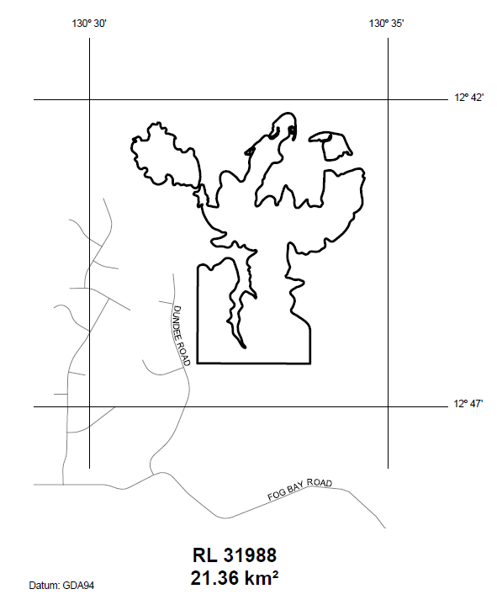

Police Administration Act

Sale of Goods
Notice is hereby given that pursuant to Section 166 of the Police Administration Act, the following property as shown on the attached schedule has been in the possession of the Officer in Charge, Police Station, Peter McAulay Centre, for a period in excess of 3 months and this property will be sold or otherwise disposed of in a manner as determined by the Commissioner of Police, if after twenty-eight (28) days from the publication of this notice the property remains unclaimed.
Nathan Finn
A/Superintendent
Palmerston Division
27 September 2018
Exhibit number | Item Description
514619/001 | Silver coloured necklace with a cross & clear stone
496180/002 | Scooter Pursuit of Perfection silver
486281/003  486281/022  486281/022/001  486281/022/002  486281/022/004  486281/022/005  486281/022/006  486281/022/007  486281/022/008  486281/022/009 | Dewalt charger & 3 x batteries  Dewalt bag with assorted tools  Dewalt 18v battery drill S/N 184100  Dewalt 18v battery drill S/N 093901  AEG angle grinder  Rockwell 240v drill  Crescent soldering iron  Soldering iron  Dewalt drill S/N 002536  Mechpro digital multimeter
480372/010 | Gold and glass looking pendant
473195/007 | Black Bushnell Perma Focus binoculars
473195/005 | Clear 8mm stone (shape of a diamond)
510546/001 | New Kids & Co baby walker
510226/001 | Red Shindaiwa petrol leaf blower
509621/005 | 1 x gold coloured ring and 1 x gold coloured bangle
509386/001 | Blue Nikon Coolpix camera
509338/001 | Gold ring with cut diamonds
508780/001 | Silver Nikon Coolpix digital camera
510533/001/001 | $8.05
510224/002 | $1.90
510020/002 | $5.20
509745/001 | $1.70
509619/001 | $35.00
509615/001 | $42.20
509557/001 | $3.00
509386/005 | 2 x $1 Brunei (foreign currency)
509386/003 | $13.95
509254/001 | $55.00
509238/002 | $54.90
509193/001 | .90 Cents
509055/001 | $11.00
508968/001 | $1.00
508901/002 | $78.30
508897/002 | $13.45
508838/002 | $78.15
508831/001 | $1.90
508822/002 | $5.00
508801/002 | $2.55
508774/001 | $25.00
508719/001 | $60.00
510685/001 | Black ZTE mobile
510578/001 | Black Apple iPad
510572/001 | Silver/black Oppo mobile
510551/001 | Black Telstra LG mobile
510533/001  510533/003 | Brown Bad Girl wallet  Black Alcatel mobile
510504/001  510504/002  510504/003  510504/004 | White Winning 16oz boxing gloves  Orange Nile skipping rope  Red Everlast hand wrap  Black Cleto Reyes groin protector belt
510501/001 | Silver Apple iPhone
510499/001 | Black Samsung Galaxy J3
510498/002  510498/004 | Blue Apple iPhone  Brown Optus mobile
510337/001  510337/002 | Black Apple iPhone  NT drivers licence
510335/001  510335/002 | White Samsung mobile  Black Apple iPad
510224/001 | Black ladies Billabong wallet
510185/001 | Silver Apple iPad
510169/001 | White/silver Apple iPhone
510093/001  510093/002  510093/003  510093/004  510093/005 | Black Alcatel mobile  White Telstra ZTE  White Telstra ZTE L5  Black Telstra ZTE Blade L111  White/silver Telstra ZTE Blade L5
510058/001 | Black Telstra ZTE T126
510050/001 | Floral purse
509992/001 | Gold/white Apple iPhone
509862/001 | Blue Konka mobile
509822/001 | Silver Apple iPhone
509765/001 | Black back pack containing clothing
509745/001 | Black Marikai handbag
509621/001  509621/002  509621/003  509621/004  509621/006 | Black Telstra flip mobile  Black Optus mobile  Black Telstra mobile  Black Telstra mobile  2 x grey Apple iPods
509619/002 | Small blue coin purse
509615/002 | Brown coin purse with gold elephants
509570/001 | Silver HTC mobile
509512/001 | Black Telstra ZTE mobile
509386/002  509386/004 | Blue Colorado wallet  American Tourister wallet
509382/001 | Gold/white Apple iPhone
509376/001 | Black/silver Apple iPhone
509300/001 | Black Samsung A5
509238/001 | Black Ripcurl wallet
509232/001 | Black wallet
509228/001  509228/002  509228/003 | Blue HTC mobile  Sliver Apple iPhone  Black Samsung mobile
509153/001 | Black backpack with assorted items
509101/003 | Sliver/black Apple iPhone 6
509018/001 | Ladies beige purse
509000/001 | Blue/black Nokia TA-1024 mobile
508901/001 | Multi coloured zipper purse
508897/001 | Brown wallet
508839/001 | Black Telstra ZTE mobile
508838/001 | Black wallet
508822/001 | Grey Marcs leather wallet
508718/003 | Black Telstra ZTE Blade A112 mobile
508698/001 | 7 x keys
508674/001 | White Samsung Galaxy tablet
498935/003 | Telstra white/silver mobile
497549/001 | iPad A1337 silver S/N GB37EG9ETV
495855/001 | Pink Colette Hayman handbag
494041/007 | Brown Fossil passport wallet
490578/013 | Aust Post parcel with 2 x mobile phones
487189/013  487187/014 | White mobile  White mobile
480898/001 | Black ZTE mobile
471385/008  471385/009  471385/011 | Black Telstra mobile  White/pink Apple iPhone  White Apple iPhone
451900/001 | White Samsung mobile
451458/001 | White Oppo mobile
451454/001  451454/002  451454/003 | Blackberry  White Motorola mobile  Black Apple iPhone
449900/001 | White Telstra mobile
449148/001 | Black Microsoft mobile
426058/002  426058/006  426058/007  426058/008  426058/009  426058/010 | Navman  2 x mobiles  Blackberry  2 x mobiles  2 x mobiles  2 x mobiles
510463/001  510463/002  510463/003  510463/004  510463/005 | Umarex .177 RAR S/N G012838  Escort 12g SUO S/N 10572  Marlin .22 RBA S/N 93658500  Ruger .270 RBA S/N 71095453  Assorted ammunition
509575/005 | Assorted ammunition
509206/001  509206/002  509206/003  509205/004  509206/005 | Beretta 12g SUO S/N D06050B  Marlin 444 RLA, S/N 21097333  Browning 308 RLA, S/N 10211MY341  BRNO .22 RBA, S/N 828681  Assorted ammunition
507220/013 | Replica mini handgun
510657/001 | White/orange Crest MTB
510171/001 | Black/grey Giant Roam
509908/001 | Black/green James MTB
509907/001 | Yellow Avanti Shadow BMX
509762/001 | Green/black Cyclops MTB
509761/001 | Orange childs Cyclops
509760/001 | Black/red Stratosphere MTB
509759/001 | Black/yellow Repco Hornet
509451/001 | Black/orange Chubby Nitro MTB
509072/001 | Black/green Diamond Back Over Drive 29
508926/001 | White/purple Malvern Star
508801/001 | Brown Fossil wallet
492619/001 | Silver Honda Accord - Tasmanian rego A40VU

Northern Territory of Australia

Monitoring of Places of Detention (Optional Protocol to the Convention Against Torture) Act 2018
Commencement Notice
I, Vicki Susan O'Halloran, Administrator of the Northern Territory of Australia, under section 2 of the Monitoring of Places of Detention (Optional Protocol to the Convention Against Torture) Act 2018 (No. 18 of 2018), fix 1 November 2018 as the day on which the Act commences.
Dated 27 September 2018
V. S. O'Halloran
Administrator
Northern Territory of Australia

Monetary Units Act 2018
Commencement Notice
I, Vicki Susan O'Halloran, Administrator of the Northern Territory of Australia, under section 2 of the Monetary Units Act 2018 (No. 17 of 2018), fix 1 November 2018 as the day on which the Act commences.
Dated 26 September 2018
V. S. O'Halloran
Administrator
Northern Territory of Australia

Northern Territory Aboriginal Sacred Sites Act
Aboriginal Areas Protection Authority
Appointment of Member
I, Vicki Susan O'Halloran , Administrator of the Northern Territory of Australia, acting with the advice of the Executive Council, under section 6(1) of the Northern Territory Aboriginal Sacred Sites Act and with reference to section 6(4) of the Act, appoint Leah Marree Clifford to be a member of the Aboriginal Areas Protection Authority for 3 years on and from the date on which this instrument is published in the Gazette.
Dated 28 September 2018
V. S. O'Halloran
Administrator
By Her Honour's Command
M. P. F. Gunner
Chief Minister
acting for
Minister for Environment and Natural Resources
Northern Territory of Australia

Teacher Registration (Northern Territory) Act
Teacher Registration Board of the Northern Territory
Appointment of Members
I, Vicki Susan O'Halloran, Administrator of the Northern Territory of Australia, acting with the advice of the Executive Council, under section 7(1) of the Teacher Registration (Northern Territory) Act, appoint each person named in the Schedule, who is eligible for appointment under the provision of the Act specified opposite the person, to be a member of the Teacher Registration Board of the Northern Territory for 4 years on and from 11 October 2018.

Dated 28 September 2018

V. S. O'Halloran

Administrator

By Her Honour's Command
M. P. F. Gunner
Chief Minister
acting for

Minister for Education

Schedule
Person | Provision
Louise Maree Corrigan | 7(1)(a)
Gordon Francis Canning | 7(1)(b)
Bernadette Mary Morriss | 7(1)(g)
Gregory Shaw | 7(1)(h)
Claire Bartlett | 7(1)(i)
Marisa Daniella Boscato | 7(1)(j)

