Front cover page.
Heading of Remote Towns Jobs Profile 2017
Jobs profile remote town name WadeyeRemote Towns Jobs Profile

WADEYE

**© Northern Territory of Australia 2018**

**Preferred Reference:** Department of Trade, Business and Innovation, 2017 Remote Towns Jobs Profiles, Northern Territory Government, June 2018, Darwin.

**Disclaimer**

The data in this publication were predominantly collected by conducting a face-to-face survey of businesses within town boundaries during mid-2017. The collection methodology was created in accordance with Australian Bureau of Statistics data quality framework principles. Data in this publication are only reflective of those businesses reported on as operating in the town at the time of data collection (see table at the end of publication for list of businesses reported on).

To comply with privacy legislation or where appropriate, some data in this publication may have been adjusted and will not reflect the actual data reported by businesses. As a result of this, combined with certain data not being reported by some businesses, some components may not add to totals. Changes over time may also reflect business' change in propensity to report on certain data items rather than actual changes over time. Total figures have generally not been adjusted.

Caution is advised when interpreting the comparisons made to the earlier 2011 and 2014 publications as the businesses identified and reported on and the corresponding jobs may differ between publications.

Notes for each table and chart are alphabetically ordered and listed at the end of the publication.

Any use of this report for commercial purposes is not endorsed by the Department of Trade, Business and Innovation.

Contents

Wadeye 4

Introduction 5

Summary 6

Jobs Overview 7

Jobs by Aboriginal Status 8

Jobs by Sector: Private and Public 10

Job status: Permanent and Temporary 15

Job Vacancies 18

Jobs by Industry 20

Jobs by Occupation 26

Jobs by Industry by Occupation 29

Jobs by Gender 31

Jobs by Age 36

Vocational Education and Training 42

Population 46

Community Development Programme 48

Businesses 49

Notes 50

Abbreviations and Acronyms 51

.

# Wadeye

Wadeye (also known as Port Keats) is located 420 kilometres south-west of Darwin, with a population of 2631 residents.

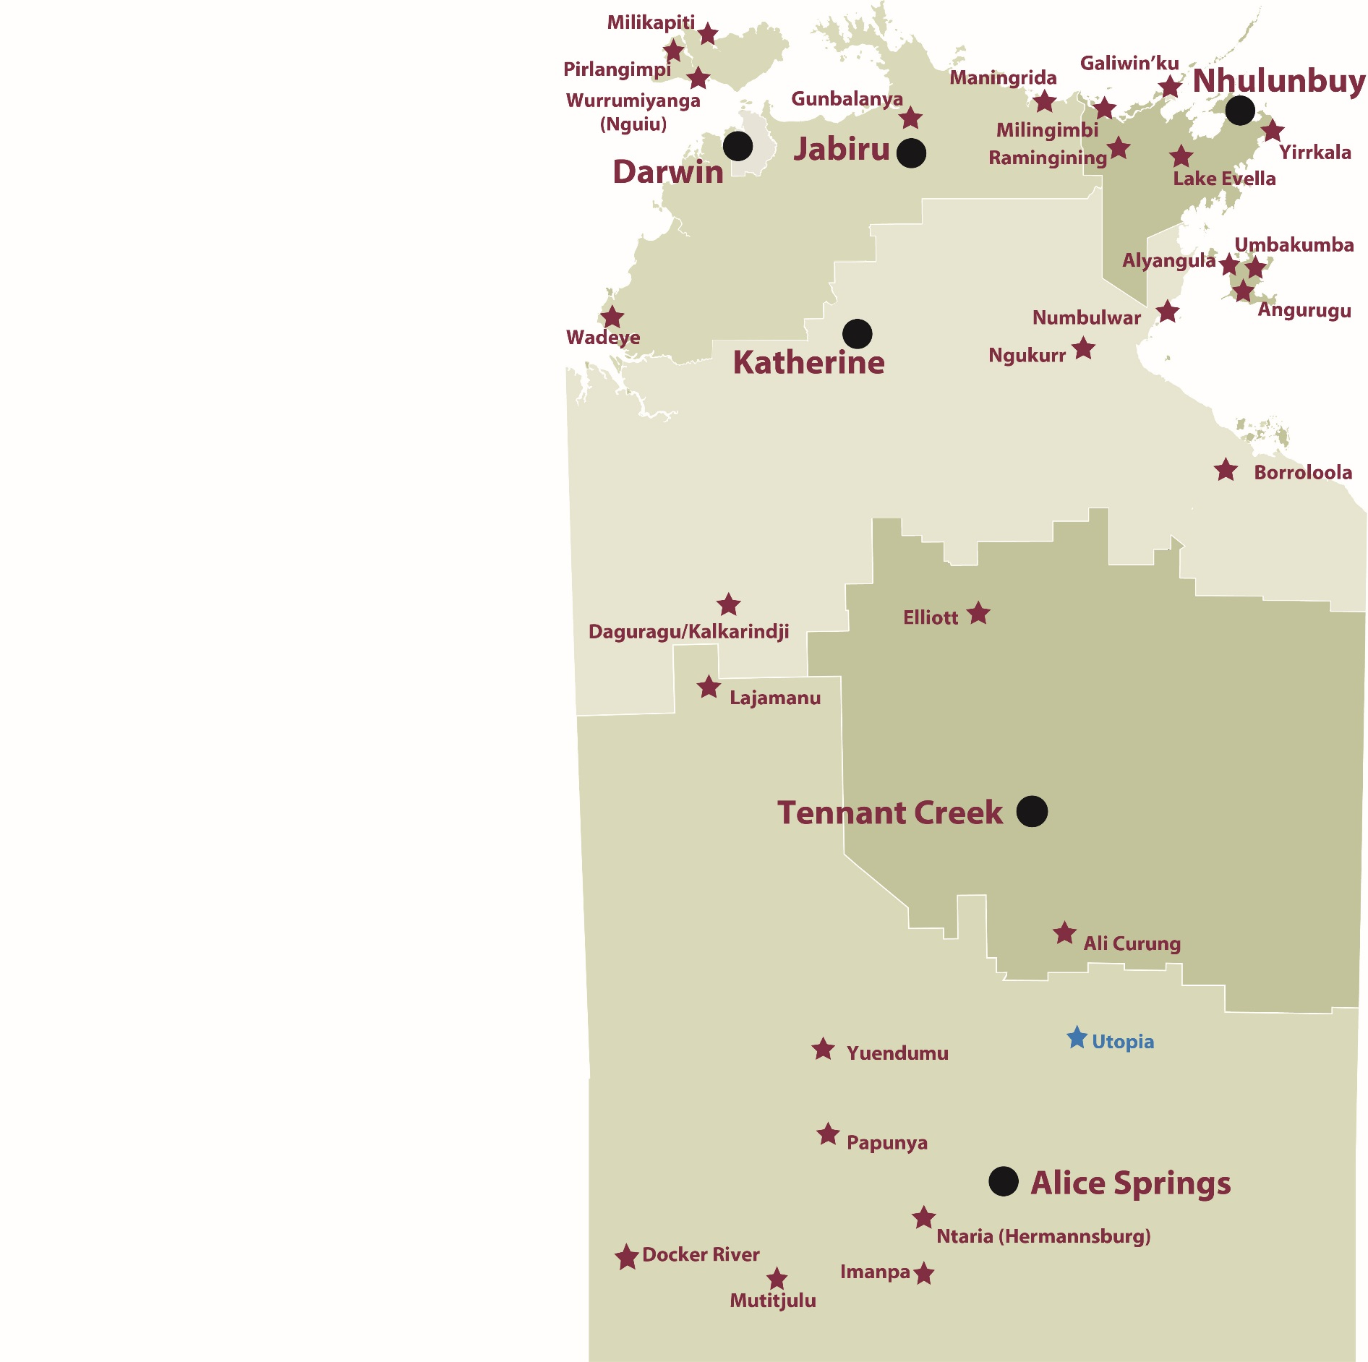

*Source: Department of Trade, Business and Innovation*

# Introduction

This jobs profile provides a snapshot of jobs and the characteristics of job holders in Wadeye as at July 2017. It also outlines trends from the 2014 and 2011 surveys.

This job profile is one of 28 profiles developed for remote towns in the Northern Territory. It is anticipated these and subsequent profiles will contribute to a robust evidence base to inform decision making in and relating to these remote Territory towns.

This profile contains information collected by the Northern Territory Department of Trade, Business and Innovation from businesses operating within the town and is supplemented by other administrative data sets and information.

Each profile provides up-to-date information that is intended to inform the planning and design of current and future government programs and as an evidence base to inform decision making relating to workforce development, enterprise and job opportunities.

The data collection methodology and corresponding questionnaire were created in partnership with the Australian Bureau of Statistics (ABS) and in accordance with ABS data quality framework and survey principles.

The surveys were predominantly conducted by the Department’s Small Business Champions and Workforce Training Coordinators, on a face-to-face basis with business representatives.

The information collected and reported on represents a significant goodwill investment by those businesses and organisations that participated. Each business is listed at the end of this publication.

# Summary

The 2017 jobs profile was developed based on responses from 21 businesses operating within the Wadeye town boundary, 1 less than in the 2014 survey. Of these, there were:

* 14 businesses from the private sector, accounting for 410 filled jobs or 82% of total filled jobs
* 7 businesses from the public sector, accounting for 90 filled jobs or 18% of total filled jobs
* 13 businesses participated in all three surveys (completed in 2011, 2014 and 2017)

A total of 540 filled and vacant jobs in Wadeye were reported, an increase of 83 jobs from 2014.[1]

The 2017 profile highlights:

* there were 500 filled jobs of which:
* 291 jobs (58%) were filled by Aboriginal persons, an increase of 62 jobs from 2014
* 209 jobs (42%) were filled by non-Aboriginal persons, an increase of 12 jobs from 2014
* 48% of employed Aboriginal people are working in the private sector
* Aboriginal persons accounted for 58% of job holders in the town compared to 54% in 2014
* Aboriginal females made up 60% of total Aboriginal filled jobs in the town compared to 45% in 2014
* there were 40 vacant jobs, of which:
* job vacancies as a percentage of jobs is unchanged at 7% in 2017 from 2014
* job vacancies equate to 1 in 14 jobs
* 25 of the vacancies were in Community and Personal Service Workers and Professional areas
* Public Administration and Safety was the largest industry employer in 2017, having the highest increase of 58 jobs filled between 2017 and 2014
* Retail Trade had the 2nd highest increase in jobs filled between 2017 and 2014
* Training increased in student numbers between 2016 and 2013
* Community Services, Health and Education had the highest student numbers in 2016 as well as the highest increase in student numbers between 2016 and 2013
* the Automotive and Primary Industry training sectors had the highest decreases in student numbers between 2016 and 2013 of 22 and 23 respectively.

The overall population in Wadeye increased by 770 persons (41%) between 2006 and 2016 to 2631 persons.

In comparison, the overall Northern Territory population increased by 16.5% between 2006 and 2016.

In 2016, the working age population (15 years and over) in Wadeye was an estimated 1,796 persons compared to 1,115 in 2006 an increase of 55%.

There were 0.3 jobs in Wadeye per working age person compared to 0.4 jobs per working age person across the 28 remote towns in the Northern Territory.

# Jobs Overview

Table 1: Count of filled jobs and vacancies, 2011, 2014 and 2017 (a)(b)

|  |  |  |  |  |  |
| --- | --- | --- | --- | --- | --- |
|  | **2011** | **2014** | **2017** | **Change 2011-2014** | **Change 2014-2017** |
| **Total All Jobs** | **452** | **457** | **540** | **5** | **83** |
| **Vacancies** | **28** | **31** | **40** | **3** | **9** |
| Vacancies as % of Total All Jobs | 6.2% | 6.8% | 7.4% | 0.6 ppt | 0.6 ppt |
| **Filled Jobs** | **424** | **426** | **500** | **2** | **74** |
| Full-time | 338 | 297 | 295 | -41 | -2 |
| Part-time | 86 | 129 | 205 | 43 | 76 |

Source: Department of Trade, Business and Innovation

Chart 1: Count of vacant jobs and filled jobs by full-time/part-time status, 2011, 2014 and 2017 (a)(b)

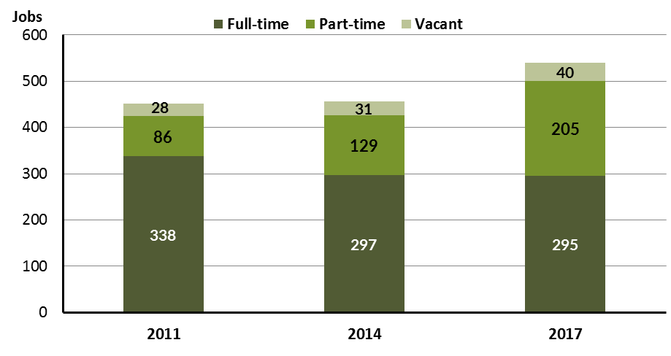

Source: Department of Trade, Business and Innovation

In 2017 in Wadeye:

* there were a total of 500 **filled jobs**, an increase of 74 jobs from 2014 and an increase of 76 jobs from 2011
* of the 500 **filled jobs** in 2017:
* 295 were full-time jobs, a decrease of 2 jobs from 2014 and a decrease of 43 jobs from 2011
* 205 were part-time jobs, an increase of 76 jobs from 2014 and an increase of 119 jobs from 2011
* there were 40 total **job vacancies** in 2017, an increase of 9 vacancies from 2014 and an increase of 12 vacancies from 2011.

# Jobs by Aboriginal Status

Chart 2: Count of filled jobs by Aboriginal status, 2011, 2014 and 2017 (a)(c)

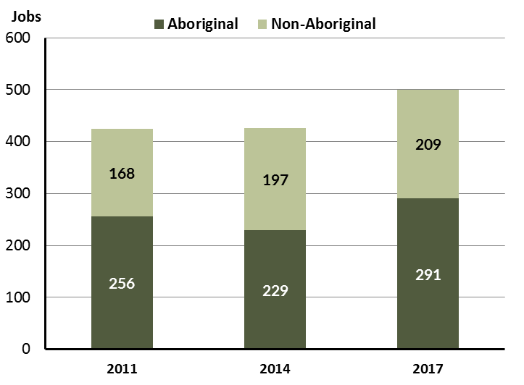

Source: Department of Trade, Business and Innovation

In 2017 in Wadeye:

* of the 500 filled jobs:
* 291 jobs were filled by **Aboriginal** persons, an increase of 62 jobs from 2014 and an increase of 35 jobs from 2011
* 209 jobs were filled by **non-Aboriginal** persons, an increase of 12 jobs from 2014 and an increase of 41 jobs from 2011
* **Aboriginal** persons accounted for 58% of job holders compared to 54% in 2014 and 60% in 2011.

Table 2: Count of filled jobs by full-time/part-time status and Aboriginal status of person in job, 2011, 2014 and 2017 (a)(b)(c)

|  |  |  |  |  |  |  |  |  |  |  |  |  |  |  |  |
| --- | --- | --- | --- | --- | --- | --- | --- | --- | --- | --- | --- | --- | --- | --- | --- |
| **Indicator** | **2011** | | | **2014** | | | **2017** | | | **Change 2011-2014** | | | **Change 2014-2017** | | |
| **Aboriginal** | **Non-Aboriginal** | **Total** | **Aboriginal** | **Non-Aboriginal** | **Total** | **Aboriginal** | **Non-Aboriginal** | **Total** | **Aboriginal** | **Non-Aboriginal** | **Total** | **Aboriginal** | **Non-Aboriginal** | **Total** |
| Full-time | 177 | 161 | **338** | 122 | 175 | **297** | 99 | 196 | **295** | -55 | 14 | **-41** | -23 | 21 | **-2** |
| Part-time | 79 | 7 | **86** | 107 | 22 | **129** | 192 | 13 | **205** | 28 | 15 | **43** | 85 | -9 | **76** |
| **Total** | **256** | **168** | **424** | **229** | **197** | **426** | **291** | **209** | **500** | **-27** | **29** | **2** | **62** | **12** | **74** |

Source: Department of Trade, Business and Innovation

Chart 3: Count of filled jobs by full-time/part-time status and Aboriginal status of person in job, 2011, 2014 and 2017 (a)(b)(c)

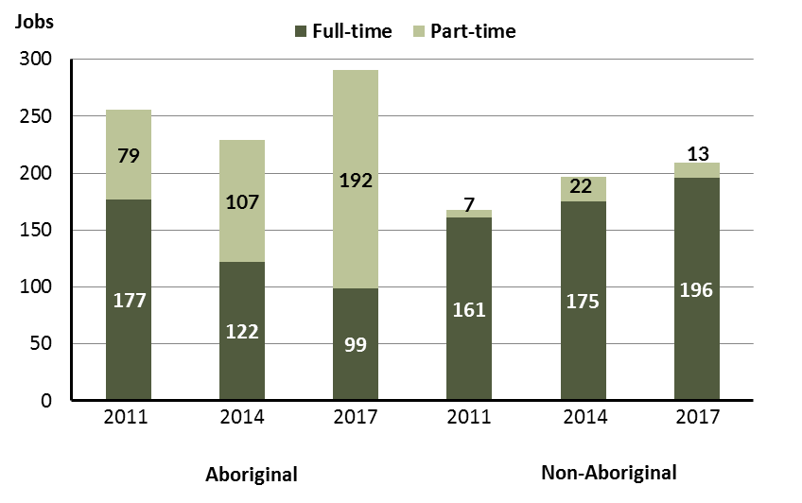

Source: Department of Trade, Business and Innovation

In 2017 in Wadeye:

* of the 500 **filled jobs:**
* 99 were **full-time** jobs filled by **Aboriginal** persons, a decrease of 23 jobs from 2014 and a decrease of 78 jobs from 2011
* 192 were **part-time** jobs filled by **Aboriginal** persons, an increase of 85 jobs from 2014 and an increase of 113 jobs from 2011
* 196 were **full-time** jobs filled by **non-Aboriginal** persons, an increase of 21 jobs from 2014 and an increase of 35 jobs from 2011
* 13 were **part-time** jobs filled by **non-Aboriginal** persons, a decrease of 9 jobs from 2014 and an increase of 6 jobs from 2011.

# Jobs by Sector: Private and Public

Table 3: Count of filled jobs by sector of business and by Aboriginal status of person employed in job, 2011, 2014 and 2017 (a)(b)(c)

|  |  |  |  |  |  |  |  |  |  |  |  |  |  |  |  |  |  |
| --- | --- | --- | --- | --- | --- | --- | --- | --- | --- | --- | --- | --- | --- | --- | --- | --- | --- |
| **Indicator** | **2011** | | | **2014** | | | **2017** | | | | **Change 2011-2014** | | | | **Change 2014-2017** | | |
| **Aboriginal** | **Non-Aboriginal** | **Total** | **Aboriginal** | **Non-Aboriginal** | **Total** | **Aboriginal** | **Non-Aboriginal** | **Total** | **Aboriginal** | | **Non-Aboriginal** | **Total** | **Aboriginal** | | **Non-Aboriginal** | **Total** |
| **Public Sector** | 78 | 37 | **115** | 59 | 52 | **111** | 47 | 43 | **90** | -19 | | 15 | **-4** | -12 | | -9 | **-21** |
| Australia Government | 3 | 2 | **5** | 13 | 7 | **20** | 6 | 1 | **7** | 10 | | 5 | **15** | -7 | | -6 | **-13** |
| Territory Government | 11 | 13 | **24** | 14 | 32 | **46** | 17 | 30 | **47** | 3 | | 19 | **22** | 3 | | -2 | **1** |
| Local Government | 64 | 22 | **86** | 32 | 13 | **45** | 16 | 6 | **22** | -32 | | -9 | **-41** | -16 | | -7 | **-23** |
| **Private Sector** | 178 | 131 | **309** | 170 | 145 | **315** | 244 | 166 | **410** | -8 | | 14 | **6** | 74 | | 21 | **95** |
| **Total** | **256** | **168** | **424** | **229** | **197** | **426** | **291** | **209** | **500** | **-27** | | **29** | **2** | **62** | | **12** | **74** |

Source: Department of Trade, Business and Innovation

Chart 4: Count of filled jobs by sector of business, 2011, 2014 and 2017 (a)(d)

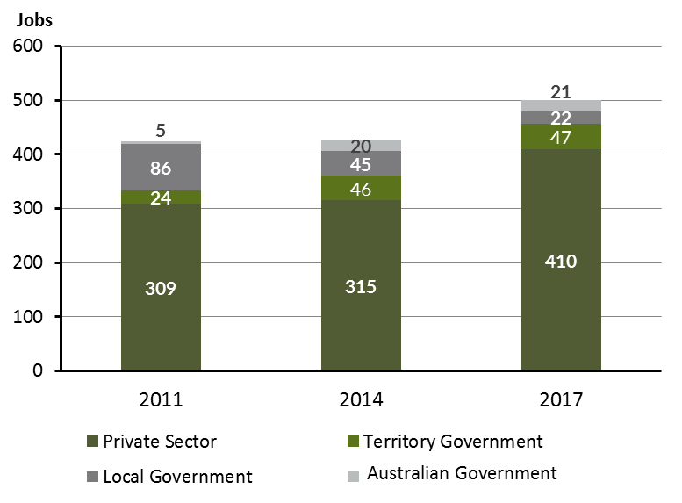

Source: Department of Trade, Business and Innovation

Chart 5: Percentage of filled jobs by sector of business in 2017 (a)(d)

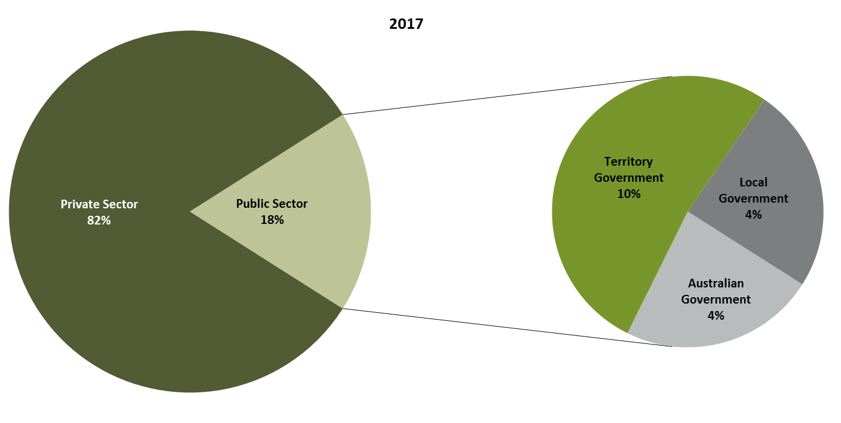

Source: Department of Trade, Business and Innovation

In 2017 in Wadeye:

* there were 90 jobs in the **public sector**, a decrease of 21 jobs from 2014 and a decrease of 25 jobs from 2011
* of the 90 jobs in the **public sector** in 2017:
* 7 jobs were in the Australian Government, a decrease of 13 jobs from 2014 and an increase of 2 jobs from 2011
* 47 jobs were in the Territory Government, an increase of 1 job from 2014 and an increase of 23 jobs from 2011
* 22 jobs were in the Local Government, a decrease of 23 jobs from 2014 and a decrease of 64 jobs from 2011
* there were 410 jobs in the **private** **sector** in 2017, an increase of 95 jobs from 2014 and an increase of 101 jobs from 2011.

Chart 6: Count of filled jobs by sector and Aboriginal status of person in job, 2011, 2014 and 2017 (a)(c)(d)

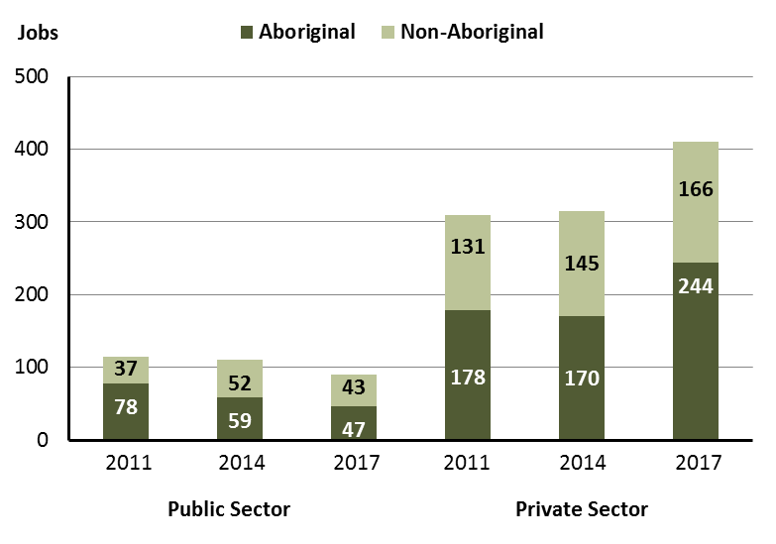

Source: Department of Trade, Business and Innovation

In 2017 in Wadeye:

* of the 90 jobs in the **public sector**:
* 47 jobs were filled by **Aboriginal** persons, a decrease of 12 jobs from 2014 and a decrease of 31 jobs from 2011
* 43 jobs were filled by **non-Aboriginal** persons, a decrease of 9 jobs from 2014 and an increase of 6 jobs from 2011
* of the 410 jobs in the **private sector**:
* 244 jobs were filled by **Aboriginal** persons, an increase of 74 jobs from 2014 and an increase of 66 jobs from 2011
* 166 jobs were filled by **non-Aboriginal** persons, an increase of 21 jobs from 2014 and an increase of 35 jobs from 2011.

Chart 7: Count of filled jobs by sector and full-time/part-time status of person in job, 2011, 2014 and 2017 (a)(b)(d)

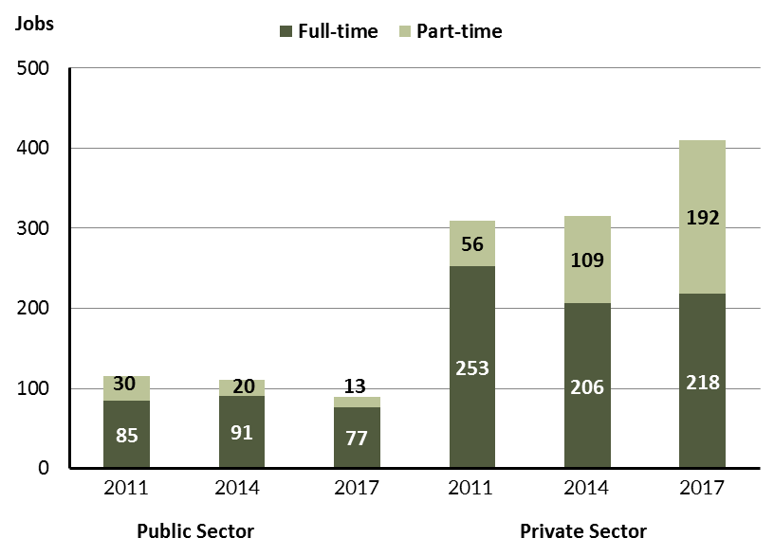

Source: Department of Trade, Business and Innovation

In 2017 in Wadeye there were:

* of the 90 jobs in the **public sector**:
* 63 were **full-time** jobs, a decrease of 28 jobs from 2014 and a decrease of 22 jobs from 2011
* 13 were **part-time** jobs, a decrease of 7 jobs from 2014 and a decrease of 17 jobs from 2011
* of the 410 jobs in the **private sector**:
* 232 were **full-time** jobs, an increase of 26 jobs from 2014 and a decrease of 21 jobs from 2011
* 192 were **part-time** jobs, an increase of 83 jobs from 2014 and an increase of 136 jobs from 2011.

Table 4: Count of filled jobs by full-time/part-time status and Aboriginal status of person in job by sector, 2011, 2014, and 2017 (a)(b)(c)(d)

|  |  |  |  |  |  |  |  |  |  |  |
| --- | --- | --- | --- | --- | --- | --- | --- | --- | --- | --- |
| **Indicator** | **2011** | | | | | | | | | |
| **Aboriginal** | | | **Non-Aboriginal** | | | **Total** | | | |
| **Full-time** | **Part-time** | **Total** | **Full-time** | **Part-time** | **Total** | **Full-time** | **Part-time** | **Total** |
| Public Sector | 53 | 25 | **78** | 32 | 5 | **37** | 85 | 30 | **115** |
| Private Sector | 124 | 54 | **178** | 129 | 2 | **131** | 253 | 56 | **309** |
| **Total** | **177** | **79** | **256** | **161** | **7** | **168** | **338** | **86** | **424** |

|  |  |  |  |  |  |  |  |  |  |
| --- | --- | --- | --- | --- | --- | --- | --- | --- | --- |
| **Indicator** | **2014** | | | | | | | | |
| **Aboriginal** | | | **Non-Aboriginal** | | | **Total** | | |
| **Full-time** | **Part-time** | **Total** | **Full-time** | **Part-time** | **Total** | **Full-time** | **Part-time** | **Total** |
| Public Sector | 46 | 13 | **59** | 45 | 7 | **52** | 91 | 20 | **111** |
| Private Sector | 76 | 94 | **170** | 130 | 15 | **145** | 206 | 109 | **315** |
| **Total** | **122** | **107** | **229** | **175** | **22** | **197** | **297** | **129** | **426** |

|  |  |  |  |  |  |  |  |  |  |  |
| --- | --- | --- | --- | --- | --- | --- | --- | --- | --- | --- |
| **Indicator** | **2017** | | | | | | | | | |
| **Aboriginal** | | | **Non-Aboriginal** | | | **Total** | | | |
| **Full-time** | **Part-time** | **Total** | **Full-time** | **Part-time** | **Total** | **Full-time** | **Part-time** | **Total** |
| Public Sector | 30 | 9 | **39** | 33 | 4 | **37** | 63 | 13 | **76** |
| Private Sector | 69 | 183 | **252** | 163 | 9 | **172** | 232 | 192 | **424** |
| **Total** | **122** | **107** | **291** | **196** | **13** | **209** | **295** | **205** | **500** |

Source: Department of Trade, Business and Innovation

In 2017 in Wadeye there were:

* 39 jobs in the **public** **sector** filled by **Aboriginal** persons, a decrease of 20 jobs from 2014 and a decrease of 39 jobs from 2011, of which:
* 30 were **full-time** jobs, a decrease of 16 jobs from 2014 and a decrease of 23 jobs from 2011
* 9 were **part-time** jobs, a decrease of 4 jobs from 2014 and a decrease of 16 jobs from 2011
* 252 jobs in the **private** **sector** filled by **Aboriginal** persons, an increase of 82 jobs from 2014 and an increase of 74 jobs from 2011, of which:
* 69 were **full-time** jobs, a decrease of 7 jobs from 2014 and a decrease of 55 jobs from 2011
* 183 were **part-time** jobs, an increase of 89 jobs from 2014 and an increase of 129 jobs from 2011
* 37 jobs in the **public** **sector** filled by **non-Aboriginal** persons, a decrease of 15 jobs from 2014 and unchanged from 2011, of which:
* 33 were **full-time** jobs, a decrease of 12 jobs from 2014 and an increase of 1 job from 2011
* 4 were **part-time** jobs, a decrease of 3 jobs from 2014 and a decrease of 1 job from 2011
* 172 jobs in the **private** **sector** filled by **non-Aboriginal** persons, an increase of 27 jobs from 2014 and an increase of 41 jobs from 2011, of which:
* 163 were **full-time** jobs, an increase of 33 jobs from 2014 and an increase of 34 jobs from 2011
* 9 were **part-time** jobs, a decrease of 6 jobs from 2014 and an increase of 7 jobs from 2011.

# Job status: Permanent and Temporary

Table 5: Count of filled jobs by employment status and Aboriginal status of person in job, 2011, 2014, and 2017 (a)(c)(e)

|  |  |  |  |  |  |  |  |  |  |  |  |  |  |  |  |
| --- | --- | --- | --- | --- | --- | --- | --- | --- | --- | --- | --- | --- | --- | --- | --- |
| **Indicator** | **2011** | | | **2014** | | | **2017** | | | **Change 2011-2014** | | | **Change 2014-2017** | | |
| **Aboriginal** | **Non-Aboriginal** | **Total** | **Aboriginal** | **Non-Aboriginal** | **Total** | **Aboriginal** | **Non-Aboriginal** | **Total** | **Aboriginal** | **Non-Aboriginal** | **Total** | **Aboriginal** | **Non-Aboriginal** | **Total** |
| Permanent | 198 | 145 | **343** | 97 | 81 | **178** | 102 | 104 | **206** | -101 | -64 | **-165** | 5 | 23 | **28** |
| Temporary | 58 | 23 | **81** | 132 | 116 | **248** | 189 | 105 | **294** | 74 | 93 | **167** | 57 | -11 | **46** |
| **Total** | **256** | **168** | **424** | **229** | **197** | **426** | **291** | **209** | **500** | **-27** | **29** | **2** | **62** | **12** | **74** |

Source: Department of Trade, Business and Innovation

Chart 8: Count of filled jobs by employment status and Aboriginal status of person in job, 2011, 2014 and 2017 (a)(c)(e))

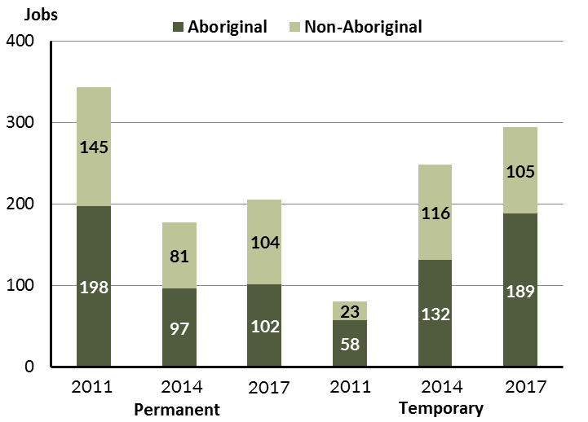

Source: Department of Trade, Business and Innovation

In 2017 in Wadeye:

* there were 206 **permanent** jobs, an increase of 28 jobs from 2014, and a decrease of 137 jobs from 2011, of which:
* 102 jobs were filled by **Aboriginal** persons, an increase of 5 jobs from 2014 and a decrease of 96 jobs from 2011
* 104 jobs were filled by **non-Aboriginal** persons, an increase of 23 jobs from 2014 and a decrease of 41 jobs from 2011
* there were 294 **temporary** jobs, an increase of 46 jobs from 2014 and an increase of 213 jobs from 2011, of which:
* 189 jobs were filled by **Aboriginal** persons, an increase of 57 jobs from 2014 and an increase of 131 jobs from 2011
* 105 jobs were filled by **non-Aboriginal** persons, a decrease of 11 jobs from 2014 and an increase of 82 jobs from 2011.

Table 6: Count of filled jobs by sector, Aboriginal status and employment status of person in job, 2011, 2014 and 2017 (a)(c)(d)(e)

|  |  |  |  |  |  |  |  |  |  |
| --- | --- | --- | --- | --- | --- | --- | --- | --- | --- |
| **Indicator** | **2011** | | | | | | | | |
| **Aboriginal** | | | **Non-Aboriginal** | | | **Total** | | |
| **Perm** | **Temp** | **Total** | **Perm** | **Temp** | **Total** | **Perm** | **Temp** | **Total** |
| Public Sector | 71 | 7 | **78** | 31 | 6 | **37** | 102 | 13 | **115** |
| Private Sector | 127 | 51 | **178** | 114 | 17 | **131** | 241 | 68 | **309** |
| **Total** | **198** | **58** | **256** | **145** | **23** | **168** | **343** | **81** | **424** |

|  |  |  |  |  |  |  |  |  |  |  |
| --- | --- | --- | --- | --- | --- | --- | --- | --- | --- | --- |
| **Indicator** | **2014** | | | | | | | | | |
| **Aboriginal** | | | **Non-Aboriginal** | | | **Total** | | | |
| **Perm** | **Temp** | **Total** | **Perm** | **Temp** | **Total** | **Perm** | **Temp** | **Total** |
| Public Sector | 18 | 41 | **59** | 24 | 28 | **52** | 42 | 69 | **111** |
| Private Sector | 79 | 91 | **170** | 57 | 88 | **145** | 136 | 179 | **315** |
| **Total** | **97** | **132** | **229** | **81** | **116** | **197** | **178** | **248** | **426** |

|  |  |  |  |  |  |  |  |  |  |
| --- | --- | --- | --- | --- | --- | --- | --- | --- | --- |
| **Indicator** | **2017** | | | | | | | | |
| **Aboriginal** | | | **Non-Aboriginal** | | | **Total** | | |
| **Perm** | **Temp** | **Total** | **Perm** | **Temp** | **Total** | **Perm** | **Temp** | **Total** |
| Public Sector | 8 | 39 | **47** | 14 | 29 | **43** | 22 | 68 | **90** |
| Private Sector | 94 | 150 | **244** | 90 | 76 | **166** | 184 | 226 | **410** |
| **Total** | **102** | **189** | **291** | **104** | **105** | **209** | **206** | **294** | **500** |

Source: Department of Trade, Business and Innovation

In 2017 in Wadeye there were:

* 90 jobs in the **public** **sector**, a decrease of 21 jobs from 2014 and a decrease of 25 jobs from 2011, of which:
* 22 jobs were **permanent**, a decrease of 20 jobs from 2014 and a decrease of 80 jobs from 2011, of which:
* 8 jobs were filled by **Aboriginal** persons, a decrease of 10 jobs from 2014 and a decrease of 63 jobs from 2011
* 14 jobs were filled by **non-Aboriginal** persons, a decrease of 10 jobs from 2014 and a decrease of 17 jobs from 2011
* 68 jobs were **temporary**, a decrease of 1 job from 2014 and an increase of 55 jobs from 2011, of which:
* 39 jobs were filled by **Aboriginal** persons, a decrease of 2 jobs from 2014 and an increase of 32 jobs from 2011
* 29 jobs were filled by **non-Aboriginal** persons, an increase of 1 job from 2014 and an increase of 23 jobs from 2011
* 410 jobs in the **private** **sector**, an increase of 95 jobs from 2014 and an increase of 101 jobs from 2011, of which:
* 184 jobs were **permanent**, an increase of 48 jobs from 2014 and a decrease of 57 jobs from 2011, of which:
* 94 jobs were filled by **Aboriginal** persons, an increase of 15 jobs from 2014 and a decrease of 33 jobs from 2011
* 90 jobs were filled by **non-Aboriginal** persons, an increase of 33 jobs from 2014 and a decrease of 24 jobs from 2011
* 226 jobs were **temporary**, an increase of 47 jobs from 2014 and an increase of 158 jobs from 2011, of which:
* 150 jobs were filled by **Aboriginal** persons, an increase of 59 jobs from 2014 and an increase of 99 jobs from 2011
* 76 jobs were filled by **non-Aboriginal** persons, a decrease of 12 jobs from 2014 and an increase of 59 jobs from 2011.

# Job Vacancies

Table 7: Job vacancies, 2011, 2014, and 2017

|  |  |  |  |  |  |
| --- | --- | --- | --- | --- | --- |
| **Indicator** | **2011** | **2014** | **2017** | **Change 2011-2014** | **Change 2014-2017** |
| **Job vacancies** | **28** | **31** | **40** | **3** | **9** |

Source: Department of Trade, Business and Innovation

Table 8: Job vacancies by occupation, 2011, 2014, and 2017 (f)(g)

|  |  |  |  |  |  |
| --- | --- | --- | --- | --- | --- |
| **Occupation (ANZSCO major group)** | **2011** | **2014** | **2017** | **Change 2011-2014** | **Change 2014-2017** |
| Clerical and Administrative Workers | 2 | 5 | 8 | 3 | 3 |
| Community and Personal Service Workers | 5 | 9 | 14 | 4 | 5 |
| Labourers | 6 | 1 | 5 | -5 | 4 |
| Machinery Operators and Drivers | 0 | 0 | 1 | 0 | 1 |
| Managers | 0 | 2 | 0 | 2 | -2 |
| Professionals | 9 | 11 | 11 | 2 | 0 |
| Sales Workers | 4 | 3 | 1 | -1 | -2 |
| Other occupations | 2 | 0 | 0 | -2 | 0 |
| **Total** | **28** | **31** | **40** | **3** | **9** |

Source: Department of Trade, Business and Innovation

Table 9: Job vacancies by job title, July 2017 (f)

|  |  |
| --- | --- |
| **Job Vacancy** | **No.** |
| Aboriginal and Torres Strait Islander Health Worker | 6 |
| Bank Worker | 1 |
| Bus Driver | 1 |
| Commercial Cleaner | 4 |
| Community Arts Worker | 1 |
| Community Worker | 4 |
| Drug and Alcohol Counsellor | 3 |
| General Clerk | 3 |
| Handyperson | 1 |
| Nutritionist | 1 |
| Police Officer | 4 |
| Program or Project Administrator | 2 |
| Receptionist (General) | 2 |
| Recreation Officer | 1 |
| Registered Nurses nec | 4 |
| Sales Assistant (General) | 1 |
| Training and Development Professional | 1 |
| **Total** | **40** |

Source: Department of Trade, Business and Innovation

In 2017 in Wadeye:

* there were 40 **vacancies** reported, an increase of 9 vacancies from 2014 and an increase of 12 vacancies from 2011
* of the 40 reported **vacancies,** the largest requirements were for:
* 14 Community and Personal Service Workers in the following jobs:
* Aboriginal and Torres Strait Islander health Worker
* Community Worker
* Police Officer
* 11 Professionals, the majority of which are in the following jobs:
* Registered Nurse nec
* Drug and Alcohol Counsellor
* 8 Clerical and Administrative Workers, the majority of which are in the following jobs:
* General Clerk
* Program or Project Administrator
* Receptionist (General).

# Jobs by Industry

Table 10: Count of filled jobs by industry of business, 2011, 2014 and 2017 (a)(h)

|  |  |  |  |  |  |  |  |  |
| --- | --- | --- | --- | --- | --- | --- | --- | --- |
| **Industry (ANZSIC Division)** | **2011** | | **2014** | | **2017** | | **Change 2011-2014** | **Change 2014-2017** |
| **Total** | **% of Total** | **Total** | **% of Total** | **Total** | **% of Total** | **Total** | **Total** |
| Accommodation and Food Services | 0 | 0.0% | 14 | 3.3% | 14 | 2.8% | 14 | 0 |
| Administrative and Support Services | 8 | 1.9% | 0 | 0.0% | 0 | 0.0% | -8 | 0 |
| Construction | 1 | 0.2% | 2 | 0.5% | 0 | 0.0% | 1 | -2 |
| Education and Training | 133 | 31.4% | 170 | 39.9% | 158 | 31.6% | 37 | -12 |
| Electricity, Gas, Water and Waste Services | 0 | 0.0% | 0 | 0.0% | 1 | 0.2% | 0 | 1 |
| Financial and Insurance Services | 3 | 0.7% | 2 | 0.5% | 3 | 0.6% | -1 | 1 |
| Health Care and Social Assistance | 41 | 9.7% | 68 | 16.0% | 64 | 12.8% | 27 | -4 |
| Other Services | 2 | 0.5% | 0 | 0.0% | 0 | 0.0% | -2 | 0 |
| Public Administration and Safety | 184 | 43.4% | 132 | 31.0% | 190 | 38.0% | -52 | 58 |
| Rental, Hiring and Real Estate Services | 3 | 0.7% | 2 | 0.5% | 0 | 0.0% | -1 | -2 |
| Retail Trade | 42 | 9.9% | 33 | 7.7% | 70 | 14.0% | -9 | 37 |
| Transport, Postal and Warehousing | 3 | 0.7% | 3 | 0.7% | 0 | 0.0% | 0 | -3 |
| **Total** | **424** | **100.0%** | **426** | **100.0%** | **500** | **100.0%** | **2** | **74** |

Source: Department of Trade, Business and Innovation

In 2017 in Wadeye:

* the Public Administration and Safety industry was the **largest** **industry** **employer**, with 190 filled jobs or 38% of filled jobs, an increase of 58 jobs from 2014 and an increase of 6 jobs from 2011
* **other** **significant** industry employers were:
* Education and Training with 158 jobs (or 31.6% of filled jobs), a decrease of 12 jobs from 2014 and an increase of 25 jobs from 2011
* Retail Trade with 70 jobs (or 14% of filled jobs), an increase of 37 jobs from 2014 and an increase of 28 jobs from 2011
* Health Care and Social Assistance with 64 jobs (or 12.8% of filled jobs), a decrease of 4 jobs from 2014 and an increase of 23 jobs from 2011.

Table 11: Count of filled jobs by industry of business and Aboriginal status of person in job, 2011, 2014, and 2017 (a)(c)(h)

|  |  |  |  |  |  |  |  |  |  |  |  |  |  |  |  |
| --- | --- | --- | --- | --- | --- | --- | --- | --- | --- | --- | --- | --- | --- | --- | --- |
| **Industry (ANZSIC division)** | **2011** | | | **2014** | | | **2017** | | | **Change 2011-2014** | | | **Change  2014-2017** | | |
| **Aboriginal** | **Non-Aboriginal** | **Total** | **Aboriginal** | **Non-Aboriginal** | **Total** | **Aboriginal** | **Non-Aboriginal** | **Total** | **Aboriginal** | **Non-Aboriginal** | **Total** | **Aboriginal** | **Non-Aboriginal** | **Total** |
| Accommodation and Food Services | 0 | 0 | **0** | 9 | 5 | **14** | 8 | 6 | **14** | 9 | 5 | **14** | -1 | 1 | **0** |
| Administrative and Support Services | 2 | 6 | **8** | 0 | 0 | **0** | 0 | 0 | **0** | -2 | -6 | **-8** | 0 | 0 | **0** |
| Construction | 1 | 0 | **1** | 0 | 2 | **2** | 0 | 0 | **0** | -1 | 2 | **1** | 0 | -2 | **-2** |
| Education and Training | 88 | 45 | **133** | 96 | 74 | **170** | 92 | 66 | **158** | 8 | 29 | **37** | -4 | -8 | **-12** |
| Electricity, Gas, Water and Waste Services | 0 | 0 | **0** | 0 | 0 | **0** | 0 | 1 | **1** | 0 | 0 | **0** | 0 | 1 | **1** |
| Financial and Insurance Services | 3 | 0 | **3** | 2 | 0 | **2** | 3 | 0 | **3** | -1 | 0 | **-1** | 1 | 0 | **1** |
| Health Care and Social Assistance | 28 | 13 | **41** | 34 | 34 | **68** | 31 | 33 | **64** | 6 | 21 | **27** | -3 | -1 | **-4** |
| Other Services | 0 | 2 | **2** | 0 | 0 | **0** | 0 | 0 | **0** | 0 | -2 | **-2** | 0 | 0 | **0** |
| Public Administration and Safety | 114 | 70 | **184** | 78 | 54 | **132** | 125 | 65 | **190** | -36 | -16 | **-52** | 47 | 11 | **58** |
| Rental, Hiring and Real Estate Services | 0 | 3 | **3** | 0 | 2 | **2** | 0 | 0 | **0** | 0 | -1 | **-1** | 0 | -2 | **-2** |
| Retail Trade | 16 | 26 | **42** | 7 | 26 | **33** | 32 | 38 | **70** | -9 | 0 | **-9** | 25 | 12 | **37** |
| Transport, Postal and Warehousing | 3 | 0 | **3** | 3 | 0 | **3** | 0 | 0 | **0** | 0 | 0 | **0** | -3 | 0 | **-3** |
| **Total** | **256** | **168** | **424** | **229** | **197** | **426** | **291** | **209** | **500** | **-27** | **29** | **2** | **62** | **12** | **74** |

Source: Department of Trade, Business and Innovation

Chart 9: Count of filled jobs by top 5 industries of business and Aboriginal status of person in job, 2017 (a)(c)(h)

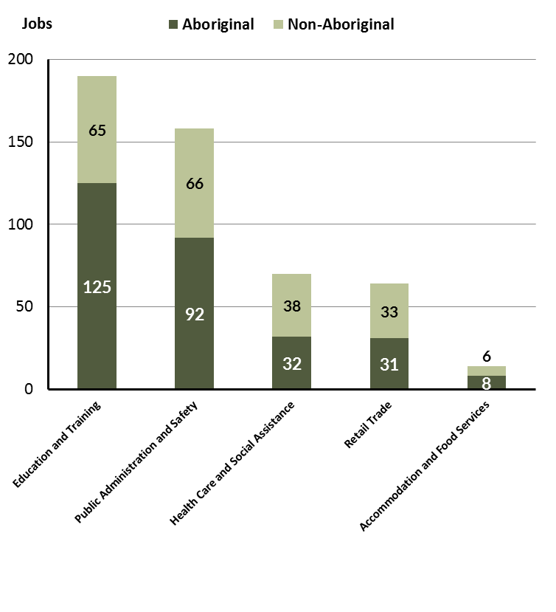

Source: Department of Trade, Business and Innovation

In 2017 in Wadeye:

* of the 291 **jobs filled** by **Aboriginal** persons, there were:
* 125 jobs in Public Administration and Safety, an increase of 47 jobs from 2014 and an increase of 11 jobs from 2011
* 92 jobs in Education and Training, a decrease of 4 jobs from 2014 and an increase of 4 jobs from 2011
* 32 jobs in Retail Trade, an increase of 25 jobs from 2014 and an increase of 16 jobs from 2011
* of the 209 **jobs filled** by **non-Aboriginal** persons, there were:
* 65 jobs in Public Administration and Safety, an increase of 11 jobs from 2014 and a decrease of 5 jobs from 2011
* 66 jobs in Education and Training, a decrease of 8 jobs from 2014 and an increase of 21 jobs from 2011
* 38 jobs in Retail Trade, an increase of 12 jobs from 2014 and an increase of 12 jobs from 2011.

Table 12: Count of filled jobs by industry, employment status and Aboriginal status of person in job, 2011 (a)(c)(e)(h)

|  |  |  |  |  |  |  |  |  |  |
| --- | --- | --- | --- | --- | --- | --- | --- | --- | --- |
| **Industry (ANZSIC division)** | **2011** | | | | | | | | |
| **Aboriginal** | | | **Non-Aboriginal** | | | **Total** | | |
| **Perm** | **Temp** | **Total** | **Perm** | **Temp** | **Total** | **Perm** | **Temp** | **Total** |
| Administrative and Support Services | 0 | 2 | **2** | 1 | 5 | **6** | 1 | 7 | **8** |
| Construction | 1 | 0 | **1** | 0 | 0 | **0** | 1 | 0 | **1** |
| Education and Training | 62 | 26 | **88** | 41 | 4 | **45** | 103 | 30 | **133** |
| Financial and Insurance Services | 3 | 0 | **3** | 0 | 0 | **0** | 3 | 0 | **3** |
| Health Care and Social Assistance | 7 | 21 | **28** | 8 | 5 | **13** | 15 | 26 | **41** |
| Other Services | 0 | 0 | **0** | 1 | 1 | **2** | 1 | 1 | **2** |
| Public Administration and Safety | 112 | 2 | **114** | 68 | 2 | **70** | 180 | 4 | **184** |
| Rental, Hiring and Real Estate Services | 0 | 0 | **0** | 1 | 2 | **3** | 1 | 2 | **3** |
| Retail Trade | 11 | 5 | **16** | 22 | 4 | **26** | 33 | 9 | **42** |
| Transport, Postal and Warehousing | 1 | 2 | **3** | 0 | 0 | **0** | 1 | 2 | **3** |
| **Total** | **198** | **58** | **256** | **145** | **23** | **168** | **343** | **81** | **424** |

Source: Department of Trade, Business and Innovation

Table 13: Count of filled jobs by industry, employment status and Aboriginal status of person in job, 2014 (a)(c)(e)(h)

|  |  |  |  |  |  |  |  |  |  |
| --- | --- | --- | --- | --- | --- | --- | --- | --- | --- |
| **Industry (ANZSIC division)** | **2014** | | | | | | | | |
| **Aboriginal** | | | **Non-Aboriginal** | | | **Total** | | |
| **Perm** | **Temp** | **Total** | **Perm** | **Temp** | **Total** | **Perm** | **Temp** | **Total** |
| Accommodation and Food Services | 0 | 9 | **9** | 0 | 5 | **5** | 0 | 14 | **14** |
| Construction | 0 | 0 | **0** | 2 | 0 | **2** | 2 | 0 | **2** |
| Education and Training | 31 | 65 | **96** | 6 | 68 | **74** | 37 | 133 | **170** |
| Financial and Insurance Services | 2 | 0 | **2** | 0 | 0 | **0** | 2 | 0 | **2** |
| Health Care and Social Assistance | 25 | 9 | **34** | 27 | 7 | **34** | 52 | 16 | **68** |
| Public Administration and Safety | 32 | 46 | **78** | 22 | 32 | **54** | 54 | 78 | **132** |
| Rental, Hiring and Real Estate Services | 0 | 0 | **0** | 2 | 0 | **2** | 2 | 0 | **2** |
| Retail Trade | 6 | 1 | **7** | 22 | 4 | **26** | 28 | 5 | **33** |
| Transport, Postal and Warehousing | 1 | 2 | **3** | 0 | 0 | **0** | 1 | 2 | **3** |
| **Total** | **97** | **132** | **229** | **81** | **116** | **197** | **178** | **248** | **426** |

Source: Department of Trade, Business and Innovation

Table 14: Count of filled jobs by industry, employment status and Aboriginal status of person in job, 2017 (a)(c)(e)(h)

|  |  |  |  |  |  |  |  |  |  |
| --- | --- | --- | --- | --- | --- | --- | --- | --- | --- |
| **Industry (ANZSIC division)** | **2017** | | | | | | | | |
| **Aboriginal** | | | **Non-Aboriginal** | | | **Total** | | |
| **Perm** | **Temp** | **Total** | **Perm** | **Temp** | **Total** | **Perm** | **Temp** | **Total** |
| Accommodation and Food Services | 0 | 8 | **8** | 0 | 6 | **6** | 0 | 14 | **14** |
| Education and Training | 0 | 92 | **92** | 0 | 66 | **66** | 0 | 158 | **158** |
| Electricity, Gas, Water and Waste Services | 0 | 0 | **0** | 1 | 0 | **1** | 1 | 0 | **1** |
| Financial and Insurance Services | 3 | 0 | **3** | 0 | 0 | **0** | 3 | 0 | **3** |
| Health Care and Social Assistance | 6 | 25 | **31** | 16 | 17 | **33** | 22 | 42 | **64** |
| Public Administration and Safety | 77 | 48 | **125** | 57 | 8 | **65** | 134 | 56 | **190** |
| Retail Trade | 16 | 16 | **32** | 30 | 8 | **38** | 46 | 24 | **70** |
| **Total** | **102** | **189** | **291** | **104** | **105** | **209** | **206** | **294** | **500** |

Source: Department of Trade, Business and Innovation

In 2017 in Wadeye:

* of the 206 **permanent jobs**, there were:
* 134 jobs in Public Administration and Safety, an increase of 80 jobs from 2014 and a decrease of 46 jobs from 2011, including:
* 77 jobs filled by **Aboriginal** persons, an increase of 45 jobs from 2014 and a decrease of 35 jobs from 2011
* 57 jobs filled by **non-Aboriginal** persons, an increase of 35 jobs from 2014 and a decrease of 11 jobs from 2011
* 46 jobs in Retail Trade, an increase of 18 jobs from 2014 and an increase of 13 jobs from 2011, including:
* 16 jobs filled by **Aboriginal** persons, an increase of 10 jobs from 2014 and an increase of 5 jobs from 2011
* 30 jobs filled by **non-Aboriginal** persons, an increase of 8 jobs from 2014 and an increase of 8 jobs from 2011
* 22 jobs in Health Care and Social Assistance, a decrease of 30 jobs from 2014 and an increase of 7 jobs from 2011, including:
* 6 jobs filled by **Aboriginal** persons, a decrease of 19 jobs from 2014 and a decrease of 1 job from 2011
* 16 jobs filled by **non-Aboriginal** persons, a decrease of 11 jobs from 2014 and an increase of 8 jobs from 2011
* of the 294 **temporary jobs**, there were:
* 158 jobs in Education and Training, an increase of 25 jobs from 2014 and an increase of 128 jobs from 2011, including:
* 92 jobs filled by **Aboriginal** persons, an increase of 27 jobs from 2014 and an increase of 66 jobs from 2011
* 66 jobs filled by **non-Aboriginal** persons, a decrease of 2 jobs from 2014 and an increase of 62 jobs from 2011
* 56 jobs in Public Administration and Safety, a decrease of 22 jobs from 2014 and an increase of 52 jobs from 2011, including:
* 48 jobs filled by **Aboriginal** persons, an increase of 2 jobs from 2014 and an increase of 46 jobs from 2011
* 8 jobs filled by **non-Aboriginal** persons, a decrease of 24 jobs from 2014 and an increase of 6 jobs from 2011
* 42 jobs in Health Care and Social Assistance, an increase of 26 jobs from 2014 and an increase of 16 jobs from 2011, including
* 25 jobs filled by **Aboriginal** persons, an increase of 16 jobs from 2014 and an increase of 4 jobs from 2011
* 17 jobs filled by **non-Aboriginal** persons, an increase of 10 jobs from 2014 and an increase of 12 jobs from 2011.

# Jobs by Occupation

Table 15: Count of filled jobs by occupation, 2011, 2014 and 2017 (a)(f)(g)

|  |  |  |  |  |  |  |  |  |
| --- | --- | --- | --- | --- | --- | --- | --- | --- |
| **Occupation (ANZSCO major group)** | **2011** | | **2014** | | **2017** | | **Change 2011-2014** | **Change 2014-2017** |
| **Total** | **% of Total** | **Total** | **% of Total** | **Total** | **% of Total** | **Total** | **Total** |
| Clerical and Administrative Workers | 39 | 9.2% | 41 | 9.6% | 68 | 13.6% | 2 | 27 |
| Community and Personal Service Workers | 124 | 29.2% | 159 | 37.3% | 156 | 31.2% | 35 | -3 |
| Labourers | 62 | 14.6% | 52 | 12.2% | 73 | 14.6% | -10 | 21 |
| Machinery Operators and Drivers | 2 | 0.5% | 7 | 1.6% | 8 | 1.6% | 5 | 1 |
| Managers | 24 | 5.7% | 25 | 5.9% | 33 | 6.6% | 1 | 8 |
| Professionals | 123 | 29.0% | 107 | 25.1% | 102 | 20.4% | -16 | -5 |
| Sales Workers | 30 | 7.1% | 17 | 4.0% | 27 | 5.4% | -13 | 10 |
| Technicians and Trades Workers | 16 | 3.8% | 18 | 4.2% | 33 | 6.6% | 2 | 15 |
| Other occupations | 4 | 0.9% | 0 | 0.0% | 0 | 0.0% | -4 | 0 |
| **Total** | **424** | **100.0%** | **426** | **100.0%** | **500** | **100.0%** | **2** | **74** |

Source: Department of Trade, Business and Innovation

Chart 10: Percentage and count of top 6 filled jobs by occupation, 2011, 2014 and 2017 (a)(f)(g)

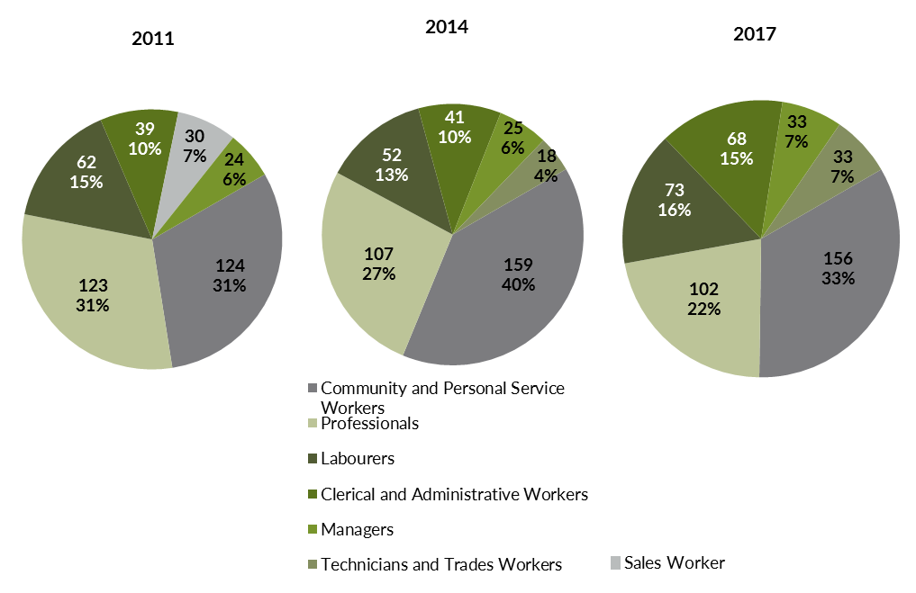

Source: Department of Trade, Business and Innovation

In 2017 in Wadeye:

* Community and Personal Service Workers was the **largest** **occupation** **classification** in terms of filled jobs, accounting for 156 jobs (31.2% of total filled jobs), a decrease of 3 jobs from 2014 and an increase of 32 jobs from 2011
* **other** **significant** occupation classifications were:
* Professionals accounting for 102 jobs or 20.4% of total jobs a decrease of 5 jobs from 2014 and a decrease of 21 jobs from 2011
* Labourers accounting for 73 jobs or 14.6% of total jobs an increase of 21 jobs from 2014 and an increase of 11 jobs from 2011
* Clerical and Administrative Workers accounting for 68 jobs or 13.6% of total jobs an increase of 27 jobs from 2014 and an increase of 29 jobs from 2011.

**Table 16 Count of filled jobs by ANZSCO occupation by Aboriginal status of person employed in job, 2011, 2014 and 2017 (a)(c)(f)(g)**

|  |  |  |  |  |  |  |  |  |  |  |  |  |  |  |  |
| --- | --- | --- | --- | --- | --- | --- | --- | --- | --- | --- | --- | --- | --- | --- | --- |
| **Occupation (ANZSCO major group)** | **2011** | | | **2014** | | | **2017** | | | **Change 2011-2014** | | | **Change 2014-2017** | | |
| **Aboriginal** | **Non-Aboriginal** | **Total** | **Aboriginal** | **Non-Aboriginal** | **Total** | **Aboriginal** | **Non-Aboriginal** | **Total** | **Aboriginal** | **Non-Aboriginal** | **Total** | **Aboriginal** | **Non-Aboriginal** | **Total** |
| Clerical and Administrative Workers | 21 | 18 | **39** | 21 | 20 | **41** | 48 | 20 | **68** | 0 | 2 | **2** | 27 | 0 | **27** |
| Community and Personal Service Workers | 102 | 22 | **124** | 115 | 44 | **159** | 115 | 41 | **156** | 13 | 22 | **35** | 0 | -3 | **-3** |
| Labourers | 43 | 19 | **62** | 36 | 16 | **52** | 59 | 14 | **73** | -7 | -3 | **-10** | 23 | -2 | **21** |
| Machinery Operators and Drivers | 2 | 0 | **2** | 3 | 4 | **7** | 2 | 6 | **8** | 1 | 4 | **5** | -1 | 2 | **1** |
| Managers | 2 | 22 | **24** | 1 | 24 | **25** | 5 | 28 | **33** | -1 | 2 | **1** | 4 | 4 | **8** |
| Professionals | 66 | 57 | **123** | 42 | 65 | **107** | 40 | 62 | **102** | -24 | 8 | **-16** | -2 | -3 | **-5** |
| Sales Workers | 15 | 15 | **30** | 4 | 13 | **17** | 9 | 18 | **27** | -11 | -2 | **-13** | 5 | 5 | **10** |
| Technicians and Trades Workers | 2 | 14 | **16** | 7 | 11 | **18** | 13 | 20 | **33** | 5 | -3 | **2** | 6 | 9 | **15** |
| Other occupations | 3 | 1 | **4** | 0 | 0 | **0** | 0 | 0 | **0** | -3 | -1 | **-4** | 0 | 0 | **0** |
| **Total** | **256** | **168** | **424** | **229** | **197** | **426** | **291** | **209** | **500** | **-27** | **29** | **2** | **62** | **12** | **74** |

Source: Department of Trade, Business and Innovation

In 2017 in Wadeye:

* of the 291 **jobs filled** by **Aboriginal** persons, there were:
* 115 Community and Personal Service Workers, unchanged from 2014 and an increase of 13 jobs from 2011
* 59 Labourers, an increase of 23 jobs from 2014 and an increase of 16 jobs from 2011
* 48 Clerical and Administrative Workers, an increase of 27 jobs from 2014 and an increase of 27 jobs from 2011
* of the 209 **jobs filled** by **non-Aboriginal** persons, there were:
* 62 Professionals, a decrease of 3 jobs from 2014 and an increase of 5 jobs from 2011
* 41 Community and Personal Service Workers, a decrease of 3 jobs from 2014 and an increase of 19 jobs from 2011
* 28 Managers, an increase of 4 jobs from 2014 and an increase of 6 jobs from 2011.

# Jobs by Industry by Occupation

Table 17: Count of filled jobs by industry by occupation, 2011 (a)(f)(g)(h)

|  |  |  |  |  |  |  |  |  |  |  |  |
| --- | --- | --- | --- | --- | --- | --- | --- | --- | --- | --- | --- |
| **2011** | | | | | | | | | | | |
| **Industry (ANZSIC Division)** |  | **Occupation (ANZSCO major group)** | | | | | | | | | |
| **Clerical and Administrative Workers** | **Community and Personal Service Workers** | **Labourers** | **Machinery Operators and Drivers** | **Managers** | **Professionals** | **Sales Workers** | **Technicians and Trades Workers** | **Other occupations** | **Total** |
| Administrative and Support Services | 2 | 1 | 0 | 0 | 0 | 5 | 0 | 0 | 0 | **8** |
| Construction | 0 | 0 | 0 | 0 | 0 | 1 | 0 | 0 | 0 | **1** |
| Education and Training | 2 | 72 | 14 | 0 | 2 | 43 | 0 | 0 | 0 | **133** |
| Financial and Insurance Services | 3 | 0 | 0 | 0 | 0 | 0 | 0 | 0 | 0 | **3** |
| Health Care and Social Assistance | 1 | 20 | 3 | 0 | 2 | 8 | 0 | 3 | 4 | **41** |
| Other Services | 0 | 0 | 0 | 0 | 0 | 2 | 0 | 0 | 0 | **2** |
| Public Administration and Safety | 28 | 30 | 38 | 0 | 11 | 63 | 2 | 12 | 0 | **184** |
| Rental, Hiring and Real Estate Services | 0 | 0 | 0 | 0 | 1 | 0 | 2 | 0 | 0 | **3** |
| Retail Trade | 2 | 0 | 5 | 0 | 8 | 0 | 26 | 1 | 0 | **42** |
| Transport, Postal and Warehousing | 1 | 0 | 0 | 2 | 0 | 0 | 0 | 0 | 0 | **3** |
| **Total** | **39** | **124** | **62** | **2** | **24** | **123** | **30** | **16** | **4** | **424** |

Source: Department of Trade, Business and Innovation

Table 18: Count of filled jobs by industry by occupation, 2014 (a)(f)(g)(h)

|  |  |  |  |  |  |  |  |  |  |  |
| --- | --- | --- | --- | --- | --- | --- | --- | --- | --- | --- |
| **2014** | | | | | | | | | | |
| **Industry (ANZSIC Division)** |  | **Occupation (ANZSCO major group)** | | | | | | | | |
| **Clerical and Administrative Workers** | **Community and Personal Service Workers** | **Labourers** | **Machinery Operators and Drivers** | **Managers** | **Professionals** | **Sales Workers** | **Technicians and Trades Workers** | **Other occupations** | **Total** |
| Accommodation and Food Services | 0 | 8 | 3 | 0 | 2 | 0 | 0 | 1 | 0 | **14** |
| Construction | 0 | 0 | 1 | 0 | 0 | 0 | 0 | 1 | 0 | **2** |
| Education and Training | 14 | 82 | 19 | 0 | 2 | 53 | 0 | 0 | 0 | **170** |
| Financial and Insurance Services | 2 | 0 | 0 | 0 | 0 | 0 | 0 | 0 | 0 | **2** |
| Health Care and Social Assistance | 5 | 33 | 5 | 3 | 7 | 14 | 0 | 1 | 0 | **68** |
| Public Administration and Safety | 16 | 36 | 18 | 2 | 7 | 40 | 1 | 12 | 0 | **132** |
| Rental, Hiring and Real Estate Services | 1 | 0 | 0 | 0 | 0 | 0 | 1 | 0 | 0 | **2** |
| Retail Trade | 2 | 0 | 4 | 2 | 7 | 0 | 15 | 3 | 0 | **33** |
| Transport, Postal and Warehousing | 1 | 0 | 2 | 0 | 0 | 0 | 0 | 0 | 0 | **3** |
| **Total** | **41** | **159** | **52** | **7** | **25** | **107** | **17** | **18** | **0** | **426** |

Source: Department of Trade, Business and Innovation

Table 19: Count of filled jobs by occupation and by industry, 2017 (a)(f)(g)(h)

|  |  |  |  |  |  |  |  |  |  |  |
| --- | --- | --- | --- | --- | --- | --- | --- | --- | --- | --- |
| **2017** | | | | | | | | | | |
| **Industry (ANZSIC Division)** |  | **Occupation (ANZSCO major group)** | | | | | | | | |
| **Clerical and Administrative Workers** | **Community and Personal Service Workers** | **Labourers** | **Machinery Operators and Drivers** | **Managers** | **Professionals** | **Sales Workers** | **Technicians and Trades Workers** | **Other Occupations** | **Total** |
| Accommodation and Food Services | 1 | 8 | 2 | 0 | 1 | 0 | 0 | 2 | 0 | **14** |
| Education and Training | 16 | 69 | 13 | 0 | 5 | 50 | 0 | 5 | 0 | **158** |
| Electricity, Gas, Water and Waste Services | 0 | 0 | 0 | 0 | 0 | 0 | 0 | 1 | 0 | **1** |
| Financial and Insurance Services | 3 | 0 | 0 | 0 | 0 | 0 | 0 | 0 | 0 | **3** |
| Health Care and Social Assistance | 5 | 30 | 11 | 0 | 3 | 15 | 0 | 0 | 0 | **64** |
| Public Administration and Safety | 42 | 40 | 44 | 2 | 10 | 31 | 0 | 21 | 0 | **190** |
| Retail Trade | 1 | 9 | 3 | 6 | 14 | 6 | 27 | 4 | 0 | **70** |
| **Total** | **68** | **156** | **73** | **8** | **33** | **102** | **27** | **33** | **0** | **500** |

Source: Department of Trade, Business and Innovation

In 2017 in Wadeye:

* the majority of Community and Personal Service Workers (102) jobs (the largest occupation group) were shared across the Education and Training (50), Public Administration and Safety (31) and Health Care and Social Assistance (15) industries
* the majority of Public Administration and Safety jobs (190) (the largest industry group) were shared across Labourers, Clerical and Administrative Workers and Community and Personal Service Workers occupation groups
* Public Administration and Safety and Retail Trade both had increases in filled jobs of 58 and 37 respectively between 2017 and 2014.

# Jobs by Gender

Table 20: Counts of filled jobs by gender and Aboriginal status of person employed in job 2011, 2014 and 2017 (a)(c)(i)

|  |  |  |  |  |  |  |  |  |  |  |  |  |  |  |  |
| --- | --- | --- | --- | --- | --- | --- | --- | --- | --- | --- | --- | --- | --- | --- | --- |
| **Indicator** | **2011** | | | **2014** | | | **2017** | | | **2011-2014 Change** | | | **2014-2017 Change** | | |
| **Aboriginal** | **Non-Aboriginal** | **Total** | **Aboriginal** | **Non-Aboriginal** | **Total** | **Aboriginal** | **Non-Aboriginal** | **Total** | **Aboriginal** | **Non-Aboriginal** | **Total** | **Aboriginal** | **Non-Aboriginal** | **Total** |
| Male | 95 | 77 | **172** | 127 | 91 | **218** | 115 | 103 | **218** | 32 | 14 | **46** | -12 | 12 | **0** |
| Female | 74 | 51 | **125** | 102 | 106 | **208** | 176 | 106 | **282** | 28 | 55 | **83** | 74 | 0 | **74** |
| **Total** | **256** | **168** | **424** | **229** | **197** | **426** | **291** | **209** | **500** | **-27** | **29** | **2** | **62** | **12** | **74** |

Source: Department of Trade, Business and Innovation

Chart 11: Count of filled jobs by gender and Aboriginal status of person in job, 2011, 2014 and 2017 (a)(c)(i)

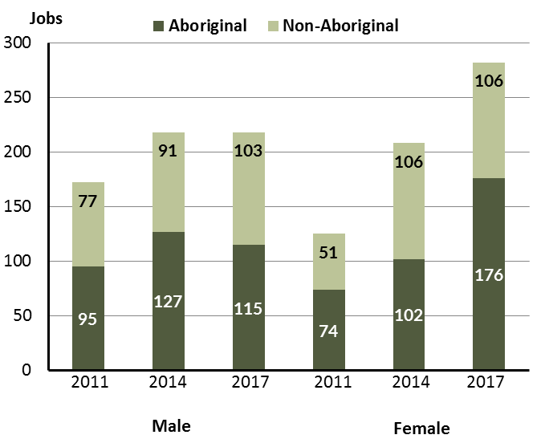

Source: Department of Trade, Business and Innovation

In 2017 in Wadeye:

* there were 218 jobs **filled** **by** **males**, unchanged from 2014 and unchanged from 2011
* of the 218 jobs **filled by males:**
* 115 were **Aboriginal**, a decrease of 12 jobs from 2014 and an increase of 20 jobs from 2011
* 103 were **non-Aboriginal**, an increase of 12 jobs from 2014 and an increase of 26 jobs from 2011
* there were 282 jobs **filled** **by** **females**, an increase of 74 jobs from 2014 and an increase of 157 jobs from 2011
* of the 282 jobs **filled by females**:
* 176 were **Aboriginal**, an increase of 74 jobs from 2014 and an increase of 102 jobs from 2011
* 106 were **non-Aboriginal**, unchanged from 2014 and unchanged from 2011.

Table 21: Counts of filled jobs by gender, by Aboriginal status of person in the job, by full-time/part-time status, by job permanency and by sector 2011 (a)(b)(c)(d)(e)(i)

|  |  |  |  |  |  |  |  |  |  |
| --- | --- | --- | --- | --- | --- | --- | --- | --- | --- |
| **2011** | | | | | | | | | |
| **Indicator** | **Male** | | | **Female** | | | **Total** | | |
| **Aboriginal** | **Non-Aboriginal** | **Total** | **Aboriginal** | **Non-Aboriginal** | **Total** | **Aboriginal** | **Non-Aboriginal** | **Total** |
| Full-time | 66 | 74 | **140** | 49 | 47 | **96** | 177 | 161 | **338** |
| Part-time | 29 | 3 | **32** | 25 | 4 | **29** | 79 | 7 | **86** |
| **Total** | **95** | **77** | **172** | **74** | **51** | **125** | **256** | **168** | **424** |
| Permanent | 81 | 65 | **146** | 55 | 40 | **95** | 198 | 145 | **343** |
| Temporary | 14 | 12 | **26** | 19 | 11 | **30** | 58 | 23 | **81** |
| **Total** | **95** | **77** | **172** | **74** | **51** | **125** | **256** | **168** | **424** |
| Public Sector | 55 | 25 | **80** | 23 | 12 | **35** | 78 | 37 | **115** |
| Private Sector | 40 | 52 | **92** | 51 | 39 | **90** | 178 | 131 | **309** |
| **Total** | **95** | **77** | **172** | **74** | **51** | **125** | **256** | **168** | **424** |

Source: Department of Trade, Business and Innovation

Table 22: Counts of filled jobs by gender, by Aboriginal status of person in the job, by full-time/part-time status, by job permanency and by sector 2014 (a)(b)(c)(d)(e)(i)

|  |  |  |  |  |  |  |  |  |  |  |
| --- | --- | --- | --- | --- | --- | --- | --- | --- | --- | --- |
| **2014** | | | | | | | | | | |
| **Indicator** | **Male** | | | **Female** | | | **Total** | | | |
| **Aboriginal** | **Non-Aboriginal** | **Total** | **Aboriginal** | **Non-Aboriginal** | **Total** | **Aboriginal** | **Non-Aboriginal** | **Total** |
| Full-time | 74 | 86 | **160** | 48 | 89 | **137** | 122 | 175 | **297** |
| Part-time | 53 | 5 | **58** | 54 | 17 | **71** | 107 | 22 | **129** |
| **Total** | **127** | **91** | **218** | **102** | **106** | **208** | **229** | **197** | **426** |
| Permanent | 52 | 33 | **85** | 45 | 48 | **93** | 97 | 81 | **178** |
| Temporary | 75 | 58 | **133** | 57 | 58 | **115** | 132 | 116 | **248** |
| **Total** | **127** | **91** | **218** | **102** | **106** | **208** | **229** | **197** | **426** |
| Public Sector | 31 | 27 | **58** | 28 | 25 | **53** | 59 | 52 | **111** |
| Private Sector | 96 | 64 | **160** | 74 | 81 | **155** | 170 | 145 | **315** |
| **Total** | **127** | **91** | **218** | **102** | **106** | **208** | **229** | **197** | **426** |

Source: Department of Trade, Business and Innovation

Table 23: Counts of filled jobs by gender, by Aboriginal status of person in the job, by full-time/part-time status, by job permanency and by sector 2017 (a)(b)(c)(d)(e)(i)

|  |  |  |  |  |  |  |  |  |  |  |
| --- | --- | --- | --- | --- | --- | --- | --- | --- | --- | --- |
| **2017** | | | | | | | | | | |
| **Indicator** | **Male** | | | **Female** | | | **Total** | | |
| **Aboriginal** | **Non-Aboriginal** | **Total** | **Aboriginal** | **Non-Aboriginal** | **Total** | **Aboriginal** | **Non-Aboriginal** | **Total** |
| Full-time | 51 | 100 | **151** | 48 | 96 | **144** | 99 | 196 | **295** |
| Part-time | 64 | 3 | **67** | 128 | 10 | **138** | 192 | 13 | **205** |
| **Total** | **115** | **103** | **218** | **176** | **106** | **282** | **291** | **209** | **500** |
| Permanent | 60 | 50 | **110** | 42 | 54 | **96** | 102 | 104 | **206** |
| Temporary | 55 | 53 | **108** | 134 | 52 | **186** | 189 | 105 | **294** |
| **Total** | **115** | **103** | **218** | **176** | **106** | **282** | **291** | **209** | **500** |
| Public Sector | 18 | 22 | **40** | 29 | 21 | **50** | 47 | 43 | **90** |
| Private Sector | 97 | 81 | **178** | 147 | 85 | **232** | 244 | 166 | **410** |
| **Total** | **115** | **103** | **218** | **176** | **106** | **282** | **291** | **209** | **500** |

Source: Department of Trade, Business and Innovation

In 2017 in Wadeye:

* of the 218 **jobs** **filled** **by** **males**, there were:
* 115 jobs filled by **Aboriginal** **males,** a decrease of 12 jobs from 2014 and an increase of 20 jobs from 2011, including:
* 51 full-time jobs, a decrease of 23 jobs from 2014 and a decrease of 15 jobs from 2011
* 64 part-time jobs, an increase of 11 jobs from 2014 and an increase of 35 jobs from 2011
* 60 permanent jobs, an increase of 8 jobs from 2014 and a decrease of 21 jobs from 2011
* 55 temporary jobs, a decrease of 20 jobs from 2014 and an increase of 41 jobs from 2011
* 18 public sector jobs, a decrease of 13 jobs from 2014 and a decrease of 37 jobs from 2011
* 97 private sector jobs, an increase of 1 job from 2014 and an increase of 57 jobs from 2011
* 103 **jobs filled by non-Aboriginal males**, an increase of 12 jobs from 2014 and an increase of 26 jobs from 2011, including:
* 100 full-time jobs, an increase of 14 jobs from 2014 and an increase of 26 jobs from 2011
* 3 part-time jobs, a decrease of 2 jobs from 2014 and unchanged from 2011
* 50 permanent jobs, an increase of 17 jobs from 2014 and a decrease of 15 jobs from 2011
* 53 temporary jobs, a decrease of 5 jobs from 2014 and an increase of 41 jobs from 2011
* 22 public sector jobs, a decrease of 5 jobs from 2014 and a decrease of 3 jobs from 2011
* 81 private sector jobs, an increase of 17 jobs from 2014 and an increase of 29 jobs from 2011
* of the 282 **jobs** **filled** **by** **females**, there were:
* 176 jobs filled by Aboriginal females, an increase of 74 jobs from 2014 and an increase of 102 jobs from 2011, including:
* 48 full-time jobs, unchanged from 2014 and a decrease of 1 job from 2011
* 128 part-time jobs, an increase of 74 jobs from 2014 and an increase of 103 jobs from 2011
* 42 permanent jobs, a decrease of 3 jobs from 2014 and a decrease of 13 jobs from 2011
* 134 temporary jobs, an increase of 77 jobs from 2014 and an increase of 115 jobs from 2011
* 29 public sector jobs, an increase of 1 job from 2014 and an increase of 6 jobs from 2011
* 147 private sector jobs, an increase of 73 jobs from 2014 and an increase of 96 jobs from 2011
* 106 jobs filled by **non-Aboriginal females**, unchanged from 2014 and an increase of 55 jobs from 2011, including:
* 96 full-time jobs, an increase of 7 jobs from 2014 and an increase of 49 jobs from 2011
* 10 part-time jobs, a decrease of 7 jobs from 2014 and an increase of 6 jobs from 2011
* 54 permanent jobs, an increase of 6 jobs from 2014 and an increase of 14 jobs from 2011
* 52 temporary jobs, a decrease of 6 jobs from 2014 and an increase of 41 jobs from 2011
* 21 public sector jobs, a decrease of 4 jobs from 2014 and an increase of 9 jobs from 2011
* 85 private sector jobs, an increase of 4 jobs from 2014 and an increase of 46 jobs from 2011.

# Jobs by Age

Table 24: Counts of filled jobs by age and Aboriginal status of person employed in job, 2011, 2014 and 2017 (a)(c)(j)

|  |  |  |  |  |  |  |  |  |  |  |  |  |  |  |  |  |
| --- | --- | --- | --- | --- | --- | --- | --- | --- | --- | --- | --- | --- | --- | --- | --- | --- |
| **Indicator** | **2011** | | | **2014** | | | **2017** | | | **Change 2011-2014** | | | **Change 2014-2017** | | | |
| **Aboriginal** | **Non-Aboriginal** | **Total** | **Aboriginal** | **Non-Aboriginal** | **Total** | **Aboriginal** | **Non-Aboriginal** | **Total** | **Aboriginal** | **Non-Aboriginal** | **Total** | **Aboriginal** | **Non-Aboriginal** | **Total** |
| 15-24 years | 25 | 7 | **32** | 5 | 14 | **19** | 25 | 8 | **33** | -20 | 7 | **-13** | 20 | -6 | **14** |
| 25-44 years | 84 | 64 | **148** | 150 | 91 | **241** | 199 | 135 | **334** | 66 | 27 | **93** | 49 | 44 | **93** |
| 45+ years | 60 | 57 | **117** | 74 | 92 | **166** | 67 | 66 | **133** | 14 | 35 | **49** | -7 | -26 | **-33** |
| **Total** | **256** | **168** | **424** | **229** | **197** | **426** | **291** | **209** | **500** | **-27** | **29** | **2** | **62** | **12** | **74** |

Source: Department of Trade, Business and Innovation

Chart 12: Count of filled jobs by age and Aboriginal status of person in job, 2011, 2014 and 2017 (a)(c)(j)

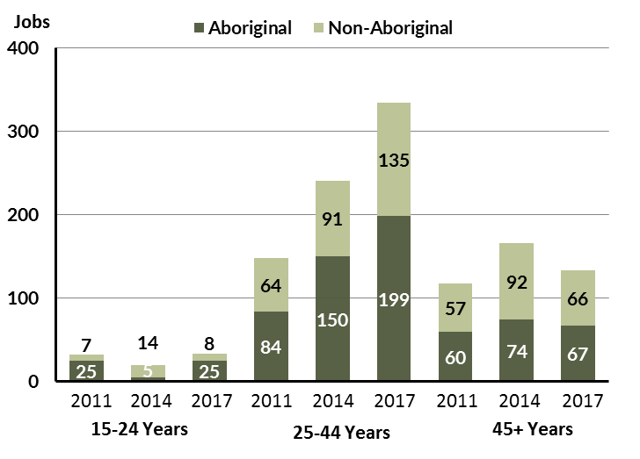

Source: Department of Trade, Business and Innovation

In 2017 in Wadeye:

* there were 33 **jobs** filled by persons aged **15-24 years,** an increase of 14 jobs from 2014 and an increase of 1 job from 2011. Of these:
* 25 jobs were filled by **Aboriginal** persons, an increase of 20 jobs from 2014 and unchanged from 2011
* 8 jobs were filled by **non-Aboriginal** persons, a decrease of 6 jobs from 2014 and an increase of 1 job from 2011
* there were 334 **jobs** **filled** by persons aged **25-44 years**, an increase of 93 jobs from 2014 and an increase of 186 jobs from 2011. Of these:
* 199 jobs were filled by **Aboriginal** persons, an increase of 49 jobs from 2014 and an increase of 115 jobs from 2011
* 135 jobs were filled by **non-Aboriginal** persons, an increase of 44 jobs from 2014 and an increase of 71 jobs from 2011
* there were 133 **jobs** **filled** by persons aged **45+ years**, a decrease of 33 jobs from 2011 and an increase of 16 jobs from 2011. Of these:
* 67 jobs were filled by **Aboriginal** persons, a decrease of 7 jobs from 2014 and an increase of 7 jobs from 2011
* 66 jobs were filled by **non-Aboriginal** persons, a decrease of 26 jobs from 2014 and an increase of 9 jobs from 2011.

Table 25: Counts of filled jobs by age, by Aboriginal status of person in the job, by full-time/part-time status, by job permanency and by sector June-July 2011 (a)(b)(c)(d)(e)(i)

|  |  |  |  |  |  |  |  |  |  |  |  |  |  |
| --- | --- | --- | --- | --- | --- | --- | --- | --- | --- | --- | --- | --- | --- |
| **2011** | | | | | | | | | | | | | |
| **Indicator** | **15-24 years** | | | **25-44 years** | | | **45+ years** | | | **Total** | | | |
| **Aboriginal** | **Non-Aboriginal** | **Total** | **Aboriginal** | **Non-Aboriginal** | **Total** | **Aboriginal** | **Non-Aboriginal** | **Total** | **Aboriginal** | **Non-Aboriginal** | **Total** |
| Full-time | 20 | 6 | **26** | 55 | 60 | **115** | 40 | 55 | **95** | 177 | 161 | **338** |
| Part-time | 5 | 1 | **6** | 29 | 4 | **33** | 20 | 2 | **22** | 79 | 7 | **86** |
| **Total** | **25** | **7** | **32** | **84** | **64** | **148** | **60** | **57** | **117** | **256** | **168** | **424** |
| Permanent | 23 | 5 | **28** | 62 | 56 | **118** | 51 | 44 | **95** | 198 | 145 | **343** |
| Temporary | 2 | 2 | **4** | 22 | 8 | **30** | 9 | 13 | **22** | 58 | 23 | **81** |
| **Total** | **25** | **7** | **32** | **84** | **64** | **148** | **60** | **57** | **117** | **256** | **168** | **424** |
| Public Sector | 3 | 5 | **8** | 40 | 14 | **54** | 35 | 18 | **53** | 78 | 37 | **115** |
| Private Sector | 22 | 2 | **24** | 44 | 50 | **94** | 25 | 39 | **64** | 178 | 131 | **309** |
| **Total** | **25** | **7** | **32** | **84** | **64** | **148** | **60** | **57** | **117** | **256** | **168** | **424** |

Source: Department of Trade, Business and Innovation

Table 26: Counts of filled jobs by age, by Aboriginal status of person in the job, by full-time/part-time status, by job permanency and by sector June-July 2014 (a)(b)(c)(d)(e)(i)

|  |  |  |  |  |  |  |  |  |  |  |  |  |  |
| --- | --- | --- | --- | --- | --- | --- | --- | --- | --- | --- | --- | --- | --- |
| **2014** | | | | | | | | | | | | | |
| **Indicator** | **15-24 years** | | | **25-44 years** | | | **45+ years** | | | **Total** | | | |
| **Aboriginal** | **Non-Aboriginal** | **Total** | **Aboriginal** | **Non-Aboriginal** | **Total** | **Aboriginal** | **Non-Aboriginal** | **Total** | **Aboriginal** | **Non-Aboriginal** | **Total** |
| Full-time | 2 | 12 | **14** | 79 | 84 | **163** | 41 | 79 | **120** | 122 | 175 | **297** |
| Part-time | 3 | 2 | **5** | 71 | 7 | **78** | 33 | 13 | **46** | 107 | 22 | **129** |
| **Total** | **5** | **14** | **19** | **150** | **91** | **241** | **74** | **92** | **166** | **229** | **197** | **426** |
| Permanent | 2 | 9 | **11** | 51 | 39 | **90** | 44 | 33 | **77** | 97 | 81 | **178** |
| Temporary | 3 | 5 | **8** | 99 | 52 | **151** | 30 | 59 | **89** | 132 | 116 | **248** |
| **Total** | **5** | **14** | **19** | **150** | **91** | **241** | **74** | **92** | **166** | **229** | **197** | **426** |
| Public Sector | 1 | 1 | **2** | 34 | 26 | **60** | 24 | 25 | **49** | 59 | 52 | **111** |
| Private Sector | 4 | 13 | **17** | 116 | 65 | **181** | 50 | 67 | **117** | 170 | 145 | **315** |
| **Total** | **5** | **14** | **19** | **150** | **91** | **241** | **74** | **92** | **166** | **229** | **197** | **426** |

Source: Department of Trade, Business and Innovation

Table 27: Counts of filled jobs by age, by Aboriginal status of person in the job, by full-time/part-time status, by job permanency and by sector June-July 2017 (a)(b)(c)(d)(e)(i)

|  |  |  |  |  |  |  |  |  |  |  |  |  |  |
| --- | --- | --- | --- | --- | --- | --- | --- | --- | --- | --- | --- | --- | --- |
| **2017** | | | | | | | | | | | | | |
| **Indicator** | **15-24 years** | | | **25-44 years** | | | **45+ years** | | | **Total** | | |
| **Aboriginal** | **Non-Aboriginal** | **Total** | **Aboriginal** | **Non-Aboriginal** | **Total** | **Aboriginal** | **Non-Aboriginal** | **Total** | **Aboriginal** | **Non-Aboriginal** | **Total** |
| Full-time | 6 | 8 | **14** | 62 | 126 | **188** | 31 | 62 | **93** | 99 | 196 | **295** |
| Part-time | 19 | 0 | **19** | 137 | 9 | **146** | 36 | 4 | **40** | 192 | 13 | **205** |
| **Total** | **25** | **8** | **33** | **199** | **135** | **334** | **67** | **66** | **133** | **291** | **209** | **500** |
| Permanent | 5 | 5 | **10** | 82 | 73 | **155** | 15 | 26 | **41** | 102 | 104 | **206** |
| Temporary | 20 | 3 | **23** | 117 | 62 | **179** | 52 | 40 | **92** | 189 | 105 | **294** |
| **Total** | **25** | **8** | **33** | **199** | **135** | **334** | **67** | **66** | **133** | **291** | **209** | **500** |
| Public Sector | 3 | 0 | **3** | 28 | 20 | **48** | 16 | 23 | **39** | 47 | 43 | **90** |
| Private Sector | 22 | 8 | **30** | 171 | 115 | **286** | 51 | 43 | **94** | 244 | 166 | **410** |
| **Total** | **25** | **8** | **33** | **199** | **135** | **334** | **67** | **66** | **133** | **291** | **209** | **500** |

Source: Department of Trade, Business and Innovation

In 2017 in Wadeye:

* of the 33 **jobs** **filled** by persons aged **15-24 years**, there were:
* 25 jobs filled by **Aboriginal** persons, of which
* 6 were full-time jobs, an increase of 4 jobs from 2014 and a decrease of 14 jobs from 2011
* 19 were part-time jobs, an increase of 16 jobs from 2014 and an increase of 14 jobs from 2011
* 5 were permanent jobs, an increase of 3 jobs from 2014 and a decrease of 18 jobs from 2011
* 20 were temporary jobs, an increase of 17 jobs from 2014 and an increase of 18 jobs from 2011
* 3 were public sector jobs, an increase of 2 jobs from 2014 and unchanged from 2011
* 22 were private sector jobs, an increase of 18 jobs from 2014 and unchanged from 2011
* 8 jobs filled by **non-Aboriginal** persons, of which:
* 8 were full-time jobs, a decrease of 4 jobs from 2014 and an increase of 2 jobs from 2011
* none were part-time jobs, a decrease of 2 jobs from 2014 and a decrease of 1 job from 2011
* 5 were permanent jobs, a decrease of 4 jobs from 2014 and unchanged from 2011
* 3 were temporary jobs, a decrease of 2 jobs from 2014 and an increase of 1 job from 2011
* none were public sector jobs, a decrease of 1 job from 2014 and a decrease of 5 jobs from 2011
* 8 were private sector jobs, a decrease of 5 jobs from 2014 and an increase of 6 jobs from 2011
* of the 334 **jobs** **filled** by persons aged **25-44 years**, there were:
* 199 jobs filled by **Aboriginal** persons, of which:
* 62 were full-time jobs, a decrease of 17 jobs from 2014 and an increase of 7 jobs from 2011
* 137 were part-time jobs, an increase of 66 jobs from 2014 and an increase of 108 jobs from 2011
* 82 were permanent jobs, an increase of 31 jobs from 2014 and an increase of 20 jobs from 2011
* 117 were temporary jobs, an increase of 18 jobs from 2014 and an increase of 95 jobs from 2011
* 28 were public sector jobs, a decrease of 6 jobs from 2014 and a decrease of 12 jobs from 2011
* 171 were private sector jobs, an increase of 55 jobs from 2014 and an increase of 127 jobs from 2011
* 135 jobs filled by **non-Aboriginal** persons, of which:
* 126 were full-time jobs, an increase of 42 jobs from 2014 and an increase of 66 jobs from 2011
* 9 were part-time jobs, an increase of 2 jobs from 2014 and an increase of 5 jobs from 2011
* 73 were permanent jobs, an increase of 34 jobs from 2014 and an increase of 17 jobs from 2011
* 62 were temporary jobs, an increase of 10 jobs from 2014 and an increase of 54 jobs from 2011
* 20 were public sector jobs, a decrease of 6 jobs from 2014 and an increase of 6 jobs from 2011
* 115 were private sector jobs, an increase of 50 jobs from 2014 and an increase of 65 jobs from 2011
* of the 133 **jobs** **filled** by persons aged **45+ years**, there were:
* 67 jobs filled by **Aboriginal** persons, of which:
* 31 were full-time jobs, a decrease of 10 jobs from 2014 and a decrease of 9 jobs from 2011
* 36 were part-time jobs, an increase of 3 jobs from 2014 and an increase of 16 jobs from 2011
* 15 were permanent jobs, a decrease of 29 jobs from 2014 and a decrease of 36 jobs from 2011
* 52 were temporary jobs, an increase of 22 jobs from 2014 and an increase of 43 jobs from 2011
* 16 were public sector jobs, a decrease of 8 jobs from 2014 and a decrease of 19 jobs from 2011
* 51 were private sector jobs, an increase of 1 job from 2014 and an increase of 26 jobs from 2011
* 66 jobs filled by **non-Aboriginal** persons, of which:
* 62 were full-time jobs, a decrease of 17 jobs from 2014 and an increase of 7 jobs from 2011
* 4 were part-time jobs, a decrease of 9 jobs from 2014 and an increase of 2 jobs from 2011
* 26 were permanent jobs, a decrease of 7 jobs from 2014 and a decrease of 18 jobs from 2011
* 40 were temporary jobs, a decrease of 19 jobs from 2014 and an increase of 27 jobs from 2011
* 23 were public sector jobs, a decrease of 2 jobs from 2014 and an increase of 5 jobs from 2011
* 43 were private sector jobs, a decrease of 24 jobs from 2014 and an increase of 4 jobs from 2011.

# Vocational Education and Training

Note: *Since previous publications, the 2010 data have fallen in line with the new standardised reporting practices with an emphasis of all training activity undertaken in the remote town regardless of funding stream. As such, figures for 2010 VET data in this publication may differ from previous publications.*

*The impact of the Remote Jobs and Communities Program (RJCP) being established in 2013 has played a significant role in the downturn of accredited training in many remote towns across the Territory.*

Table 28: Northern Territory Vocational Education and Training (VET) students, 2010, 2013 and 2016 (k)

|  |  |  |  |  |  |  |  |  |
| --- | --- | --- | --- | --- | --- | --- | --- | --- |
| **VET Funding Group** | **2010** | | **2013** | | **2016** | | **Change** | |
| **No.** | **% of Total** | **No.** | **% of Total** | **No.** | **% of Total** | **2010-2013** | **2013-2016** |
| Arts, Entertainment, Sports and Recreation | 24 | 4 | 4 | 1 | 30 | 9 | - 20 | 26 |
| Automotive | 11 | 2 | 36 | 12 | 14 | 4 | 25 | - 22 |
| Building and Construction | 141 | 25 | 37 | 12 | 34 | 10 | - 104 | - 3 |
| Business and Clerical | 12 | 2 | 2 | 1 | 10 | 3 | - 10 | 8 |
| Community Services, Health and Education | 57 | 10 | 58 | 19 | 91 | 28 | 1 | 33 |
| Engineering and Mining | 33 | 6 | 0 | 0 | 17 | 5 | - 33 | 17 |
| Finance, Banking and Insurance | 3 | 1 | 3 | 1 | 4 | 1 | 0 | 1 |
| General Education and Training | 76 | 13 | 37 | 12 | 29 | 9 | - 39 | - 8 |
| Primary Industry | 149 | 26 | 85 | 28 | 62 | 19 | - 64 | - 23 |
| Sales and Personal Service | 43 | 8 | 20 | 7 | 12 | 4 | - 23 | - 8 |
| Textiles, Clothing, Footwear and Furnishings | 0 | 0 | 2 | 1 | 0 | 0 | 2 | - 2 |
| Tourism and Hospitality | 11 | 2 | 4 | 1 | 3 | 1 | - 7 | - 1 |
| Transport and Storage | 9 | 2 | 14 | 5 | 20 | 6 | 5 | 6 |
| Utilities | 0 | 0 | 1 | 0 | 0 | 0 | 1 | - 1 |
| **Total** | **569** | **100** | **303** | **100** | **326** | **100** | **- 266** | **23** |

Source: Department of Trade, Business and Innovation

In 2016 in Wadeye:

* there were 326 **VET students**, an increase of 23 students from 2013 and a decrease of 243 students from 2010
* the areas of VET activity with the most students were Community Services, Health and Education (91), Primary Industry (62), and Building and Construction (34)
* Community Services, Health and Education reported the largest increase in students (33) compared to 2013 and Primary Industry reported the largest decrease in students (-23) over the same period.

Table 29: Northern Territory Vocational Education and Training (VET) unit enrolments, 2010, 2013 and 2016 (l)

|  |  |  |  |  |  |  |  |  |
| --- | --- | --- | --- | --- | --- | --- | --- | --- |
| **VET Funding Group** | **2010** | | **2013** | | **2016** | | **Change** | |
| **No.** | **% of Total** | **No.** | **% of Total** | **No.** | **% of Total** | **2010-2013** | **2013-2016** |
| Arts, Entertainment, Sports and Recreation | 144 | 7 | 13 | 1 | 63 | 4 | - 131 | 50 |
| Automotive | 82 | 4 | 184 | 12 | 56 | 3 | 102 | - 128 |
| Building and Construction | 448 | 22 | 331 | 22 | 342 | 20 | - 117 | 11 |
| Business and Clerical | 27 | 1 | 6 | 0 | 10 | 1 | - 21 | 4 |
| Community Services, Health and Education | 238 | 12 | 232 | 16 | 445 | 26 | - 6 | 213 |
| Engineering and Mining | 33 | 2 | 0 | 0 | 80 | 5 | - 33 | 80 |
| Finance, Banking and Insurance | 11 | 1 | 8 | 1 | 28 | 2 | - 3 | 20 |
| Food Processing | 0 | 0 | 0 | 0 | 0 | 0 | 0 | 0 |
| General Education and Training | 138 | 7 | 202 | 14 | 151 | 9 | 64 | - 51 |
| Primary Industry | 450 | 22 | 240 | 16 | 323 | 19 | - 210 | 83 |
| Sales and Personal Service | 265 | 13 | 118 | 8 | 52 | 3 | - 147 | - 66 |
| Textiles, Clothing, Footwear and Furnishings | 0 | 0 | 6 | 0 | 0 | 0 | 6 | - 6 |
| Tourism and Hospitality | 110 | 5 | 8 | 1 | 3 | 0 | - 102 | - 5 |
| Transport and Storage | 106 | 5 | 125 | 8 | 152 | 9 | 19 | 27 |
| Utilities | 0 | 0 | 2 | 0 | 0 | 0 | 2 | - 2 |
| **Total** | **2 052** | **100** | **1 475** | **100** | **1 705** | **100** | **- 577** | **230** |

Source: Department of Trade, Business and Innovation

In 2016 in Wadeye:

* there were 1705 **VET unit enrolments**, an increase of 230 unit enrolments from 2013 and a decrease of 347 unit enrolments from 2010
* the areas of VET activity with the most unit enrolments were Community Services, Health and Education (445), Building and Construction (342), and Primary Industry (323)
* Community Services, Health and Education reported the largest increase in unit enrolments (213) compared to 2013 and Automotive reported the largest decrease in unit enrolments (-128) over the same period.

Table 30: Northern Territory Vocational Education and Training (VET) nominal hours, 2010, 2013 and 2016 (m)

|  |  |  |  |  |  |  |  |  |
| --- | --- | --- | --- | --- | --- | --- | --- | --- |
| **VET Funding Group** | **2010** | | **2013** | | **2016** | | **Change** | |
| **No.** | **% of Total** | **No.** | **% of Total** | **No.** | **% of Total** | **2010-2013** | **2013-2016** |
| Arts, Entertainment, Sports and Recreation | 5 760 | 10 | 180 | 0 | 1 330 | 4 | -5 580 | 1 150 |
| Automotive | 1 255 | 2 | 3 365 | 8 | 910 | 2 | 2 110 | -2 455 |
| Building and Construction | 15 172 | 25 | 9 420 | 23 | 9 928 | 27 | -5 752 | 508 |
| Business and Clerical | 615 | 1 | 295 | 1 | 200 | 1 | - 320 | - 95 |
| Community Services, Health and Education | 5 085 | 9 | 7 689 | 19 | 9 017 | 24 | 2 604 | 1 328 |
| Engineering and Mining | 660 | 1 | 0 | 0 | 2 212 | 6 | - 660 | 2 212 |
| Finance, Banking and Insurance | 330 | 1 | 195 | 0 | 800 | 2 | - 135 | 605 |
| General Education and Training | 9 370 | 16 | 5 490 | 13 | 1 470 | 4 | -3 880 | -4 020 |
| Primary Industry | 10 080 | 17 | 7 800 | 19 | 7 730 | 21 | -2 280 | - 70 |
| Sales and Personal Service | 6 411 | 11 | 3 345 | 8 | 316 | 1 | -3 066 | -3 029 |
| Textiles, Clothing, Footwear and Furnishings | 0 | 0 | 180 | 0 | 0 | 0 | 180 | - 180 |
| Tourism and Hospitality | 2 068 | 3 | 116 | 0 | 0 | 0 | -1 952 | - 116 |
| Transport and Storage | 2 825 | 5 | 2 795 | 7 | 3 275 | 9 | - 30 | 480 |
| Utilities | 0 | 0 | 140 | 0 | 0 | 0 | 140 | - 140 |
| **Total** | **59 631** | **100** | **41 010** | **100** | **37 188** | **100** | **-18 621** | **-3 822** |

Source: Department of Trade, Business and Innovation

In 2016 in Wadeye:

* there were 37 188 **VET nominal hours** delivered, a decrease of 3822 nominal hours delivered from 2013 and a decrease of 22443 nominal hours delivered from 2010
* the areas of VET activity with the most nominal hours delivered were Building and Construction (9928), Community Services, Health and Education (9017), and Primary Industry (7730)
* Engineering and Mining reported the largest increase in nominal hours delivered (2212) compared to 2013 and General Education and Training reported the largest decrease in nominal hours delivered (-4020) over the same period.

Caveat: *Nominal hours are based on the hours funded through Department of Trade Business and Innovation contracts; students and units includes delivery that has been funded in a previous year, fee for service or training that did not meet the funding requirements. Because of this a direct match cannot be made between hours and student/units*.

Table 31: Northern Territory Vocational Education and Training (VET) unit completions, 2010, 2013 and 2016 (n)

|  |  |  |  |  |  |  |  |  |
| --- | --- | --- | --- | --- | --- | --- | --- | --- |
| **VET Funding Group** | **2010** | | **2013** | | **2016** | | **Change** | |
| **No.** | **% of Total** | **No.** | **% of Total** | **No.** | **% of Total** | **2010-2013** | **2013-2016** |
| Arts, Entertainment, Sports and Recreation | 0 | 0 | 13 | 3 | 40 | 3 | 13 | 27 |
| Automotive | 31 | 3 | 105 | 21 | 23 | 2 | 74 | - 82 |
| Building and Construction | 291 | 28 | 69 | 14 | 215 | 18 | - 222 | 146 |
| Business and Clerical | 6 | 1 | 4 | 1 | 0 | 0 | - 2 | - 4 |
| Community Services, Health and Education | 195 | 19 | 63 | 13 | 269 | 23 | - 132 | 206 |
| Computing | 0 | 0 | 0 | 0 | 0 | 0 | 0 | 0 |
| Engineering and Mining | 33 | 3 | 0 | 0 | 64 | 5 | - 33 | 64 |
| Finance, Banking and Insurance | 0 | 0 | 0 | 0 | 12 | 1 | 0 | 12 |
| General Education and Training | 37 | 4 | 20 | 4 | 57 | 5 | - 17 | 37 |
| Primary Industry | 235 | 22 | 77 | 16 | 313 | 27 | - 158 | 236 |
| Sales and Personal Service | 108 | 10 | 10 | 2 | 25 | 2 | - 98 | 15 |
| Tourism and Hospitality | 11 | 1 | 8 | 2 | 3 | 0 | - 3 | - 5 |
| Transport and Storage | 106 | 10 | 125 | 25 | 152 | 13 | 19 | 27 |
| Utilities | 0 | 0 | 1 | 0 | 0 | 0 | 1 | - 1 |
| **Total** | **1 053** | **100** | **495** | **100** | **1 173** | **100** | **- 558** | **678** |

Source: Department of Trade, Business and Innovation

In 2016 in Wadeye:

* there were 1173 **VET unit completions,** an increase of 678 unit completions from 2013 and an increase of 120 unit completions from 2010
* the areas of VET activity with the most unit completions were Primary Industry (313), Community Services, Health and Education (269), and Building and Construction (215)
* Primary Industry reported the largest increase in nominal hours delivered (236) compared to 2013 and Automotive reported the largest decrease in nominal hours delivered (-82) over the same period.

# Population

**Table 32: Population distribution by gender and age (p)(r)**

|  |  |  |  |  |  |  |  |  |  |
| --- | --- | --- | --- | --- | --- | --- | --- | --- | --- |
| **Indicator** | **2006** | | | **2016** | | | **Change** | | |
| **Male** | **Female** | **Total** | **Male** | **Female** | **Total** | **Male** | **Female** | **Total** |
| **0-4 years** | 157 | 134 | 291 | 141 | 140 | 281 | -16 | 6 | -10 |
| **5-14 years** | 208 | 207 | 415 | 304 | 250 | 554 | 96 | 43 | 139 |
| **15-24 years** | 171 | 220 | 391 | 191 | 243 | 434 | 20 | 23 | 43 |
| **25-44 years** | 235 | 260 | 495 | 448 | 501 | 949 | 213 | 241 | 454 |
| **45-64 years** | 103 | 93 | 196 | 171 | 211 | 382 | 68 | 118 | 186 |
| **65+ years** | 25 | 48 | 73 | 8 | 23 | 31 | -17 | -25 | -42 |
| **TOTAL** | 899 | 962 | 1861 | 1263 | 1368 | 2631 | 364 | 406 | 770 |

*Source: Department of Trade, Business and Innovation*

In 2016 in Wadeye:

* there were an estimated 2631 persons, of which:
* 1263 (48%) were male
* 1368 (52%) were female
* between 2006 and 2016, the **overall population** in Wadeye increased by 770 persons from 2006, or an average of 3.5% per year compared to 0.7% across the 28 remote towns and 1.5% Territory wide
* the **male population** increased by 364 persons from 2006
* the **female population** increased by 406 persons from 2006
* in 2016, the **working age population** (15 years and over) in Wadeye was an estimated 1796 persons (68.3% of the total population) compared with 1155 persons (62.1% of the total population) in 2006. Of these:
* 434 (16.5%) were between 15 and 24 years of age
* 949 (36.1%) were between 25 and 44 years of age
* 382 (14.5%) were between 45 and 64 years of age
* 31 (1.2%) were over 65 years of age
* of the 1796 persons of **working age:**
* 818 (45.5%) were male
* 978 (54.5%) were female.

There were 0.3 jobs in Wadeye per working age person compared to 0.4 jobs per working age person across the 28 remote towns in the Northern Territory.

**Chart 13: Population by Aboriginal status compared to the 28 remote towns and the NT (p)(q)**

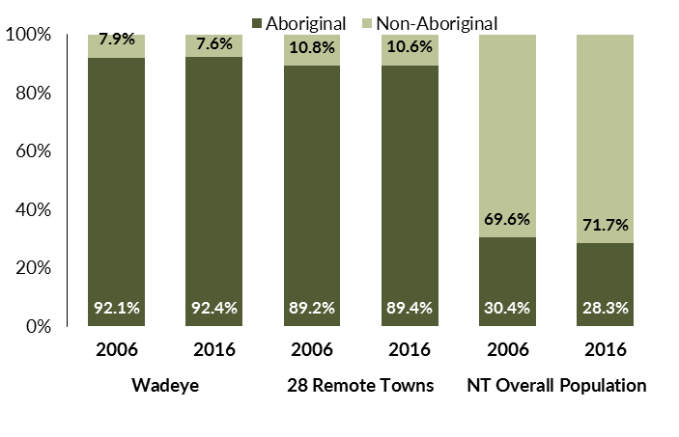

*Source: Department of Trade, Business and Innovation*

In 2016 in Wadeye:

* 92.4% of the population in Wadeye were **Aboriginal**, compared to 92.1% in 2006
* 89.4% of the population across all 28 remote towns were **Aboriginal**
* 28.3% of the Northern Territory population were **Aboriginal**.

**Table 33: Unemployment and participation rates by Aboriginal status compared to the NT (q)**

|  |  |  |  |  |  |  |
| --- | --- | --- | --- | --- | --- | --- |
|  | **Wadeye** | | | **Northern Territory** | | |
| **Aboriginal** | **Non-Aboriginal** | **Total** | **Aboriginal** | **Non-Aboriginal** | **Total** |
| **Unemployment rate** | 58.3% | 2.1% | 44.5% | 26.7% | 3.8% | 7.0% |
| **Participation rate** | 36.3% | 94.0% | 42.7% | 41.0% | 79.9% | 70.6% |

*Source: Department of Trade, Business and Innovation*

In 2016 in Wadeye the:

* **total unemployment rate** was 44.5% compared to 7% for the total Northern Territory
* **Aboriginal** **unemployment rate** was 58.3% compared to 26.7% for the total Northern Territory
* **non-Aboriginal unemployment rate** was 2.1% compared to 3.8% for the total Northern Territory
* **total participation rate** was 42.7% compared to 70.6% for the total Northern Territory
* **Aboriginal participation rate** was 36.3% compared to 41% for the total Northern Territory
* **non-Aboriginal participation** rate was 94% compared to 79.9% for the total Northern Territory.

# Community Development Programme

**Table 34: Community Development Programme Aboriginal Job Seekers, 30 April 2018 (o)**

|  |  |  |
| --- | --- | --- |
| **Indicator** | **Aboriginal** | |
| **No.** | **%** |
| **Total Aboriginal Job Seekers** | 484 | N/A |
| **Age (years)** | | |
| 15-24 | 116 | 24.0 |
| 25-44 | 276 | 57.0 |
| 45+ | 92 | 19.0 |
| **Total** | 484 | 100.0 |
| **Gender** | | |
| Male | 247 | 51.0 |
| Female | 237 | 49.0 |
| **Total** | 484 | 100.0 |
| **Employment Outcome - 1 July 2015 to 30 April 2018** | | |
| 13 Weeks | 118 | 57.8 |
| 26 Weeks | 86 | 42.2 |
| **Currently in Activities** | 374 |  |

*Source: Department of Prime Minister and Cabinet*

**Chart 14: Community Development Programme Aboriginal Job Seekers by Gender and Age Group, 30 April 2018 (o)**

See detailed description below.

*Source: Department of Prime Minister and Cabinet*

As at 30 April 2018, in Wadeye, there were 484 CDP **Aboriginal** job seekers, of these:

* 247 (51%) were male and 237 (49%) were female
* 116 (24%) were aged 15-24 years, 276 (57%) were aged 25-44 years, and 92 (19%) were aged 45+ years
* between 1 July 2015 and 30 April 2018, 118 had reached the 13 week reporting milestone and 86 had reached the 26 week reporting milestone
* 374 were currently in activities.

# Businesses

**Table 35: Businesses by Sector (d)(s)**

|  |  |  |  |
| --- | --- | --- | --- |
| **Business Name** | **Reported on in 2011?** | **Reported on in 2014?** | **Reported on in 2017?** |
| **PUBLIC SECTOR** | | | |
| **Aboriginal Hostels Limited** | No | Yes | **Yes** |
| Department of Corrections | Yes | Yes | No |
| **Department of Health** | Yes | Yes | **Yes** |
| Department of Housing | Yes | Yes | No |
| **Department of Human Services trading as Centrelink** | Yes | Yes | **Yes** |
| **Department of the Prime Minister and Cabinet** | Yes | Yes | **Yes** |
| **Northern Territory Police, Fire Emergency Services** | Yes | Yes | **Yes** |
| **Territory Families** | No | No | **Yes** |
| Victoria Daly Shire Council | Yes | No | No |
| **West Daly Regional Council** | No | Yes | **Yes** |
| **PRIVATE SECTOR** | | | |
| Australian Football League Northern Territory (AFLNT) | Yes | No | No |
| **Batchelor Institute of Indigenous Tertiary Education (BIITE)** | Yes | Yes | **Yes** |
| **Catholic Care NT** | Yes | Yes | **Yes** |
| Catholic Church of the Diocese of Darwin | Yes | No | No |
| Dave Reddy Pty Ltd | Yes | No | No |
| **DJ Air & Electrical Services Pty Ltd** | No | Yes | **Yes** |
| Jobfind Centres Australia | Yes | No | No |
| **Maninh Projects Pty Ltd trading as Werrk Store** | No | Yes | **Yes** |
| Menzies School of Health Research | Yes | No | No |
| Mipatha Take Away | Yes | No | No |
| Murin Association Incorporated | Yes | Yes | No |
| **Murrinhpatha Nimmipa Store** | Yes | Yes | Yes |
| **Our Lady of the Sacred Heart Thamurrurr Catholic School** | Yes | Yes | **Yes** |
| **Palngun Wurnangat Aboriginal Corporation** | Yes | Yes | **Yes** |
| Palumpa Station Pty Ltd | Yes | No | No |
| **Samjin Agriculture and Food Enterprise t/as Wadeye 24 Hour** | No | No | **Yes** |
| **Save the Children Australia** | No | Yes | **Yes** |
| **Thamarrurr Development Corporation** | Yes | Yes | **Yes** |
| Thamurrurr Aged Care - D & R Community Services | Yes | Yes | No |
| **Thathangathay Foundation** | No | No | **Yes** |
| The Arnhem Land Progress Aboriginal Corporation (ALPA) | Yes | No | No |
| **Traditional Credit Union (TCU)** | Yes | Yes | **Yes** |
| **Wadeye Creche - Childrens Services Support Unit** | Yes | Yes | **Yes** |
| **Wadeye Safe House - Children Services Support Unit** | Yes | Yes | **Yes** |

*Source: Department of Trade, Business and Innovation*

*Note: Business names captured across the three survey periods have been identified by the current 2017 Business ABN name listed as at 2017.*

In 2017 in Wadeye:

* there were 21 businesses reported on, of which:
* 7 businesses were from the public sector (33%)
* 14 businesses were from the private sector (67%)
* there were 8 businesses operating that were not operating in 2011.

# Notes

1. These counts represent numbers of filled jobs and not numbers of persons. As such the totals represent the total number of filled jobs, not the total number of employees. This count is not directly comparable to the total number of employed persons as a person may have several jobs or one job may be shared by more than one person.
2. Full-time is defined as a job usually requiring 35 hours or more per week or that required 35 hours or more work during the reference week. Part-time is defined as a job usually requiring less than 35 hours per week or that required less than 35 hours work during the reference week. The reference week refers to the period that respondents were asked to provide information about. In most instances it would be the week prior to the week the questionnaire was completed. Questionnaires were predominantly conducted in June and July.
3. Care needs to be taken when analysing the counts of filled jobs by the Aboriginal status of persons in the jobs. The Aboriginal status of the person employed in a job was reported by the business representative completing the questionnaire.
4. Sector was classified using the Standard Economic Sector of Classifications of Australia (SESCA), 2008.
5. Job permanency is classified according to what the business believes the level of job permanency is based on guidelines provided by data collectors. Those guidelines state a permanent job has paid annual and/or sick leave entitlements while a temporary job includes casual and fixed-term contract jobs.
6. Classified according to the Australian and New Zealand Standard Classification of Occupations (ANZSCO), 2006, major occupation level.
7. Other occupations include jobs where occupation was not stated, not known or inadequately described.
8. Classified using the Australian and New Zealand Standard Industrial Classification (ANZSIC), 2006, division level.
9. Care needs to be taken when analysing the counts of filled jobs by the gender of persons in the jobs. The gender of the person employed in a job is reported by the business representative completing the questionnaire.
10. Care needs to be taken when analysing the counts of filled jobs by the age of persons in the jobs. The age of the person employed in a job is reported by the business representative completing the questionnaire.
11. Students represent the number of individual clients that enrolled in a Vocational Education and Training unit during the calendar year.
12. Unit enrolments represent the count of individual units that students enrolled in during the calendar year.
13. Nominal hours delivered is the sum of the nominal hours of the units commenced during the calendar year regardless of when the course enrolment commenced.
14. Unit completions are the count of all successfully completed units reported in the calendar year regardless of the year of commencement of the units.
15. The Community Development Programme (CDP) supports job seekers in remote Australia to build skills, address barriers and contribute to their communities through a range of flexible activities. Under the CDP, job seekers with activity requirements are expected to do up to 25 hours per week of work-like activities that benefit their community. It should be noted that some CDP participants may be reported on within the profile if they are attached to a filled position with an employer captured in the survey. Due to confidentiality issues, data below 20 people is not published.
16. Population estimates for both 2006 and 2016 are taken from the estimated resident population (ERP) data produced by the Australian Bureau of Statistics (ABS) and based on Australian Statistical Geography Standard (ASGS) Statistical Area Level 1 (SA1) regions. ERP are official estimates of the Australian population, which link people to a place of usual residence with Australia. All ERP data sources, including the Census of Population and Housing (Census), are subject to error (including inaccuracies in collection, recording and processing data) and should be used with caution.
17. Indigenous population proportions, unemployment and workforce participation rates are based on ABS Census counts at ASGS Indigenous Locations (ILOCs) for each remote town.
18. Working-age population includes all residents aged 15 years and over (commonly referred to as the civilian population) and consists of persons that are employed, unemployed or not in the labour force.
19. A ‘business’ has been defined as any organisation that has undertaken productive activities in the last year, including companies, non-profit organisations, government departments and enterprises operating within the designated remote geography (town), and has one or more employees in paid employment and an Australian Business Number (ABN).

# Abbreviations and Acronyms

ABN Australian Business Number

ABS Australian Bureau of Statistics

ANZSCO Australian and New Zealand Standard Classification of Occupations

ANZSIC Australian and New Zealand Standard Industrial Classification

ASGS Australian Statistical Geography Standard

CDP Community Development Programme

ERP Estimated Resident Population

ILOC Indigenous Locations

nec Not Elsewhere Classified

No. Number

Perm Permanent

ppt Percentage point

RJCP Remote Jobs and Communities Program

Temp Temporary

SA1 Statistical Area Level 1

VET Vocational Education and Training

1. The number of filled jobs does not represent numbers of persons as a person may have several jobs or one job may be shared by more than one person.