Remote Towns Jobs Profile

Elliott

© Northern Territory of Australia 2018
Preferred Reference: Department of Trade, Business and Innovation, 2017 Remote Towns Jobs Profiles, Northern Territory Government, June 2018, Darwin.
Disclaimer
The data in this publication were predominantly collected by conducting a face-to-face survey of businesses within town boundaries during mid-2017. The collection methodology was created in accordance with Australian Bureau of Statistics data quality framework principles. Data in this publication are only reflective of those businesses reported on as operating in the town at the time of data collection (see table at the end of publication for list of businesses reported on).
To comply with privacy legislation or where appropriate, some data in this publication may have been adjusted and will not reflect the actual data reported by businesses. As a result of this, combined with certain data not being reported by some businesses, some components may not add to totals. Changes over time may also reflect business' change in propensity to report on certain data items rather than actual changes over time. Total figures have generally not been adjusted.
Caution is advised when interpreting the comparisons made to the earlier 2011 and 2014 publications as the businesses identified and reported on and the corresponding jobs may differ between publications.
Notes for each table and chart are alphabetically ordered and listed at the end of the publication.
Any use of this report for commercial purposes is not endorsed by the Department of Trade, Business and Innovation.
Contents

Elliott 4
Introduction 5
Summary 6
Jobs Overview 7
Jobs by Aboriginal Status 8
Jobs by Sector: Private and Public 10
Job Status: Permanent and Temporary 16
Job Vacancies 19
Jobs by Industry 21
Jobs by Occupation 27
Jobs by Industry by Occupation 30
Jobs by Gender 32
Jobs by Age 37
Vocational Education and Training 42
Population 46
Community Development Programme 48
Businesses 49
Notes 50
Abbreviations and Acronyms 51

Elliott
Elliott is located about 250 kilometres north of Tennant Creek, Elliott is the halfway point between Darwin and Alice Springs, with a population of 387 residents.
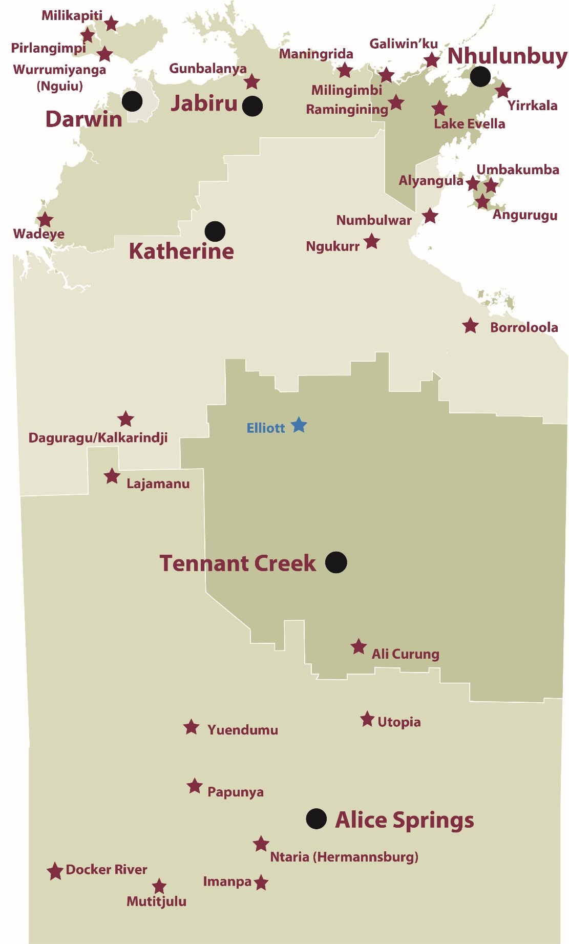
Source: Department of Trade, Business and Innovation

Introduction
This jobs profile provides a snapshot of jobs and the characteristics of job holders in Elliott as at July 2017. It also outlines trends from the 2014 and 2011 surveys.
This job profile is one of 28 profiles developed for remote towns in the Northern Territory. It is anticipated these and subsequent profiles will contribute to a robust evidence base to inform decision making in and relating to these remote Territory towns.
This profile contains information collected by the Northern Territory Department of Trade, Business and Innovation from businesses operating within the town and is supplemented by other administrative data sets and information.
Each profile provides up-to-date information that is intended to inform the planning and design of current and future government programs and as an evidence base to inform decision making relating to workforce development, enterprise and job opportunities.
The data collection methodology and corresponding questionnaire were created in partnership with the Australian Bureau of Statistics (ABS) and in accordance with ABS data quality framework and survey principles.
The surveys were predominantly conducted by the Department’s Small Business Champions and Workforce Training Coordinators, on a face-to-face basis with business representatives.
The information collected and reported on represents a significant goodwill investment by those businesses and organisations that participated. Each business is listed at the end of this publication.

Summary
The 2017 jobs profile was developed based on responses from 13 businesses operating within the Elliott town boundary, 2 less than in the 2014 survey. Of these, there were:
- 8 businesses from the private sector, accounting for 41 filled jobs or 42% of total filled jobs
- 5 businesses from the public sector, accounting for 57 filled jobs or 58% of total filled jobs
- 8 businesses participated in all three surveys (completed in 2011, 2014 and 2017)
A total of 120 filled and vacant jobs in Elliott were reported, an increase of 27 jobs from 2014.
The 2017 profile highlights:
- there were 98 filled jobs of which:
- 63 jobs (64%) were filled by Aboriginal persons, an increase of 9 jobs from 2014
- 35 jobs (36%) were filled by non-Aboriginal persons, an increase of 1 job from 2014
- 39% of employed Aboriginal people are working in the public sector
- Aboriginal persons accounted for 64% of job holders in the town compared to 61% in 2014
- Aboriginal females made up 46% of total Aboriginal filled jobs in the town compared to 54% in 2014
- there were 22 vacant jobs, of which:
- job vacancies as a percentage of jobs increased to 18% in 2017 from 5 % in 2014
- job vacancies equate to 1 in 5 jobs
- 19 of the vacancies were in Community and Personal Service Workers, Labourers and Clerical and Administrative Workers areas
- Public Administration and Safety industry continues to be the largest industry employer over the three survey periods, despite a decrease of 10 filled jobs over this time
- the Construction industry filled 14 jobs in 2016 after recording nil jobs in 2011 and 2014
- Training had a decrease in student numbers between 2013 and 2016, with the largest decrease of 19 students in the Primary Industry
- Transport and Storage was the largest training activity sector in 2016, followed by Business and Clerical
- new training activity in 2016, Transport and Storage, was delivered to 12 students; a training area not delivered in 2013 and 2010.
The overall population in Elliott increased by 14 persons (4%) between 2006 and 2016 to 387 persons.
In comparison, the overall Northern Territory population increased by 16.5% between 2006 and 2016.
In 2016, the working age population (15 years and over) in Elliott was an estimated 249 persons compared to 238 in 2006 an increase of 5%.
There were 0.5 jobs in Elliott per working age person compared to 0.4 jobs per working age person across the 28 remote towns in the Northern Territory.

Jobs Overview
Table 1: Count of filled jobs and vacancies, 2011, 2014 and 2017 (a)(b)
 | 2011 | 2014 | 2017 | Change  2011-2014 | Change  2014-2017
Total All Jobs | 118 | 93 | 120 | -25 | 27
Vacancies | 14 | 5 | 22 | -9 | 17
Vacancies as % of Total All Jobs | 11.9% | 5.4% | 18.3% | -6.5 ppt | 13. ppt
Filled Jobs | 104 | 88 | 98 | -16 | 10
Full-time | 71 | 65 | 64 | -6 | -1
Part-time | 33 | 23 | 34 | -10 | 11
Source: Department of Trade, Business and Innovation
Chart 1: Count of vacant jobs and filled jobs by full-time/part-time status, 2011, 2014 and 2017 (a)(b)
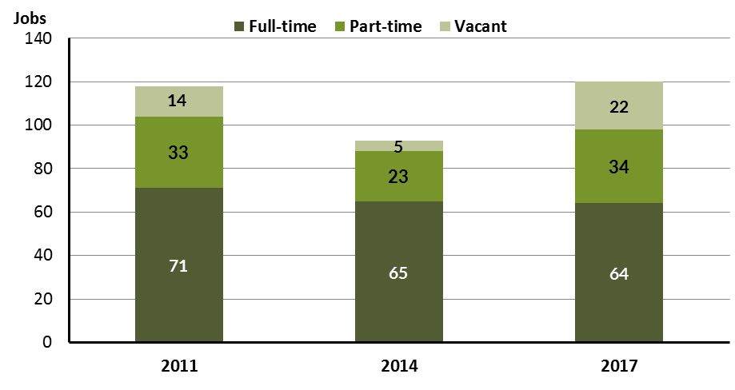
Source: Department of Trade, Business and Innovation
In 2017 in Elliott:
- there were a total of 98 filled jobs, an increase of 10 jobs from 2011 and a decrease of 6 jobs from 2011
- of the 98 filled jobs in 2017:
- 64 were full-time jobs, a decrease of 1 job from 2014 and a decrease of 7 jobs from 2011
- 34 were part-time jobs, an increase of 11 jobs from 2014 and an increase of 1 job from 2011
- there were 22 total job vacancies in 2017, an increase of 17 vacancies from 2014 and an increase of 8 vacancies from 2011.

Jobs by Aboriginal Status
Chart 2: Count of filled jobs by Aboriginal status, 2011, 2014 and 2017 (a)(c)
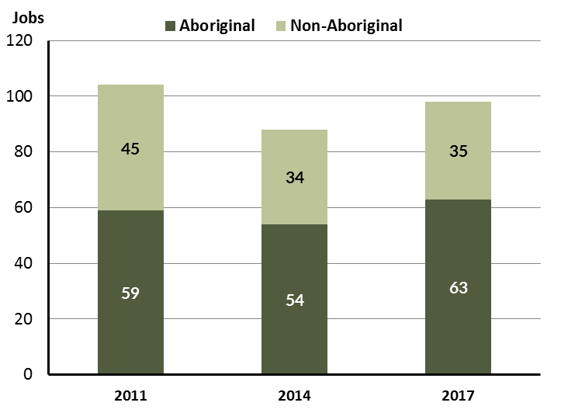
Source: Department of Trade, Business and Innovation
In 2017 in Elliott:
- of the 98 filled jobs:
- 63 jobs were filled by Aboriginal persons, an increase of 9 jobs from 2014 and an increase of 4 jobs from 2011
- 35 jobs were filled by non-Aboriginal persons, a decrease of 11 jobs from 2014 and a decrease of 10 jobs from 2011
- Aboriginal persons accounted for 64% of job holders compared to 61% in 2014 and 57% in 2011.
Table 2: Count of filled jobs by full-time/part-time status and Aboriginal status of person in job, 2011, 2014 and 2017 (a)(b)(c)
Indicator | 2011 |  |  | 2014 |  |  | 2017 |  |  | Change  2011-2014 |  |  | Change  2014-2017
 | Aboriginal | Non-Aboriginal | Total | Aboriginal | Non-Aboriginal | Total | Aboriginal | Non-Aboriginal | Total | Aboriginal | Non-Aboriginal | Total | Aboriginal | Non-Aboriginal | Total
Full-time | 33 | 38 | 71 | 34 | 31 | 65 | 33 | 31 | 64 | 1 | -7 | -6 | -1 | 0 | -1
Part-time | 26 | 7 | 33 | 20 | 3 | 23 | 30 | 4 | 34 | -6 | -4 | -10 | 10 | 1 | 11
Total | 59 | 45 | 104 | 54 | 34 | 88 | 63 | 35 | 98 | -5 | -11 | -16 | 9 | 1 | 10
Source: Department of Trade, Business and Innovation
Chart 3: Count of filled jobs by full-time/part-time status and Aboriginal status of person in job, 2011, 2014 and 2017 (a)(b)(c)
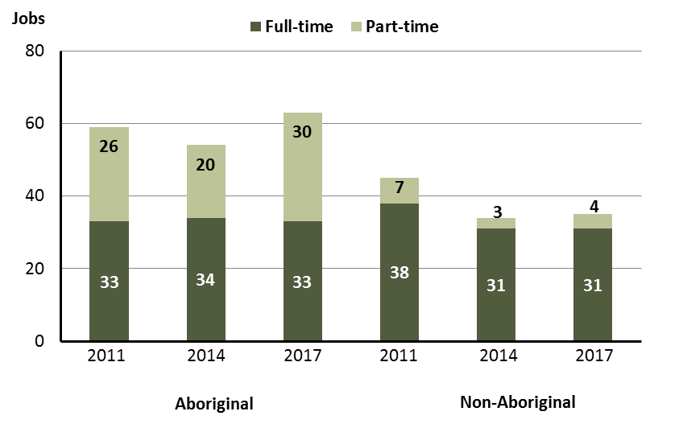
Source: Department of Trade, Business and Innovation
In 2017 in Elliott:
- of the 98 filled jobs:
- 33 were full-time jobs filled by Aboriginal persons, a decrease of 1 job from 2014 and unchanged from 2011
- 30 were part-time jobs filled by Aboriginal persons, an increase of 10 jobs from 2014 and an increase of 4 jobs from 2011
- 31 were full-time jobs filled by non-Aboriginal persons, unchanged from 2014 and a decrease of 7 jobs from 2011
- 4 were part-time jobs filled by non-Aboriginal persons, an increase of 1 job from 2014 and a decrease of 3 jobs from 2011.

Jobs by Sector: Private and Public
Table 3: Count of filled jobs by sector of business and by Aboriginal status of person employed in job, 2011, 2014 and 2017 (a)(b)(c)
Indicator | 2011 |  |  | 2014 |  |  | 2017 |  |  | Change  2011-2014 |  |  |  | Change  2014-2017
 | Aboriginal | Non-Aboriginal | Total | Aboriginal | Non-Aboriginal | Total | Aboriginal | Non-Aboriginal | Total | Aboriginal | Non-Aboriginal | Total | Aboriginal |  | Non-Aboriginal | Total
Public Sector | 52 | 21 | 73 | 48 | 16 | 64 | 38 | 19 | 57 | -4 | -5 | -9 | -10 |  | 3 | -7
Australian Government | 1 | 0 | 1 | 1 | 0 | 1 | 1 | 0 | 1 | 0 | 0 | 0 | 0 |  | 0 | 0
Territory Government | 15 | 13 | 28 | 14 | 13 | 27 | 11 | 11 | 22 | -1 | 0 | -1 | -3 |  | -2 | -5
Local Government | 36 | 8 | 44 | 33 | 3 | 36 | 26 | 8 | 34 | -3 | -5 | -8 | -7 |  | 5 | -2
Private Sector | 7 | 24 | 31 | 6 | 18 | 24 | 25 | 16 | 41 | -1 | -6 | -7 | 19 |  | -2 | 17
Total | 59 | 45 | 104 | 54 | 34 | 88 | 63 | 35 | 98 | -5 | -11 | -16 | 9 |  | 1 | 10
Source: Department of Trade, Business and Innovation
Chart 4: Count of filled jobs by sector of business, 2011, 2014 and 2017 (a)(d)
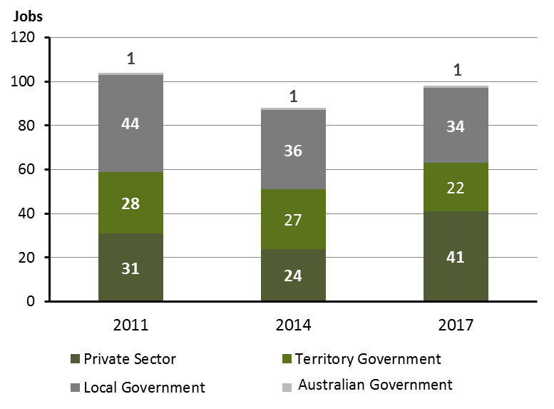
Source: Department of Trade, Business and Innovation
Chart 5: Percentage of filled jobs by sector of business in 2017 (a)(d)
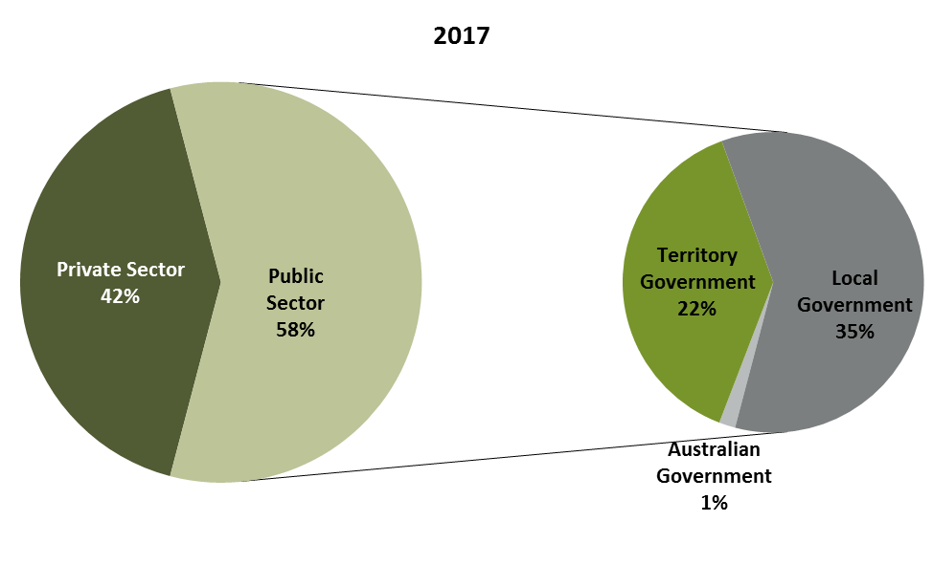
Source: Department of Trade, Business and Innovation
In 2017 in Elliott:
- there were 57 jobs in the public sector, a decrease of 7 jobs from 2014 and a decrease of 16 jobs from 2011
- of the 57 jobs in the public sector:
- 1 job was in the Australian Government, unchanged from 2014 and unchanged from 2011
- 22 jobs were in the Territory Government, a decrease of 5 jobs from 2014 and a decrease of 6 jobs from 2011
- 34 jobs were in the Local Government, a decrease of 2 jobs from 2014 and a decrease of 10 jobs from 2011
- there were 41 jobs in the private sector in 2017, an increase of 17 jobs from 2014 and an increase of 10 jobs from 2011.

Chart 6: Count of filled jobs by sector and Aboriginal status of person in job, 2011, 2014 and 2017 (a)(c)(d)
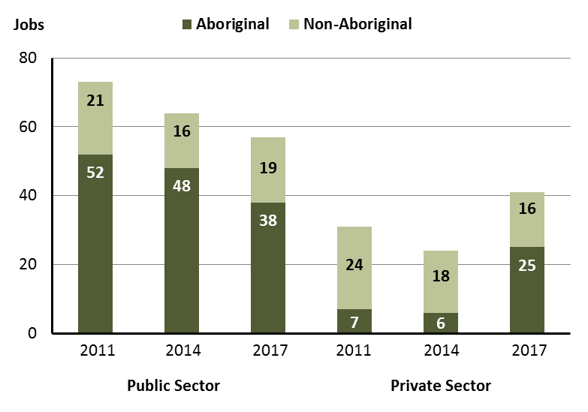
Source: Department of Trade, Business and Innovation
In 2017 in Elliott:
- of the 57 jobs in the public sector:
- 38 jobs were filled by Aboriginal persons, a decrease of 10 jobs from 2014 and a decrease of 14 jobs from 2011
- 19 jobs were filled by non-Aboriginal persons, an increase of 3 jobs from 2014 and a decrease of 2 jobs from 2011
- of the 41 jobs in the private sector:
- 25 jobs were filled by Aboriginal persons, an increase of 19 jobs from 2014 and an increase of 18 jobs from 2011
- 16 jobs were filled by non-Aboriginal persons, a decrease of 2 jobs from 2014 and a decrease of 8 jobs from 2011.
Chart 7: Count of filled jobs by sector and full-time/part-time status of person in job, 2011, 2014 and 2017 (a)(b)(d)
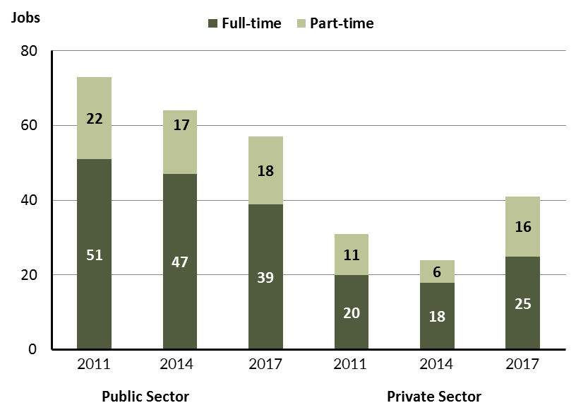
Source: Department of Trade, Business and Innovation
In 2017 in Elliott:
- of the 57 jobs in the public sector:
- 39 were full-time jobs, a decrease of 8 jobs from 2014 and a decrease of 12 jobs from 2011
- 18 were part-time jobs, an increase of 1 job from 2014 and a decrease of 4 jobs from 2011
- of the 41 jobs in the private sector:
- 25 were full-time jobs, an increase of 7 jobs from 2014 and an increase of 5 jobs from 2011
- 16 were part-time jobs, an increase of 10 jobs from 2014 and an increase of 5 jobs from 2011.
Table 4: Count of filled jobs by full-time/part-time status and Aboriginal status of person in job by sector, 2011, 2014, and 2017 (a)(b)(c)(d)
Indicator | 2011
 | Aboriginal |  |  | Non-Aboriginal |  |  | Total
 | Full-time | Part-time | Total | Full-time | Part-time | Total | Full-time | Part-time | Total
Public sector | 31 | 21 | 52 | 20 | 1 | 21 | 51 | 22 | 73
Private sector | 2 | 5 | 7 | 18 | 6 | 24 | 20 | 11 | 31
Total | 33 | 26 | 59 | 38 | 7 | 45 | 71 | 33 | 104

Indicator | 2014
 | Aboriginal |  |  | Non-Aboriginal |  |  | Total
 | Full-time | Part-time | Total | Full-time | Part-time | Total | Full-time | Part-time | Total
Public sector | 33 | 15 | 48 | 14 | 2 | 16 | 47 | 17 | 64
Private sector | 1 | 5 | 6 | 17 | 1 | 18 | 18 | 6 | 24
Total | 34 | 20 | 54 | 31 | 3 | 34 | 65 | 23 | 88

Indicator | 2017
 | Aboriginal |  |  | Non-Aboriginal |  |  | Total
 | Full-time | Part-time | Total | Full-time | Part-time | Total | Full-time | Part-time | Total
Public sector | 22 | 16 | 38 | 17 | 2 | 19 | 39 | 18 | 57
Private sector | 11 | 14 | 25 | 14 | 2 | 16 | 25 | 16 | 41
Total | 34 | 20 | 63 | 31 | 4 | 35 | 64 | 34 | 98
Source: Department of Trade, Business and Innovation
In 2017 in Elliott there were:
- 38 jobs in the public sector filled by Aboriginal persons, a decrease of 10 jobs from 2014 and a decrease of 14 jobs from 2011, of which:
- 22 were full-time jobs, a decrease of 11 jobs from 2014 and a decrease of 9 jobs from 2011
- 16 were part-time jobs, an increase of 1 job from 2014 and a decrease of 5 jobs from 2011
- 25 jobs in the private sector filled by Aboriginal persons, an increase of 19 jobs from 2014 and an increase of 18 jobs from 2011, of which:
- 11 were full-time jobs, an increase of 10 jobs from 2014 and an increase of 9 jobs from 2011
- 14 were part-time jobs, an increase of 9 jobs from 2014 and an increase of 9 jobs from 2011
- 19 jobs in the public sector filled by non-Aboriginal persons, an increase of 3 jobs from 2014 and a decrease of 2 jobs from 2011, of which:
- 17 were full-time jobs, an increase of 3 jobs from 2014 and a decrease of 3 jobs from 2011
- 2 were part-time jobs, unchanged from 2014 and an increase of 1 job from 2011
- 16 jobs in the private sector filled by non-Aboriginal persons, a decrease of 2 jobs from 2014 and a decrease of 8 jobs from 2011, of which:
- 14 were full-time jobs, a decrease of 3 jobs from 2014 and a decrease of 4 jobs from 2011
- 2 were part-time jobs, an increase of 1 job from 2014 and a decrease of 4 jobs from 2011.

Job Status: Permanent and Temporary
Table 5: Count of filled jobs by employment status and Aboriginal status of person in job, 2011, 2014, and 2017 (a)(c)(e)
Indicator | 2011 |  |  | 2014 |  |  | 2017 |  |  | Change  2011-2014 |  |  | Change  2014-2017
 | Aboriginal | Non-Aboriginal | Total | Aboriginal | Non-Aboriginal | Total | Aboriginal | Non-Aboriginal | Total | Aboriginal | Non-Aboriginal | Total | Aboriginal | Non-Aboriginal | Total
Permanent | 42 | 25 | 67 | 43 | 22 | 65 | 45 | 19 | 64 | 1 | -3 | -2 | 2 | -3 | -1
Temporary | 17 | 20 | 37 | 11 | 12 | 23 | 18 | 16 | 34 | -6 | -8 | -14 | 7 | 4 | 11
Total | 59 | 45 | 104 | 54 | 34 | 88 | 63 | 35 | 98 | -5 | -11 | -16 | 9 | 1 | 10
Source: Department of Trade, Business and Innovation
Chart 8: Count of filled jobs by employment status and Aboriginal status of person in job, 2011, 2014 and 2017 (a)(c)(e)
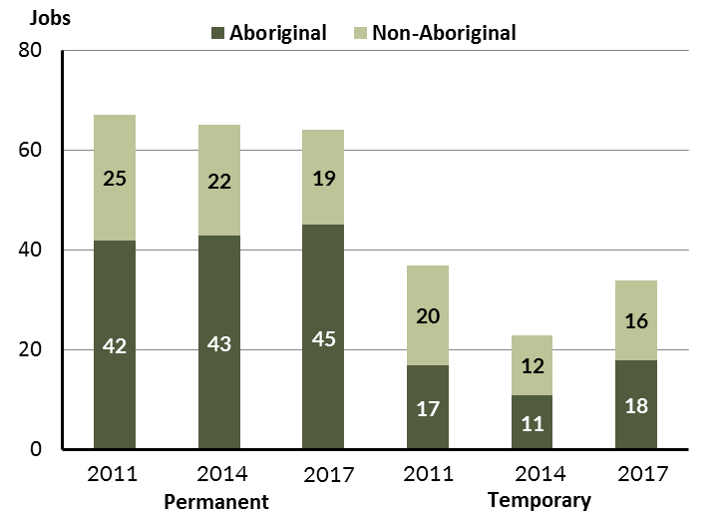
Source: Department of Trade, Business and Innovation
In 2017 in Elliott:
- there were 64 permanent jobs, a decrease of 1 job from 2014, and a decrease of 3 jobs from 2011, of which:
- 45 jobs were filled by Aboriginal persons, an increase of 2 jobs from 2014 and an increase of 3 jobs from 2011
- 19 jobs were filled by non-Aboriginal persons, a decrease of 3 jobs from 2014 and a decrease of 6 jobs from 2011
- there were 34 temporary jobs, an increase of 11 jobs from 2014 and a decrease of 3 jobs from 2011, of which:
- 18 jobs were filled by Aboriginal persons, an increase of 7 jobs from 2014 and an increase of 1 job from 2011
- 16 jobs were filled by non-Aboriginal persons, an increase of 4 jobs from 2014 and a decrease of 4 jobs from 2011.
Table 6: Count of filled jobs by sector, Aboriginal status and employment status of person in job, 2011, 2014 and 2017 (a)(c)(d)(e)
Indicator | 2011
 | Aboriginal |  |  | Non-Aboriginal |  |  | Total
 | Perm | Temp | Total | Perm | Temp | Total | Perm | Temp | Total
Public Sector | 40 | 12 | 52 | 14 | 7 | 21 | 54 | 19 | 73
Private Sector | 2 | 5 | 7 | 11 | 13 | 24 | 13 | 18 | 31
Total | 42 | 17 | 59 | 25 | 20 | 45 | 67 | 37 | 104

Indicator | 2014
 | Aboriginal |  |  | Non-Aboriginal |  |  | Total
 | Perm | Temp | Total | Perm | Temp | Total | Perm | Temp | Total
Public Sector | 41 | 7 | 48 | 15 | 1 | 16 | 56 | 8 | 64
Private Sector | 2 | 4 | 6 | 7 | 11 | 18 | 9 | 15 | 24
Total | 43 | 11 | 54 | 22 | 12 | 34 | 65 | 23 | 88

Indicator | 2017
 | Aboriginal |  |  | Non-Aboriginal |  |  | Total
 | Perm | Temp | Total | Perm | Temp | Total | Perm | Temp | Total
Public Sector | 32 | 6 | 38 | 12 | 7 | 19 | 44 | 13 | 57
Private Sector | 13 | 12 | 25 | 7 | 9 | 16 | 20 | 21 | 41
Total | 45 | 18 | 63 | 19 | 16 | 35 | 64 | 34 | 98
Source: Department of Trade, Business and Innovation
In 2017 in Elliott there were:
- 57 jobs in the public sector, a decrease of 7 jobs from 2014 and a decrease of 16 jobs from 2011, of which:
- 44 jobs were permanent, a decrease of 12 jobs from 2014 and a decrease of 10 jobs from 2011, of which:
- 32 jobs were filled by Aboriginal persons, a decrease of 9 jobs from 2014 and a decrease of 8 jobs from 2011
- 12 jobs were filled by non-Aboriginal persons, a decrease of 3 jobs from 2014 and a decrease of 2 jobs from 2011
- 13 jobs were temporary, an increase of 5 jobs from 2014 and a decrease of 6 jobs from 2011, of which:
- 6 jobs were filled by Aboriginal persons, a decrease of 1 job from 2014 and a decrease of 6 jobs from 2011
- 7 jobs were filled by non-Aboriginal persons, an increase of 6 jobs from 2014 and unchanged from 2011
- 41 jobs in the private sector, an increase of 17 jobs from 2014 and an increase of 10 jobs from 2011, of which:
- 20 jobs were permanent, an increase of 11 jobs from 2014 and an increase of 7 jobs from 2011, of which:
- 13 jobs were filled by Aboriginal persons, an increase of 11 jobs from 2014 and an increase of 11 jobs from 2011
- 7 jobs were filled by non-Aboriginal persons, unchanged from 2014 and a decrease of 4 jobs from 2011
- 21 jobs were temporary, an increase of 6 jobs from 2014 and an increase of 3 jobs from 2011, of which:
- 12 jobs were filled by Aboriginal persons, an increase of 8 jobs from 2014 and an increase of 7 jobs from 2011
- 9 jobs were filled by non-Aboriginal persons, a decrease of 2 jobs from 2014 and a decrease of 4 jobs from 2011.

Job Vacancies
Table 7: Job vacancies, 2011, 2014, and 2017
Indicator | 2011 | 2014 | 2017 | Change  2011-2014 | Change  2014-2017
Job vacancies | 14 | 5 | 22 | -9 | 17
Source: Department of Trade, Business and Innovation
Table 8: Job vacancies by occupation, 2011, 2014, and 2017 (f)(g)
Occupation (ANZSCO major group) | 2011 | 2014 | 2017 | Change  2011-2014 | Change  2014-2017
Clerical and Administrative Workers | 1 | 0 | 5 | -1 | 5
Community and Personal Service Workers | 6 | 2 | 8 | -4 | 6
Labourers | 6 | 1 | 6 | -5 | 5
Machinery Operators and Drivers | 0 | 0 | 0 | 0 | 0
Managers | 0 | 0 | 0 | 0 | 0
Professionals | 0 | 1 | 2 | 1 | 1
Sales Workers | 0 | 1 | 0 | 1 | -1
Technicians and Trades Workers | 0 | 0 | 1 | 0 | 1
Total | 14 | 5 | 22 | -9 | 17
Source: Department of Trade, Business and Innovation
Table 9: Job vacancies by job title, July 2017 (f)
Job Vacancy | No.
Aboriginal and Torres Strait Islander Health Worker | 4
Cook | 1
Family Support Worker | 2
Garden Labourer | 4
General Clerk | 1
Handyperson | 2
Information Officer | 1
Noxious Weeds and Pest Inspector | 3
Primary School Teacher | 1
Registered Nurses nec | 1
Teachers' Aide | 2
Total | 22
Source: Department of Trade, Business and Innovation
In 2017 in Elliott:
- there were 22 vacancies reported, an increase of 17 vacancies from 2014 and an increase of 8 vacancies from 2011
- of the 22 reported vacancies, the largest requirements were for:
- 8 Community and Personal Service Workers, the majority of which is in the following job:
- Aboriginal and Torres Strait Islander Health Workers
- Family Support Workers
- 6 Labourers in the following jobs:
- Garden Labourer
- Handyperson
- 5 Clerical and Administrative Workers, the majority of which is in the following job:
- Noxious Weeds and Pest Inspector
- General Clerk.

Jobs by Industry
Table 10: Count of filled jobs by industry of business, 2011, 2014 and 2017 (a)(h)
Industry (ANZSIC Division) | 2011 |  | 2014 |  | 2017 |  | Change  2011-2014 | Change  2014-2017
 | Total | % of Total | Total | % of Total | Total | % of Total | Total | Total
Administrative and Support Services | 0 | 0.0% | 0 | 0.0% | 8 | 8.2% | 0 | 8
Arts and Recreation Services | 1 | 1.0% | 1 | 1.1% | 3 | 3.1% | 0 | 2
Construction | 0 | 0.0% | 0 | 0.0% | 14 | 14.3% | 0 | 14
Education and Training | 14 | 13.5% | 14 | 15.9% | 16 | 16.3% | 0 | 2
Health Care and Social Assistance | 10 | 9.6% | 12 | 13.6% | 5 | 5.1% | 2 | -7
Other Services | 6 | 5.8% | 8 | 9.1% | 0 | 0.0% | 2 | -8
Public Administration and Safety | 48 | 46.2% | 39 | 44.3% | 38 | 38.8% | -9 | -1
Rental, Hiring and Real Estate Services | 0 | 0.0% | 1 | 1.1% | 0 | 0.0% | 1 | -1
Retail Trade | 16 | 15.4% | 13 | 14.8% | 11 | 11.2% | -3 | -2
Transport, Postal and Warehousing | 1 | 1.0% | 0 | 0.0% | 3 | 3.1% | -1 | 3
Total | 104 | 100.0% | 88 | 100.0% | 98 | 100.0% | -16 | 10
Source: Department of Trade, Business and Innovation
In 2017 in Elliott:
- the Public Administration and Safety industry was the largest industry employer, with 38 filled jobs or 38.8% of filled jobs, a decrease of 1 job from 2014 and a decrease of 10 jobs from 2011
- other significant industry employers were:
- Education and Training with 16 jobs (or 16.3% of filled jobs), an increase of 2 jobs from 2014 and an increase of 2 jobs from 2011
- Construction with 14 jobs (or 14.3% of filled jobs), an increase of 14 jobs from 2014 and an increase of 14 jobs from 2011
- Retail Trade with 11 jobs (or 11.2% of filled jobs), a decrease of 2 jobs from 2014 and a decrease of 5 jobs from 2011.
Table 11: Count of filled jobs by industry of business and Aboriginal status of person in job, 2011, 2014, and 2017 (a)(c)(h)
Industry (ANZSIC division) | 2011 |  |  | 2014 |  |  | 2017 |  |  | Change  2011-2014 |  |  | Change  2014-2017
 | Aboriginal | Non-Aboriginal | Total | Aboriginal | Non-Aboriginal | Total | Aboriginal | Non-Aboriginal | Total | Aboriginal | Non-Aboriginal | Total | Aboriginal | Non-Aboriginal | Total
Administrative and Support Services | 0 | 0 | 0 | 0 | 0 | 0 | 7 | 1 | 8 | 0 | 0 | 0 | 7 | 1 | 8
Arts and Recreation Services | 1 | 0 | 1 | 1 | 0 | 1 | 3 | 0 | 3 | 0 | 0 | 0 | 2 | 0 | 2
Construction | 0 | 0 | 0 | 0 | 0 | 0 | 13 | 1 | 14 | 0 | 0 | 0 | 13 | 1 | 14
Education and Training | 6 | 8 | 14 | 6 | 8 | 14 | 7 | 9 | 16 | 0 | 0 | 0 | 1 | 1 | 2
Health Care and Social Assistance | 7 | 3 | 10 | 8 | 4 | 12 | 2 | 3 | 5 | 1 | 1 | 2 | -6 | -1 | -7
Other Services | 1 | 5 | 6 | 3 | 5 | 8 | 0 | 0 | 0 | 2 | 0 | 2 | -3 | -5 | -8
Public Administration and Safety | 38 | 10 | 48 | 35 | 4 | 39 | 29 | 9 | 38 | -3 | -6 | -9 | -6 | 5 | -1
Rental, Hiring and Real Estate Services | 0 | 0 | 0 | 1 | 0 | 1 | 0 | 0 | 0 | 1 | 0 | 1 | -1 | 0 | -1
Retail Trade | 0 | 16 | 16 | 0 | 13 | 13 | 1 | 10 | 11 | 0 | -3 | -3 | 1 | -3 | -2
Transport, Postal and Warehousing | 0 | 1 | 1 | 0 | 0 | 0 | 1 | 2 | 3 | 0 | -1 | -1 | 1 | 2 | 3
Total | 59 | 45 | 104 | 54 | 34 | 88 | 63 | 35 | 98 | -5 | -11 | -16 | 9 | 1 | 10
Source: Department of Trade, Business and Innovation
Chart 9: Count of filled jobs by top 5 industries of business and Aboriginal status of person in job, 2017 (a)(c)(h)
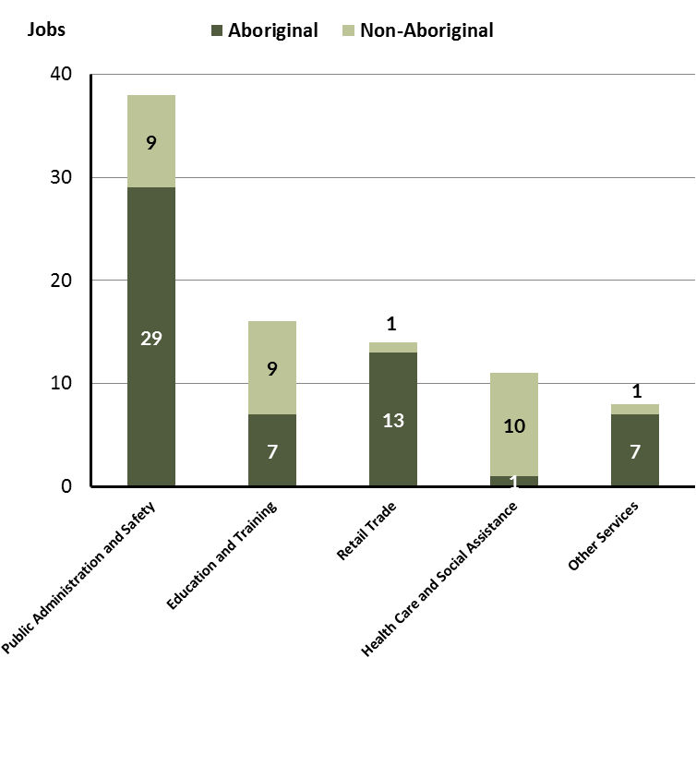
Source: Department of Trade, Business and Innovation
In 2017 in Elliott:
- of the 63 jobs filled by Aboriginal persons, there were:
- 29 jobs in Public Administration and Safety, a decrease of 6 jobs from 2014 and a decrease of 9 jobs from 2011
- 7 jobs in Education and Training, an increase of 1 job from 2014 and an increase of 1 job from 2011
- 13 jobs in Construction, an increase of 13 jobs from 2014 and an increase of 13 jobs from 2011
- of the 35 jobs filled by non-Aboriginal persons, there were:
- 9 jobs in Public Administration and Safety, an increase of 5 jobs from 2014 and a decrease of 1 job from 2011
- 9 jobs in Education and Training, an increase of 1 job from 2014 and an increase of 1 job from 2011
- 1 job in Construction, an increase of 1 job from 2014 and an increase of 1 job from 2011.
Table 12: Count of filled jobs by industry, employment status and Aboriginal status of person in job, 2011 (a)(c)(e)(h)
Industry (ANZSIC division) | 2011
 | Aboriginal |  |  | Non-Aboriginal |  |  | Total
 | Perm | Temp | Total | Perm | Temp | Total | Perm | Temp | Total
Arts and Recreation Services | 1 | 0 | 1 | 0 | 0 | 0 | 1 | 0 | 1
Education and Training | 1 | 5 | 6 | 4 | 4 | 8 | 5 | 9 | 14
Health Care and Social Assistance | 2 | 5 | 7 | 1 | 2 | 3 | 3 | 7 | 10
Other Services | 1 | 0 | 1 | 1 | 4 | 5 | 2 | 4 | 6
Public Administration and Safety | 37 | 1 | 38 | 9 | 1 | 10 | 46 | 2 | 48
Retail Trade | 0 | 0 | 0 | 7 | 9 | 16 | 7 | 9 | 16
Transport, Postal and Warehousing | 0 | 0 | 0 | 1 | 0 | 1 | 1 | 0 | 1
Total | 42 | 17 | 59 | 25 | 20 | 45 | 67 | 37 | 104
Source: Department of Trade, Business and Innovation
Table 13: Count of filled jobs by industry, employment status and Aboriginal status of person in job, 2014 (a)(c)(e)(h)
Industry (ANZSIC division) | 2014
 | Aboriginal |  |  | Non-Aboriginal |  |  | Total
 | Perm | Temp | Total | Perm | Temp | Total | Perm | Temp | Total
Arts and Recreation Services | 1 | 0 | 1 | 0 | 0 | 0 | 1 | 0 | 1
Education and Training | 3 | 3 | 6 | 7 | 1 | 8 | 10 | 4 | 14
Health Care and Social Assistance | 8 | 0 | 8 | 4 | 0 | 4 | 12 | 0 | 12
Other Services | 1 | 2 | 3 | 0 | 5 | 5 | 1 | 7 | 8
Public Administration and Safety | 30 | 5 | 35 | 4 | 0 | 4 | 34 | 5 | 39
Rental, Hiring and Real Estate Services | 0 | 1 | 1 | 0 | 0 | 0 | 0 | 1 | 1
Retail Trade | 0 | 0 | 0 | 7 | 6 | 13 | 7 | 6 | 13
Total | 43 | 11 | 54 | 22 | 12 | 34 | 65 | 23 | 88
Source: Department of Trade, Business and Innovation
Table 14: Count of filled jobs by industry, employment status and Aboriginal status of person in job, 2017 (a)(c)(e)(h)
Industry (ANZSIC division) | 2017
 | Aboriginal |  |  | Non-Aboriginal |  |  | Total
 | Perm | Temp | Total | Perm | Temp | Total | Perm | Temp | Total
Administrative and Support Services | 6 | 1 | 7 | 1 | 0 | 1 | 7 | 1 | 8
Arts and Recreation Services | 2 | 1 | 3 | 0 | 0 | 0 | 2 | 1 | 3
Construction | 5 | 8 | 13 | 0 | 1 | 1 | 5 | 9 | 14
Education and Training | 2 | 5 | 7 | 2 | 7 | 9 | 4 | 12 | 16
Health Care and Social Assistance | 1 | 1 | 2 | 1 | 2 | 3 | 2 | 3 | 5
Public Administration and Safety | 29 | 0 | 29 | 9 | 0 | 9 | 38 | 0 | 38
Retail Trade | 0 | 1 | 1 | 4 | 6 | 10 | 4 | 7 | 11
Transport, Postal and Warehousing | 0 | 1 | 1 | 2 | 0 | 2 | 2 | 1 | 3
Total | 45 | 18 | 63 | 19 | 16 | 35 | 64 | 34 | 98
Source: Department of Trade, Business and Innovation
In 2017 in Elliott:
- of the 64 permanent jobs, there were:
- 38 jobs in Public Administration and Safety, an increase of 4 jobs from 2014 and a decrease of 8 jobs from 2011, including:
- 29 jobs filled by Aboriginal persons, a decrease of 1 job from 2014 and a decrease of 8 jobs from 2011
- 9 jobs filled by non-Aboriginal persons, an increase of 5 jobs from 2014 and unchanged from 2011
- 7 jobs in Administrative and Support Services, an increase of 7 jobs from 2014 and an increase of 7 jobs from 2011, including:
- 6 jobs filled by Aboriginal persons, an increase of 6 jobs from 2014 and an increase of 6 jobs from 2011
- 1 job filled by a non-Aboriginal person, an increase of 1 job from 2014 and an increase of 1 job from 2011
- 5 jobs in Construction, an increase of 5 jobs from 2014 and an increase of 5 jobs from 2011, including:
- 5 jobs filled by Aboriginal persons, an increase of 5 jobs from 2014 and an increase of 5 jobs from 2011
- no jobs were filled by non-Aboriginal persons, unchanged from 2014 and unchanged from 2011
- of the 34 temporary jobs, there were:
- 12 jobs in Education and Training, an increase of 8 jobs from 2014 and an increase of 3 jobs from 2011, including:
- 5 jobs filled by Aboriginal persons, an increase of 2 jobs from 2014 and unchanged from 2011
- 7 jobs filled by non-Aboriginal persons, an increase of 6 jobs from 2014 and an increase of 3 jobs from 2011
- 9 jobs in Construction, an increase of 9 jobs from 2014 and an increase of 9 jobs from 2011, including:
- 8 jobs filled by Aboriginal persons, an increase of 8 jobs from 2014 and an increase of 8 jobs from 2011
- 1 job filled by a non-Aboriginal person, an increase of 1 job from 2014 and an increase of 1 job from 2011
- 7 jobs in Retail Trade, an increase of 1 job from 2014 and a decrease of 2 jobs from 2011, including
- 1 job filled by an Aboriginal person, an increase of 1 job from 2014 and an increase of 1 job from 2011
- 6 jobs filled by non-Aboriginal persons, unchanged from 2014 and a decrease of 3 jobs from 2011.

Jobs by Occupation
Table 15: Count of filled jobs by occupation, 2011, 2014 and 2017 (a)(f)(g)
Occupation (ANZSCO major group) | 2011 |  | 2014 |  | 2017 |  | Change  2011-2014 | Change  2014-2017
 | Total | % of Total | Total | % of Total | Total | % of Total | Total | Total
Clerical and Administrative Workers | 14 | 13.5% | 7 | 8.0% | 13 | 13.3% | -7 | 6
Community and Personal Service Workers | 29 | 27.9% | 27 | 30.7% | 23 | 23.5% | -2 | -4
Labourers | 18 | 17.3% | 19 | 21.6% | 20 | 20.4% | 1 | 1
Machinery Operators and Drivers | 0 | 0.0% | 4 | 4.5% | 1 | 1.0% | 4 | -3
Managers | 13 | 12.5% | 8 | 9.1% | 14 | 14.3% | -5 | 6
Professionals | 16 | 15.4% | 15 | 17.0% | 22 | 22.4% | -1 | 7
Sales Workers | 5 | 4.8% | 1 | 1.1% | 3 | 3.1% | -4 | 2
Technicians and Trades Workers | 8 | 7.7% | 7 | 8.0% | 2 | 2.0% | -1 | -5
Total | 104 | 100.0% | 88 | 100.0% | 98 | 100.0% | -16 | 10
Source: Department of Trade, Business and Innovation
Chart 10: Percentage and count of top 6 filled jobs by occupation, 2011, 2014 and 2017 (a)(f)(g)
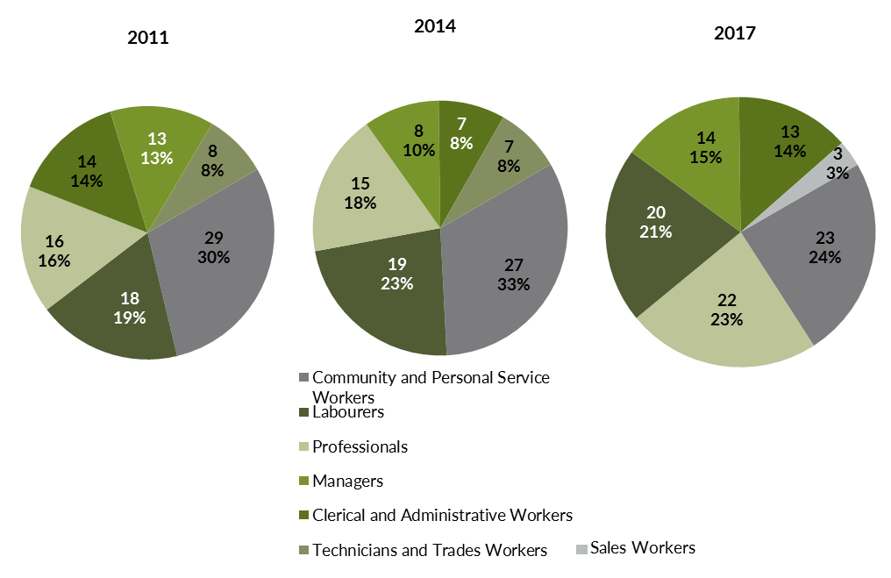
Source: Department of Trade, Business and Innovation
In 2017 in Elliott:
- Community and Personal Service Workers was the largest occupation classification in terms of filled jobs, accounting for 23 jobs (23.5% of total filled jobs), a decrease of 4 jobs from 2014 and a decrease of 6 jobs from 2011
- other significant occupation classifications were:
- Professionals accounting for 22 jobs or 22.4% of total jobs an increase of 7 jobs from 2014 and an increase of 6 jobs from 2011
- Labourers accounting for 20 jobs or 20.4% of total jobs an increase of 1 job from 2014 and an increase of 2 jobs from 2011
- Managers accounting for 14 jobs or 14.3% of total jobs an increase of 6 jobs from 2014 and an increase of 1 job from 2011.
Table 16 Count of filled jobs by ANZSCO occupation by Aboriginal status of person employed in job, 2011, 2014 and 2017 (a)(c)(f)(g)
Occupation (ANZSCO major group) | 2011 |  |  | 2014 |  |  | 2017 |  |  | Change  2011-2014 |  |  | Change  2014-2017
 | Aboriginal | Non-Aboriginal | Total | Aboriginal | Non-Aboriginal | Total | Aboriginal | Non-Aboriginal | Total | Aboriginal | Non-Aboriginal | Total | Aboriginal | Non-Aboriginal | Total
Clerical and Administrative Workers | 9 | 5 | 14 | 4 | 3 | 7 | 9 | 4 | 13 | -5 | -2 | -7 | 5 | 1 | 6
Community and Personal Service Workers | 23 | 6 | 29 | 25 | 2 | 27 | 18 | 5 | 23 | 2 | -4 | -2 | -7 | 3 | -4
Labourers | 11 | 7 | 18 | 12 | 7 | 19 | 18 | 2 | 20 | 1 | 0 | 1 | 6 | -5 | 1
Machinery Operators and Drivers | 0 | 0 | 0 | 4 | 0 | 4 | 0 | 1 | 1 | 4 | 0 | 4 | -4 | 1 | -3
Managers | 1 | 12 | 13 | 0 | 8 | 8 | 5 | 9 | 14 | -1 | -4 | -5 | 5 | 1 | 6
Professionals | 8 | 8 | 16 | 6 | 9 | 15 | 12 | 10 | 22 | -2 | 1 | -1 | 6 | 1 | 7
Sales Workers | 3 | 2 | 5 | 0 | 1 | 1 | 0 | 3 | 3 | -3 | -1 | -4 | 0 | 2 | 2
Technicians and Trades Workers | 3 | 5 | 8 | 3 | 4 | 7 | 1 | 1 | 2 | 0 | -1 | -1 | -2 | -3 | -5
Total | 59 | 45 | 104 | 54 | 34 | 88 | 63 | 35 | 98 | -5 | -11 | -16 | 9 | 1 | 10
Source: Department of Trade, Business and Innovation
In 2017 in Elliott:
- of the 63 jobs filled by Aboriginal persons, there were
- 18 Community and Personal Service Workers, a decrease of 7 jobs from 2014 and a decrease of 5 jobs from 2011
- 18 Labourers, an increase of 6 jobs from 2014 and an increase of 7 jobs from 2011
- 12 Professionals, an increase of 6 jobs from 2014 and an increase of 4 jobs from 2011
- of the 35 jobs filled by non-Aboriginal persons, there were:
- 10 Professionals, an increase of 1 job from 2014 and an increase of 2 jobs from 2011
- 9 Managers, an increase of 1 job from 2014 and a decrease of 3 jobs from 2011
- 5 Community and Personal Service Workers, an increase of 3 jobs from 2014 and a decrease of 1 job from 2011.

Jobs by Industry by Occupation
Table 17: Count of filled jobs by industry by occupation, 2011 (a)(f)(g)(h)
2011
Industry (ANZSIC Division) |  | Occupation (ANZSCO major group)
 | Clerical and Administrative Workers | Community and Personal Service Workers | Labourers | Machinery Operators and Drivers | Managers | Professionals | Sales Workers | Technicians and Trades Workers | Other occupations | Total
Arts and Recreation Services | 1 | 0 | 0 | 0 | 0 | 0 | 0 | 0 | 0 | 1
Education and Training | 1 | 4 | 1 | 0 | 1 | 7 | 0 | 0 | 0 | 14
Health Care and Social Assistance | 0 | 4 | 2 | 0 | 0 | 3 | 0 | 0 | 1 | 10
Other Services | 1 | 0 | 0 | 0 | 1 | 0 | 0 | 4 | 0 | 6
Public Administration and Safety | 9 | 19 | 6 | 0 | 2 | 6 | 3 | 3 | 0 | 48
Retail Trade | 0 | 0 | 6 | 0 | 8 | 0 | 1 | 1 | 0 | 16
Transport, Postal and Warehousing | 0 | 0 | 0 | 0 | 1 | 0 | 0 | 0 | 0 | 1
Total | 14 | 29 | 18 | 0 | 13 | 16 | 5 | 8 | 1 | 104
Source: Department of Trade, Business and Innovation
Table 18: Count of filled jobs by industry by occupation, 2014 (a)(f)(g)(h)
2014
Industry (ANZSIC Division) |  | Occupation (ANZSCO major group)
 | Clerical and Administrative Workers | Community and Personal Service Workers | Labourers | Machinery Operators and Drivers | Managers | Professionals | Sales Workers | Technicians and Trades Workers | Other occupations | Total
Arts and Recreation Services | 0 | 0 | 0 | 0 | 0 | 1 | 0 | 0 | 0 | 1
Education and Training | 1 | 5 | 1 | 0 | 1 | 6 | 0 | 0 | 0 | 14
Health Care and Social Assistance | 1 | 6 | 1 | 0 | 1 | 3 | 0 | 0 | 0 | 12
Other Services | 2 | 0 | 2 | 0 | 1 | 0 | 0 | 3 | 0 | 8
Public Administration and Safety | 3 | 16 | 9 | 3 | 0 | 5 | 0 | 3 | 0 | 39
Rental, Hiring and Real Estate Services | 0 | 0 | 0 | 1 | 0 | 0 | 0 | 0 | 0 | 1
Retail Trade | 0 | 0 | 6 | 0 | 5 | 0 | 1 | 1 | 0 | 13
Total | 7 | 27 | 19 | 4 | 8 | 15 | 1 | 7 | 0 | 88
Source: Department of Trade, Business and Innovation
Table 19: Count of filled jobs by occupation and by industry, 2017 (a)(f)(g)(h)
2017
Industry (ANZSIC Division) |  | Occupation (ANZSCO major group)
 | Clerical and Administrative Workers | Community and Personal Service Workers | Labourers | Machinery Operators and Drivers | Managers | Professionals | Sales Workers | Technicians and Trades Workers | Other Occupations | Total
Administrative and Support Services | 6 | 0 | 0 | 0 | 0 | 2 | 0 | 0 | 0 | 8
Arts and Recreation Services | 0 | 0 | 0 | 0 | 2 | 1 | 0 | 0 | 0 | 3
Construction | 3 | 0 | 9 | 0 | 2 | 0 | 0 | 0 | 0 | 14
Education and Training | 0 | 4 | 1 | 0 | 1 | 10 | 0 | 0 | 0 | 16
Health Care and Social Assistance | 1 | 2 | 0 | 0 | 1 | 1 | 0 | 0 | 0 | 5
Public Administration and Safety | 3 | 17 | 7 | 0 | 1 | 8 | 0 | 2 | 0 | 38
Retail Trade | 0 | 0 | 1 | 1 | 6 | 0 | 3 | 0 | 0 | 11
Transport, Postal and Warehousing | 0 | 0 | 2 | 0 | 1 | 0 | 0 | 0 | 0 | 3
Total | 13 | 23 | 20 | 1 | 14 | 22 | 3 | 2 | 0 | 98
Source: Department of Trade, Business and Innovation
In 2017 in Elliott
- the majority of Community and Personal Service Workers (23) jobs (the largest occupation group) and Professionals(22) (the second largest occupation group) were shared across the Public Administration and Safety (17) and Education and Training (10) industries
- the Health Care and Social Assistance sector showed the largest decrease of 5 filled jobs between 2017 and 2014
- new industries in 2017 were Administrative and Support Services and Construction which filled 22 jobs; these industries had nil jobs filled in 2014.

Jobs by Gender
Table 20: Counts of filled jobs by gender and Aboriginal status of person employed in job 2011, 2014 and 2017 (a)(c)(i)
Indicator | 2011 |  |  | 2014 |  |  | 2017 |  |  | 2011-2014 Change |  |  | 2014-2017 Change
 | Aboriginal | Non-Aboriginal | Total | Aboriginal | Non-Aboriginal | Total | Aboriginal | Non-Aboriginal | Total | Aboriginal | Non-Aboriginal | Total | Aboriginal | Non-Aboriginal | Total
Male | 21 | 27 | 48 | 25 | 18 | 43 | 33 | 17 | 50 | 4 | -9 | -5 | 8 | -1 | 7
Female | 38 | 18 | 56 | 29 | 16 | 45 | 29 | 18 | 47 | -9 | -2 | -11 | 0 | 2 | 2
Total | 59 | 45 | 104 | 54 | 34 | 88 | 62 | 35 | 97 | -5 | -11 | -16 | 8 | 1 | 9
Source: Department of Trade, Business and Innovation
Chart 11: Count of filled jobs by gender and Aboriginal status of person in job, 2011, 2014 and 2017 (a)(c)(i)
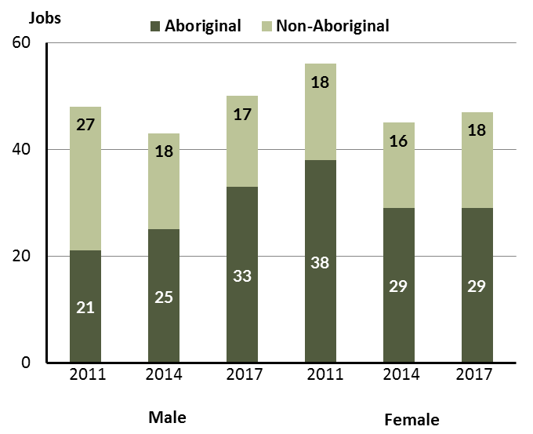
Source: Department of Trade, Business and Innovation
In 2017 in Elliott:
- there were 50 jobs filled by males, an increase of 7 jobs from 2014 and an increase of 2 jobs from 2011

- of the 50 jobs filled by males:
- 33 were Aboriginal, an increase of 8 jobs from 2014 and an increase of 12 jobs from 2011
- 17 were non-Aboriginal, a decrease of 1 job from 2014 and a decrease of 10 jobs from 2011
- there were 47 jobs filled by females, an increase of 2 jobs from 2014 and a decrease of 9 jobs from 2011
- of the 47 jobs filled by females:
- 29 were Aboriginal, unchanged from 2014 and a decrease of 9 jobs from 2011
- 18 were non-Aboriginal, an increase of 2 jobs from 2014 and a decrease of nil jobs from 2011.
Table 21: Counts of filled jobs by gender, by Aboriginal status of person in the job, by full-time/part-time status, by job permanency and by sector 2011 (a)(b)(c)(d)(e)(i)
2011
Indicator | Male |  |  | Female |  |  | Total
 | Aboriginal | Non-Aboriginal | Total | Aboriginal | Non-Aboriginal | Total | Aboriginal | Non-Aboriginal | Total
Full-time | 15 | 24 | 39 | 18 | 14 | 32 | 33 | 38 | 71
Part-time | 6 | 3 | 9 | 20 | 4 | 24 | 26 | 7 | 33
Total | 21 | 27 | 48 | 38 | 18 | 56 | 59 | 45 | 104
Permanent | 18 | 16 | 34 | 24 | 9 | 33 | 42 | 25 | 67
Temporary | 3 | 11 | 14 | 14 | 9 | 23 | 17 | 20 | 37
Total | 21 | 27 | 48 | 38 | 18 | 56 | 59 | 45 | 104
Public sector | 20 | 11 | 31 | 32 | 10 | 42 | 52 | 21 | 73
Private sector | 1 | 16 | 17 | 6 | 8 | 14 | 7 | 24 | 31
Total | 21 | 27 | 48 | 38 | 18 | 56 | 59 | 45 | 104
Source: Department of Trade, Business and Innovation
Table 22: Counts of filled jobs by gender, by Aboriginal status of person in the job, by full-time/part-time status, by job permanency and by sector 2014 (a)(b)(c)(d)(e)(i)
2014
Indicator | Male |  |  | Female |  |  | Total
 | Aboriginal | Non-Aboriginal | Total | Aboriginal | Non-Aboriginal | Total | Aboriginal | Non-Aboriginal | Total
Full-time | 16 | 18 | 34 | 18 | 13 | 31 | 34 | 31 | 65
Part-time | 9 | 0 | 9 | 11 | 3 | 14 | 20 | 3 | 23
Total | 25 | 18 | 43 | 29 | 16 | 45 | 54 | 34 | 88
Permanent | 21 | 12 | 33 | 22 | 10 | 32 | 43 | 22 | 65
Temporary | 4 | 6 | 10 | 7 | 6 | 13 | 11 | 12 | 23
Total | 25 | 18 | 43 | 29 | 16 | 45 | 54 | 34 | 88
Public sector | 22 | 8 | 30 | 26 | 8 | 34 | 48 | 16 | 64
Private sector | 3 | 10 | 13 | 3 | 8 | 11 | 6 | 18 | 24
Total | 25 | 18 | 43 | 29 | 16 | 45 | 54 | 34 | 88
Source: Department of Trade, Business and Innovation
Table 23: Counts of filled jobs by gender, by Aboriginal status of person in the job, by full-time/part-time status, by job permanency and by sector 2017 (a)(b)(c)(d)(e)(i)
2017
Indicator | Male |  |  | Female |  |  | Total
 | Aboriginal | Non-Aboriginal | Total | Aboriginal | Non-Aboriginal | Total | Aboriginal | Non-Aboriginal | Total
Full-time | 22 | 16 | 38 | 10 | 15 | 25 | 33 | 31 | 64
Part-time | 11 | 1 | 12 | 19 | 3 | 22 | 30 | 4 | 34
Total | 33 | 17 | 50 | 29 | 18 | 47 | 63 | 35 | 98
Permanent | 24 | 9 | 33 | 20 | 10 | 30 | 45 | 19 | 64
Temporary | 9 | 8 | 17 | 9 | 8 | 17 | 18 | 16 | 34
Total | 33 | 17 | 50 | 29 | 18 | 47 | 63 | 35 | 98
Public sector | 18 | 7 | 25 | 19 | 12 | 31 | 38 | 19 | 57
Private sector | 15 | 10 | 25 | 10 | 6 | 16 | 25 | 16 | 41
Total | 33 | 17 | 50 | 29 | 18 | 47 | 63 | 35 | 98
Source: Department of Trade, Business and Innovation
In 2017 in Elliott:
- of the 50 jobs filled by males, there were:
- 33 jobs filled by Aboriginal males, an increase of 8 jobs from 2014 and an increase of 12 jobs from 2011, including:
- 22 full-time jobs, an increase of 6 jobs from 2014 and an increase of 7 jobs from 2011
- 11 part-time jobs, an increase of 2 jobs from 2014 and an increase of 5 jobs from 2011
- 24 permanent jobs, an increase of 3 jobs from 2014 and an increase of 6 jobs from 2011
- 9 temporary jobs, an increase of 5 jobs from 2014 and an increase of 6 jobs from 2011
- 18 public sector jobs, a decrease of 4 jobs from 2014 and a decrease of 2 jobs from 2011
- 15 private sector jobs, an increase of 12 jobs from 2014 and an increase of 14 jobs from 2011
- 17 jobs filled by non-Aboriginal males, a decrease of 1 job from 2014 and a decrease of 10 jobs from 2011, including:
- 16 full-time jobs, a decrease of 2 jobs from 2014 and a decrease of 8 jobs from 2011
- 1 part-time jobs, an increase of 1 job from 2014 and a decrease of 2 jobs from 2011
- 9 permanent jobs, a decrease of 3 jobs from 2014 and a decrease of 7 jobs from 2011
- 8 temporary jobs, an increase of 2 jobs from 2014 and a decrease of 3 jobs from 2011
- 7 public sector jobs, a decrease of 1 job from 2014 and a decrease of 4 jobs from 2011
- 10 private sector jobs, unchanged from 2014 and a decrease of 6 jobs from 2011
- of the 47 jobs filled by females, there were:
- 29 jobs filled by Aboriginal females, unchanged from 2014 and a decrease of 9 jobs from 2011, including:
- 10 full-time jobs, a decrease of 8 jobs from 2014 and a decrease of 8 jobs from 2011
- 19 part-time jobs, an increase of 8 jobs from 2014 and a decrease of 1 job from 2011
- 20 permanent jobs, a decrease of 2 jobs from 2014 and a decrease of 4 jobs from 2011
- 9 temporary jobs, an increase of 2 jobs from 2014 and a decrease of 5 jobs from 2011
- 19 public sector jobs, a decrease of 7 jobs from 2014 and a decrease of 13 jobs from 2011
- 10 private sector jobs, an increase of 7 jobs from 2014 and an increase of 4 jobs from 2011

- 18 jobs filled by non-Aboriginal females, an increase of 2 jobs from 2014 and unchanged from 2011, including:
- 15 full-time jobs, an increase of 2 jobs from 2014 and an increase of 1 job from 2011
- 3 part-time jobs, unchanged from 2014 and a decrease of 1 job from 2011
- 10 permanent jobs, unchanged from 2014 and an increase of 1 job from 2011
- 8 temporary jobs, an increase of 2 jobs from 2014 and a decrease of 1 job from 2011
- 12 public sector jobs, an increase of 4 jobs from 2014 and an increase of 2 jobs from 2011
- 6 private sector jobs, a decrease of 2 jobs from 2014 and a decrease of 2 jobs from 2011.

Jobs by Age
Table 24: Counts of filled jobs by age and Aboriginal status of person employed in job, 2011, 2014 and 2017 (a)(c)(j)
Indicator | 2011 |  |  | 2014 |  |  | 2017 |  |  | Change  2011-2014 |  |  | Change  2014-2017
 | Aboriginal | Non-Aboriginal | Total | Aboriginal | Non-Aboriginal | Total | Aboriginal | Non-Aboriginal | Total | Aboriginal | Non-Aboriginal | Total | Aboriginal | Non-Aboriginal | Total
15-24 years | 9 | 0 | 9 | 12 | 3 | 15 | 8 | 0 | 8 | 3 | 3 | 6 | -4 | -3 | -7
25-44 years | 38 | 23 | 61 | 35 | 11 | 46 | 43 | 13 | 56 | -3 | -12 | -15 | 8 | 2 | 10
45+ years | 12 | 22 | 34 | 7 | 20 | 27 | 11 | 22 | 33 | -5 | -2 | -7 | 4 | 2 | 6
Total | 59 | 45 | 104 | 54 | 34 | 88 | 63 | 35 | 98 | -5 | -11 | -16 | 9 | 1 | 10
Source: Department of Trade, Business and Innovation
Chart 12: Count of filled jobs by age and Aboriginal status of person in job, 2011, 2014 and 2017 (a)(c)(j)
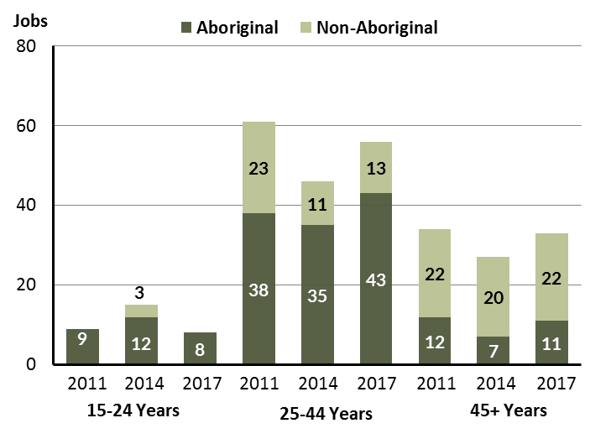
Source: Department of Trade, Business and Innovation
In 2017 in Elliott there were:
- 8 jobs filled by persons aged 15-24 years, a decrease of 7 jobs from 2014 and a decrease of 1 job from 2011. Of these:
- 8 jobs were filled by Aboriginal persons, a decrease of 4 jobs from 2014 and a decrease of 1 job from 2011
- none were filled by non-Aboriginal persons, a decrease of 3 jobs from 2014 and unchanged from 2011
- 56 jobs filled by persons aged 25-44 years, an increase of 10 jobs from 2014 and a decrease of 5 jobs from 2011. Of these:
- 43 jobs were filled by Aboriginal persons, an increase of 8 jobs from 2014 and an increase of 5 jobs from 2011
- 13 jobs were filled by non-Aboriginal persons, an increase of 2 jobs from 2014 and a decrease of 10 jobs from 2011
- 33 jobs filled by persons aged 45+ years, an increase of 6 jobs from 2011 and a decrease of 1 job from 2011. Of these:
- 11 jobs were filled by Aboriginal persons, an increase of 4 jobs from 2014 and a decrease of 1 job from 2011
- 22 jobs were filled by non-Aboriginal persons, an increase of 2 jobs from 2014 and unchanged from 2011.
Table 25: Counts of filled jobs by age, by Aboriginal status of person in the job, by full-time/part-time status, by job permanency and by sector June-July 2011 (a)(b)(c)(d)(e)(i)
2011
Indicator | 15-24 years |  |  | 25-44 years |  |  | 45+ years |  |  | Total
 | Aboriginal | Non-Aboriginal | Total | Aboriginal | Non-Aboriginal | Total | Aboriginal | Non-Aboriginal | Total | Aboriginal | Non-Aboriginal | Total
Full-time | 2 | 0 | 2 | 22 | 18 | 40 | 9 | 20 | 29 | 33 | 38 | 71
Part-time | 7 | 0 | 7 | 16 | 5 | 21 | 3 | 2 | 5 | 26 | 7 | 33
Total | 9 | 0 | 9 | 38 | 23 | 61 | 12 | 22 | 34 | 59 | 45 | 104
Permanent | 8 | 0 | 8 | 26 | 18 | 44 | 8 | 7 | 15 | 42 | 25 | 67
Temporary | 1 | 0 | 1 | 12 | 5 | 17 | 4 | 15 | 19 | 17 | 20 | 37
Total | 9 | 0 | 9 | 38 | 23 | 61 | 12 | 22 | 34 | 59 | 45 | 104
Public sector | 9 | 0 | 9 | 33 | 9 | 42 | 10 | 12 | 22 | 52 | 21 | 73
Private sector | 0 | 0 | 0 | 5 | 14 | 19 | 2 | 10 | 12 | 7 | 24 | 31
Total | 9 | 0 | 9 | 38 | 23 | 61 | 12 | 22 | 34 | 59 | 45 | 104
Source: Department of Trade, Business and Innovation
Table 26: Counts of filled jobs by age, by Aboriginal status of person in the job, by full-time/part-time status, by job permanency and by sector June-July 2014 (a)(b)(c)(d)(e)(i)
2014
Indicator | 15-24 years |  |  | 25-44 years |  |  | 45+ years |  |  | Total
 | Aboriginal | Non-Aboriginal | Total | Aboriginal | Non-Aboriginal | Total | Aboriginal | Non-Aboriginal | Total | Aboriginal | Non-Aboriginal | Total
Full-time | 9 | 3 | 12 | 19 | 11 | 30 | 6 | 17 | 23 | 34 | 31 | 65
Part-time | 3 | 0 | 3 | 16 | 0 | 16 | 1 | 3 | 4 | 20 | 3 | 23
Total | 12 | 3 | 15 | 35 | 11 | 46 | 7 | 20 | 27 | 54 | 34 | 88
Permanent | 11 | 2 | 13 | 27 | 8 | 35 | 5 | 12 | 17 | 43 | 22 | 65
Temporary | 1 | 1 | 2 | 8 | 3 | 11 | 2 | 8 | 10 | 11 | 12 | 23
Total | 12 | 3 | 15 | 35 | 11 | 46 | 7 | 20 | 27 | 54 | 34 | 88
Public sector | 12 | 2 | 14 | 31 | 7 | 38 | 5 | 7 | 12 | 48 | 16 | 64
Private sector | 0 | 1 | 1 | 4 | 4 | 8 | 2 | 13 | 15 | 6 | 18 | 24
Total | 12 | 3 | 15 | 35 | 11 | 46 | 7 | 20 | 27 | 54 | 34 | 88
Source: Department of Trade, Business and Innovation
Table 27: Counts of filled jobs by age, by Aboriginal status of person in the job, by full-time/part-time status, by job permanency and by sector June-July 2017 (a)(b)(c)(d)(e)(i)
2017
Indicator | 15-24 years |  |  | 25-44 years |  |  | 45+ years |  |  | Total
 | Aboriginal | Non-Aboriginal | Total | Aboriginal | Non-Aboriginal | Total | Aboriginal | Non-Aboriginal | Total | Aboriginal | Non-Aboriginal | Total
Full-time | 2 | 0 | 2 | 26 | 12 | 38 | 4 | 19 | 23 | 33 | 31 | 64
Part-time | 6 | 0 | 6 | 17 | 1 | 18 | 7 | 3 | 10 | 30 | 4 | 34
Total | 8 | 0 | 8 | 43 | 13 | 56 | 11 | 22 | 33 | 63 | 35 | 98
Permanent | 3 | 0 | 3 | 33 | 7 | 40 | 8 | 12 | 20 | 45 | 19 | 64
Temporary | 5 | 0 | 5 | 10 | 6 | 16 | 3 | 10 | 13 | 18 | 16 | 34
Total | 8 | 0 | 8 | 43 | 13 | 56 | 11 | 22 | 33 | 63 | 35 | 98
Public sector | 3 | 0 | 3 | 27 | 9 | 36 | 7 | 10 | 17 | 38 | 19 | 57
Private sector | 5 | 0 | 5 | 16 | 4 | 20 | 4 | 12 | 16 | 25 | 16 | 41
Total | 8 | 0 | 8 | 43 | 13 | 56 | 11 | 22 | 33 | 63 | 35 | 98
Source: Department of Trade, Business and Innovation
In 2017 in Elliott:
- of the 8 jobs filled by persons aged 15-24 years, there were:
- 8 jobs filled by Aboriginal persons, of which
- 2 were full-time jobs, a decrease of 7 jobs from 2014 and unchanged from 2011
- 6 were part-time jobs, an increase of 3 jobs from 2014 and a decrease of 1 job from 2011
- 3 were permanent jobs, a decrease of 8 jobs from 2014 and a decrease of 5 jobs from 2011
- 5 were temporary jobs, an increase of 4 jobs from 2014 and an increase of 4 jobs from 2011
- 3 were public sector jobs, a decrease of 9 jobs from 2014 and a decrease of 6 jobs from 2011
- 5 were private sector jobs, an increase of 5 jobs from 2014 and an increase of 5 jobs from 2011
- none were filled by non-Aboriginal persons
- none were full-time jobs, a decrease of 3 jobs from 2014 and unchanged from 2011
- none were part-time jobs, unchanged from 2014 and unchanged from 2011
- none were permanent jobs, a decrease of 2 jobs from 2014 and unchanged from 2011
- none were temporary jobs, a decrease of 1 job from 2014 and unchanged from 2011
- none were public sector jobs, a decrease of 2 jobs from 2014 and unchanged from 2011
- none were private sector jobs, a decrease of 1 job from 2014 and unchanged from 2011
- of the 56 jobs filled by persons aged 25-44 years, there were:
- 43 jobs filled by Aboriginal persons, of which:
- 26 were full-time jobs, an increase of 7 jobs from 2014 and an increase of 4 jobs from 2011
- 17 were part-time jobs, an increase of 1 job from 2014 and an increase of 1 job from 2011
- 33 were permanent jobs, an increase of 6 jobs from 2014 and an increase of 7 jobs from 2011
- 10 were temporary jobs, an increase of 2 jobs from 2014 and a decrease of 2 jobs from 2011
- 27 were public sector jobs, a decrease of 4 jobs from 2014 and a decrease of 6 jobs from 2011
- 16 were private sector jobs, an increase of 12 jobs from 2014 and an increase of 11 jobs from 2011
- 13 jobs filled by non-Aboriginal persons, of which:
- 12 were full-time jobs, an increase of 1 job from 2014 and a decrease of 6 jobs from 2011
- 1 was a part-time job, an increase of 1 job from 2014 and a decrease of 4 jobs from 2011
- 7 were permanent jobs, a decrease of 1 job from 2014 and a decrease of 11 jobs from 2011
- 6 were temporary jobs, an increase of 3 jobs from 2014 and an increase of 1 job from 2011
- 9 were public sector jobs, an increase of 2 jobs from 2014 and unchanged from 2011
- 4 were private sector jobs, unchanged from 2014 and a decrease of 10 jobs from 2011
- of the 33 jobs filled by persons aged 45+ years, there were:
- 11 jobs filled by Aboriginal persons, of which:
- 4 were full-time jobs, a decrease of 2 jobs from 2014 and a decrease of 5 jobs from 2011
- 7 were part-time jobs, an increase of 6 jobs from 2014 and an increase of 4 jobs from 2011
- 8 were permanent jobs, an increase of 3 jobs from 2014 and unchanged from 2011
- 3 were temporary jobs, an increase of 1 job from 2014 and a decrease of 1 job from 2011
- 7 were public sector jobs, an increase of 2 jobs from 2014 and a decrease of 3 jobs from 2011
- 4 were private sector jobs, an increase of 2 jobs from 2014 and an increase of 2 jobs from 2011
- 22 jobs filled by non-Aboriginal persons, of which:
- 19 were full-time jobs, an increase of 2 jobs from 2014 and a decrease of 1 job from 2011
- 3 were part-time jobs, unchanged from 2014 and an increase of 1 job from 2011
- 12 were permanent jobs, unchanged from 2014 and an increase of 5 jobs from 2011
- 10 were temporary jobs, an increase of 2 jobs from 2014 and a decrease of 5 jobs from 2011
- 10 were public sector jobs, an increase of 3 jobs from 2014 and a decrease of 2 jobs from 2011
- 12 were private sector jobs, a decrease of 1 job from 2014 and an increase of 2 jobs from 2011.

Vocational Education and Training
Note: Since previous publications, the 2010 data have fallen in line with the new standardised reporting practices with an emphasis of all training activity undertaken in the remote town regardless of funding stream. As such, figures for 2010 VET data in this publication may differ from previous publications.
The impact of the Remote Jobs and Communities Program (RJCP) being established in 2013 has played a significant role in the downturn of accredited training in many remote towns across the Territory.
Table 28: Northern Territory Vocational Education and Training (VET) students, 2010, 2013 and 2016 (k)
VET Funding Group | 2010 |  | 2013 |  | 2016 |  | Change
 | No. | % of Total | No. | % of Total | No. | % of Total | 2010-2013 | 2013-2016
Building and Construction | 18 | 38 | 0 | 0 | 4 | 15 | - 18 | 4
Business and Clerical | 8 | 17 | 1 | 2 | 10 | 37 | - 7 | 9
Community Services, Health and Education | 0 | 0 | 10 | 21 | 1 | 4 | 10 | - 9
Engineering and Mining | 0 | 0 | 16 | 33 | 0 | 0 | 16 | - 16
General Education and Training | 0 | 0 | 2 | 4 | 0 | 0 | 2 | - 2
Primary Industry | 0 | 0 | 19 | 40 | 0 | 0 | 19 | - 19
Tourism and Hospitality | 19 | 40 | 0 | 0 | 0 | 0 | - 19 | 0
Transport and Storage | 0 | 0 | 0 | 0 | 12 | 44 | 0 | 12
Utilities | 2 | 4 | 0 | 0 | 0 | 0 | - 2 | 0
Total | 47 | 100 | 48 | 100 | 27 | 100 | 1 | - 21
Source: Department of Trade, Business and Innovation
In 2016 in Elliott:
- there were 27 VET students, a decrease of 21 students from 2013 and a decrease of 20 students from 2010
- the areas of VET activity with the most students were Transport and Storage (12), Business and Clerical (10), and Building and Construction (4)
- Transport and Storage reported the largest increase in students (12) compared to 2013 and Primary Industry reported the largest decrease in students (-19) over the same period.
Table 29: Northern Territory Vocational Education and Training (VET) unit enrolments, 2010, 2013 and 2016 (l)
VET Funding Group | 2010 |  | 2013 |  | 2016 |  | Change
 | No. | % of Total | No. | % of Total | No. | % of Total | 2010-2013 | 2013-2016
Building and Construction | 171 | 42 | 0 | 0 | 14 | 13 | - 171 | 14
Business and Clerical | 25 | 6 | 4 | 2 | 50 | 45 | - 21 | 46
Community Services, Health and Education | 0 | 0 | 45 | 21 | 1 | 1 | 45 | - 44
Engineering and Mining | 0 | 0 | 112 | 52 | 0 | 0 | 112 | - 112
General Education and Training | 0 | 0 | 8 | 4 | 0 | 0 | 8 | - 8
Primary Industry | 0 | 0 | 48 | 22 | 0 | 0 | 48 | - 48
Tourism and Hospitality | 204 | 50 | 0 | 0 | 0 | 0 | - 204 | 0
Transport and Storage | 0 | 0 | 0 | 0 | 46 | 41 | 0 | 46
Utilities | 9 | 2 | 0 | 0 | 0 | 0 | - 9 | 0
Total | 409 | 100 | 217 | 100 | 111 | 100 | - 192 | - 106
Source: Department of Trade, Business and Innovation
In 2016 in Elliott:
- there were 111 VET unit enrolments, a decrease of 106 unit enrolments from 2013 and a decrease of 298 unit enrolments from 2010
- the areas of VET activity with the most unit enrolments were Business and Clerical (50), Transport and Storage (46), and Building and Construction (14)
- Business and Clerical reported the largest increase in unit enrolments (46) compared to 2013 and Engineering and Mining reported the largest decrease in unit enrolments (-112) over the same period.
Table 30: Northern Territory Vocational Education and Training (VET) nominal hours, 2010, 2013 and 2016 (m)
VET Funding Group | 2010 |  | 2013 |  | 2016 |  | Change
 | No. | % of Total | No. | % of Total | No. | % of Total | 2010-2013 | 2013-2016
Building and Construction | 4 491 | 46 | 0 | 0 | 1 692 | 39 | -4 491 | 1 692
Business and Clerical | 640 | 7 | 120 | 2 | 1 395 | 33 | - 520 | 1 275
Community Services, Health and Education | 0 | 0 | 1 938 | 25 | 25 | 1 | 1 938 | -1 913
Engineering and Mining | 0 | 0 | 3 596 | 46 | 0 | 0 | 3 596 | -3 596
General Education and Training | 0 | 0 | 540 | 7 | 0 | 0 | 540 | - 540
Primary Industry | 0 | 0 | 1 570 | 20 | 0 | 0 | 1 570 | -1 570
Tourism and Hospitality | 4 182 | 43 | 0 | 0 | 0 | 0 | -4 182 | 0
Transport and Storage | 0 | 0 | 0 | 0 | 1 180 | 27 | 0 | 1 180
Utilities | 380 | 4 | 0 | 0 | 0 | 0 | - 380 | 0
Total | 9 693 | 100 | 7 764 | 100 | 4 292 | 100 | -1 929 | -3 472
Source: Department of Trade, Business and Innovation
In 2016 in Elliott:
- there were 4292 VET nominal hours delivered, a decrease of 3472 nominal hours delivered from 2013 and a decrease of 5401 nominal hours delivered from 2010
- the areas of VET activity with the most nominal hours delivered were Building and Construction (1692), Business and Clerical (1395), and Transport and Storage (1180)
- Building and Construction reported the largest increase in nominal hours delivered (1692) compared to 2013 and Engineering and Mining reported the largest decrease in nominal hours delivered (-3596) over the same period.
Caveat: Nominal hours are based on the hours funded through Department of Trade Business and Innovation contracts; students and units includes delivery that has been funded in a previous year, fee for service or training that did not meet the funding requirements. Because of this a direct match cannot be made between hours and student/units.
Table 31: Northern Territory Vocational Education and Training (VET) unit completions, 2010, 2013 and 2016 (n)
VET Funding Group | 2010 |  | 2013 |  | 2016 |  | Change
 | No. | % of Total | No. | % of Total | No. | % of Total | 2010-2013 | 2013-2016
Building and Construction | 171 | 45 | 0 | 0 | 14 | 16 | - 171 | 14
Business and Clerical | 0 | 0 | 0 | 0 | 24 | 28 | 0 | 24
Community Services, Health and Education | 0 | 0 | 39 | 25 | 1 | 1 | 39 | - 38
Engineering and Mining | 0 | 0 | 68 | 44 | 0 | 0 | 68 | - 68
Primary Industry | 0 | 0 | 46 | 30 | 0 | 0 | 46 | - 46
Tourism and Hospitality | 204 | 54 | 0 | 0 | 0 | 0 | - 204 | 0
Transport and Storage | 0 | 0 | 0 | 0 | 46 | 54 | 0 | 46
Utilities | 6 | 2 | 0 | 0 | 0 | 0 | - 6 | 0
Total | 381 | 100 | 153 | 100 | 85 | 100 | - 228 | - 68
Source: Department of Trade, Business and Innovation
In 2016 in Elliott:
- there were 85 VET unit completions, a decrease of 68 unit completions from 2013 and a decrease of 296 unit completions from 2010
- the areas of VET activity with the most unit completions were Transport and Storage (46), Business and Clerical (24), and Building and Construction (14)
- Transport and Storage reported the largest increase in nominal hours delivered (46) compared to 2013 and Engineering and Mining reported the largest decrease in nominal hours delivered (-68) over the same period.

Population
Table 32: Population distribution by gender and age (p)(r)
Indicator | 2006 |  |  | 2016 |  |  | Change
 | Male | Female | Total | Male | Female | Total | Male | Female | Total
0-4 years | 34 | 23 | 57 | 30 | 21 | 51 | -4 | -2 | -6
5-14 years | 43 | 35 | 78 | 38 | 49 | 87 | -5 | 14 | 9
15-24 years | 48 | 29 | 77 | 32 | 26 | 58 | -16 | -3 | -19
25-44 years | 53 | 46 | 99 | 58 | 63 | 121 | 5 | 17 | 22
45-64 years | 18 | 32 | 50 | 16 | 47 | 63 | -2 | 15 | 13
65+ years | 8 | 4 | 12 | 0 | 7 | 7 | -8 | 3 | -5
TOTAL | 204 | 169 | 373 | 174 | 213 | 387 | -30 | 44 | 14
Source: Department of Trade, Business and Innovation
In 2016 in Elliott:
- there were an estimated 387 persons, of which:
- 174 (45%) were male
- 213 (55%) were female
- between 2006 and 2016, the overall population in Elliott increased by 14 persons from 2006, or an average of 0.4% per year compared to 0.7% across the 28 remote towns and 1.5% Territory wide
- the male population decreased by 30 persons from 2006
- the female population increased by 44 persons from 2006
- in 2016, the working age population (15 years and over) in Elliott was an estimated 249 persons (64.3% of the total population) compared with 238 persons (63.8% of the total population) in 2006. Of these:
- 58 (15%) were between 15 and 24 years of age
- 121 (31.3%) were between 25 and 44 years of age
- 63 (16.3%) were between 45 and 64 years of age
- 7 (1.8%) were over 65 years of age
- of the 249 persons of working age:
- 106 (42.6%) were male
- 143 (57.4%) were female.
There were 0.5 jobs in Elliott per working age person compared to 0.4 jobs per working age person across the 28 remote towns in the Northern Territory.
Chart 13: Population by Aboriginal status compared to 28 remote towns and the NT (p)(q)
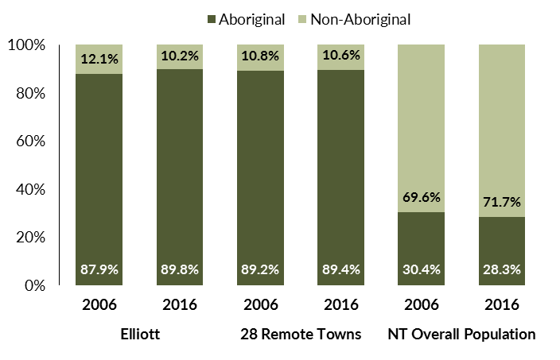
Source: Department of Trade, Business and Innovation
In 2016 in Elliott:
- 89.8% of the population in Elliott were Aboriginal, compared to 87.9% in 2006
- 89.4% of the population across all 28 remote towns were Aboriginal
- 28.3% of the NT population were Aboriginal.
Table 33: Unemployment and participation rates by Aboriginal status compared to the NT (q)
 | Elliott |  |  | Northern Territory
 | Aboriginal | Non-Aboriginal | Total | Aboriginal | Non-Aboriginal | Total
Unemployment rate | 43.6% | 0.0% | 33.8% | 26.7% | 3.8% | 7.0%
Participation rate | 55.5% | 81.5% | 60.7% | 41.0% | 79.9% | 70.6%
Source: Department of Trade, Business and Innovation
In 2016 in Elliott the:
- total unemployment rate was 33.8% compared to 7% for the total Northern Territory
- Aboriginal unemployment rate was 43.6% compared to 26.7% for the total Northern Territory
- non-Aboriginal unemployment rate was 0% compared to 3.8% for the total Northern Territory
- total participation rate was 60.7% compared to 70.6% for the total Northern Territory
- Aboriginal participation rate was 55.5% compared to 41% for the total Northern Territory
- non-Aboriginal participation rate was 81.5% compared to 79.9% for the total Northern Territory.

Community Development Programme
Table 34: Community Development Programme Aboriginal Job Seekers, 30 April 2018 (o)
Indicator | Aboriginal
 | No. | %
Total Aboriginal Job Seekers | 25 | N/A
Age (years)
19 and under | < 20 | N/A
20-24 | < 20 | N/A
25-44 | < 20 | N/A
45+ | < 20 | N/A
Total | < 20 | N/A
Gender
Male | < 20 | N/A
Female | < 20 | N/A
Total | < 20 | N/A
Employment Outcome - 1 July 2015 to 30 April 2018
13 Weeks | < 20 | N/A
26 Weeks | < 20 | N/A
Currently in Activities | < 20
Source: Department of Prime Minister and Cabinet
As at 30 April 2018, in Elliott, there were less than 20 CDP Aboriginal job seekers, of these:
- less than 20 were male and less than 20 were female
- less than 20 were aged 19 years and under, less than 20 were aged 20-24 years, less than 20 were aged 25-44 years, and less than 20 were aged 45+ years
- between 1 July 2015 and 30 April 2018, less than 20 had reached the 13 week reporting milestone and less than 20 had reached the 26 week reporting milestone
- less than 20 were currently in activities.

Businesses
Table 35: Businesses by sector (d)(s)
Business Name | Reported on in 2011? | Reported on in 2014? | Reported on in 2017?
PUBLIC SECTOR
Barkly Regional Council | Yes | Yes | Yes
Centrelink Department of Human Services (DHS) | Yes | No | No
Department of Education | Yes | Yes | Yes
Department of Health | Yes | Yes | Yes
Department of the Prime Minister and Cabinet | No | Yes | Yes
Northern Territory Police, Fire Emergency Services | Yes | Yes | Yes
PRIVATE SECTOR
Barkly Regional Arts Inc | Yes | Yes | Yes
Batchelor Institute of Indigenous Tertiary Education (BIITE) | Yes | No | No
Elliott Hotel | Yes | Yes | Yes
Elliott Mechanical | Yes | Yes | Yes
Elliott Service Station/United Fuel | Yes | No | No
Fuchs Motors | Yes | Yes | No
Fuchs, Gwendolyne trading as Sparkle Cleaning | No | Yes | No
Julalikari Council Aboriginal Corporation - CDP | No | No | Yes
Midland Caravan Park | Yes | Yes | Yes
Northern Interests trading as The Elliot Store NT | No | Yes | Yes
Post Office | Yes | No | No
Steps Group Australia Limited | No | Yes | Yes
Triple P Contracting Pty Ltd | No | Yes | Yes
Williams, Neil Edward | No | Yes | No
Source: Department of Trade, Business and Innovation
Note: Business names captured across the three survey periods have been identified by the current 2017 Business ABN name listed as at 2017.
In 2017 in Elliott:
- there were 13 businesses reported on, of which:
- 5 businesses were from the Public Sector (38%)
- 8 businesses were from the Private Sector (62%)
- there were 4 businesses operating that were not operating in 2011.

Notes
- These counts represent numbers of filled jobs and not numbers of persons. As such the totals represent the total number of filled jobs, not the total number of employees. This count is not directly comparable to the total number of employed persons as a person may have several jobs or one job may be shared by more than one person.
- Full-time is defined as a job usually requiring 35 hours or more per week or that required 35 hours or more work during the reference week. Part-time is defined as a job usually requiring less than 35 hours per week or that required less than 35 hours work during the reference week. The reference week refers to the period that respondents were asked to provide information about. In most instances it would be the week prior to the week the questionnaire was completed. Questionnaires were predominantly conducted in June and July.
- Care needs to be taken when analysing the counts of filled jobs by the Aboriginal status of persons in the jobs. The Aboriginal status of the person employed in a job was reported by the business representative completing the questionnaire.
- Sector was classified using the Standard Economic Sector of Classifications of Australia (SESCA), 2008.
- Job permanency is classified according to what the business believes the level of job permanency is based on guidelines provided by data collectors. Those guidelines state a permanent job has paid annual and/or sick leave entitlements while a temporary job includes casual and fixed-term contract jobs.
- Classified according to the Australian and New Zealand Standard Classification of Occupations (ANZSCO), 2006, major occupation level.
- Other occupations include jobs where occupation was not stated, not known or inadequately described.
- Classified using the Australian and New Zealand Standard Industrial Classification (ANZSIC), 2006, division level.
- Care needs to be taken when analysing the counts of filled jobs by the gender of persons in the jobs. The gender of the person employed in a job is reported by the business representative completing the questionnaire.
- Care needs to be taken when analysing the counts of filled jobs by the age of persons in the jobs. The age of the person employed in a job is reported by the business representative completing the questionnaire.
- Students represent the number of individual clients that enrolled in a Vocational Education and Training unit during the calendar year.
- Unit enrolments represent the count of individual units that students enrolled in during the calendar year.
- Nominal hours delivered is the sum of the nominal hours of the units commenced during the calendar year regardless of when the course enrolment commenced.
- Unit completions are the count of all successfully completed units reported in the calendar year regardless of the year of commencement of the units.
- The Community Development Programme (CDP) supports job seekers in remote Australia to build skills, address barriers and contribute to their communities through a range of flexible activities. Under the CDP, job seekers with activity requirements are expected to do up to 25 hours per week of work-like activities that benefit their community. It should be noted that some CDP participants may be reported on within the profile if they are attached to a filled position with an employer captured in the survey. Due to confidentiality issues, data below 20 people is not published.
- Population estimates for both 2006 and 2016 are taken from the estimated resident population (ERP) data produced by the Australian Bureau of Statistics (ABS) and based on Australian Statistical Geography Standard (ASGS) Statistical Area Level 1 (SA1) regions. ERP are official estimates of the Australian population, which link people to a place of usual residence with Australia. All ERP data sources, including the Census of Population and Housing (Census), are subject to error (including inaccuracies in collection, recording and processing data) and should be used with caution.
- Indigenous population proportions, unemployment and workforce participation rates are based on ABS Census counts at ASGS Indigenous Locations (ILOCs) for each remote town.
- Working-age population includes all residents aged 15 years and over (commonly referred to as the civilian population) and consists of persons that are employed, unemployed or not in the labour force.
- A ‘business’ has been defined as any organisation that has undertaken productive activities in the last year, including companies, non-profit organisations, government departments and enterprises operating within the designated remote geography (town), and has one or more employees in paid employment and an Australian Business Number (ABN).

Abbreviations and Acronyms
ABN Australian Business Number
ABS Australian Bureau of Statistics
ANZSCO Australian and New Zealand Standard Classification of Occupations
ANZSIC Australian and New Zealand Standard Industrial Classification
ASGS Australian Statistical Geography Standard
CDP Community Development Programme
ERP Estimated Resident Population
ILOC Indigenous Locations
nec Not Elsewhere Classified
No. Number
Perm Permanent
ppt Percentage point
RJCP Remote Jobs and Communities Program
Temp Temporary
SA1 Statistical Area Level 1
VET Vocational Education and Training

The number of filled jobs does not represent numbers of persons as a person may have several jobs or one job may be shared by more than one person.
1 Aboriginal filled jobs gender status not identified in 2017
1 Aboriginal filled jobs gender status not identified in 2017

