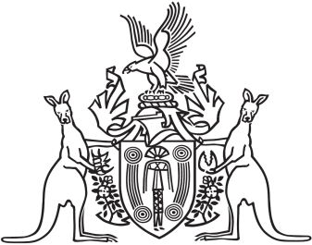
Northern Territory of Australia

Government Gazette
ISSN-0157-833X
No. S72 4 September 2018
Northern Territory of Australia
Plant Health Act
Restriction of Introduction into the Territory of
Specified Plant and Material
I, Anne Christine Walters, Chief Inspector of Plant Health, under section 17(2) of the Plant Health Act and with reference to 17(1)(a) of the Act, for the control of the declared pest Xanthomonas citri subsp. citri (citrus canker) (the declared pest), restrict the introduction into the Territory of a plant or plant-related material as specified in the Schedule for 12 months on and from the date of publication of this notice.
Dated 4 September 2018
A. C. Walters
Chief Inspector of Plant Health
Schedule
1 Definitions
In this Schedule:
another jurisdiction means a State or another Territory.
area freedom certificate means a certificate given by an officer of a department responsible for agriculture in another jurisdiction certifying that the jurisdiction or a part of the jurisdiction is known to be free from the declared pest.
restricted material means plant-related material that is, or might reasonably be, affected by the declared pest.
restricted plant means a declared host plant for the declared pest.
2 Restriction of Introduction into the Territory
A person must not introduce into the Territory a restricted plant or restricted material unless the plant or material:
(a) is exported from a jurisdiction, or part of a jurisdiction, certified by an area freedom certificate in force when the plant or material is introduced; or
(b) is commercially-grown Citrus spp. fruit that is:
(i) grown, processed, treated and packed in accordance with an agreed operating procedure or other documented arrangement managed by the department responsible for agriculture in the jurisdiction from which it is exported; and
(ii) accompanied by a government certificate certifying that the condition in paragraph (b)(i) has been met; or
(c) is machinery or equipment that is:
(i) treated in accordance with an agreed operating procedure or other documented arrangement managed by the department responsible for agriculture in the jurisdiction from which it is exported, immediately prior to export; and
(ii) accompanied by a government certificate certifying that the condition in paragraph (c)(i) has been met; or
(d) is introduced in accordance with a written permit given by the Chief Inspector.

