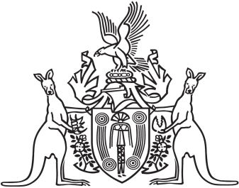
Northern Territory of Australia

Government Gazette
ISSN-0157-833X
No. S61 1 August 2018
Northern Territory of Australia

Interpretation Act
Amendment of By-Law Notification
Under Local Government Act
I, Gerald Francis McCarthy, Minister for Housing and Community Development, under section 63(3) of the Interpretation Act and with reference to section 43 of that Act, amend the notification of the making of by-laws by the Tiwi Islands Regional Council under section 188(1) of the Local Government Act dated 30 July 2018 and published in Gazette No. S60 of 1 August 2018 by omitting the citation of the By-laws and inserting instead "Tiwi Islands Regional Council By-laws".
Copies of the by-laws may be purchased from the Print Management Unit, Department of Corporate and Information Services, Level 10, Charles Darwin Centre, 19 The Mall, Darwin (email pmu.ntg@nt.gov.au or phone (08) 8999 6727).
Dated 1 August 2018
G. F. McCarthy
Minister for Housing and Community Development

