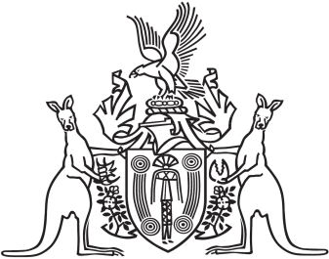
Northern Territory of Australia

Government Gazette
ISSN-0157-833X
No. S15 2 March 2018

Notification of Subordinate Legislation
Notice is given of the making of the following subordinate legislation, effective from the date specified:
Subordinate Legislation | Commencement details | Empowering Act
Environment Protection (Beverage Containers and Plastic Bags) Amendment Regulations 2018  (No. 4 of 2018) | Date of this Gazette | Environment Protection (Beverage Containers and Plastic Bags) Act
Bushfires Management (General) Amendment Regulations 2018  (No. 5 of 2018) | Date of this Gazette | Bushfires Management Act
For copies of legislation please direct your request to the Print Management Unit, email pmu.ntg@nt.gov.au or phone (08) 8999 6727

