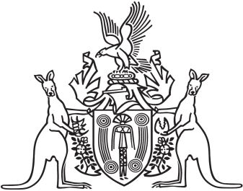
Northern Territory of Australia

Government Gazette
ISSN-0157-833X
No. S14 28 February 2018
Northern Territory of Australia

Liquor Amendment Act 2017
Commencement Notice
I, Vicki Susan O'Halloran, Administrator of the Northern Territory of Australia, under section 2 of the Liquor Amendment Act 2017 (No. 24 of 2017), fix the day on which this notice is published in the Gazette as the day on which the Act commences.
Dated 26 February 2018
V. S. O'Halloran
Administrator
Northern Territory of Australia

Liquor Commission Act 2018
Commencement Notice
I, Vicki Susan O'Halloran, Administrator of the Northern Territory of Australia, under section 2 of the Liquor Commission Act 2018 (No. 1 of 2018), fix the day on which this notice is published in the Gazette as the day on which the Act commences.
Dated 26 February 2018
V. S. O'Halloran
Administrator

