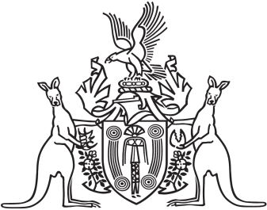
Northern Territory of Australia

Government Gazette
ISSN-0157-833X
No. S9 19 February 2018

Assent to Proposed Laws
Her Honour the Administrator declared assent to the following proposed laws:
16 February 2018
Liquor Commission Act 2018 (Act No. 1 of 2018)
Liquor Legislation Amendment (Licensing) Act 2018 (Act No. 2 of 2018)
Michael Tatham
Clerk of the Legislative Assembly

