Northern Territory of Australia

Government Gazette
ISSN-0157-8324
No. G5 31 January 2018

General information
The Gazette is published by the Office of the Parliamentary Counsel.
The Gazette will be published every Wednesday, with the closing date for notices being the previous Friday at 4.00 pm.
Notices not received by the closing time will be held over until the next issue.
Notices will not be published unless a Gazette notice request form together with a copy of the signed notice and a clean copy of the notice in Word or PDF is emailed to gazettes@nt.gov.au
Notices will be published in the next issue, unless urgent publication is requested.

Availability
The Gazette will be available online at 12 Noon on the day of publication at https://nt.gov.au/about-government/gazettes
Unauthorised versions of Northern Territory Acts and Subordinate legislation are available online at https://legislation.nt.gov.au/

Police Administration Act
Sale of Goods
Notice is hereby given that pursuant to Section 166 of the Police Administration Act, the following property as shown on the attached schedule has been in the possession of the Officer in Charge, Water Police Section, for a period in excess of three (3) months and this property will be sold or otherwise disposed of in a manner as determined by the Commissioner of Police, if after twenty-eight (28) days from the publication of this notice the property remains unclaimed.
James Gray-Spence
A/Superintendent
Territory Specialist Services Division

23 January 2018

Property List
Item No. | Details
493662 / 001 | 1 x 3.7m Stacer dinghy  1 x lifejacket  1 x pair of wooden oars  1 x anchor/chain/rope
Northern Territory of Australia

Territory Parks and Wildlife Conservation Act
Application of By-Laws to
Tjuwaliyn (Douglas) Hot Springs Park
The Parks and Wildlife Commission of the Northern Territory, under section 71A(2) of the Territory Parks and Wildlife Conservation Act, gives notice of the application of the Territory Parks and Wildlife Conservation By-laws to the area of land, known as the Tjuwaliyn (Douglas) Hot Springs Park, shown hatched on the map in the Schedule.
The Common Seal of the Commission was affixed in the presence of:
Chris Day
Dated 23 January 2018
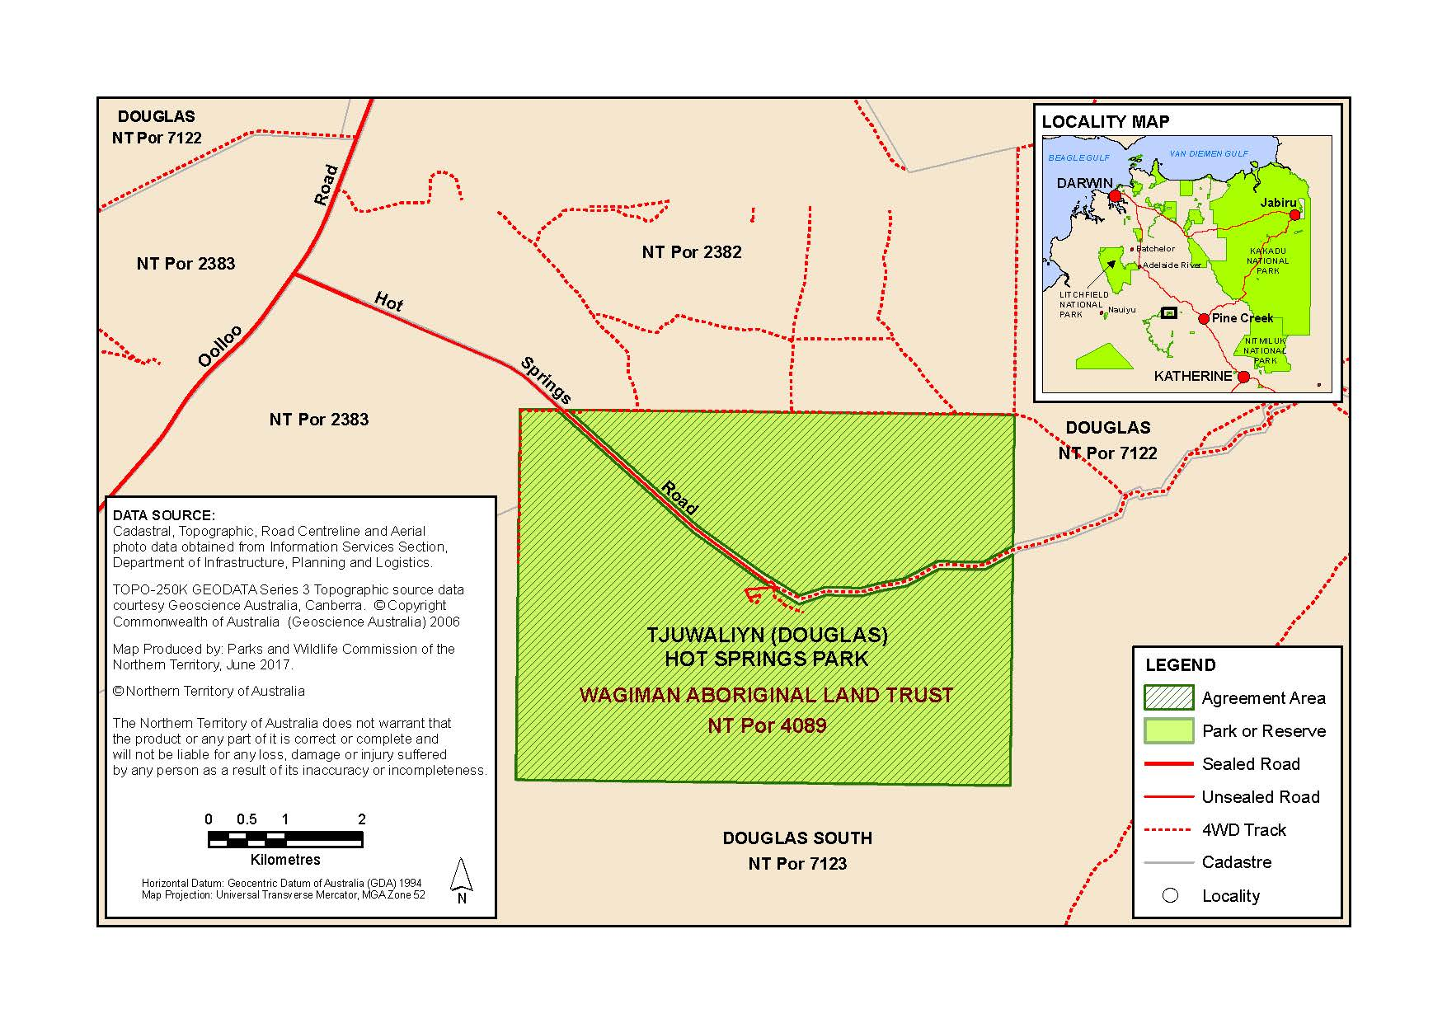
Schedule

Police Administration Act

Sale of Goods
Notice is hereby given that pursuant to Section 166 of the Police Administration Act, the following property as shown on the attached schedule has been in the possession of the Officer in Charge, Police Station, Peter McAulay Centre, for a period in excess of 3 months and this property will be sold or otherwise disposed of in a manner as determined by the Commissioner of Police, if after twenty-eight (28) days from the publication of this notice the property remains unclaimed.
John Atkin
Superintendent
Operational Support Directorate
24 January 2018
Exhibits Auction
Exhibit number | Item Description
461426/019  461426/021 | 2 x gold rings + 1 x pearl pendant  Gold necklace with pearl looking beads
498136/003  498136/001  498136/004 | 12 v jump starter and power pack  2 x Makita drills  4 x Altec Blue tooth speakers
459694/003 | Gold Chisel watch
494899/002 | Small silver ring with opal coloured and clear stones
494529/001 | 1 x silver (white gold?) eternity ring set with 5 small clear stone in claw setting.  1 x silver (white gold?) engagement ring set with single clear stone in basket setting.  1 x silver (white gold?) wedding ring
494529/002 | 2 x gold rings in a Prouds earring box. 1 x mens gold ring with two small clear cut stones set in rub over filigree design. 1 x gold ring with 6 s mall clear cut stones set in a hexagonal shape surrounding a single clear stone.
494529/003 | Single gold earring stud with square clear stone
494382/002 | Christyn Aidan gents watch
494091/001 | Silver Diesel gents watch
494659/001 | Casio G-Shock gent’s watch
499016/002 | $50.00
495132/002 | $0.50 (50 cents)
494940/002 | $0.10 (10 cents)
494743/002  494743/003 | $4.50  Various foreign coins
493686/002 | $12.80
493582/001/001 | $25.00
493514/002 | $2.00
493487/002 | $5.55
493423/002 | $18.05
493270/003 | $2.30
493204/002 | $11.05
461426/004  461426/012 | Mobile phone  Black LG phone
461426/009 | Black Telstra phone
461426/005  461426/006 | Black Microsoft phone  Black Microsoft phone
461654/015 | Apple iPhone 8
458098/006 | Black iPhone
495132/001 | Black wallet and contents
495047/001  495047/002 | Black Huawei mobile  Black Telstra mobile
495003/001 | Black Telstra mobile
494979/001 | Black Apple iPhone
494940/001 | Black wallet and contents
494899/001  484899/003 | White Telstra mobile  Black Samsung mobile
494864/001  494864/002 | Black Alcatel mobile  White Telstra mobile
494743/001 | Handbag
494624/001 | Black Telstra mobile
494622/001 | Black Samsung mobile
494618/001 | EFM battery bank for mobile
494614/001  494614/002 | Pink sequined purse  Digitech speaker
494534/001 | Black iPhone
494528/001 | Gold Samsung mobile
494457/001  494457/002  494457/003 | Red Telstra mobile  Black Telstra tablet  Silver iPad
494450/001 | Black Alcatel mobile
494415/001 | iPhone
494382/001 | Samsung tablet
494327/001  494327/002 | Gold iPhone  Black iPhone
494288/001  494288/002  494288/003 | White Telstra ZTE mobile  Blue iPod  Black Sony mobile
494041/001  494041/002  494041/003  494041/004 | Silver LG mobile  Black Alcatel mobile  Silver Telstra mobile  Gold Samsung mobile
494025/001 | White Samsung tablet
494024/001 | EFTPOS machine (portable)
493703/001 | Grey Telstra mobile
493686/001 | Gold Collette handbag and contents
493582/001 | Blue Ripcurl wallet and contents
493527/002  493527/004 | Bike rear basket  Rear wheel for MTB
493514/001 | Black wallet and contents
493512/001 | Black Samsung mobile
493769/001 | Silver iPhone
493487/001 | Blue Warehouse wallet and contents
493465/001  493465/002 | Black ZTE mobile  White Vodaphone mobile
493458/001 | Black iPhone
493456/001 | Black Samsung mobile
493423/001 | Black wallet and contents
493422/001  493422/002 | White Huawei mobile  Black Samsung mobile
493394/001 | White Samsung mobile
493287/001 | White HTC mobile
493286/001 | Black Telstra mobile
493285/001 | Grey Telstra mobile
493284/001 | Black Huawei mobile
493283/001 | Black Microsoft mobile
493282/001 | Black Telstra Alcatel mobile
493279/001 | Black Samsung mobile
493277/001 | Gold iPhone
493276/001 | Gold iPhone
493275/001 | Black Samsung mobile
493270/001  493270/002 | Adome floral design clutch purse  Bank cards
493266/001 | Black Samsung mobile
493251/001 | Silver MacBook Pro
493221/001 | Black Huawei mobile
493204/001  493204/003  493204/004  493204/005 | Black Billabong wallet and contents  Blue Flexfit cap  Pair black Globe shoes  Black Oakley sunglasses
493122/001 | Samsung mobile
495028/001 | Silver iPad
496186/001 | Lee Enfield .303 RBA S/N 69418
483512/004 | Lee Enfield .303 RBA S/N F1263
478095/001 | Stirling .22 RBA S/N 626970
487727/005 | Black Microsoft mobile phone
497063/001 | Brown Stoeger Arms SOU 12 g S/N 17142707
494256/001  494256/002 | Stirling SBS 12 S/N 35156  Winchester 94 30.30 RLA S/N 4456650
495102/001 | Red Repco MTB
495063/001 | Yellow scooter
494248/001 | Silver Mongoose MTB
494217/001 | Red Southern Star lady’s MTB
494165/001 | Blue/silver Everest MTB
494047/001 | Silver Repco MTB
494017/001 | White Repco MTB
493771/001 | Red Giant MTB
493619/01 | Purple Dunlop lady’s bike
493462/001 | Green Tourex MTB
493461/001 | White Southern Star MTB
493108/001 | Blue Cyclops BMX
493094/001 | Green Bella child’s bicycle
493094/002 | Black C-Cruiser scooter
493094/003 | White Merida MTB
493094/004 | Blue Cell MTB
474757/001 | Blue Holden Commodore wagon rego CB64IU

