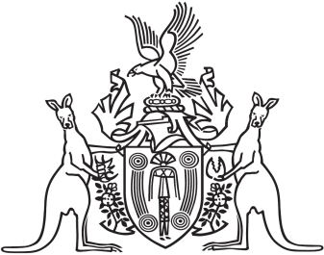
Northern Territory of Australia

Government Gazette
ISSN-0157-833X
No. S95 15 December 2017
Northern Territory of Australia

Architects Act
Northern Territory Architects Board
Appointment of Member
I, Natasha Kate Fyles, Attorney-General and Minister for Justice, under section 6(1C) of the Architects Act and with reference to sections 6(1B) and 7(1) of the Act, appoint Damien Francis Moriarty to be a member of the Northern Territory Architects Board.
Dated 7 December 2017
N. K. Fyles
Attorney-General and Minister for Justice

