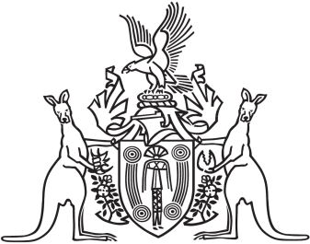

Northern Territory of Australia

Government Gazette

ISSN-0157-833X

No. S93 6 December 2017

Northern Territory of Australia

*Local Government Act*

Order to Open Road

I, Kaylene Maree Conrick, Chief Executive Officer of the Litchfield Council, as the delegate for the Litchfield Council:

(a) under section 185(1)(e) of the *Local Government Act*, and with reference to section 43 of the *Interpretation Act*, revoke the instrument titled "Order to Open Road" dated 31 October 2017 and published in *Gazette* S79 of 9 November 2017; and

(b) under section 185(1)(e) of the *Local Government Act*, declare that the land on Lot 7 of LTO 73/026 Hundred of Strangways shown on the map in thick black lines in the Schedule and being more particularly delineated on Survey Plan No. S2017/157 lodged with the Surveyor‑General is a road.

Dated 6 December 2017

K. M. Conrick

Chief Executive Officer

Land on Lot 7 73/026 Hundred of Strangways is a road