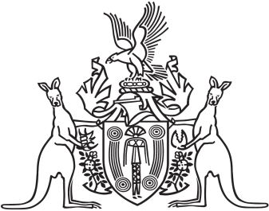
Northern Territory of Australia

Government Gazette
ISSN-0157-833X
No. S84 21 November 2017
Northern Territory of Australia

Supreme Court Amendment (Associate Judges) Act 2017
Commencement Notice
I, Vicki Susan O'Halloran, Administrator of the Northern Territory of Australia, under section 2 of the Supreme Court Amendment (Associate Judges) Act 2017 (No. 18 of 2017), fix 22 November 2017 as the day on which the Act commences.
Dated 17 November 2017
V. S. O' Halloran
Administrator
Northern Territory of Australia

Interpretation Act
Notification of Making of Rules under
Corporations Reform (Northern Territory) Act
I, Natasha Kate Fyles, Attorney-General and Minister for Justice, under section 63(3) of the Interpretation Act, give notice that the following rules
have been made under section 29 of the Corporations Reform (Northern Territory) Act:
Subordinate Legislation No. 31 of 2017: Corporations Law Amendment (Associate Judges) Rules 2017
Copies of the rules may be purchased from the Print Management Unit in the Department of Corporate and Information Services, by email request sent to pmu.ntg@nt.gov.au.
Dated 14 November 2017
N. K. Fyles
Attorney-General and Minister for Justice
Northern Territory of Australia

Interpretation Act
Notification of Making of Rules
under Supreme Court Act
I, Natasha Kate Fyles, Attorney-General and Minister for Justice, under section 63(3) of the Interpretation Act, give notice that the following rules have been made under section 86 of the Supreme Court Act:
Subordinate Legislation No. 32 of 2017: Supreme Court Amendment (Associate Judges) Rules 2017
Copies of the rules may be purchased from the Print Management Unit in the Department of Corporate and Information Services, by email request sent to pmu.ntg@nt.gov.au.
Dated 14 November 2017
N. K. Fyles
Attorney-General and Minister for Justice

