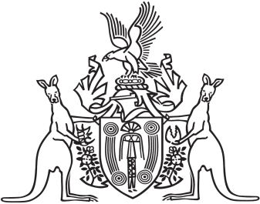
Northern Territory of Australia

Government Gazette
ISSN-0157-833X
No. S43 1 July 2017
Northern Territory of Australia

Medical Services Act
Amendment of Determination of Amount of
Remittance or Postponement of Charge or Expense
I, Natasha Kate Fyles, Minister for Health, under section 15(2) of the Medical Services Act and with reference to section 43 of the Interpretation Act, amend the instrument entitled "Determination of Amount of Remittance or Postponement of Charge or Expense" and dated 4 October 2016, as specified in the Schedule.
Dated 8 June 2017
N. K. Fyles
Minister for Health
Schedule

Schedule, entry for "Acute care same day/same day band 4"
omit
67.68%
insert
66.63%
Northern Territory of Australia

Medical Services Act
Amendment of Determination of
Charges for Medical Services
I, Natasha Kate Fyles, Minister for Health, under section 6(2)(b) of the Medical Services Act and with reference to section 43 of the Interpretation Act, amend the determination of charges for medical services dated 4 October 2016 and published in Gazette No. G42 on 19 October 2016, as specified in the Schedule.
Dated 8 June 2017
N. K. Fyles
Minister for Health
Schedule
(1) Schedule, entry for "Same day band 1"
omit
$246
insert
$254
(2) Schedule, entry for "Same day band 2"
omit
$281
insert
$291
(3) Schedule, entry for "Same day band 3"
omit
$326
insert
$337

