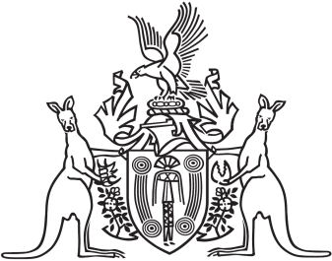
Northern Territory of Australia

Government Gazette
ISSN-0157-833X
No. S42 30 June 2017
Northern Territory of Australia

Health Services Act
Central Australia Health Service
Appointment of Service Administrator
I, Natasha Kate Fyles, Minister for Health, under section 66(1) of the Health Services Act, appoint Patricia Ann Miller to administer the Central Australia Health Service for 1 year on and from 1 July 2017.
Dated 30 June 2017
N. K. Fyles
Minister for Health
Northern Territory of Australia

Health Services Act
Top End Health Service
Appointment of Service Administrator
I, Natasha Kate Fyles, Minister for Health, under section 66(1) of the Health Services Act, appoint Paul Charles Wilford Tyrrell to administer the Top End Health Service for 1 year on and from 1 July 2017.
Dated 30 June 2017
N. K. Fyles
Minister for Health

