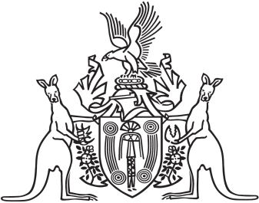
Northern Territory of Australia

Government Gazette
ISSN-0157-833X
No. S37 28 June 2017

Assent to Proposed Laws
His Honour the Administrator assented to the following proposed laws:
27 June 2017
Appropriation (2017-2018) Act 2017 (Act No 12 of 2017)
Revenue and Other Legislation Amendment Act 2017 (Act No 13 of 2017)
Liquor Legislation Amendment Act 2017 (Act No 14 of 2017)
National Electricity (Northern Territory) (National Uniform Legislation) Amendment Act 2017 (Act No 15 of 2017)
Yours sincerely
Marianne Conaty
Acting Clerk of the Legislative Assembly
Date 28 June 2017

