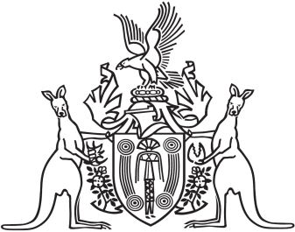
Northern Territory of Australia

Government Gazette
ISSN-0157-8324
No. G24 14 June 2017

General information
The Gazette is published by the Office of the Parliamentary Counsel.
The Gazette will be published every Wednesday, with the closing date for notices being the previous Friday at 4.00 pm.
Notices not received by the closing time will be held over until the next issue.
Notices will not be published unless a Gazette notice request form together with a copy of the signed notice and a clean copy of the notice in Word or PDF is emailed to gazettes@nt.gov.au
Notices will be published in the next issue, unless urgent publication is requested.

Availability
The Gazette will be available online at 12 Noon on the day of publication at http://www.nt.gov.au/ntg/gazette.shtml
Unauthorised versions of Northern Territory Acts and Subordinate legislation are available online at https://nt.gov.au/about-government/gazettes

Crown Lands Act
Notice of Temporary Closure of Reserve
Robbie Robbins Reserve
Notice is hereby given in accordance with the Crown Lands Act and Section 8 (b) of the Crown Lands (Recreation Reserve) Regulations, that Robbie Robbins Reserve will be closed to the public for the period 29 June to 1 July 2017 inclusive, for the purpose of conducting the Professional Bull Rides Event.
Dated 8th June 2017
John McLaren
Chairman
Board of Trustees
Northern Territory of Australia

Liquor Act
Conditions about Identification System
Exemptions from Conditions of Licence
I, Cynthia-Lee Bravos, Director-General of Licensing, under section 31A(8) of the Liquor Act, exempt a licence prescribed under section 31A(1)(b) of the Act from the conditions specified in section 31A(5)(a) and (b) of the Act from 15 June 2017 to 18 August 2017.
Dated 9 June 2017
C-L. Bravos
Director-General of Licensing

