Northern Territory of Australia

Government Gazette
ISSN-0157-8324
No. G21 24 May 2017

General information
The Gazette is published by the Office of the Parliamentary Counsel.
The Gazette will be published every Wednesday, with the closing date for notices being the previous Friday at 4.00 pm.
Notices not received by the closing time will be held over until the next issue.
Notices will not be published unless a Gazette notice request form together with a copy of the signed notice and a clean copy of the notice in Word or PDF is emailed to gazettes@nt.gov.au
Notices will be published in the next issue, unless urgent publication is requested.

Availability
The Gazette will be available online at 12 Noon on the day of publication at http://www.nt.gov.au/ntg/gazette.shtml
Unauthorised versions of Northern Territory Acts and Subordinate legislation are available online at https://nt.gov.au/about-government/gazettes

Northern Territory of Australia

Mineral Titles Act
General Reservation of Land
(RL 31583)
I, Alan Charles Holland, Senior Director Mines/Director Mineral Titles, as the delegate of the Minister for Primary Industry and Resources, under section 113(2) of the Mineral Titles Act:
(a) reserve the land in the locality of Lake Amadeus that is shown unshaded within the thick black lines on the plan in the Schedule from the following activities:
(i) exploration for minerals generally;
(ii) extraction of minerals generally;
(iii) exploration for extractive minerals;
(iv) extraction of extractive minerals; and
(b) give notice that:
(i) the reservation takes effect on the day this notice is published in the Gazette; and
(ii) the land specified in paragraph (a) is being reserved to protect Watarrka National Park; and
(iii) a person is not entitled to apply for the grant of any mineral title in relation to the land.
Dated 15 May 2017
A. C. Holland
Senior Director Mines/Director Mineral Titles
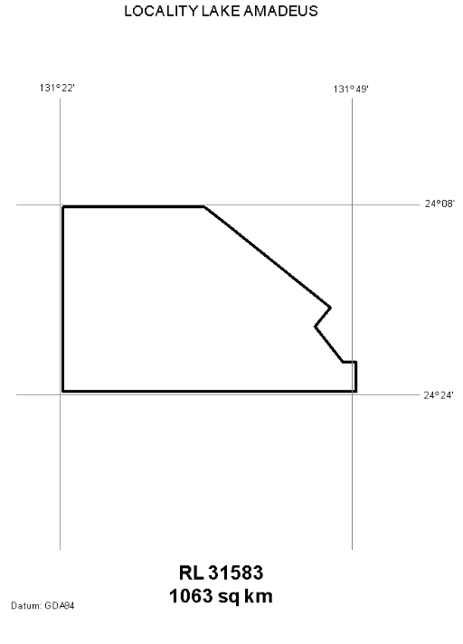
Northern Territory of Australia

Petroleum Act
Reservation of Blocks – RB 69
I, Vicki Lorraine Jackson, as the delegate of the Minister for Primary Industry and Resources, in pursuance of section 9(1) of the Petroleum Act, declare that the blocks within the area, shown on the plan in the Schedule are not to be the subject of a grant of an exploration permit or licence.
Dated 10 May 2017
V. L. Jackson
Executive Director, Energy
Schedule
SG52 Petermann Ranges
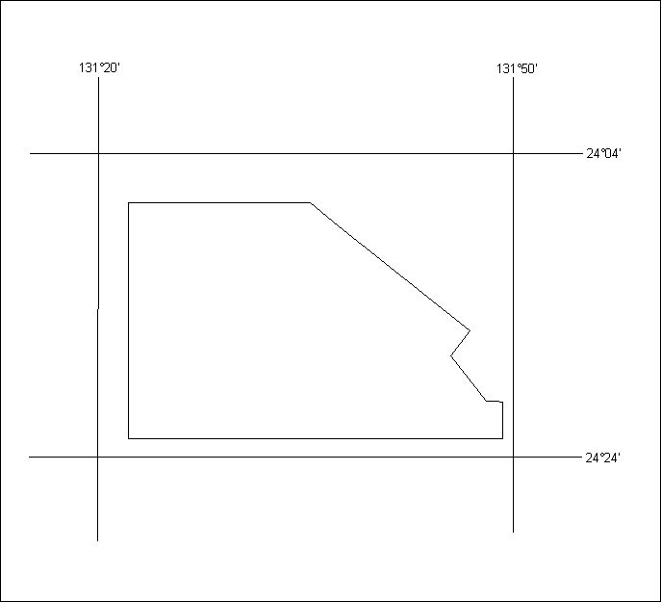
RB 69
1,063 Sq. Km
Datum: The displayed grid defining the 5’x 5’ blocks is AGD66 and coordinates shown are GDA94

Police Administration Act

Sale of Goods
Notice is hereby given that pursuant to Section 166 of the Police Administration Act, the following property as shown on the attached schedule has been in the possession of the Officer in Charge, Police Station, Peter McAulay Centre, for a period in excess of 3 months and this property will be sold or otherwise disposed of in a manner as determined by the Commissioner of Police, if after twenty-eight (28) days from the publication of this notice the property remains unclaimed.
Pauline Vicary
Superintendent
Tennant Creek Police Station
15 May 2017
Exhibit # | Item Description
431578/001 | Firearm – Savage – SN H361015
431578/002 | Ammo
431578/003 | Ammo
460821/001/001 | 74x .22 rounds, 2x .22 rounds
460821/002/001 | 10x .22 rounds, magazine, bolt
470181/001 | Black Mongoose MTB
473890/001 | Black ladies MTB

Notification of Subordinate Legislation
Notice is given of the making of the following subordinate legislation, effective from the date specified:
Subordinate Legislation | Commencement details | Empowering Act
Business Tenancies (Fair Dealings) Amendment Regulations 2017  (No. 9 of 2017) | Date of this Gazette | Business Tenancies (Fair Dealings) Act
Administration and Probate Amendment Regulations 2017  (No. 10 of 2017) | Date of this Gazette | Administration and Probate Act
Bushfires Management (General) Regulations  (No. 11 of 2017) | Date of this Gazette | Bushfires Management Act
For copies of legislation please direct your request to the Print Management Unit, email pmu.ntg@nt.gov.au or phone (08) 8999 6727.
Northern Territory of Australia
Local Government Act
I, Ms Kaylene Conrick, Chief Executive Officer of Litchfield Council, pursuant to Section 185 (1) (e) of the Local Government Act, declare that the land described in Schedule 1 below and depicted on the map in Schedule 2 is to be a road with consent of the owner(s).
Dated 16 May 2017
Ms K. Conrick
Chief Executive Officer, Litchfield Council
Schedule 1:
Part Section 2618 of S.90/244
Schedule 2:
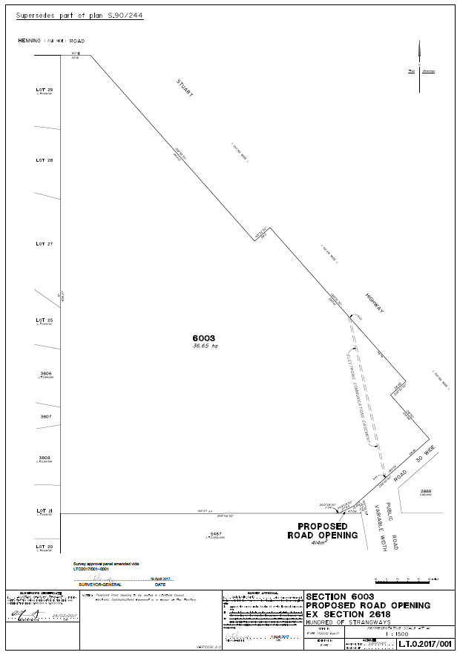
Northern Territory of Australia

Professional Standards Act
Notification
The South Australian Bar Association Inc Professional Standards Scheme
I, Natasha Kate Fyles, Attorney-General and Minister for Justice, under section 13(1) of the Professional Standards Act, give notice that:
(a) a scheme entitled "The South Australian Bar Association Inc Professional Standards Scheme" has been approved by the Professional Standards Council established by section 42 of the Professional Standards Act 2004 (SA); and
(b) copies of the scheme are available from the Council at Level 2 St James Centre, 111 Elizabeth Street, Sydney NSW 2000 and the Council’s website at www.psc.gov.au.
Dated 15 May 2017
N. K. Fyles
Attorney-General and Minister for Justice
Note
The scheme commences on 1 July 2017
Northern Territory
Associations Act
Notice of Intention to Dissolve Associations
I, John McLaren, as a delegate of the Commissioner, pursuant to section 65(4)(c) of the Associations Act, give notice that the associations specified in the Schedule will be dissolved after 3 months after the date of this notice unless cause to the contrary is shown.
Dated: 19 May 2017
J. McLaren
Delegate of Commissioner
Note: Enquiries should be directed to John McLaren at Licensing NT, Department of Attorney-General and Justice, Level 3, NAB House, 71 Smith Street, Darwin. Phone: (08) 8999 7824.
____________________________
Schedule
IA03048 | Larrakia Aboriginal Association Incorporated
IA02756 | Bicycle NT Incorporated
00976C | Barkly Region Alcohol & Drug Abuse Advisory Group Incorporated
_____________________________

Northern Territory
Associations Act
Notice of Dissolution of Associations
I, John McLaren, as a delegate of the Commissioner, pursuant to section 65(5) of the Associations Act, give notice that the associations specified in the Schedule are dissolved.
Dated: 19 May 2017
J. McLaren
Delegate of Commissioner
Note: Enquiries should be directed to John McLaren at Licensing NT, Department of Attorney-General and Justice, Level 3, NAB House, 71 Smith Street, Darwin. Phone: (08) 8999 7824.
____________________________
Schedule
00062C | RSPCA (N. T.) Incorporated
01593C | Council for Aboriginal Alcohol Program Services Incorporated
_____________________________

