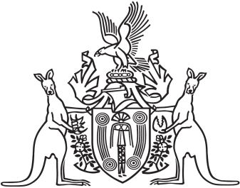
Northern Territory of Australia

Government Gazette
ISSN-0157-8324
No. G11 15 March 2017

General information
The Gazette is published by the Office of the Parliamentary Counsel.
The Gazette will be published every Wednesday, with the closing date for notices being the previous Friday at 4.00 pm.
Notices not received by the closing time will be held over until the next issue.
Notices will not be published unless a Gazette notice request form together with a copy of the signed notice and a clean copy of the notice in Word or PDF is emailed to gazettes@nt.gov.au
Notices will be published in the next issue, unless urgent publication is requested.

Availability
The Gazette will be available online at 12 Noon on the day of publication at http://www.nt.gov.au/ntg/gazette.shtml
Unauthorised versions of Northern Territory Acts and Subordinate legislation are available online at https://nt.gov.au/about-government/gazettes

Northern Territory of Australia

Strehlow Research Centre Act
Strehlow Research Centre Board
Appointment of Member
I, Lauren Jane Moss, Minister for Tourism and Culture, under section 14(1)(a) of the Strehlow Research Centre Act, appoint Edward Solomon Rontji to be a member of the Strehlow Research Centre Board for 3 years.
Dated 6 March 2017
L. J. Moss
Minister for Tourism and Culture

