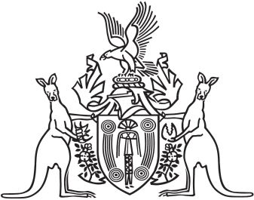
Northern Territory of Australia

Government Gazette
ISSN-0157-833X
No. S121 23 December 2016
Northern Territory of Australia

Interpretation Act
Notification of Making Rules
Under Local Court Act
I, Michael Patrick Francis Gunner, Chief Minister, acting for the Attorney-General and Minister for Justice, under section 63(3) of the Interpretation Act, give notice that the following rules have been made under section 48(1) of the Local Court Act:
Subordinate Legislation No. 45 of 2016: Local Court (General) Amendment Rules 2016
Copies of the rules may be purchased from the Print Management Unit in the Department of Corporate and Information Services, by email request sent to pmu.ntg@nt.gov.au.
Dated 22 December 2016
M. P. F. GUNNER
Chief Minister
acting for
Attorney-General and Minister for Justice

