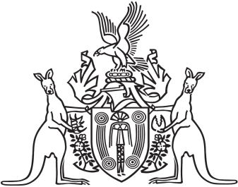
Northern Territory of Australia

Government Gazette
ISSN-0157-833X
No. S120 22 December 2016
Northern Territory of Australia

Public Sector Employment and Management Act
Appointment of Chief Executive Officer
I, Michael Patrick Francis Gunner, Chief Minister, under section 19A(1) of the Public Sector Employment and Management Act, appoint Jodie Elizabeth Ryan to be the Chief Executive Officer of the Department of the Chief Minister with effect on and from 19 December 2016.
Dated 15 December 2016
M. P. F. GUNNER
Chief Minister

