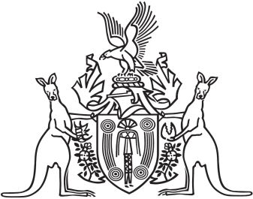
Northern Territory of Australia

Government Gazette
ISSN-0157-833X
No. S59 1 July 2016
Northern Territory of Australia

Justice and Other Legislation Amendment (Records of Depositions and Other Matters) Act 2016
Commencement Notice
I, John Laurence Hardy, Administrator of the Northern Territory of Australia, under section 2 of the Justice and Other Legislation Amendment (Records of Depositions and Other Matters) Act 2016 (No. 16 of 2016), fix the day on which this notice is published in the Gazette as the day on which that Act commences.
Dated 27 June 2016
J. L. Hardy
Administrator

