Brands in the NT
Branding cattle and horses is a clear way of identifying ownership of stock, and can also play an important role in disease control programs and chemical residue trace back programs. This is important to both consumers and producers, to maintain confidence in the safety and integrity of livestock products.
The Northern Territory Livestock Act and Regulations uses a three-letter brand system where one letter must be the letter "T" and a distinctive (symbol) brand system.
In any proceedings, proof that an animal is branded in accordance with the provisions of the Livestock Act with a registered brand is prima facie proof that the animal is the property of the owner of the registered brand.
A brand is registered to a person or company for use on a nominated NT property only.
Under NO circumstances are these brands to be used in any other State or Territory, or on any other property. This means the branding iron can only be used by the registered owner (or their representative) on the registered NT property (as stated on NT Brands Register – https://nt.gov.au/ntbrands on your Branding Certificate/s).
To legally use a brand in the Northern Territory the brand must be registered in the NT and comply with the Livestock Act and Livestock Regulations.
Please ensure you discuss your branding requirements with the Livestock Biosecurity Officer in your Region, prior to submitting application/s.
All forms can be downloaded from the NT.GOV.AU website www.nt.gov.au/industry/agriculture/livestock

Registering a Three-Letter Brand
It is compulsory to brand cattle before they are moved off a property or are sold (unless they are less than 8 months of age).
To legally use a brand in the NT the brand must be registered in the NT and comply with the Livestock Act and Livestock Regulations.
Brands can also be used on horses, buffalo and camel but it is not compulsory.
Only one 3-letter brand can be registered to a particular person or company for use on a specified property.
Your first choice of a three-letter Brand is not automatically approved, surrounding properties must be checked to ensure none are similar or previously registered in the same region.
Submit an Application for 3 Letter Brand for Horses, Cattle and Buffalo to the Registrar, ensuring:
- Applicant must be at least 18 years of age; and
- Applicant must choose three (3) x 3-letter brands from the Three-Letter Brands Available for Registration in the NT list; and
- Applicant must specify the property on which the 3-letter brand will be used; and
- Applicant must specify the livestock and branding position/s to which the brand will be applied; and
- Must be the owner of the specified property; or
- Must have permission of the owner of the specified property. If you are not the registered owner of the land, you must have the owner of land complete the Owner's Permission to Use Run form; and
  - All registered owners of the land must sign the form.
  - Additional documentation is required if the application is for use on Aboriginal Land Trust (ALT).
- Payment must accompany Application.

Construction and size of 3-letter brands
- All 3 letters of a 3-letter brand must be constructed on 1 handle; and
- Each letter must be between 4cm and 8cm in both height and width; and
- The imprint surface of the irons is to be no more than 4mm wide and no less than 3mm wide. The letters must also be ‘clean joined’ print and not ‘fancy’ or ‘broken’ print.
- Refer to Factsheet - NT requirements for making branding irons

Registering a Distinctive (symbol) Brand
Submit an Application for Distinctive (Symbol) Brand for Horses and Cattle to the Registrar, ensuring:
- A 3-Letter Brand must be held before applying for distinctive (symbol) brand; and
- Registered owner/s of 3-Letter Brand must sign the application for distinctive (symbol) brand; and
- Applicant can register up to 3 distinctive (symbol) brands registered in connection with the 3-letter brand. When registered, it may be used in addition to, or instead of, a 3-letter brand; and
- A symbol brand must be 2 letters with a symbol - over, under, vertical. Single letters are no longer accepted; and
- A symbol brand cannot be 3 equal sized letters or characters and not be a 3 character brand registered in another State; and
- A symbol brand must be unique to the Northern Territory and if in the opinion of the Registrar or Delegate of the Registrar, a distinctive (symbol) brand produced from the chosen design would not be clearly legible the distinctive brand will not be registered; and
- Applicant must draw a full scale image of the distinctive (symbol) brand required; and
- Applicant must specify the livestock and branding position/s to which the brand will be applied; and
- Payment must accompany Application.

Construction and size of Distinctive (symbol) brands
- A distinctive (symbol) brand shall not be less than 4cm high and wide or no more than 12cm high or wide.
- The imprint surface of the irons is to be no more than 4mm wide and no less than 3mm wide.
- It is recommended that any adjacent lines of a distinctive brand be at least 20mm apart to avoid blotching.
- Refer to Factsheet - NT requirements for making branding irons

Cross branding
Cross branding Cattle after purchase is not mandatory in the NT, however if livestock are cross branded correctly it assists in proving ownership.

Requirement to submit an impression of brand
The registered owner of a 3-letter brand and a Distinctive (symbol) brand must, within 60 days after receiving the certificate of registration for the brand, give the Registrar an impression of the brand made on linen, canvas, cardboard, leather or other material acceptable to the Registrar.
This means once you have had your branding iron made, you must make a physical imprint/impression for inspection by a delegate of the Registrar (your Livestock Biosecurity Officer).
The Brand owner/s will then be notified in writing whether the imprint meets with the Livestock Act and Regulations.
Please note: Certificate of Registration of Brand is not approval of Brand imprint.

Brand to be consistent with registered design
The registered owner of a brand commits an offence if the instrument used to apply the brand to livestock does not produce a brand consistent with the design or description in the certificate of registration for the brand.
This means once your branding iron is made, if it is different to the design on your Certificate of Registration, then you must advise your Livestock Biosecurity Officer as soon as possible, as you will need to have your design amended in the NT Brands Register (redraw so that your Certificate matches your actual branding iron).

Registering an Earmark
A 3-Letter Brand must be held before applying for an Earmark.
Earmarks are not compulsory they are used to aid identification of Cattle.
Earmarks can be registered for use on one or both ears.
No earmark shall be made upon the ear of any stock if such stock are already earmarked (Livestock Regulations 27).
All earmarks must be made by pliers and these marks are only for use in conjunction with the registered brand and locality for which they are registered.
Applicants choose from the NT Code index of Registered Earmarks for Use with Registered Brands in the NT and the preferred position/s on the beast’s ear.
Code Index of Registered Earmarks for Use with Registered Brands in the NT
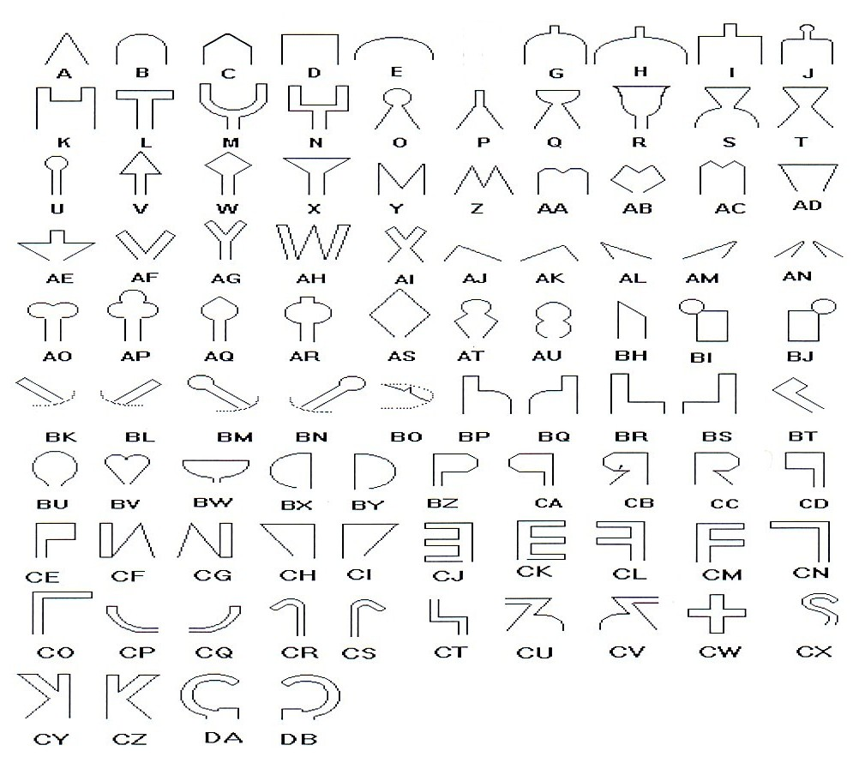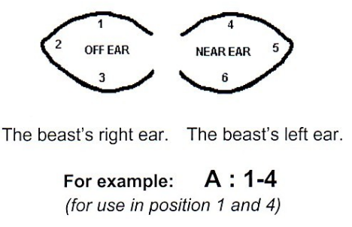
Submit an Application for Earmark for Cattle to the Registrar, ensuring:
- A 3-Letter Brand must be held before applying for and Earmark; and
- Registered owner/s of 3-Letter Brand must sign the application for earmark for cattle; and
- Applicant selects 3 Earmark Codes and position from the NT Code index of Registered Earmarks for Use with Registered Brands in the NT;
- Payment must accompany Application.

POSITION OF BRANDS ON HORSES  Near Shoulder = NS  Near Quarter = NQ  Off Shoulder = OS  Off Quarter = OQ | POSITION OF BRANDS ON CATTLE  Near shoulder = NS  Near rump, hip or thigh = NRHT  Off shoulder = OS  Off rump, hip or thigh = ORHT

Transfer Brand to new owner
Brands are not transferred automatically by a property sale or by a will.
When a 3-letter brand is transferred, the distinctive (symbol) brand/s and/or Earmark associated with it are automatically included in the transfer, unless otherwise stated by the registered owner of the Brand.
Examples of when the ownership of a brand should change are:
- an agreement is made in the sale contract to transfer the brand to the new owners; or
- change of name by marriage; or
- notification of death; or
- the company that owns the registered brand is dissolved; or
- a part owner is added or removed.
Submit an Application for Transfer of Brand to the Registrar, ensuring:
- Current Registered owner is correct – Solicitors usually conduct a NT Brands Register Search to obtain the current and accurate information. Alternatively, search NT Brands Register - https://nt.gov.au/ntbrands ; and
- New Owner/s details are correct, if company please include ABN or ACN; and
- Transferor – all current registered owners must sign the application; and
- Transferee – all new Owner/s must sign the application; and
- If the owner is a company, the signature of director/s is required, or the signature of a sole director. They must state their capacity on the application; or
- If an owner is deceased, the executor or administrator of their estate must sign the form, stating their capacity as executor or administrator. Copy of death certificate is also required; and
- Must be the owner of the specified property; or
- Must have permission of the owner of the specified property. If you are not the registered owner of the land, you MUST have the Owner of the land complete the Owner's Permission to Use Run; and
  - All registered owners of the land must sign the form.
  - Additional documentation is required if the application is for use on Aboriginal Land Trust (ALT).
- Payment must accompany Application.

Request to Change the Run form
If you are using your Brand on a different property/run (to where it is registered for use on) you MUST complete the Request to Change the Run form.
Changing the run/property is not automatically approved, surrounding properties must be checked to ensure none are similar or previously registered in the same region.
If you are not the Owner of the property/run, you MUST have the Owner/s of the land complete the Owner's Permission to Use Run form; and
- All registered owners of the land must sign the form.
- Additional documentation is required if the application is for use on Aboriginal Land Trust (ALT).
If you have original Certificate/s, please send them in with the above paperwork for amending. Note: All Certificates must be amended (ie Brand Cert, Earmark Cert, Distinctive Cert or Transfer Cert).
If you have lost or misplaced Certificate/s, then a Replacement Certificate must be issued, please complete the payment section on the Request to Change the Run form.

Fully completed forms can be sent:
NTPIC.Brands@nt.gov.au |  | Registrar - Brands  Livestock Biosecurity, BAW,  GPO Box 3000, Darwin NT 0801
Please note: Fully completed applications are processed within 30 days

NT Brands Register search and NT PIC search
- NT Brands Register - https://nt.gov.au/ntbrands Allows Searches by Brand or Owner or Property Name.
- Property Identification Code (PIC) search - https://nt.gov.au/pic-list

Brands for use on Aboriginal Land Trust (ALT)
To register a brand on Aboriginal Land Trust (ALT) you must first discuss your proposal with either the Northern Land Council (NLC) or Central Land Council (CLC). These Land Councils act as a body corporate established pursuant to, and has statutory functions under, the Aboriginal Land Rights Act and provides administrative support to the Land Trust.
You will most likely be required to enter into a legal agreement with the Land Council and the Aboriginal Land Trust for example; licence agreement, grazing or mustering agreement, Section 19 Land Use Agreement, lease etc. Once all parties involved have agreed and signed the appropriate agreement, then paperwork can be submitted in order to register an NT brand on the ALT.
NT brands options may include:
- Special permission to use an existing registered NT brand temporarily on ALT (for short term agreements i.e. less than 3 months); or
- Register NT brand for the period of the agreement as per Land Council conditions and/or restrictions. May include an Application for Three-letter Brand or Request to Change the Run.

The applicant must submit appropriate paperwork:
- Request for Special Permission (to use existing brand off registered run) on ALT; or
- Application for 3 Letter Brand (register a new 3ltr brand); or
- Request to Change the Run (move an existing brand);
- Together with: evidence that the appropriate agreement with NLC or CLC has been signed off stating the terms of the agreement (period and any conditions / restrictions).
And
The NLC or CLC must submit appropriate paperwork –
- Owner’s Permission to Use Run on ALT form to be completed by NLC or CLC authorised representative, together with
- NLC or CLC legal advisor/solicitor to attach letter confirming the terms of the agreement (period of and conditions/restrictions) that the Land Council consents and has no objections to this application being approved by Registrar and processed as per Livestock Act and Regulations; and
- NLC or CLC to supply a map of the area in which the brand is to be registered for use on.
Northern Land Council – Ph: 08 8920 5100 | Fax: 08 8920 5177
Central Land Council – Ph: 08 8951 6211 | Fax: 08 8953 4343
Note: Applicant must have signed agreement in place with the Land Council plus follow instructions as listed. Without supporting documentation from NLC or CLC your application/request will be returned unprocessed - payment won’t be accepted.

Certificates
As soon as practicable after registering a brand or earmark, the Registrar must issue to the registered owner a:
- Certificate of Registration of Three-letter Brand  - Certificate of Registration of Distinctive Brand | - Certificate of Transfer of Brand  - Certificate of Registration of Earmark
These certificates are official legal documents and it is the registered owners’ responsibility to ensure all information written on the above certificate/s is accurate and abided by, and ensure their safekeeping.
Should the registered owner wish to make any future changes regarding their brand/s or earmark registration (ie change name by marriage, change the run, change the branding or earmark position/s), then the original certificate/s will need to be returned and amended by LISA / Brands Clerk.
If certificate/s are lost or misplaced, then a Replacement Certificate can be issued at a cost.

Cancellation of brands
If the brand is no longer being used, then the registered owner/s of the brand may choose to cancel the brand by completing Application for Cancellation of Brand. All registered owners of the brand must sign the form.
2 and 3 below applies.
Cancellation by Registrar
1. The Registrar may decide to cancel the registration of a three-letter brand in any of the following circumstances (Livestock Regulation 14):
a) if the registered owner of the brand is also the owner of the registered property for the brand – the registered owner:
- Has sold or rented out the registered property
- Has not applied to the Registrar to register the transfer of the brand to the purchase or tenant of the property.
b) If the registered owner of the brand is not also the owner of the registered property for the brand, the registered owner no longer has the permission of the registered property owner to use the brand on the property.
c) If the registered owner of the brand is deceased and the administrator or executor of the owner’s estate has not, within 12 months after the date of death, applied for the registration of the brand to continue.
d) If the registered owner of the brand is found guilty of an offence against a provision of this Division or Division 2.
e) If to the best of the Registrar’s knowledge and belief, the brand has not been used for at least three years.
f) if a notice under this part is sent by post to the last known address is undeliverable;
g) If the registered owner of the brand fails or refuses to comply with a notice that
- is sent to the owners last known address; and
- requires the owner to reply in 60 days of the date of the notice.
h) If there is any other reasonable ground for the cancellation.
2. If the registration of a three-letter brand is cancelled, then it includes any earmarks, distinctive (symbol) brands, or distinctive numbers, registered for use in connection with that brand (Livestock Act 12(3)).
3. Once cancelled, a three-letter brand may not be re-registered again for five years or more, from date of cancellation (Livestock Act 12(4)).

If you are selling or purchasing a property
In the first instance, we would suggest conducting a search to confirm what NT Brands are registered for use on the property/parcel of land. You can do this yourself by using the NT Brands Register search - https://nt.gov.au/ntbrands or complete online Request a search of the NT Brands Register – Click Start now.
While the sale of a property may include the stock, the brand is not automatically transferred to the new owners.
Note: when a 3-letter brand is transferred, the distinctive (symbol) brand/s and/or Earmark associated with it are automatically included in the transfer, unless otherwise stated by the registered owner of the Brand.
One of the following options are required to be completed upon sale of a property:
- If an agreement is made in the sale contract to transfer the brand to the new owners, an application to Transfer Brand must be lodged with the Registrar; or
- If the registered owner of the brand no longer wishes to use the brand, it may be cancelled. An Application for Cancellation of Brand must be lodged with the Registrar; or
- If registered owner of the brand wishes to keep the brand, but move it to a new property, a Request to Change of Run must be lodged with the Registrar, together with original certificate/s for amending. If not registered owner of new property, Owners Permission to Use Run form is required and must be lodged with the Registrar; or
- If other brands are registered for use on property/parcel of land, then the new property/land owner/s will need to complete Owners Permission to Use Run, and lodge with the Registrar; or
- If the new owner of the land does not want other brands registered for use on their property/parcel of land (eg continue agreements previous owner/s may have had) then the new Owner must complete Owners Permission to Use Run - REVOKED form and lodge with the Registrar.

Other documents relating to the sale of a property
- Due Diligence requests - associated with the sale of pastoral properties with livestock
- Upon Sale of a Property - Brand/s & PIC
- NT Brands Register - Search Request form - Complete this form if you wish LISA / Brands Clerk to conduct a full NT Brands Search for you (payment details on bottom of form).

Changing requests and Cancellation forms
- Request to Change/Add Branding position/s
- Request to Change Earmark position (not code)
- Application for Cancellation of Brand
- Application for Cancellation of Distinctive (symbol) Brand only
- Application for Cancellation of Registered Earmark only
- Owner's Permission to Use Run - Revoked

Factsheets
- Brands for use on Aboriginal Land Trust (ALT)
- Branding Iron Requirements
- Branding Positions for Cattle and Horses
- Distinctive (symbol) Brands in the NT
- Earmarking of Cattle and Buffalo with Registered Earmarks in the NT

Update your Contact details
NT Brands Register - Update your Contact details

Notification to the Registrar
Owners of brands must give notification to the Registrar in the following events:
- No longer use Brand on registered run/property  - No longer have owners permission to use run  - No longer uses branding iron - Cancellation  - Want to use Brand on a different run/property  - Change of branding position | - Change of name by marriage  - Notification of death  - Transfer Brand to a new owner  - Change of contact address.

Special Permission (to use branding iron off registered run)
The Registrar may grant Special Permission to brand cattle (off registered run) for a short period of time (ie calves on agistment, newly purchased etc), which means permission is given to the Registered Owner/s of the Brand to use Branding Iron on another property, very short term.
Instructions:
1. Discuss your proposed branding needs with your Regional Livestock Biosecurity Officer (RLBO).
2. Fill in the request for special permission to brand cattle off registered run Request for special permission to brand cattle off registered run
3. Get the property or land owner to fill in the Owners permission to use run (to use branding iron temporarily on run)
4. Submit the request and supporting documentation to the regional livestock biosecurity officer by emailing ntnlis@nt.gov.au and await written authorisation.
If your request is approved, the registrar will email authorisation back to the owner of the brand, the owner of the temporary run and the regional livestock biosecurity officer.

Special Permission (to move unbranded cattle)
The Registrar may grant Special Permission to move unbranded cattle. You must discuss with your Livestock Biosecurity Officer to see if your circumstances warrant special permission under Livestock Regulations - Division 2 Offences relating to unbranded cattle – Regulation 58 Owner must not hand over unbranded cattle for travel – authorisation from the Registrar 58(2).

General notes
- Unbranded cattle, means cattle of at least 8 months of age that have not been branded.
- Owner must not hand over unbranded cattle for travel A person in charge of travelling cattle shall ensure that all animals over the age of eight months in the mob are branded. (Livestock Regulations 58(1)(a) & (b).
- Person in charge must not include unbranded cattle The person in charge of travelling livestock commits an offence if any of the livestock are unbranded cattle (Livestock Regulations 59(1)).
- No transaction relating to unbranded cattle A person must not sell, give away, exchange or receive travelling livestock that are unbranded cattle. (Livestock Regulations 60(1)).
Branding of other travelling stock (ie. buffalo, camels, horses) is optional.
- Brands to be permanent
Brands shall be made and impressed in a manner which so far as is practicable is clear, legible and permanent (Livestock Regulation 22(1)).

Branding cattle – a mandatory requirement
Under current Northern Territory (NT) legislation, all cattle MUST be branded before being moved off a property or sold, unless they are less than eight months of age. To legally use a brand in the NT, it must be registered in the NT and comply with the Livestock Act (2008) and Livestock Regulations (2009).

Branding is a clear way of identifying ownership of stock. Although not legally required, it is recommended that purchased cattle are cross branded correctly to provide evidence of ownership.

The first brand must be applied in the position specified on the certificate of registration. Subsequent brands can be applied on the near or off side of the shoulder or rump, hip or thigh. According to the Livestock Regulations, it is an offence to apply a brand that is not clear, legible and permanent.

A brand is registered to a person or company for use on a nominated property. This means only the registered owner or their representative can use the branding iron on the registered property. Note: Brands can be registered for use on horses and buffalo, however they are not required for movement in the NT.
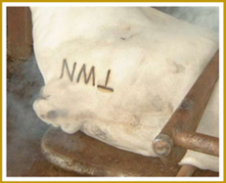
Branding tips
- Brands MUST be applied so they are clear, legible and permanent to the livestock.
- When using hot iron branding,
  - Do not overheat the iron. Red-hot irons can ignite the hair, causing blemishes on the brand.
Clear Brand
  - Do not use an iron that is too cool. Cool irons are held on for too long, cooking the total area
leaving an unreadable brand.
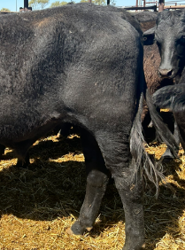
  - Do not brand when the hide is wet. Wet-branding results in scalding.
  - Replace worn, thin-edged branding irons, as these can burn too deeply, causing crusting or
blotching and can make the brand too fine to read easily.
- Freeze branding is an alternative method to hot iron branding.
- Restrain stock securely for branding. A squeeze crush is ideal for hard-to-handle adult stock.
- To ensure clear visibility for livestock inspectors at saleyards or authorised officers, shave the hair or wet around the branding areas.

More information
For more information on livestock brand and identity, visit:
https://nt.gov.au/industry/agriculture/livestock-and-animals/brand-and-identify-livestock

For more information on best practice husbandry in beef cattle, visit: https://www.mla.com.au/globalassets/mla-corporate/research-and-development/program-areas/animal-health-welfare-and-biosecurity/mla-guide-to-best-practice-husbandry-in-beef-cattle_final.pdf
Fees payable for 2026-27 Fees subject to change 1 July each year
Brand Applications
Application for Three-Letter brand $149
Application for Distinctive (symbol) brand $149
Application for Earmark $111
Application for Transfer of brand $74
Additional services and charges
Replacement Certificate for lost or damaged certificate $74
NT Brand Search (includes GST) $53.12
Waybill Books (includes GST) $27

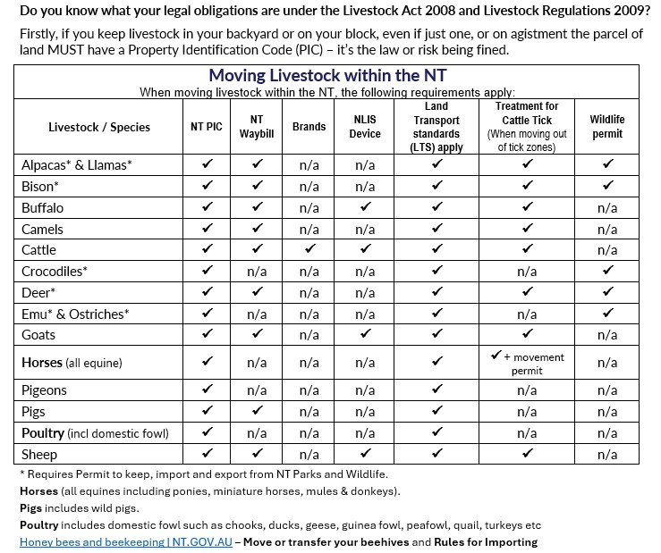

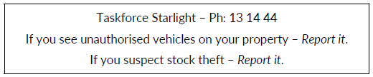

Farm Biosecurity - https://www.farmbiosecurity.com.au/
Farm Biosecurity Action Planner - https://www.farmbiosecurity.com.au/toolkit/planner/
Gate Sign - https://www.farmbiosecurity.com.au/toolkit/gate-signs/

