Mineral Titles Act 2010
NOTICE OF LAND CEASING TO BE A MINERAL TITLE AREA
Title Type and Number: | Exploration Licence 33601
Area Ceased on: | 15 March 2026
Area: | 1 Block, 1.38 km²
Locality: | BATCHELOR
Name of Applicant(s)/Holder(s): | 100% HOWARD Michael James
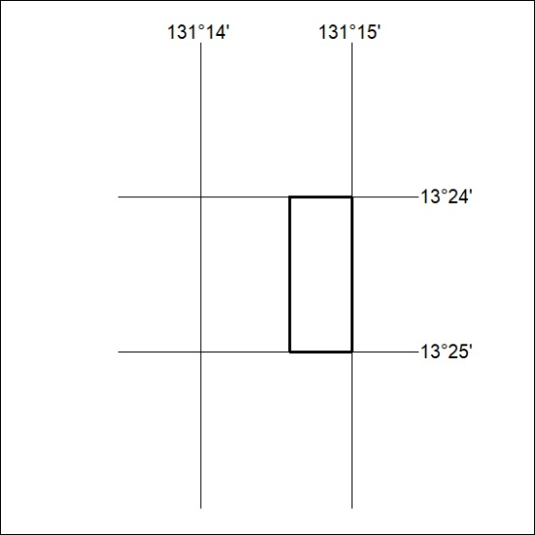

137/26

Mineral Titles Act 2010
NOTICE OF LAND CEASING TO BE A MINERAL TITLE AREA
Title Type and Number: | Exploration Licence 33644
Area Ceased on: | 23 April 2026
Area: | 8 Blocks, 19.37 km²
Locality: | DOREEN
Name of Applicant(s)/Holder(s): | 100% CHALCO RESOURCES PTY LTD [ACN. 648 662 346]
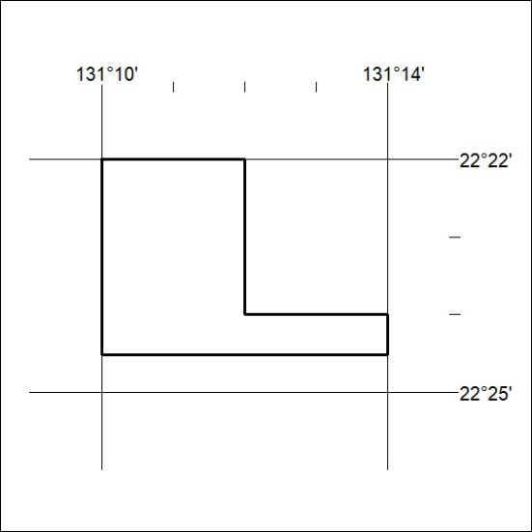

138/26

Mineral Titles Act 2010
NOTICE OF LAND CEASING TO BE A MINERAL TITLE AREA
Title Type and Number: | Exploration Licence 33646
Area Ceased on: | 23 April 2026
Area: | 11 Blocks, 34.11 km²
Locality: | YUENDUMU
Name of Applicant(s)/Holder(s): | 100% CHALCO RESOURCES PTY LTD [ACN. 648 662 346]
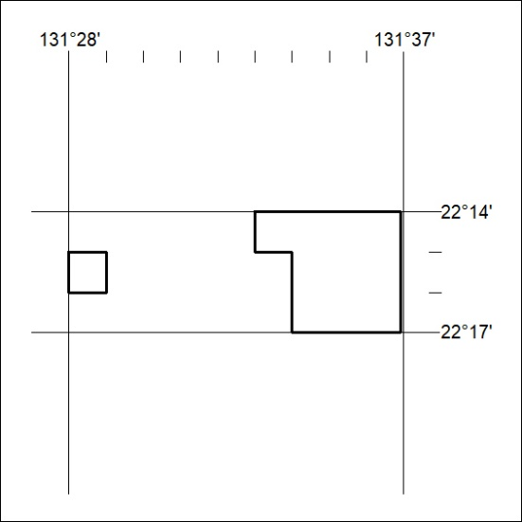

139/26

