Mineral Titles Act 2010
NOTICE OF LAND CEASING TO BE A MINERAL TITLE AREA
Title Type and Number: | Exploration License 33596
Area Ceased on: | 03 April 2025
Area: | 42 Blocks, 130.19 km²
Locality: | VICTORY
Name of Applicant(s)/Holder(s): | 100% TERRALITH METALS PTY LTD [ACN. 669 527 360]
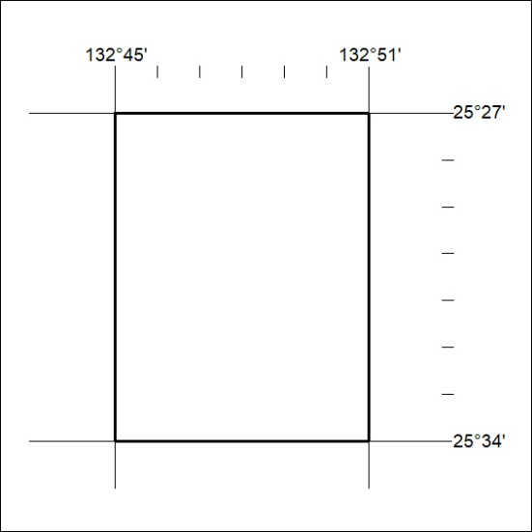

241/25

Mineral Titles Act 2010
NOTICE OF LAND CEASING TO BE A MINERAL TITLE AREA
Title Type and Number: | Exploration Licence 33597
Area Ceased on: | 03 April 2025
Area: | 24 Blocks, 74.69 km²
Locality: | EBENEZER
Name of Applicant(s)/Holder(s): | 100% TERRALITH METALS PTY LTD [ACN. 669 527 360]
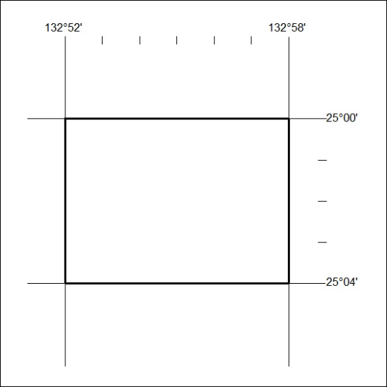

242/25

Mineral Titles Act 2010
NOTICE OF LAND CEASING TO BE A MINERAL TITLE AREA
Title Type and Number: | Exploration License 33598
Area Ceased on: | 03 April 2025
Area: | 32 Blocks, 97.51 km²
Locality: | PALM VALLEY
Name of Applicant(s)/Holder(s): | 100% TERRALITH METALS PTY LTD [ACN. 669 527 360]
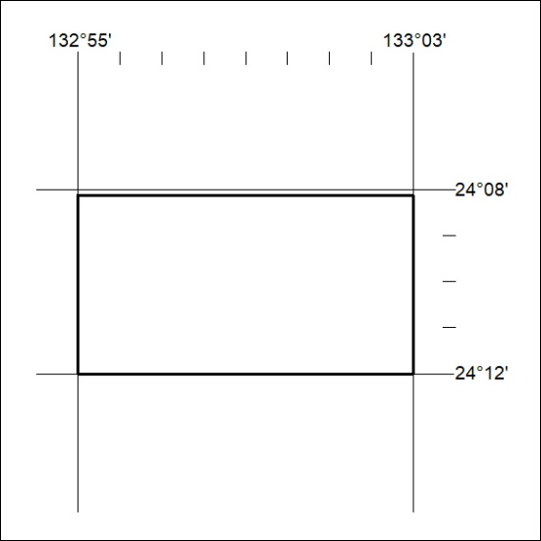

243/25

Mineral Titles Act 2010
NOTICE OF LAND CEASING TO BE A MINERAL TITLE AREA
Title Type and Number: | Exploration Licence 33599
Area Ceased on: | 03 April 2025
Area: | 18 Blocks, 56.37 km²
Locality: | PEACHY
Name of Applicant(s)/Holder(s): | 100% TERRALITH METALS PTY LTD [ACN. 669 527 360]
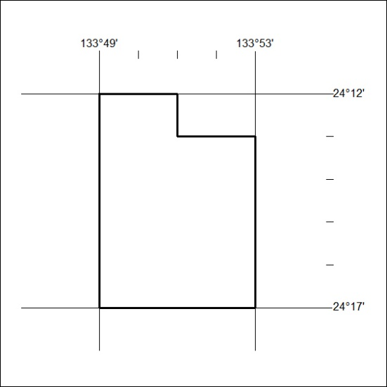

244/25

Mineral Titles Act 2010
NOTICE OF LAND CEASING TO BE A MINERAL TITLE AREA
Title Type and Number: | Exploration License 33600
Area Ceased on: | 03 April 2025
Area: | 25 Blocks, 78.43 km²
Locality: | SANTA TERESA
Name of Applicant(s)/Holder(s): | 100% TERRALITH METALS PTY LTD [ACN. 669 527 360]
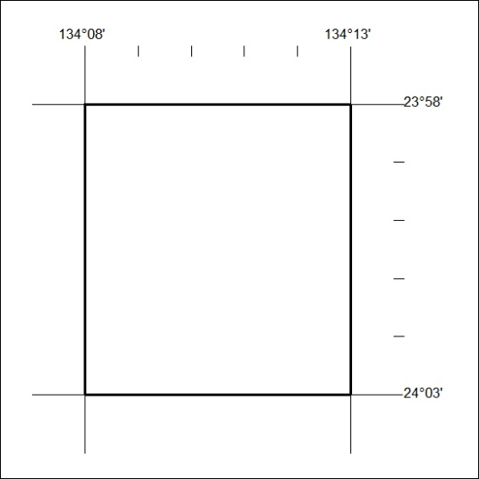

245/25

