Mineral Titles Act 2010
NOTICE OF LAND CEASING TO BE A MINERAL TITLE AREA
Title Type and Number: | Exploration Licence 33606
Area Ceased on: | 19 March 2025
Area: | 250 Blocks, 789.52 km²
Locality: | NONGRA
Name of Applicant(s)/Holder(s): | 100% IGO NEWSEARCH PTY LTD [ACN. 142 192 701]
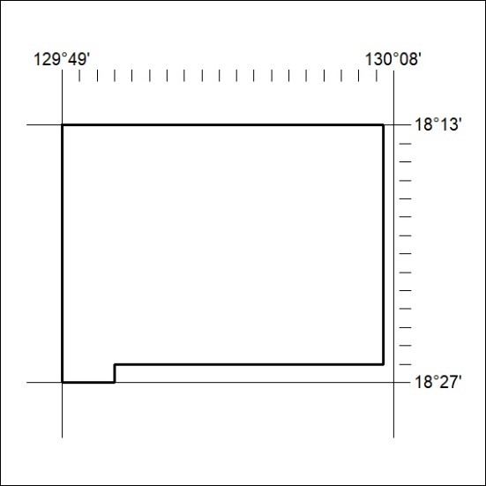

109/25

Mineral Titles Act 2010
NOTICE OF LAND CEASING TO BE A MINERAL TITLE AREA
Title Type and Number: | Exploration Licence 33607
Area Ceased on: | 19 March 2025
Area: | 250 Blocks, 783.77 km²
Locality: | WARE
Name of Applicant(s)/Holder(s): | 100% IGO NEWSEARCH PTY LTD [ACN. 142 192 701]
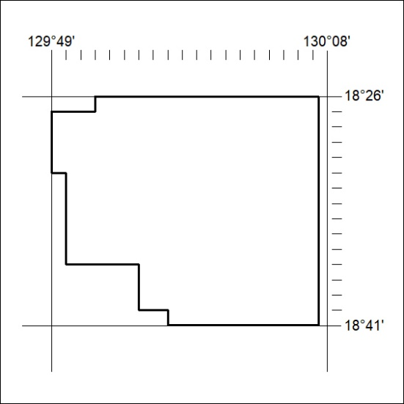

110/25

Mineral Titles Act 2010
NOTICE OF LAND CEASING TO BE A MINERAL TITLE AREA
Title Type and Number: | Exploration Licence 33619
Area Ceased on: | 19 March 2025
Area: | 250 Blocks, 815.37 km²
Locality: | NONGRA
Name of Applicant(s)/Holder(s): | 100% IGO NEWSEARCH PTY LTD [ACN. 142 192 701]
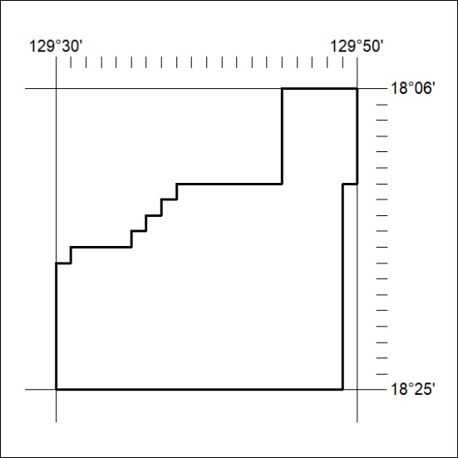

111/25

Mineral Titles Act 2010
NOTICE OF LAND CEASING TO BE A MINERAL TITLE AREA
Title Type and Number: | Exploration Licence 33620
Area Ceased on: | 19 March 2025
Area: | 250 Blocks, 814.00 km²
Locality: | WARE
Name of Applicant(s)/Holder(s): | 100% IGO NEWSEARCH PTY LTD [ACN. 142 192 701]
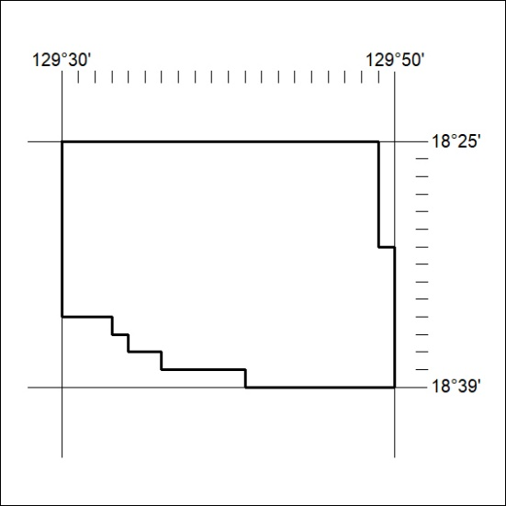

112/25

Mineral Titles Act 2010
NOTICE OF LAND CEASING TO BE A MINERAL TITLE APPLICATION AREA
Title Type and Number: | Exploration Licence 33639
Area Ceased on: | 19 March 2025
Area: | 45 Blocks, 143.03 km²
Locality: | YUENDUMU
Name of Applicant(s)/Holder(s): | 100% NORTH TENNANT MINERALS PTY LTD [ACN. 654 828 912]
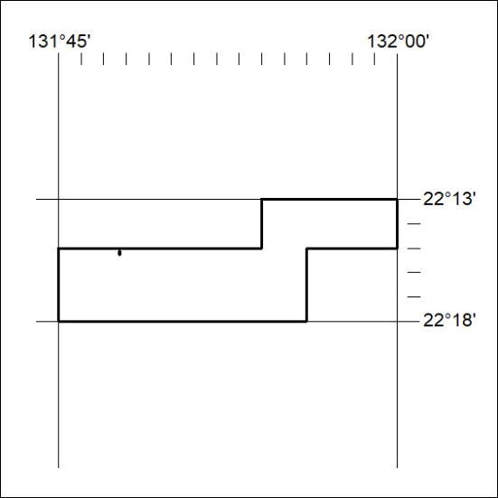

113/25

Mineral Titles Act 2010
NOTICE OF LAND CEASING TO BE A MINERAL TITLE APPLICATION AREA
Title Type and Number: | Exploration Licence 33679
Area Ceased on: | 19 March 2025
Area: | 18 Blocks, 47.80 km²
Locality: | LANDER
Name of Applicant(s)/Holder(s): | 100% WILUNA WEST GOLD PTY LTD [ACN. 116 550 111]
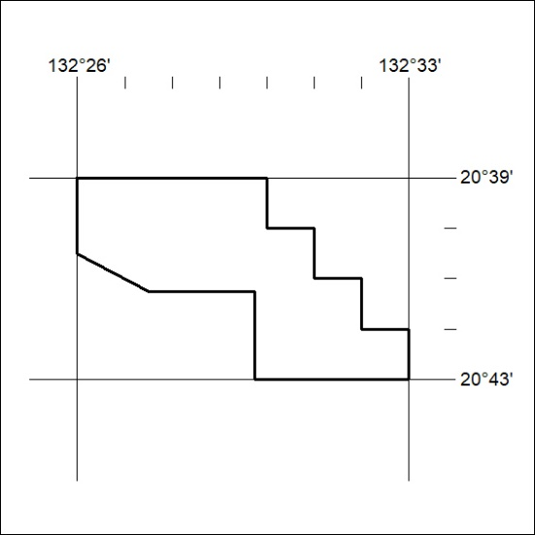

114/25

Mineral Titles Act
NOTICE OF GRANT OF A MINERAL TITLE
Title Type and Number: | Exploration Licence 33935
Granted: | 19 March 2025, for a period of 6 Years
Area: | 20 Blocks, 62.18 km²
Locality: | CRAWFORD
Name of Holder/s: | 100% NORTH TENNANT MINERALS PTY LTD [ACN. 654 828 912]
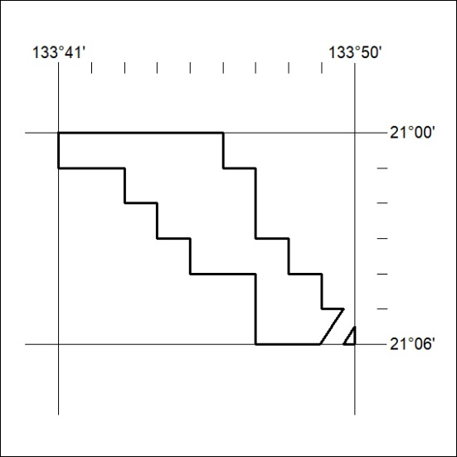
Area granted is indicated above. The titleholder is not permitted to exercise occupational rights on any land that is subject to a development title, or an application for a development title. Any land the subject of a Reserved Land gazettal under the Mineral Titles Act and all land vested in the Commonwealth of Australia is also excluded by description but not excised from the grant area.

115/25

