Mineral Titles Act
NOTICE OF GRANT OF A MINERAL TITLE
Title Type and Number: | Mineral Lease 30317
Granted: | 14 February 2025, for a period of 25 Years
Area: | 69.41 Hectares
Locality: | CHAPMAN
Name of Holder/s:
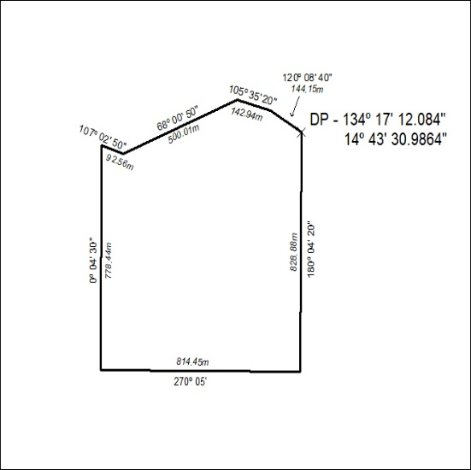

51/25

