

**© Northern Territory of Australia 2025**

**Preferred Reference:** Department of Trade, Business and Asian Relations, 2023 Remote Towns Jobs Profiles, Northern Territory Government, January 2025, Darwin.

**Front cover image:** Weaving materials at Injalak Art Centre, Gunbalanya

**Disclaimer**

The data in this publication was collected by conducting a survey of businesses located in the 28 remote town boundaries. This body of work was completed in 2023 by the former Northern Territory Department of Industry, Tourism and Trade.

The collection methodology was created in accordance with Australian Bureau of Statistics data quality framework principles. Data in this publication is only reflective of those businesses reported on as operating in the town at the time of data collection (see table at the end of publication for list of businesses reported on). To comply with privacy legislation or where appropriate, some data in this publication may have been adjusted and will not reflect the actual data reported by businesses. As a result of this, combined with certain data not being reported by some businesses, some components may not add to totals. Changes over time may also reflect change in business propensity to report on certain data items rather than actual changes over time. Total figures have generally not been adjusted. Caution is advised when interpreting the comparisons made to the earlier 2011, 2014 and 2017 publications as the businesses identified and reported on and the corresponding jobs may differ between publications. The surveys have not always gathered data on training and jobs in the same years.

**Notes for each table and chart are ordered alphabetically and listed at the end of the publication.**

The Northern Territory of Australia exercised due care and skill to ensure that at the time of publication the information contained in this publication is true and correct. However, it is not intended to be relied on as professional advice or used for commercial purposes. The Territory gives no warranty or assurances as to the accuracy of the information contained in the publication and to the maximum extent permitted by law accepts no direct or indirect liability for reliance on its content.

Any use of this report for commercial purposes is not endorsed by the Department of Trade, Business and Asian Relations.

Contents

Wadeye 4

Introduction 5

Summary 6

Jobs Overview 7

Jobs filled by Aboriginality 8

Jobs by Sector: Private and Public 11

Job status: Permanent and Temporary 18

Job Vacancies 22

Jobs by Industry 24

Jobs by Occupation 31

Jobs by Industry by Occupation 35

Jobs by Gender 38

Jobs by Age 44

Vocational Education and Training 50

Population 58

Community Development Program 60

Businesses 61

Notes 63

Abbreviations and Acronyms 64

.

# Wadeye

Wadeye (previoulsy known as Port Keats) is located 420 kilometres south-west of Darwin, with a population of 1927 residents.

*Source: Northern Territory Department of Industry, Tourism and Trade*

# Introduction

This jobs profile provides a snapshot of jobs and the characteristics of job holders in Wadeye as of September 2023. Trends from the surveys conducted in 2011, 2014, and 2017 are also described. Additionally, it presents data on Community Development Program activity, Population, and Vocational Education and Training.

This job profile is one of 28 profiles developed for remote towns in the Northern Territory. It is anticipated these, and subsequent profiles will contribute to a robust evidence base to inform decision making in and relating to these remote Territory towns.

This profile contains information collected by the Northern Territory Department of Industry, Tourism and Trade from businesses operating within the town and is supplemented by other administrative data sets and information.

Each profile provides up-to-date information that is intended to inform the planning and design of current and future government programs and as an evidence base to inform decision making relating to workforce development, enterprise and job opportunities.

The profile may best be understood as a point-in-time tool. The number of business surveys from which the data was drawn is significantly less than in earlier surveys, and business participation has decreased with each survey. For Wadeye, 52% fewer businesses than in 2017 are reported here.

The data collection methodology and corresponding questionnaire were created in partnership with the Australian Bureau of Statistics (ABS) and in accordance with ABS data quality framework and survey principles.

The Northern Territory Department of Industry, Tourism and Trades’ Territory Engagement and Delivery, Skills Initiative and VET data teams collaborated with the Northern Institute at Charles Darwin University to facilitate the surveys and reports.

The information collected and reported on represents a significant goodwill investment by those businesses and organisations that participated. Each business is listed at the end of this publication.

# Summary

The 2023 jobs profile was developed based on responses from 10 businesses operating within the Wadeye town boundary, 11 less than in the 2017 survey. Of these, there were:

* 5 businesses from the Private Sector, accounting for 256 filled jobs or 79% of total filled jobs
* 5 businesses from the Public Sector, accounting for 69 filled jobs or 21% of total filled jobs
* 5 businesses participated in all four surveys (completed in 2011, 2014, 2017 and 2023)

A total of 371 filled and vacant jobs in Wadeye were reported, a decrease of 169 jobs from 2017.[1]

The 2023 profile highlights:

* there were 325 filled jobs of which:
* 281 jobs (86%) were filled by Aboriginal people, a decrease of 10 jobs from 2017
* 44 jobs (14%) were filled by non-Aboriginal people, a decrease of 165 jobs from 2017
* 72% of employed Aboriginal people are working in the Private Sector
* Aboriginal people accounted for 86% of job holders in the town compared to 58% in 2017
* Aboriginal females made up 52% of total Aboriginal filled jobs in the town compared to 60% in 2017
* there were 46 vacant jobs, of which:
* job vacancies as a percentage of jobs was at 12% in 2023
* 1 in 8 jobs were vacant
* 23 of the vacancies were in Clerical and Administrative Workers and Community and Personal Service Workers areas
* Public Administration and Safety was the largest industry employer in 2023, having the highest increase of 73 jobs filled between 2017 and 2023
* Training decreased in student numbers between 2016 and 2023
* Community Services, Health and Education had the highest student numbers in 2023
* the Primary Industry and Community Services, Health and Education training sectors had the highest decreases in student numbers between 2016 and 2023 of 26.

The overall population in Wadeye decreased by 185 people (-8.8%) between 2011 and 2021 to 1927 people.

In comparison, the overall Northern Territory population increased by 9.7% between 2011 and 2021.

In 2021, the working age population (15 years and over) in Wadeye was an estimated 1,421 people compared to 1,331 in 2011, an increase of 6.8%.

There were 0.3 jobs in Wadeye per working age person compared to 0.3 jobs per working age person across the 28 remote towns in the Northern Territory.

# Jobs overview

Table 1: Count of filled jobs and vacancies, 2011, 2014, 2017 & 2023 (a)(b)

|  |  |  |  |  |  |  |  |
| --- | --- | --- | --- | --- | --- | --- | --- |
|  | **2011** | **2014** | **2017** | **2023** | **Change 2011-2014** | **Change 2014-2017** | **Change 2017-2023** |
| **Total All Jobs** | **452** | **457** | **540** | **371** | **5** | **83** | **-169** |
| **Vacancies** | **28** | **31** | **40** | **46** | **3** | **9** | **6** |
| Vacancies as % of Total All Jobs | 6.2% | 6.8% | 7.4% | 12.4% | 0.6 ppt | 0.6 ppt | 5.0 ppt |
| **Filled Jobs** | **424** | **426** | **500** | **325** | **2** | **74** | **-175** |
| Full-time | 338 | 297 | 295 | 298 | -41 | -2 | 3 |
| Part-time | 86 | 129 | 205 | 27 | 43 | 76 | -178 |

Source: Northern Territory Department of Industry, Tourism and Trade

Chart 1: Count of vacant jobs and filled jobs by full-time/part-time status, 2011, 2014, 2017 & 2023 (a)(b)

*Source: Northern Territory Department of Industry, Tourism and Trade*

In 2023 in Wadeye:

* there was a total of 325 **filled jobs**, a decrease of 175 jobs from 2017 and a decrease of 101 jobs from 2014
* of the 325 **filled jobs** in 2023:
* 298 were full-time jobs, an increase of 3 jobs from 2017 and an increase of 1 job from 2014
* 27 were part-time jobs, a decrease of 178 jobs from 2017 and a decrease of 102 jobs from 2014
* there were 46 total **job vacancies** in 2023, an increase of 6 vacancies from 2017 and an increase of 15 vacancies from 2014.

# Jobs filled by Aboriginality

Chart 2: Count of filled jobs by Aboriginality, 2011, 2014, 2017 & 2023 (a)(c)

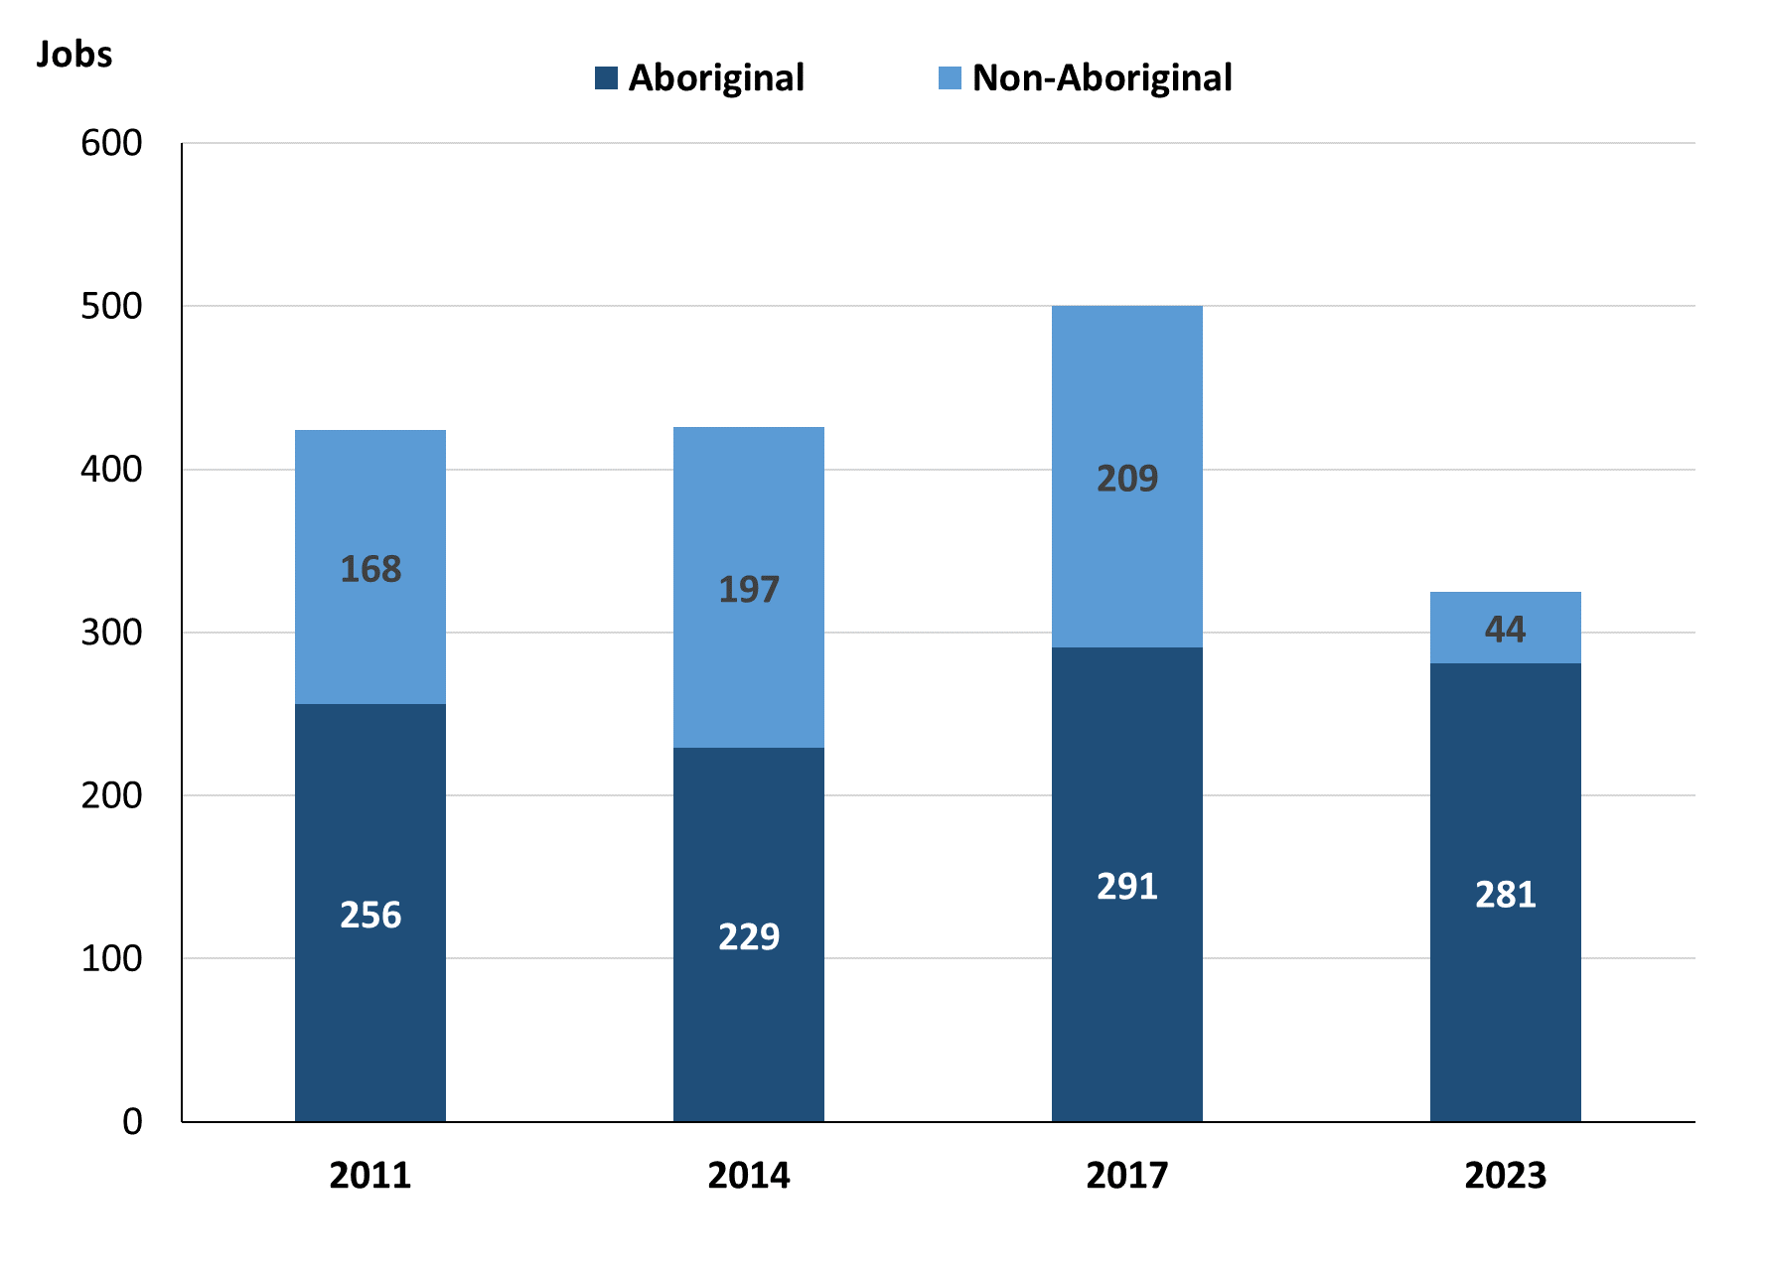

Source: Northern Territory Department of Industry, Tourism and Trade

In 2023 in Wadeye:

* of the 325 filled jobs:
* **Aboriginal** people filled 281 jobs, a decrease of 10 jobs from 2017 and an increase of 52 jobs from 2014
* **non-Aboriginal** people filled 44 jobs, a decrease of 165 jobs from 2017 and a decrease of 153 jobs from 2014
* **Aboriginal** people accounted for 86% of job holders compared to 58% in 2017 and 54% in 2014.

Table 2a: Count of filled jobs by full-time/part-time status, 2011, 2014, 2017 & 2023 (a)(b)(c)

|  |  |  |  |  |  |  |  |  |  |  |  |  |
| --- | --- | --- | --- | --- | --- | --- | --- | --- | --- | --- | --- | --- |
| **Indicator** | **2011** | | | **2014** | | | **2017** | | | **2023** | | |
| **Aboriginal** | **Non-Aboriginal** | **Total** | **Aboriginal** | **Non-Aboriginal** | **Total** | **Aboriginal** | **Non-Aboriginal** | **Total** | **Aboriginal** | **Non-Aboriginal** | **Total** |
| Full-time | 177 | 161 | **338** | 122 | 175 | **297** | 99 | 196 | **295** | 255 | 43 | **298** |
| Part-time | 79 | 7 | **86** | 107 | 22 | **129** | 192 | 13 | **205** | 26 | 1 | **27** |
| **Total** | **256** | **168** | **424** | **229** | **197** | **426** | **291** | **209** | **500** | **281** | **44** | **325** |

Source: Northern Territory Department of Industry, Tourism and Trade

Table 2b: Count of filled jobs by full-time/part-time status, 2011-2014, 2014-2017 & 2017-2023 (a)(b)(c)

|  |  |  |  |  |  |  |  |  |  |
| --- | --- | --- | --- | --- | --- | --- | --- | --- | --- |
| **Indicator** | **Change 2011-2014** | | | **Change 2014-2017** | | | **Change 2017-2023** | | |
| **Aboriginal** | **Non-Aboriginal** | **Total** | **Aboriginal** | **Non-Aboriginal** | **Total** | **Aboriginal** | **Non-Aboriginal** | **Total** |
| Full-time | -55 | 14 | **-41** | -23 | 21 | **-2** | 156 | -153 | **3** |
| Part-time | 28 | 15 | **43** | 85 | -9 | **76** | -166 | -12 | **-178** |
| **Total** | **-27** | **29** | **2** | **62** | **12** | **74** | **-10** | **-165** | **-175** |

Source: Northern Territory Department of Industry, Tourism and Trade

Chart 3: Count of filled jobs by full-time/part-time status, 2011, 2014, 2017 & 2023 (a)(b)(c)

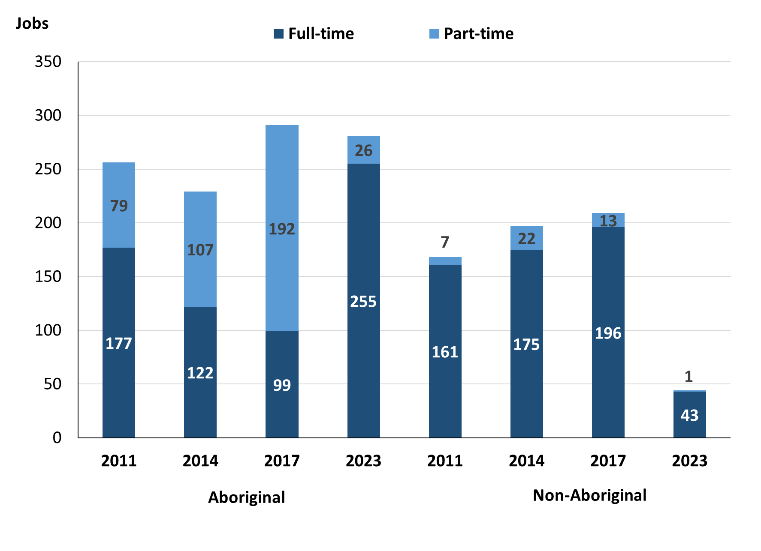

Source: Northern Territory Department of Industry, Tourism and Trade

In 2023 in Wadeye:

* of the 325 **filled jobs:**
* 255 were **full-time** jobs filled by **Aboriginal** people, an increase of 156 jobs from 2017 and an increase of 133 jobs from 2014
* 26 were **part-time** jobs filled by **Aboriginal** people, a decrease of 166 jobs from 2017 and a decrease of 81 jobs from 2014
* 43 were **full-time** jobs filled by **non-Aboriginal** people, a decrease of 153 jobs from 2017 and a decrease of 132 jobs from 2014
* 1 was a **part-time** job filled by a **non-Aboriginal** person, a decrease of 12 jobs from 2017 and a decrease of 21 jobs from 2014.

# Jobs by sector: Private and public

Table 3a: Count of filled jobs by business sector, 2011, 2014, 2017 & 2023 (a)(b)(c)

|  |  |  |  |  |  |  |  |  |  |  |  |  |
| --- | --- | --- | --- | --- | --- | --- | --- | --- | --- | --- | --- | --- |
| **Indicator** | **2011** | | | **2014** | | | **2017** | | | **2023** | | |
| **Aboriginal** | **Non-Aboriginal** | **Total** | **Aboriginal** | **Non-Aboriginal** | **Total** | **Aboriginal** | **Non-Aboriginal** | **Total** | **Aboriginal** | **Non-Aboriginal** | **Total** |
| **Public Sector** | 78 | 37 | **115** | 59 | 52 | **111** | 47 | 43 | **90** | 47 | 22 | **69** |
| Australian Government | 3 | 2 | **5** | 13 | 7 | **20** | 6 | 1 | **7** | 0 | 1 | **1** |
| Territory Government | 11 | 13 | **24** | 14 | 32 | **46** | 17 | 30 | **47** | 22 | 18 | **40** |
| Local Government | 64 | 22 | **86** | 32 | 13 | **45** | 16 | 6 | **22** | 25 | 3 | **28** |
| **Private Sector** | 178 | 131 | **309** | 170 | 145 | **315** | 244 | 166 | **410** | 234 | 22 | **256** |
| **Total** | **256** | **168** | **424** | **229** | **197** | **426** | **291** | **209** | **500** | **281** | **44** | **325** |

Source: Northern Territory Department of Industry, Tourism and Trade

Table 3b: Count of filled jobs by business sector, 2011-2014, 2014-2017 & 2017-2023 (a)(b)(c)

|  |  |  |  |  |  |  |  |  |  |
| --- | --- | --- | --- | --- | --- | --- | --- | --- | --- |
| **Indicator** | **Change 2011-2014** | | | **Change 2014-2017** | | | **Change 2017-2023** | | |
| **Aboriginal** | **Non-Aboriginal** | **Total** | **Aboriginal** | **Non-Aboriginal** | **Total** | **Aboriginal** | **Non-Aboriginal** | **Total** |
| **Public Sector** | -19 | 15 | **-4** | -12 | -9 | **-21** | 0 | -21 | **-21** |
| Australian Government | 10 | 5 | **15** | -7 | -6 | **-13** | -6 | 0 | **-6** |
| Territory Government | 3 | 19 | **22** | 3 | -2 | **1** | 5 | -12 | **-7** |
| Local Government | -32 | -9 | **-41** | -16 | -7 | **-23** | 9 | -3 | **6** |
| **Private Sector** | -8 | 14 | **6** | 74 | 21 | **95** | -10 | -144 | **-154** |
| **Total** | **-27** | **29** | **2** | **62** | **12** | **74** | **-10** | **-165** | **-175** |

Source: Northern Territory Department of Industry, Tourism and Trade

Chart 4: Count of filled jobs by business sector, 2011, 2014, 2017 & 2023 (a)(d)

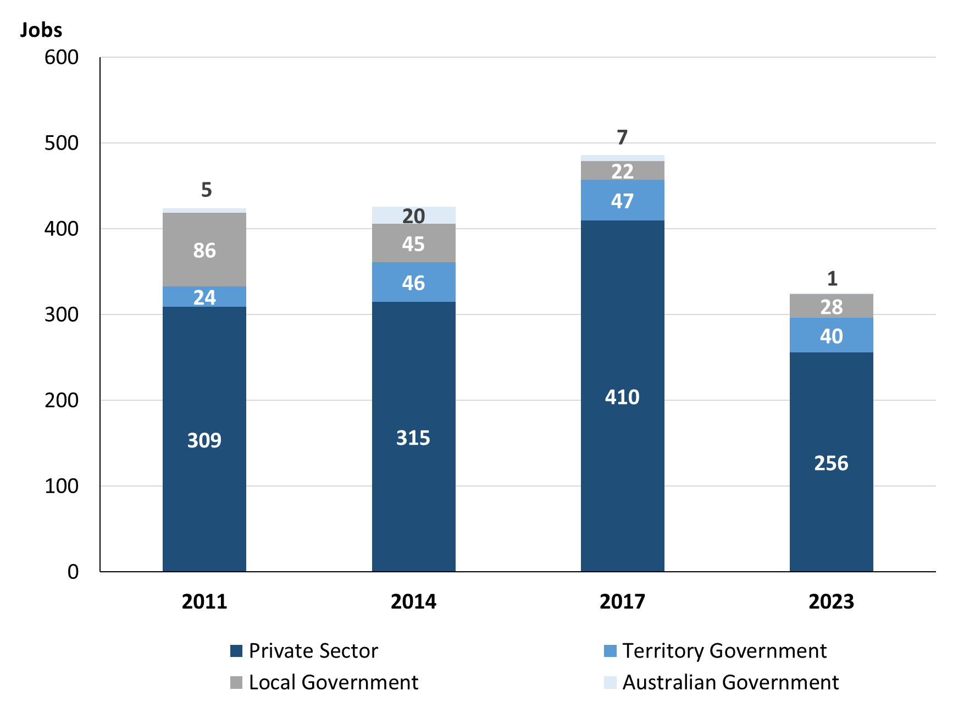

Source: Northern Territory Department of Industry, Tourism and Trade

Chart 5: Percentage of filled jobs by business sector in 2023 (a)(d)

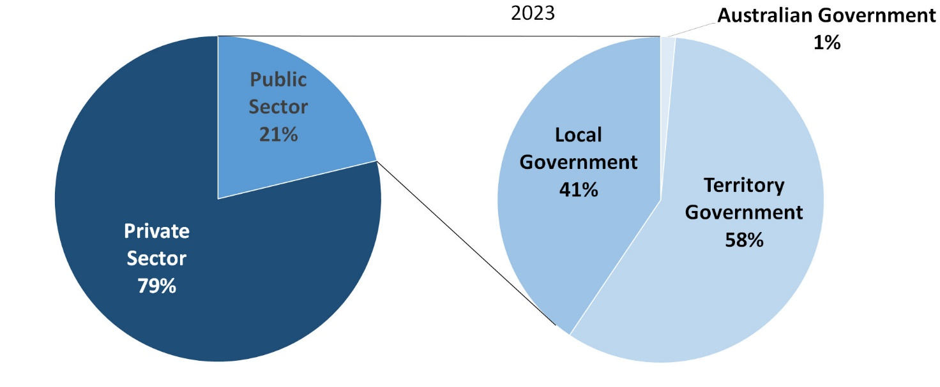

Source: Northern Territory Department of Industry, Tourism and Trade

In 2023 in Wadeye:

* there were 69 jobs in the **Public Sector**, a decrease of 21 jobs from 2017 and a decrease of 42 jobs from 2014
* of the 69 jobs in the **Public Sector** in 2023:
* 1 job was in the Australian Government, a decrease of 6 jobs from 2017 and a decrease of 19 jobs from 2014
* 40 jobs were in the Territory Government, a decrease of 7 jobs from 2017 and a decrease of 6 jobs from 2014
* 28 jobs were in the Local Government, an increase of 6 jobs from 2017 and a decrease of 17 jobs from 2014
* there were 256 jobs in the **Private Sector** in 2023, a decrease of 154 jobs from 2017 and a decrease of 59 jobs from 2014.

Chart 6: Count of filled jobs by sector, 2011, 2014, 2017 & 2023 (a)(c)(d)

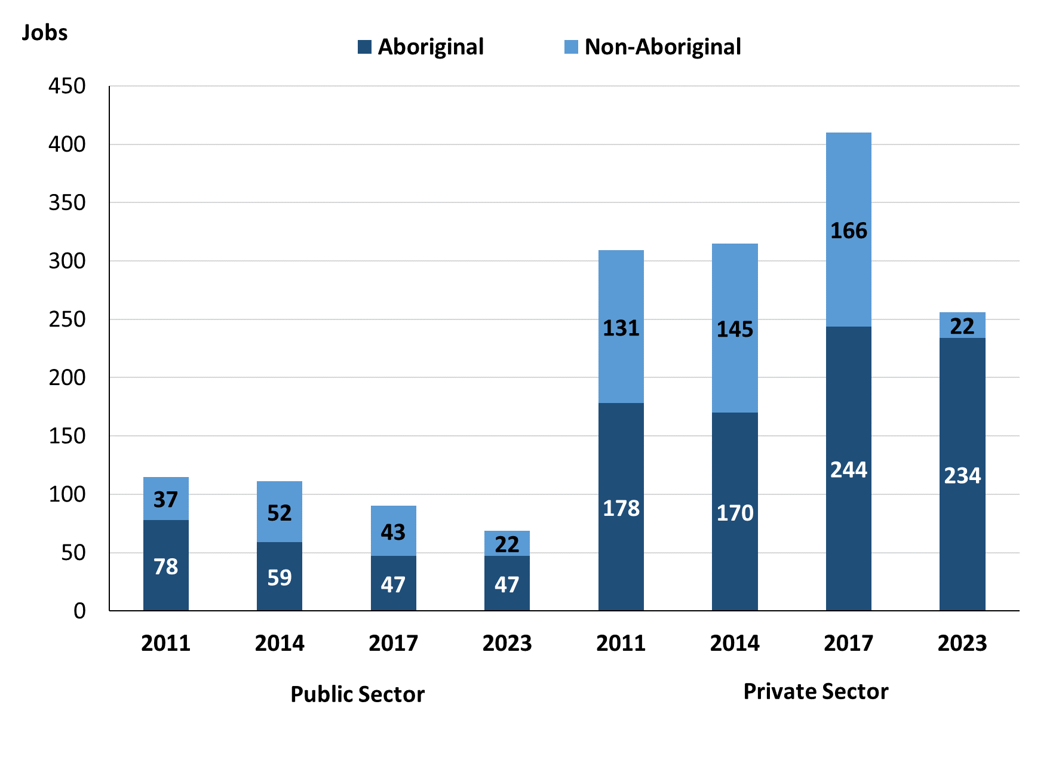

Source: Northern Territory Department of Industry, Tourism and Trade

In 2023 in Wadeye:

* of the 69 jobs in the **Public Sector**:
* **Aboriginal** people filled 47 jobs, no change from 2017 and a decrease of 12 jobs from 2014
* **non-Aboriginal** people filled 22 jobs, a decrease of 21 jobs from 2017 and a decrease of 30 jobs from 2014
* of the 256 jobs in the **Private Sector**:
* **Aboriginal** people filled 234 jobs, a decrease of 10 jobs from 2017 and an increase of 64 jobs from 2014
* **non-Aboriginal** people filled 22 jobs, a decrease of 144 jobs from 2017 and a decrease of 123 jobs from 2014.

Chart 7: Count of filled jobs by sector and full-time/part-time status, 2011, 2014, 2017 & 2023 (a)(b)(d)

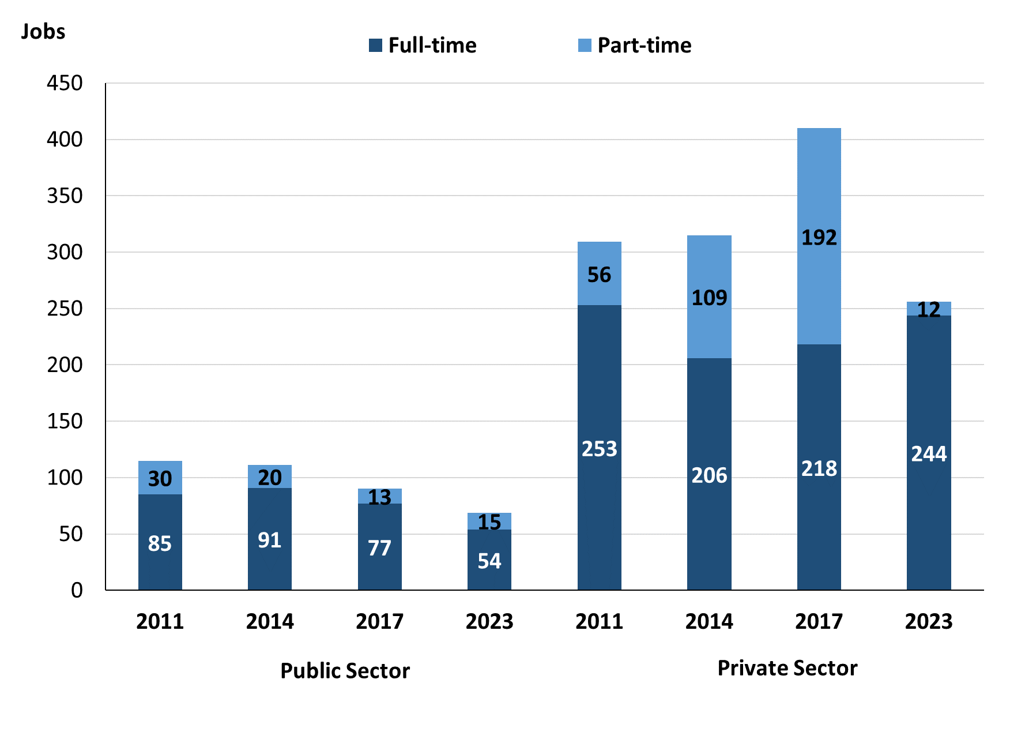

Source: Northern Territory Department of Industry, Tourism and Trade

In 2023 in Wadeye there were:

* of the 69 jobs in the **Public Sector**:
* 54 were **full-time** jobs, a decrease of 23 jobs from 2017 and a decrease of 37 jobs from 2014
* 15 were **part-time** jobs, an increase of 2 jobs from 2017 and a decrease of 5 jobs from 2014
* of the 256 jobs in the **Private Sector**:
* 244 were **full-time** jobs, an increase of 26 jobs from 2017 and an increase of 38 jobs from 2014
* 12 were **part-time** jobs, a decrease of 180 jobs from 2017 and a decrease of 97 jobs from 2014.

Table 4: Count of filled jobs by full-time/part-time status by sector, 2011, 2014, 2017 & 2023 (a)(b)(c)(d)

|  |  |  |  |  |  |  |  |  |  |  |
| --- | --- | --- | --- | --- | --- | --- | --- | --- | --- | --- |
| **Indicator** | **2011** | | | | | | | | | |
| **Aboriginal** | | | **Non-Aboriginal** | | | **Total** | | | |
| **Full-time** | **Part-time** | **Total** | **Full-time** | **Part-time** | **Total** | **Full-time** | **Part-time** | **Total** |
| Public Sector | 53 | 25 | **78** | 32 | 5 | **37** | 85 | 30 | **115** |
| Private Sector | 124 | 54 | **178** | 129 | 2 | **131** | 253 | 56 | **309** |
| **Total** | **177** | **79** | **256** | **161** | **7** | **168** | **338** | **86** | **424** |

|  |  |  |  |  |  |  |  |  |  |
| --- | --- | --- | --- | --- | --- | --- | --- | --- | --- |
| **Indicator** | **2014** | | | | | | | | |
| **Aboriginal** | | | **Non-Aboriginal** | | | **Total** | | |
| **Full-time** | **Part-time** | **Total** | **Full-time** | **Part-time** | **Total** | **Full-time** | **Part-time** | **Total** |
| Public Sector | 46 | 13 | **59** | 45 | 7 | **52** | 91 | 20 | **111** |
| Private Sector | 76 | 94 | **170** | 130 | 15 | **145** | 206 | 109 | **315** |
| **Total** | **122** | **107** | **229** | **175** | **22** | **197** | **297** | **129** | **426** |

|  |  |  |  |  |  |  |  |  |  |  |
| --- | --- | --- | --- | --- | --- | --- | --- | --- | --- | --- |
| **Indicator** | **2017** | | | | | | | | | |
| **Aboriginal** | | | **Non-Aboriginal** | | | **Total** | | | |
| **Full-time** | **Part-time** | **Total** | **Full-time** | **Part-time** | **Total** | **Full-time** | **Part-time** | **Total** |
| Public Sector | 30 | 9 | **39** | 33 | 4 | **37** | 63 | 13 | **76** |
| Private Sector | 69 | 183 | **252** | 163 | 9 | **172** | 232 | 192 | **424** |
| **Total** | **122** | **107** | **291** | **196** | **13** | **209** | **295** | **205** | **500** |

|  |  |  |  |  |  |  |  |  |  |  |
| --- | --- | --- | --- | --- | --- | --- | --- | --- | --- | --- |
| **Indicator** | **2023** | | | | | | | | | |
| **Aboriginal** | | | **Non-Aboriginal** | | | **Total** | | | |
| **Full-time** | **Part-time** | **Total** | **Full-time** | **Part-time** | **Total** | **Full-time** | **Part-time** | **Total** |
| Public Sector | 33 | 14 | **47** | 21 | 1 | **22** | 54 | 15 | **69** |
| Private Sector | 222 | 12 | **234** | 22 | 0 | **22** | 244 | 12 | **256** |
| **Total** | **255** | **26** | **281** | **43** | **1** | **44** | **298** | **27** | **325** |

Source: Northern Territory Department of Industry, Tourism and Trade

In 2023 in Wadeye there were:

* 47 jobs in the **Public Sector** filled by **Aboriginal** people, an increase of 8 jobs from 2017 and a decrease of 12 jobs from 2014, of which:
* 33 were **full-time** jobs, an increase of 3 jobs from 2017 and a decrease of 13 jobs from 2014
* 14 were **part-time** jobs, an increase of 5 jobs from 2017 and an increase of 1 job from 2014
* 234 jobs in the **Private Sector** filled by **Aboriginal** people, a decrease of 18 jobs from 2017 and an increase of 64 jobs from 2014, of which:
* 222 were **full-time** jobs, an increase of 153 jobs from 2017 and an increase of 146 jobs from 2014
* 12 were **part-time** jobs, a decrease of 171 jobs from 2017 and a decrease of 82 jobs from 2014
* 22 jobs in the **Public Sector** filled by **non-Aboriginal** people, a decrease of 15 jobs from 2017 and a decrease of 30 jobs from 2014, of which:
* 21 were **full-time** jobs, a decrease of 12 jobs from 2017 and a decrease of 24 jobs from 2014
* 1 was a **part-time** job, a decrease of 3 jobs from 2017 and a decrease of 6 jobs from 2014
* 22 jobs in the **Private Sector** filled by **non-Aboriginal** people, a decrease of 150 jobs from 2017 and a decrease of 123 jobs from 2014, of which:
* 22 were **full-time** jobs, a decrease of 141 jobs from 2017 and a decrease of 108 jobs from 2014
* none were **part-time** jobs, a decrease of 9 jobs from 2017 and a decrease of 15 jobs from 2014.

# Job status: permanent and temporary

Table 5a: Count of filled jobs by employment status, 2011, 2014, 2017 & 2023 (a)(c)(e)

|  |  |  |  |  |  |  |  |  |  |  |  |  |
| --- | --- | --- | --- | --- | --- | --- | --- | --- | --- | --- | --- | --- |
| **Indicator** | **2011** | | | **2014** | | | **2017** | | | **2023** | | |
| **Aboriginal** | **Non-Aboriginal** | **Total** | **Aboriginal** | **Non-Aboriginal** | **Total** | **Aboriginal** | **Non-Aboriginal** | **Total** | **Aboriginal** | **Non-Aboriginal** | **Total** |
| Permanent | 198 | 145 | **343** | 97 | 81 | **178** | 102 | 104 | **206** | 167 | 38 | **205** |
| Temporary | 58 | 23 | **81** | 132 | 116 | **248** | 189 | 105 | **294** | 114 | 6 | **120** |
| **Total** | **256** | **168** | **424** | **229** | **197** | **426** | **291** | **209** | **500** | **281** | **44** | **325** |

Source: Northern Territory Department of Industry, Tourism and Trade

Table 5b: Count of filled jobs by employment status, 2011-2014, 2014-2017 & 2017-2023 (a)(c)(e)

|  |  |  |  |  |  |  |  |  |  |
| --- | --- | --- | --- | --- | --- | --- | --- | --- | --- |
| **Indicator** | **Change 2011-2014** | | | **Change 2014-2017** | | | **Change**  **2017-2023** | | |
| **Aboriginal** | **Non-Aboriginal** | **Total** | **Aboriginal** | **Non-Aboriginal** | **Total** | **Aboriginal** | **Non-Aboriginal** | **Total** |
| Permanent | -101 | -64 | **-165** | 5 | 23 | **28** | 65 | -66 | **-1** |
| Temporary | 74 | 93 | **167** | 57 | -11 | **46** | -75 | -99 | **-174** |
| **Total** | **-27** | **29** | **2** | **62** | **12** | **74** | **-10** | **-165** | **-175** |

Source: Northern Territory Department of Industry, Tourism and Trade

Chart 8: Count of filled jobs by employment status, 2011, 2014, 2017 & 2023 (a)(c)(e))

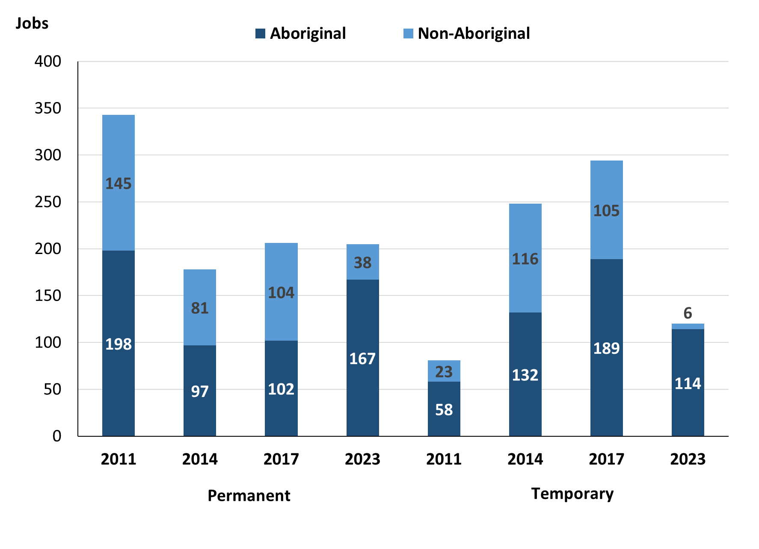

Source: Northern Territory Department of Industry, Tourism and Trade

In 2023 in Wadeye:

* there were 205 **permanent** jobs, a decrease of 1 job from 2017, and an increase of 27 jobs from 2014, of which:
* 167 jobs were filled by **Aboriginal** people, an increase of 65 jobs from 2017 and an increase of 70 jobs from 2014
* 38 jobs were filled by **non-Aboriginal** people, a decrease of 66 jobs from 2017 and a decrease of 43 jobs from 2014
* there were 120 **temporary** jobs, a decrease of 174 jobs from 2017 and a decrease of 128 jobs from 2014, of which:
* 114 jobs were filled by **Aboriginal** people, a decrease of 75 jobs from 2017 and a decrease of 18 jobs from 2014
* 6 jobs were filled by **non-Aboriginal** people, a decrease of 99 jobs from 2017 and a decrease of 110 jobs from 2014.

Table 6: Count of filled jobs by sector and employment status, 2011, 2014, 2017 & 2023 (a)(c)(d)(e)

|  |  |  |  |  |  |  |  |  |  |
| --- | --- | --- | --- | --- | --- | --- | --- | --- | --- |
| **Indicator** | **2011** | | | | | | | | |
| **Aboriginal** | | | **Non-Aboriginal** | | | **Total** | | |
| **Perm** | **Temp** | **Total** | **Perm** | **Temp** | **Total** | **Perm** | **Temp** | **Total** |
| Public Sector | 71 | 7 | **78** | 31 | 6 | **37** | 102 | 13 | **115** |
| Private Sector | 127 | 51 | **178** | 114 | 17 | **131** | 241 | 68 | **309** |
| **Total** | **198** | **58** | **256** | **145** | **23** | **168** | **343** | **81** | **424** |

|  |  |  |  |  |  |  |  |  |  |  |
| --- | --- | --- | --- | --- | --- | --- | --- | --- | --- | --- |
| **Indicator** | **2014** | | | | | | | | | |
| **Aboriginal** | | | **Non-Aboriginal** | | | **Total** | | | |
| **Perm** | **Temp** | **Total** | **Perm** | **Temp** | **Total** | **Perm** | **Temp** | **Total** |
| Public Sector | 18 | 41 | **59** | 24 | 28 | **52** | 42 | 69 | **111** |
| Private Sector | 79 | 91 | **170** | 57 | 88 | **145** | 136 | 179 | **315** |
| **Total** | **97** | **132** | **229** | **81** | **116** | **197** | **178** | **248** | **426** |

|  |  |  |  |  |  |  |  |  |  |
| --- | --- | --- | --- | --- | --- | --- | --- | --- | --- |
| **Indicator** | **2017** | | | | | | | | |
| **Aboriginal** | | | **Non-Aboriginal** | | | **Total** | | |
| **Perm** | **Temp** | **Total** | **Perm** | **Temp** | **Total** | **Perm** | **Temp** | **Total** |
| Public Sector | 8 | 39 | **47** | 14 | 29 | **43** | 22 | 68 | **90** |
| Private Sector | 94 | 150 | **244** | 90 | 76 | **166** | 184 | 226 | **410** |
| **Total** | **102** | **189** | **291** | **104** | **105** | **209** | **206** | **294** | **500** |

|  |  |  |  |  |  |  |  |  |  |
| --- | --- | --- | --- | --- | --- | --- | --- | --- | --- |
| **Indicator** | **2023** | | | | | | | | |
| **Aboriginal** | | | **Non-Aboriginal** | | | **Total** | | |
| **Perm** | **Temp** | **Total** | **Perm** | **Temp** | **Total** | **Perm** | **Temp** | **Total** |
| Public Sector | 17 | 30 | **47** | 16 | 6 | **22** | 33 | 36 | **69** |
| Private Sector | 150 | 84 | **234** | 22 | 0 | **22** | 172 | 84 | **256** |
| **Total** | **167** | **114** | **281** | **38** | **6** | **44** | **205** | **120** | **325** |

Source: Northern Territory Department of Industry, Tourism and Trade

In 2023 in Wadeye there were:

* 69 jobs in the **Public Sector**, a decrease of 21 jobs from 2017 and a decrease of 42 jobs from 2014, of which:
* 33 jobs were **permanent**, an increase of 11 jobs from 2017 and a decrease of 9 jobs from 2014, of which:
* **Aboriginal** people filled 17 jobs, an increase of 9 jobs from 2017 and a decrease of 1 job from 2014
* **non-Aboriginal** people filled 16 jobs, an increase of 2 jobs from 2017 and a decrease of 8 jobs from 2014
* 36 jobs were **temporary**, a decrease of 32 jobs from 2017 and a decrease of 33 jobs from 2014, of which:
* **Aboriginal** people filled 30 jobs, a decrease of 9 jobs from 2017 and a decrease of 11 jobs from 2014
* **non-Aboriginal** people filled 6 jobs, a decrease of 23 jobs from 2017 and a decrease of 22 jobs from 2014
* 256 jobs in the **Private Sector**, a decrease of 154 jobs from 2017 and a decrease of 59 jobs from 2014, of which:
* 172 jobs were **permanent**, a decrease of 12 jobs from 2017 and an increase of 36 jobs from 2014, of which:
* **Aboriginal** people filled 150 jobs, an increase of 56 jobs from 2017 and an increase of 71 jobs from 2014
* **non-Aboriginal** people filled 22 jobs, a decrease of 68 jobs from 2017 and a decrease of 35 jobs from 2014
* 84 jobs were **temporary**, a decrease of 142 jobs from 2017 and a decrease of 95 jobs from 2014, of which:
* **Aboriginal** people filled 84 jobs, a decrease of 66 jobs from 2017 and a decrease of 7 jobs from 2014
* **non-Aboriginal** people filled 0 jobs, a decrease of 76 jobs from 2017 and a decrease of 88 jobs from 2014.

# Job vacancies

Table 7: Job vacancies, 2011, 2014, 2017 & 2023

|  |  |  |  |  |  |  |  |
| --- | --- | --- | --- | --- | --- | --- | --- |
| **Indicator** | **2011** | **2014** | **2017** | **2023** | **Change 2011-2014** | **Change 2014-2017** | **Change 2017-2023** |
| **Job vacancies** | **28** | **31** | **40** | **46** | **3** | **9** | **6** |

Source: Northern Territory Department of Industry, Tourism and Trade

Table 8a: Job vacancies by occupation, 2011, 2014, 2017 & 2023 (f)(g)

|  |  |  |  |  |
| --- | --- | --- | --- | --- |
| **Occupation (ANZSCO major group)** | **2011** | **2014** | **2017** | **2023** |
| Clerical and Administrative Workers | 2 | 5 | 8 | 15 |
| Community and Personal Service Workers | 5 | 9 | 14 | 8 |
| Labourers | 6 | 1 | 5 | 2 |
| Machinery Operators and Drivers | 0 | 0 | 1 | 1 |
| Managers | 0 | 2 | 0 | 6 |
| Professionals | 9 | 11 | 11 | 7 |
| Sales Workers | 4 | 3 | 1 | 0 |
| Technicians and Trades Workers | 0 | 0 | 0 | 7 |
| Other Occupations | 2 | 0 | 0 | 0 |
| **Total** | **28** | **31** | **40** | **46** |

Source: Northern Territory Department of Industry, Tourism and Trade

Table 8b: Job vacancies by occupation, 2011-2014, 2014-2017 & 2017-2023 (f)(g)

|  |  |  |  |
| --- | --- | --- | --- |
| **Occupation (ANZSCO major group)** | **Change 2011-2014** | **Change 2014-2017** | **Change 2017-2023** |
| Clerical and Administrative Workers | 3 | 3 | 7 |
| Community and Personal Service Workers | 4 | 5 | -6 |
| Labourers | -5 | 4 | -3 |
| Machinery Operators and Drivers | 0 | 1 | 0 |
| Managers | 2 | -2 | 6 |
| Professionals | 2 | 0 | -4 |
| Sales Workers | -1 | -2 | -1 |
| Technicians and Trades Workers | 0 | 0 | 7 |
| Other Occupations | -2 | 0 | 0 |
| **Total** | **3** | **9** | **6** |

Source: Northern Territory Department of Industry, Tourism and Trade

Table 9: Job vacancies by job title, 2023 profile (f)

|  |  |
| --- | --- |
| **Job Vacancy** | **No.** |
| Aboriginal and Torres Strait Islander Health Worker | 2 |
| Bank Worker | 1 |
| Bus Driver | 1 |
| Café or Restaurant Manager | 1 |
| Diesel Motor Mechanic | 2 |
| Disabilities Services Officer | 2 |
| Family Support Worker | 2 |
| General Clerk | 3 |
| Handyperson | 2 |
| Health and Welfare Services Managers nec | 4 |
| Liaison Officer | 1 |
| Mechanic’s Assistant | 2 |
| Medical Practitioner | 1 |
| Midwife | 1 |
| Motor Mechanic (General) | 2 |
| Nurse Manager | 1 |
| Nurse Practitioner | 2 |
| Police Officer | 3 |
| Primary Health Organisation Manager | 1 |
| Program or Project Administrator | 9 |
| Registered Nurses nec | 2 |
| Workshop Supervisor | 1 |
| **Total** | **46** |

Source: Northern Territory Department of Industry, Tourism and Trade

In 2023 in Wadeye:

* there were 46 **vacancies** reported, an increase of 6 vacancies from 2017 and an increase of 15 vacancies from 2014
* Of the 46 reported **vacancies,** the greatest demand was for:
* 15 Clerical and Administrative Workers, the majority in the following jobs:
* General Clerk
* Program or Project Administrator
* 8 Community and Personal Service Workers, the majority in the following jobs:
* Disabilities Services Officer
* Family Support Worker
* Police Officer
* 7 Professionals, the majority in the following jobs:
* Nurse Practitioner
* Registered Nurses nec.

# Jobs by industry

Table 10: Count of filled jobs by industry of business, 2011, 2014, 2017, 2023 and change in count of filled jobs by industry 2011-2014, 2014-2017 & 2017-2023 (a)(h)

|  |  |  |  |  |  |  |  |  |  |  |  |
| --- | --- | --- | --- | --- | --- | --- | --- | --- | --- | --- | --- |
| **Industry (ANZSIC Division)** | **2011** | | **2014** | | **2017** | | **2023** | | **Change 2011-2014** | **Change 2014-2017** | **Change 2017-2023** |
| **Total** | **% of Total** | **Total** | **% of Total** | **Total** | **% of Total** | **Total** | **% of Total** | **Total** | **Total** | **Total** |
| Accommodation and Food Services | 0 | 0.0% | 14 | 3.3% | 14 | 2.8% | 0 | 0.0% | 14 | 0 | -14 |
| Administrative and Support Services | 8 | 1.9% | 0 | 0.0% | 0 | 0.0% | 0 | 0.0% | -8 | 0 | 0 |
| Construction | 1 | 0.2% | 2 | 0.5% | 0 | 0.0% | 0 | 0.0% | 1 | -2 | 0 |
| Education and Training | 133 | 31.4% | 170 | 39.9% | 158 | 31.6% | 0 | 0.0% | 37 | -12 | -158 |
| Electricity, Gas, Water and Waste Services | 0 | 0.0% | 0 | 0.0% | 1 | 0.2% | 0 | 0.0% | 0 | 1 | -1 |
| Financial and Insurance Services | 3 | 0.7% | 2 | 0.5% | 3 | 0.6% | 3 | 0.9% | -1 | 1 | 0 |
| Health Care and Social Assistance | 41 | 9.7% | 68 | 16.0% | 64 | 12.8% | 50 | 15.4% | 27 | -4 | -14 |
| Other Services | 2 | 0.5% | 0 | 0.0% | 0 | 0.0% | 0 | 0.0% | -2 | 0 |  |
| Public Administration and Safety | 184 | 43.4% | 132 | 31.0% | 190 | 38.0% | 263 | 80.9% | -52 | 58 | 73 |
| Rental, Hiring and Real Estate Services | 3 | 0.7% | 2 | 0.5% | 0 | 0.0% | 0 | 0.0% | -1 | -2 | 0 |
| Retail Trade | 42 | 9.9% | 33 | 7.7% | 70 | 14.0% | 9 | 2.8% | -9 | 37 | -61 |
| Transport, Postal and Warehousing | 3 | 0.7% | 3 | 0.7% | 0 | 0.0% | 0 | 0.0% | 0 | -3 | 0 |
| **Total** | **424** | **100.0%** | **426** | **100.0%** | **500** | **100.0%** | **325** | **100%** | **2** | **74** | **-175** |

Source: Northern Territory Department of Industry, Tourism and Trade

In 2023 in Wadeye:

* the Public Administration and Safety industry was the **largest** **industry** **employer**, with 263 filled jobs or 80.9% of filled jobs, an increase of 73 jobs from 2017 and an increase of 131 jobs from 2014
* **other** **significant** industry employers were:
* Health Care and Social Assistance with 50 jobs (or 15.4% of filled jobs), a decrease of 14 jobs from 2017 and a decrease of 18 jobs from 2014
* Retail Trade with 9 jobs (or 2.8% of filled jobs), a decrease of 61 jobs from 2017 and a decrease of 24 jobs from 2014.

Table 11a: Count of filled jobs by industry of business, 2011, 2014, 2017 & 2023 (a)(c)(h)

|  |  |  |  |  |  |  |  |  |  |  |  |  |  |  |  |  |
| --- | --- | --- | --- | --- | --- | --- | --- | --- | --- | --- | --- | --- | --- | --- | --- | --- |
| **Industry (ANZSIC division)** | **2011** | | | | **2014** | | | | **2017** | | | | **2023** | | | |
| **Aboriginal** | **Non-Aboriginal** | **Total** | **Aboriginal** | | **Non-Aboriginal** | **Total** | **Aboriginal** | | **Non-Aboriginal** | **Total** | **Aboriginal** | | **Non-Aboriginal** | **Total** |
| Accommodation and Food Services | 0 | 0 | **0** | 9 | | 5 | **14** | 8 | | 6 | **14** | 0 | | 0 | **0** |
| Administrative and Support Services | 2 | 6 | **8** | 0 | | 0 | **0** | 0 | | 0 | **0** | 0 | | 0 | **0** |
| Construction | 1 | 0 | **1** | 0 | | 2 | **2** | 0 | | 0 | **0** | 0 | | 0 | **0** |
| Education and Training | 88 | 45 | **133** | 96 | | 74 | **170** | 92 | | 66 | **158** | 0 | | 0 | **0** |
| Electricity, Gas, Water and Waste Services | 0 | 0 | **0** | 0 | | 0 | **0** | 0 | | 1 | **1** | 0 | | 0 | **0** |
| Financial and Insurance Services | 3 | 0 | **3** | 2 | | 0 | **2** | 3 | | 0 | **3** | 3 | | 0 | **3** |
| Health Care and Social Assistance | 28 | 13 | **41** | 34 | | 34 | **68** | 31 | | 33 | **64** | 29 | | 21 | **50** |
| Other Services | 0 | 2 | **2** | 0 | | 0 | **0** | 0 | | 0 | **0** | 0 | | 0 | **0** |
| Public Administration and Safety | 114 | 70 | **184** | 78 | | 54 | **132** | 125 | | 65 | **190** | 240 | | 23 | **263** |
| Rental, Hiring and Real Estate Services | 0 | 3 | **3** | 0 | | 2 | **2** | 0 | | 0 | **0** | 0 | | 0 | **0** |
| Retail Trade | 16 | 26 | **42** | 7 | | 26 | **33** | 32 | | 38 | **70** | 9 | | 0 | **9** |
| Transport, Postal and Warehousing | 3 | 0 | **3** | 3 | | 0 | **3** | 0 | | 0 | **0** | 0 | | 0 | **0** |
| **Total** | **256** | **168** | **424** | **229** | | **197** | **426** | **291** | | **209** | **500** | **281** | | **44** | **325** |

Source: Northern Territory Department of Industry, Tourism and Trade

Table 11b: Count of filled jobs by industry of business, 2011-2014, 2014-2017 & 2017-2023 (a)(c)(h)

|  |  |  |  |  |  |  |  |  |  |  |  |  |
| --- | --- | --- | --- | --- | --- | --- | --- | --- | --- | --- | --- | --- |
| **Industry (ANZSIC division)** | **Change 2011-2014** | | | | **Change  2014-2017** | | | | **Change 2017-2023** | | | |
| **Aboriginal** | **Non-Aboriginal** | **Total** | **Aboriginal** | | **Non-Aboriginal** | **Total** | **Aboriginal** | | **Non-Aboriginal** | **Total** |
| Accommodation and Food Services | 9 | 5 | **14** | -1 | | 1 | **0** | -8 | | -6 | **-14** |
| Administrative and Support Services | -2 | -6 | **-8** | 0 | | 0 | **0** | 0 | | 0 | **0** |
| Construction | -1 | 2 | **1** | 0 | | -2 | **-2** | 0 | | 0 | **0** |
| Education and Training | 8 | 29 | **37** | -4 | | -8 | **-12** | -92 | | -66 | **-158** |
| Electricity, Gas, Water and Waste Services | 0 | 0 | **0** | 0 | | 1 | **1** | 0 | | -1 | **-1** |
| Financial and Insurance Services | -1 | 0 | **-1** | 1 | | 0 | **1** | 0 | | 0 | **0** |
| Health Care and Social Assistance | 6 | 21 | **27** | -3 | | -1 | **-4** | -2 | | -12 | **-14** |
| Other Services | 0 | -2 | **-2** | 0 | | 0 | **0** | 0 | | 0 | **0** |
| Public Administration and Safety | -36 | -16 | **-52** | 47 | | 11 | **58** | 115 | | -42 | **73** |
| Rental, Hiring and Real Estate Services | 0 | -1 | **-1** | 0 | | -2 | **-2** | 0 | | 0 | **0** |
| Retail Trade | -9 | 0 | **-9** | 25 | | 12 | **37** | -23 | | -38 | **-61** |
| Transport, Postal and Warehousing | 0 | 0 | **0** | -3 | | 0 | **-3** | 0 | | 0 | **0** |
| **Total** | **-27** | **29** | **2** | **62** | | **12** | **74** | **-10** | | **-165** | **-175** |

Source: Northern Territory Department of Industry, Tourism and Trade

Chart 9: Count of filled jobs by industries, 2023 (a)(c)(h)

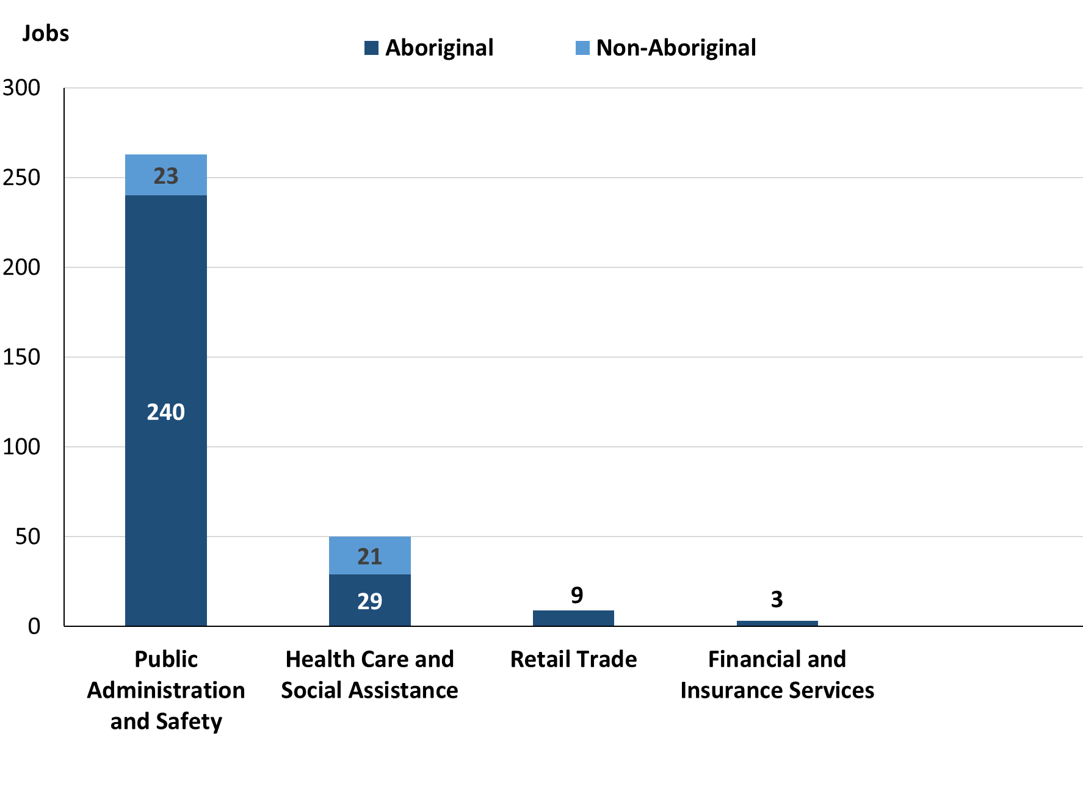

Source: Source: Northern Territory Department of Industry, Tourism and Trade

In 2023 in Wadeye:

* of the 281 **jobs filled** by **Aboriginal** people, there were:
* 240 jobs in Public Administration and Safety, an increase of 115 jobs from 2017 and an increase of 162 jobs from 2014
* 29 jobs in Health Care and Social Assistance, a decrease of 2 jobs from 2017 and a decrease of 5 jobs from 2014
* 9 jobs in Retail Trade, a decrease of 23 jobs from 2017 and an increase of 2 jobs from 2014
* of the 44 **jobs filled** by **non-Aboriginal** people, there were:
* 23 jobs in Public Administration and Safety, a decrease of 42 jobs from 2017 and a decrease of 31 jobs from 2014
* 21 jobs in Health Care and Social Assistance, a decrease of 12 jobs from 2017 and a decrease of 13 jobs from 2014.

Table 12: Count of filled jobs by industry and employment status, 2011 (a)(c)(e)(h)

|  |  |  |  |  |  |  |  |  |  |
| --- | --- | --- | --- | --- | --- | --- | --- | --- | --- |
| **Industry (ANZSIC division)** | **2011** | | | | | | | | |
| **Aboriginal** | | | **Non-Aboriginal** | | | **Total** | | |
| **Perm** | **Temp** | **Total** | **Perm** | **Temp** | **Total** | **Perm** | **Temp** | **Total** |
| Administrative and Support Services | 0 | 2 | **2** | 1 | 5 | **6** | 1 | 7 | **8** |
| Construction | 1 | 0 | **1** | 0 | 0 | **0** | 1 | 0 | **1** |
| Education and Training | 62 | 26 | **88** | 41 | 4 | **45** | 103 | 30 | **133** |
| Financial and Insurance Services | 3 | 0 | **3** | 0 | 0 | **0** | 3 | 0 | **3** |
| Health Care and Social Assistance | 7 | 21 | **28** | 8 | 5 | **13** | 15 | 26 | **41** |
| Other Services | 0 | 0 | **0** | 1 | 1 | **2** | 1 | 1 | **2** |
| Public Administration and Safety | 112 | 2 | **114** | 68 | 2 | **70** | 180 | 4 | **184** |
| Rental, Hiring and Real Estate Services | 0 | 0 | **0** | 1 | 2 | **3** | 1 | 2 | **3** |
| Retail Trade | 11 | 5 | **16** | 22 | 4 | **26** | 33 | 9 | **42** |
| Transport, Postal and Warehousing | 1 | 2 | **3** | 0 | 0 | **0** | 1 | 2 | **3** |
| **Total** | **198** | **58** | **256** | **145** | **23** | **168** | **343** | **81** | **424** |

Source: Northern Territory Department of Industry, Tourism and Trade

Table 13: Count of filled jobs by industry and employment status, 2014 (a)(c)(e)(h)

|  |  |  |  |  |  |  |  |  |  |
| --- | --- | --- | --- | --- | --- | --- | --- | --- | --- |
| **Industry (ANZSIC division)** | **2014** | | | | | | | | |
| **Aboriginal** | | | **Non-Aboriginal** | | | **Total** | | |
| **Perm** | **Temp** | **Total** | **Perm** | **Temp** | **Total** | **Perm** | **Temp** | **Total** |
| Accommodation and Food Services | 0 | 9 | **9** | 0 | 5 | **5** | 0 | 14 | **14** |
| Construction | 0 | 0 | **0** | 2 | 0 | **2** | 2 | 0 | **2** |
| Education and Training | 31 | 65 | **96** | 6 | 68 | **74** | 37 | 133 | **170** |
| Financial and Insurance Services | 2 | 0 | **2** | 0 | 0 | **0** | 2 | 0 | **2** |
| Health Care and Social Assistance | 25 | 9 | **34** | 27 | 7 | **34** | 52 | 16 | **68** |
| Public Administration and Safety | 32 | 46 | **78** | 22 | 32 | **54** | 54 | 78 | **132** |
| Rental, Hiring and Real Estate Services | 0 | 0 | **0** | 2 | 0 | **2** | 2 | 0 | **2** |
| Retail Trade | 6 | 1 | **7** | 22 | 4 | **26** | 28 | 5 | **33** |
| Transport, Postal and Warehousing | 1 | 2 | **3** | 0 | 0 | **0** | 1 | 2 | **3** |
| **Total** | **97** | **132** | **229** | **81** | **116** | **197** | **178** | **248** | **426** |

Source: Northern Territory Department of Industry, Tourism and Trade

Table 14: Count of filled jobs by industry and employment status, 2017 (a)(c)(e)(h)

|  |  |  |  |  |  |  |  |  |  |
| --- | --- | --- | --- | --- | --- | --- | --- | --- | --- |
| **Industry (ANZSIC division)** | **2017** | | | | | | | | |
| **Aboriginal** | | | **Non-Aboriginal** | | | **Total** | | |
| **Perm** | **Temp** | **Total** | **Perm** | **Temp** | **Total** | **Perm** | **Temp** | **Total** |
| Accommodation and Food Services | 0 | 8 | **8** | 0 | 6 | **6** | 0 | 14 | **14** |
| Education and Training | 0 | 92 | **92** | 0 | 66 | **66** | 0 | 158 | **158** |
| Electricity, Gas, Water and Waste Services | 0 | 0 | **0** | 1 | 0 | **1** | 1 | 0 | **1** |
| Financial and Insurance Services | 3 | 0 | **3** | 0 | 0 | **0** | 3 | 0 | **3** |
| Health Care and Social Assistance | 6 | 25 | **31** | 16 | 17 | **33** | 22 | 42 | **64** |
| Public Administration and Safety | 77 | 48 | **125** | 57 | 8 | **65** | 134 | 56 | **190** |
| Retail Trade | 16 | 16 | **32** | 30 | 8 | **38** | 46 | 24 | **70** |
| **Total** | **102** | **189** | **291** | **104** | **105** | **209** | **206** | **294** | **500** |

Source: Northern Territory Department of Industry, Tourism and Trade

Table 15: Count of filled jobs by industry and employment status, 2023 (a)(c)(e)(h)

|  |  |  |  |  |  |  |  |  |  |
| --- | --- | --- | --- | --- | --- | --- | --- | --- | --- |
| **Industry (ANZSIC division)** | **2023** | | | | | | | | |
| **Aboriginal** | | | **Non-Aboriginal** | | | **Total** | | |
| **Perm** | **Temp** | **Total** | **Perm** | **Temp** | **Total** | **Perm** | **Temp** | **Total** |
| Accommodation and Food Services | 0 | 0 | **0** | 0 | 0 | **0** | 0 | 0 | **0** |
| Education and Training | 0 | 0 | **0** | 0 | 0 | **0** | 0 | 0 | **0** |
| Electricity, Gas, Water and Waste Services | 0 | 0 | **0** | 0 | 0 | **0** | 0 | 0 | **0** |
| Financial and Insurance Services | 3 | 0 | **3** | 0 | 0 | **0** | 3 | 0 | **3** |
| Health Care and Social Assistance | 12 | 17 | **29** | 15 | 6 | **21** | 27 | 23 | **50** |
| Public Administration and Safety | 150 | 90 | **240** | 23 | 0 | **23** | 173 | 90 | **263** |
| Retail Trade | 2 | 7 | **9** | 0 | 0 | **0** | 2 | 7 | **9** |
| **Total** | **167** | **114** | **281** | **38** | **6** | **44** | **205** | **120** | **325** |

Source: Northern Territory Department of Industry, Tourism and Trade

In 2023 in Wadeye:

* of the 205 **permanent jobs**, there were:
* 173 jobs in Public Administration and Safety, an increase of 39 jobs from 2017 and an increase of 119 jobs from 2014, including:
* **Aboriginal** people filled 150 jobs, an increase of 73 jobs from 2017 and an increase of 118 jobs from 2014
* **non-Aboriginal** people filled 23 jobs, a decrease of 34 jobs from 2017 and an increase of 1 job from 2014
* 27 jobs in Health Care and Social Assistance, an increase of 5 jobs from 2017 and a decrease of 25 jobs from 2014, including:
* **Aboriginal** people filled 12 jobs, an increase of 6 jobs from 2017 and a decrease of 13 jobs from 2014
* **non-Aboriginal** people filled 15 jobs, a decrease of 1 job from 2017 and a decrease of 12 jobs from 2014
* 3 jobs in Financial and Insurance Services, unchanged from 2017 and an increase of 1 job from 2014, including:
* **Aboriginal** people filled 3 jobs, unchanged from 2017 and an increase of 1 job from 2014
* **non-Aboriginal** people filled 0 jobs, unchanged from 2017 and 2014
* of the 120 **temporary jobs**, there were:
* 90 jobs in Public Administration and Safety, an increase of 34 jobs from 2017 and an increase of 12 jobs from 2014, including:
* **Aboriginal** people filled 90 jobs, an increase of 42 jobs from 2017 and an increase of 44 jobs from 2014
* **non-Aboriginal** people filled 0 jobs, a decrease of 8 jobs from 2017 and a decrease of 32 jobs from 2014
* 23 jobs in Health Care and Social Assistance, a decrease of 19 jobs from 2017 and an increase of 7 jobs from 2014, including:
* **Aboriginal** people filled 17 jobs, a decrease of 8 jobs from 2017 and an increase of 8 jobs from 2014
* **non-Aboriginal** people filled 6 jobs, a decrease of 11 jobs from 2017 and a decrease of 1 job from 2014
* 7 jobs in Retail Trade, a decrease of 17 jobs from 2017 and an increase of 2 jobs from 2014, including
* **Aboriginal** people filled 7 jobs, a decrease of 9 jobs from 2017 and an increase of 6 jobs from 2014
* **non-Aboriginal** people filled 0 jobs, a decrease of 8 jobs from 2017 and a decrease of 4 jobs from 2014.

# Jobs by occupation

Table 16a: Count of filled jobs by occupation, 2011, 2014, 2017 & 2023 (a)(f)(g)

|  |  |  |  |  |  |  |  |  |
| --- | --- | --- | --- | --- | --- | --- | --- | --- |
| **Occupation (ANZSCO major group)** | **2011** | | **2014** | | **2017** | | **2023** | |
| **Total** | **% of Total** | **Total** | **% of Total** | **Total** | **% of Total** | **Total** | **% of Total** |
| Clerical and Administrative Workers | 39 | 9.2% | 41 | 9.6% | 68 | 13.6% | 89 | 27.4% |
| Community and Personal Service Workers | 124 | 29.2% | 159 | 37.3% | 156 | 31.2% | 46 | 14.2% |
| Labourers | 62 | 14.6% | 52 | 12.2% | 73 | 14.6% | 88 | 27.1% |
| Machinery Operators and Drivers | 2 | 0.5% | 7 | 1.6% | 8 | 1.6% | 4 | 1.2% |
| Managers | 24 | 5.7% | 25 | 5.9% | 33 | 6.6% | 17 | 5.2% |
| Professionals | 123 | 29.0% | 107 | 25.1% | 102 | 20.4% | 44 | 13.5% |
| Sales Workers | 30 | 7.1% | 17 | 4.0% | 27 | 5.4% | 0 | 0.0% |
| Technicians and Trades Workers | 16 | 3.8% | 18 | 4.2% | 33 | 6.6% | 37 | 11.4% |
| Other Occupations | 4 | 0.9% | 0 | 0.0% | 0 | 0.0% | 0 | 0.0% |
| **Total** | **424** | **100.0%** | **426** | **100.0%** | **500** | **100.0%** | **325** | **100.0%** |

Source: Northern Territory Department of Industry, Tourism and Trade

Table 16b: Count of filled jobs by occupation, 2011-2014, 2014-2017 & 2017-2023 (a)(f)(g)

|  |  |  |  |
| --- | --- | --- | --- |
| **Occupation (ANZSCO major group)** | **Change 2011-2014** | **Change 2014-2017** | **Change 2017-2023** |
| **Total** | **Total** | **Total** |
| Clerical and Administrative Workers | 2 | 27 | 21 |
| Community and Personal Service Workers | 35 | -3 | -110 |
| Labourers | -10 | 21 | 15 |
| Machinery Operators and Drivers | 5 | 1 | -4 |
| Managers | 1 | 8 | -16 |
| Professionals | -16 | -5 | -58 |
| Sales Workers | -13 | 10 | -27 |
| Technicians and Trades Workers | 2 | 15 | 4 |
| Other Occupations | -4 | 0 | 0 |
| **Total** | **2** | **74** | **-175** |

Source: Northern Territory Department of Industry, Tourism and Trade

Chart 10: Percentage and count of top 6 filled jobs by occupation, 2011, 2014, 2017 & 2023 (a)(f)(g)

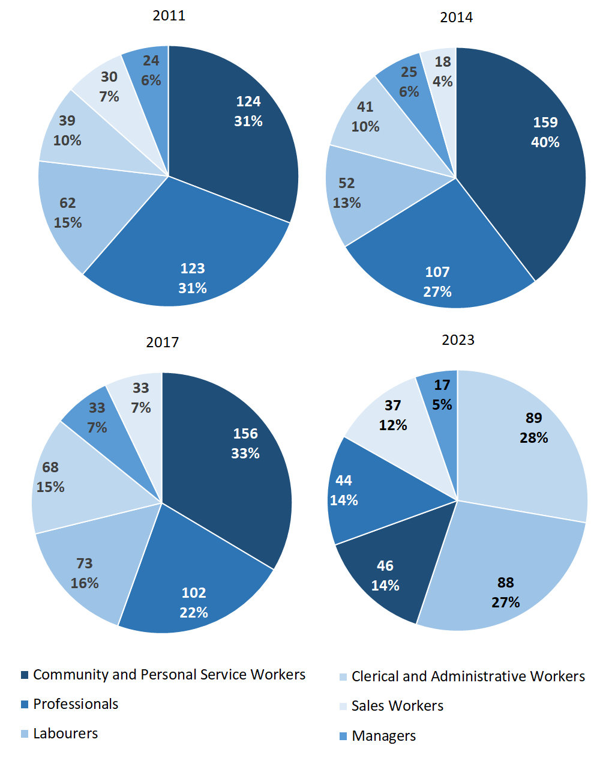

Source: Northern Territory Department of Industry, Tourism and Trade

In 2023 in Wadeye:

* Clerical and Administrative Workers was the **largest** **occupation** **classification** in terms of filled jobs, accounting for 89 jobs (27.4% of total filled jobs), an increase of 21 jobs from 2017 and an increase of 48 jobs from 2014,
* **other** **significant** occupation classifications were:
* Labourers accounting for 88 jobs or 27.1% of total jobs an increase of 15 jobs from 2017 and an increase of 36 jobs from 2014,
* Community and Personal Service Workers accounting for 46 jobs or 14.2% of total jobs a decrease of 110 jobs from 2017 and a decrease of 113 jobs from 2014,
* Professionals accounting for 44 jobs or 13.5% of total jobs a decrease of 58 jobs from 2017 and a decrease of 63 jobs from 2014.

**Table 17a: Count of filled jobs by ANZSCO occupation, 2011, 2014, 2017 & 2023 (a)(c)(f)(g)**

|  |  |  |  |  |  |  |  |  |  |  |  |  |
| --- | --- | --- | --- | --- | --- | --- | --- | --- | --- | --- | --- | --- |
| **Occupation (ANZSCO major group)** | **2011** | | | **2014** | | | **2017** | | | **2023** | | |
| **Aboriginal** | **Non-Aboriginal** | **Total** | **Aboriginal** | **Non-Aboriginal** | **Total** | **Aboriginal** | **Non-Aboriginal** | **Total** | **Aboriginal** | **Non-Aboriginal** | **Total** |
| Clerical and Administrative Workers | 21 | 18 | **39** | 21 | 20 | **41** | 48 | 20 | **68** | 81 | 8 | **89** |
| Community and Personal Service Workers | 102 | 22 | **124** | 115 | 44 | **159** | 115 | 41 | **156** | 33 | 13 | **46** |
| Labourers | 43 | 19 | **62** | 36 | 16 | **52** | 59 | 14 | **73** | 85 | 3 | **88** |
| Machinery Operators and Drivers | 2 | 0 | **2** | 3 | 4 | **7** | 2 | 6 | **8** | 3 | 1 | **4** |
| Managers | 2 | 22 | **24** | 1 | 24 | **25** | 5 | 28 | **33** | 12 | 5 | **17** |
| Professionals | 66 | 57 | **123** | 42 | 65 | **107** | 40 | 62 | **102** | 32 | 12 | **44** |
| Sales Workers | 15 | 15 | **30** | 4 | 13 | **17** | 9 | 18 | **27** | 0 | 0 | **0** |
| Technicians and Trades Workers | 2 | 14 | **16** | 7 | 11 | **18** | 13 | 20 | **33** | 35 | 2 | **37** |
| Other Occupations | 3 | 1 | **4** | 0 | 0 | **0** | 0 | 0 | **0** | 0 | 0 | **0** |
| **Total** | **256** | **168** | **424** | **229** | **197** | **426** | **291** | **209** | **500** | **281** | **44** | **325** |

Source: Northern Territory Department of Industry, Tourism and Trade

**Table 17b: Count of filled jobs by ANZSCO occupation, 2011-2014, 2014-2017 & 2017-2023 (a)(c)(f)(g)**

|  |  |  |  |  |  |  |  |  |  |
| --- | --- | --- | --- | --- | --- | --- | --- | --- | --- |
| **Occupation (ANZSCO major group)** | **Change 2011-2014** | | | **Change 2014-2017** | | | **Change 2017-2023** | | |
| **Aboriginal** | **Non-Aboriginal** | **Total** | **Aboriginal** | **Non-Aboriginal** | **Total** | **Aboriginal** | **Non-Aboriginal** | **Total** |
| Clerical and Administrative Workers | 0 | 2 | **2** | 27 | 0 | **27** | 33 | -12 | **21** |
| Community and Personal Service Workers | 13 | 22 | **35** | 0 | -3 | **-3** | -82 | -28 | **-110** |
| Labourers | -7 | -3 | **-10** | 23 | -2 | **21** | 26 | -11 | **15** |
| Machinery Operators and Drivers | 1 | 4 | **5** | -1 | 2 | **1** | 1 | -5 | **-4** |
| Managers | -1 | 2 | **1** | 4 | 4 | **8** | 7 | -23 | **-16** |
| Professionals | -24 | 8 | **-16** | -2 | -3 | **-5** | -8 | -50 | **-58** |
| Sales Workers | -11 | -2 | **-13** | 5 | 5 | **10** | -9 | -18 | **-27** |
| Technicians and Trades Workers | 5 | -3 | **2** | 6 | 9 | **15** | 22 | -18 | **4** |
| Other Occupations | -3 | -1 | **-4** | 0 | 0 | **0** | 0 | 0 | **0** |
| **Total** | **-27** | **29** | **2** | **62** | **12** | **74** | **-10** | **-165** | **-175** |

Source: Northern Territory Department of Industry, Tourism and Trade

In 2023 in Wadeye:

* of the 281 **jobs filled** by **Aboriginal** people, there were:
* 85 Labourers, an increase of 26 jobs from 2017 and an increase of 49 jobs from 2014
* 81 Clerical and Administrative Workers, an increase of 33 jobs from 2017 and an increase of 60 jobs from 2014
* 35 Technicians and Trades Workers, an increase of 22 jobs from 2017 and an increase of 28 jobs from 2014
* of the 44 **jobs filled** by **non-Aboriginal** people, there were:
* 13 Community and Personal Service Workers, a decrease of 28 jobs from 2017 and a decrease of 31 jobs from 2014
* 12 Professionals, a decrease of 50 jobs from 2017 and a decrease of 53 jobs from 2014
* 8 Clerical and Administrative Workers, a decrease of 12 jobs from 2017 and a decrease of 12 jobs from 2014.

# Jobs by industry by occupation

Table 18: Count of filled jobs by industry by occupation, 2011 (a)(f)(g)(h)

|  |  |  |  |  |  |  |  |  |  |  |  |
| --- | --- | --- | --- | --- | --- | --- | --- | --- | --- | --- | --- |
| **2011** | | | | | | | | | | | |
| **Industry (ANZSIC Division)** |  | **Occupation (ANZSCO major group)** | | | | | | | | | |
| **Clerical and Administrative Workers** | **Community and Personal Service Workers** | **Labourers** | **Machinery Operators and Drivers** | **Managers** | **Professionals** | **Sales Workers** | **Technicians and Trades Workers** | **Other Occupations** | **Total** |
| Administrative and Support Services | 2 | 1 | 0 | 0 | 0 | 5 | 0 | 0 | 0 | **8** |
| Construction | 0 | 0 | 0 | 0 | 0 | 1 | 0 | 0 | 0 | **1** |
| Education and Training | 2 | 72 | 14 | 0 | 2 | 43 | 0 | 0 | 0 | **133** |
| Financial and Insurance Services | 3 | 0 | 0 | 0 | 0 | 0 | 0 | 0 | 0 | **3** |
| Health Care and Social Assistance | 1 | 20 | 3 | 0 | 2 | 8 | 0 | 3 | 4 | **41** |
| Other Services | 0 | 0 | 0 | 0 | 0 | 2 | 0 | 0 | 0 | **2** |
| Public Administration and Safety | 28 | 30 | 38 | 0 | 11 | 63 | 2 | 12 | 0 | **184** |
| Rental, Hiring and Real Estate Services | 0 | 0 | 0 | 0 | 1 | 0 | 2 | 0 | 0 | **3** |
| Retail Trade | 2 | 0 | 5 | 0 | 8 | 0 | 26 | 1 | 0 | **42** |
| Transport, Postal and Warehousing | 1 | 0 | 0 | 2 | 0 | 0 | 0 | 0 | 0 | **3** |
| **Total** | **39** | **124** | **62** | **2** | **24** | **123** | **30** | **16** | **4** | **424** |

Source: Northern Territory Department of Industry, Tourism and Trade

Table 19: Count of filled jobs by industry by occupation, 2014 (a)(f)(g)(h)

|  |  |  |  |  |  |  |  |  |  |  |
| --- | --- | --- | --- | --- | --- | --- | --- | --- | --- | --- |
| **2014** | | | | | | | | | | |
| **Industry (ANZSIC Division)** |  | **Occupation (ANZSCO major group)** | | | | | | | | |
| **Clerical and Administrative Workers** | **Community and Personal Service Workers** | **Labourers** | **Machinery Operators and Drivers** | **Managers** | **Professionals** | **Sales Workers** | **Technicians and Trades Workers** | **Other Occupations** | **Total** |
| Accommodation and Food Services | 0 | 8 | 3 | 0 | 2 | 0 | 0 | 1 | 0 | **14** |
| Construction | 0 | 0 | 1 | 0 | 0 | 0 | 0 | 1 | 0 | **2** |
| Education and Training | 14 | 82 | 19 | 0 | 2 | 53 | 0 | 0 | 0 | **170** |
| Financial and Insurance Services | 2 | 0 | 0 | 0 | 0 | 0 | 0 | 0 | 0 | **2** |
| Health Care and Social Assistance | 5 | 33 | 5 | 3 | 7 | 14 | 0 | 1 | 0 | **68** |
| Public Administration and Safety | 16 | 36 | 18 | 2 | 7 | 40 | 1 | 12 | 0 | **132** |
| Rental, Hiring and Real Estate Services | 1 | 0 | 0 | 0 | 0 | 0 | 1 | 0 | 0 | **2** |
| Retail Trade | 2 | 0 | 4 | 2 | 7 | 0 | 15 | 3 | 0 | **33** |
| Transport, Postal and Warehousing | 1 | 0 | 2 | 0 | 0 | 0 | 0 | 0 | 0 | **3** |
| **Total** | **41** | **159** | **52** | **7** | **25** | **107** | **17** | **18** | **0** | **426** |

Source: Northern Territory Department of Industry, Tourism and Trade

Table 20: Count of filled jobs by occupation and by industry, 2017 (a)(f)(g)(h)

|  |  |  |  |  |  |  |  |  |  |  |
| --- | --- | --- | --- | --- | --- | --- | --- | --- | --- | --- |
| **2017** | | | | | | | | | | |
| **Industry (ANZSIC Division)** |  | **Occupation (ANZSCO major group)** | | | | | | | | |
| **Clerical and Administrative Workers** | **Community and Personal Service Workers** | **Labourers** | **Machinery Operators and Drivers** | **Managers** | **Professionals** | **Sales Workers** | **Technicians and Trades Workers** | **Other Occupations** | **Total** |
| Accommodation and Food Services | 1 | 8 | 2 | 0 | 1 | 0 | 0 | 2 | 0 | **14** |
| Education and Training | 16 | 69 | 13 | 0 | 5 | 50 | 0 | 5 | 0 | **158** |
| Electricity, Gas, Water and Waste Services | 0 | 0 | 0 | 0 | 0 | 0 | 0 | 1 | 0 | **1** |
| Financial and Insurance Services | 3 | 0 | 0 | 0 | 0 | 0 | 0 | 0 | 0 | **3** |
| Health Care and Social Assistance | 5 | 30 | 11 | 0 | 3 | 15 | 0 | 0 | 0 | **64** |
| Public Administration and Safety | 42 | 40 | 44 | 2 | 10 | 31 | 0 | 21 | 0 | **190** |
| Retail Trade | 1 | 9 | 3 | 6 | 14 | 6 | 27 | 4 | 0 | **70** |
| **Total** | **68** | **156** | **73** | **8** | **33** | **102** | **27** | **33** | **0** | **500** |

Source: Northern Territory Department of Industry, Tourism and Trade

Table 21: Count of filled jobs by occupation and by industry, 2023 (a)(f)(g)(h)

|  |  |  |  |  |  |  |  |  |  |  |  |
| --- | --- | --- | --- | --- | --- | --- | --- | --- | --- | --- | --- |
| **2023** | | | | | | | | | | | |
| **Industry (ANZSIC Division)** |  | **Occupation (ANZSCO major group)** | | | | | | | | | |
| **Clerical and Administrative Workers** | **Community and Personal Service Workers** | **Labourers** | **Machinery Operators and Drivers** | **Managers** | **Professionals** | **Sales Workers** | **Technicians and Trades Workers** | **Other Occupations** | **Total** |
| Accommodation and Food Services | 0 | 0 | 0 | 0 | 0 | 0 | 0 | 0 | 0 | **0** |
| Education and Training | 0 | 0 | 0 | 0 | 0 | 0 | 0 | 0 | 0 | **0** |
| Electricity, Gas, Water and Waste Services | 0 | 0 | 0 | 0 | 0 | 0 | 0 | 0 | 0 | **0** |
| Financial and Insurance Services | 3 | 0 | 0 | 0 | 0 | 0 | 0 | 0 | 0 | **3** |
| Health Care and Social Assistance | 8 | 0 | 13 | 0 | 6 | 21 | 0 | 2 | 0 | **50** |
| Public Administration and Safety | 75 | 46 | 75 | 4 | 11 | 17 | 0 | 35 | 0 | **263** |
| Retail Trade | 3 | 0 | 0 | 0 | 0 | 6 | 0 | 0 | 0 | **9** |
| **Total** | **89** | **46** | **88** | **4** | **17** | **44** | **0** | **37** | **0** | **325** |

Source: Northern Territory Department of Industry, Tourism and Trade

In 2023 in Wadeye:

* the largest occupation group, Clerical and Administrative Workers held the majority of jobs with 89 jobs which were shared across Public Administration and Safety with 75 jobs and Health Care and Social Assistance industries with 8 jobs,
* the largest industry group, Public Administration and Safety jobs held the majority of jobs with 263 jobs which were shared across Labourers, Clerical and Administrative Workers, Community and Personal Service Workers, and Technicians and Trades Workers occupation groups,
* Public Administration and Safety had an increase in filled jobs of 73 between 2023 and 2017,
* Community and Personal Service Workers occupation group had a decrease in filled jobs of 110 between 2023 and 2017.

# Jobs by gender

Table 22a: Count of filled jobs by gender, 2011, 2014, 2017 & 2023 (a)(c)(i)

|  |  |  |  |  |  |  |  |  |  |  |  |  |  |  |  |
| --- | --- | --- | --- | --- | --- | --- | --- | --- | --- | --- | --- | --- | --- | --- | --- |
| **Indicator** | **2011** | | | | **2014** | | | | **2017** | | | | **2023** | | |
| **Aboriginal** | **Non-Aboriginal** | **Total** | **Aboriginal** | | **Non-Aboriginal** | **Total** | **Aboriginal** | | **Non-Aboriginal** | **Total** | **Aboriginal** | | **Non-Aboriginal** | **Total** |
| Male | 95 | 77 | **172** | 127 | | 91 | **218** | 115 | | 103 | **218** | 131 | | 21 | **152** |
| Female | 74 | 51 | **125** | 102 | | 106 | **208** | 176 | | 106 | **282** | 143 | | 23 | **166** |
| **Total** | **256** | **168** | **424** | **229** | | **197** | **426** | **291** | | **209** | **500** | **281** | | **44** | **325** |

Source: Northern Territory Department of Industry, Tourism and Trade

Table 22b: Count of filled jobs by gender, 2011-2014, 2014-2017 & 2017-2023 (a)(c)(i)

|  |  |  |  |  |  |  |  |  |  |
| --- | --- | --- | --- | --- | --- | --- | --- | --- | --- |
| **Indicator** | **2011-2014 Change** | | | **2014-2017 Change** | | | **2017-2023 Change** | | |
| **Aboriginal** | **Non-Aboriginal** | **Total** | **Aboriginal** | **Non-Aboriginal** | **Total** | **Aboriginal** | **Non-Aboriginal** | **Total** |
| Male | 32 | 14 | **46** | -12 | 12 | **0** | 16 | -82 | **-66** |
| Female | 28 | 55 | **83** | 74 | 0 | **74** | -33 | -83 | **-116** |
| **Total** | **-27** | **29** | **2** | **62** | **12** | **74** | **-10** | **-165** | **-175** |

Source: Northern Territory Department of Industry, Tourism and Trade

Chart 11: Count of filled jobs by gender, 2011, 2014, 2017 & 2023 (a)(c)(i)

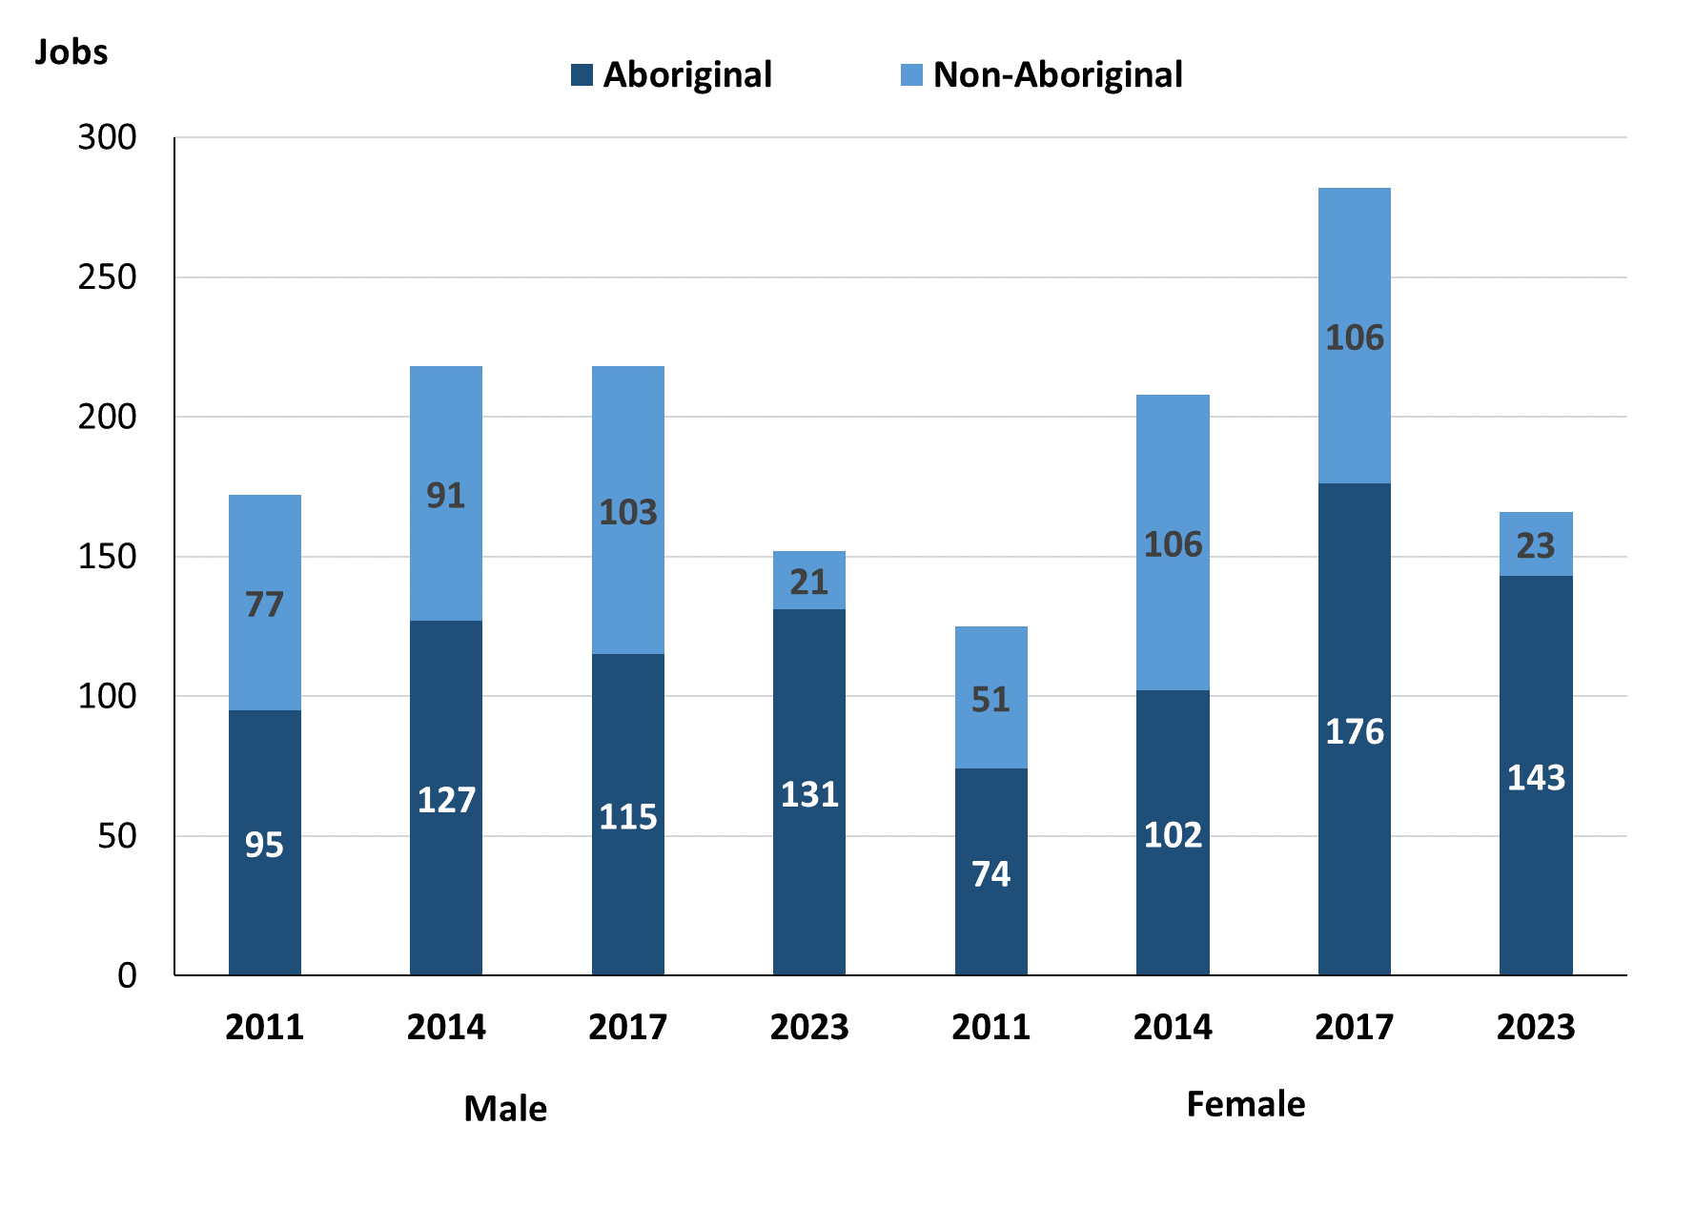

Source: Northern Territory Department of Industry, Tourism and Trade

In 2023 in Wadeye:

* there were 152 jobs **filled** **by** **males**, a decrease of 66 jobs from 2017 and a decrease of 66 jobs from 2014
* of the 152 jobs **filled by males:**
* 131 were **Aboriginal**, an increase of 16 jobs from 2017 and an increase of 4 jobs from 2014
* 21 were **non-Aboriginal**, a decrease of 82 jobs from 2017 and a decrease of 70 jobs from 2014
* there were 166 jobs **filled** **by** **females**, a decrease of 116 jobs from 2017 and a decrease of 42 jobs from 2014
* of the 166 jobs **filled by females**:
* 143 were **Aboriginal**, a decrease of 33 jobs from 2017 and an increase of 41 jobs from 2014
* 23 were **non-Aboriginal**, a decrease of 83 jobs from 2017 and a decrease of 83 jobs from 2014.

Table 23: Count of filled jobs by gender, by full-time/part-time status, by job permanency and by sector 2011 (a)(b)(c)(d)(e)(i)

|  |  |  |  |  |  |  |  |  |  |
| --- | --- | --- | --- | --- | --- | --- | --- | --- | --- |
| **2011** | | | | | | | | | |
| **Indicator** | **Male** | | | **Female** | | | **Total** | | |
| **Aboriginal** | **Non-Aboriginal** | **Total** | **Aboriginal** | **Non-Aboriginal** | **Total** | **Aboriginal** | **Non-Aboriginal** | **Total** |
| Full-time | 66 | 74 | **140** | 49 | 47 | **96** | 177 | 161 | **338** |
| Part-time | 29 | 3 | **32** | 25 | 4 | **29** | 79 | 7 | **86** |
| **Total** | **95** | **77** | **172** | **74** | **51** | **125** | **256** | **168** | **424** |
| Permanent | 81 | 65 | **146** | 55 | 40 | **95** | 198 | 145 | **343** |
| Temporary | 14 | 12 | **26** | 19 | 11 | **30** | 58 | 23 | **81** |
| **Total** | **95** | **77** | **172** | **74** | **51** | **125** | **256** | **168** | **424** |
| Public Sector | 55 | 25 | **80** | 23 | 12 | **35** | 78 | 37 | **115** |
| Private Sector | 40 | 52 | **92** | 51 | 39 | **90** | 178 | 131 | **309** |
| **Total** | **95** | **77** | **172** | **74** | **51** | **125** | **256** | **168** | **424** |

Source: Northern Territory Department of Industry, Tourism and Trade

Table 24: Count of filled jobs by gender, by full-time/part-time status, by job permanency and by sector 2014 (a)(b)(c)(d)(e)(i)

|  |  |  |  |  |  |  |  |  |  |  |
| --- | --- | --- | --- | --- | --- | --- | --- | --- | --- | --- |
| **2014** | | | | | | | | | | |
| **Indicator** | **Male** | | | **Female** | | | **Total** | | | |
| **Aboriginal** | **Non-Aboriginal** | **Total** | **Aboriginal** | **Non-Aboriginal** | **Total** | **Aboriginal** | **Non-Aboriginal** | **Total** |
| Full-time | 74 | 86 | **160** | 48 | 89 | **137** | 122 | 175 | **297** |
| Part-time | 53 | 5 | **58** | 54 | 17 | **71** | 107 | 22 | **129** |
| **Total** | **127** | **91** | **218** | **102** | **106** | **208** | **229** | **197** | **426** |
| Permanent | 52 | 33 | **85** | 45 | 48 | **93** | 97 | 81 | **178** |
| Temporary | 75 | 58 | **133** | 57 | 58 | **115** | 132 | 116 | **248** |
| **Total** | **127** | **91** | **218** | **102** | **106** | **208** | **229** | **197** | **426** |
| Public Sector | 31 | 27 | **58** | 28 | 25 | **53** | 59 | 52 | **111** |
| Private Sector | 96 | 64 | **160** | 74 | 81 | **155** | 170 | 145 | **315** |
| **Total** | **127** | **91** | **218** | **102** | **106** | **208** | **229** | **197** | **426** |

Source: Northern Territory Department of Industry, Tourism and Trade

Table 25: Count of filled jobs by gender, by full-time/part-time status, by job permanency and by sector 2017 (a)(b)(c)(d)(e)(i)

|  |  |  |  |  |  |  |  |  |  |
| --- | --- | --- | --- | --- | --- | --- | --- | --- | --- |
| **2017** | | | | | | | | | |
| **Indicator** | **Male** | | | **Female** | | | **Total** | | |
| **Aboriginal** | **Non-Aboriginal** | **Total** | **Aboriginal** | **Non-Aboriginal** | **Total** | **Aboriginal** | **Non-Aboriginal** | **Total** |
| Full-time | 51 | 100 | **151** | 48 | 96 | **144** | 99 | 196 | **295** |
| Part-time | 64 | 3 | **67** | 128 | 10 | **138** | 192 | 13 | **205** |
| **Total** | **115** | **103** | **218** | **176** | **106** | **282** | **291** | **209** | **500** |
| Permanent | 60 | 50 | **110** | 42 | 54 | **96** | 102 | 104 | **206** |
| Temporary | 55 | 53 | **108** | 134 | 52 | **186** | 189 | 105 | **294** |
| **Total** | **115** | **103** | **218** | **176** | **106** | **282** | **291** | **209** | **500** |
| Public Sector | 18 | 22 | **40** | 29 | 21 | **50** | 47 | 43 | **90** |
| Private Sector | 97 | 81 | **178** | 147 | 85 | **232** | 244 | 166 | **410** |
| **Total** | **115** | **103** | **218** | **176** | **106** | **282** | **291** | **209** | **500** |

Source: Northern Territory Department of Industry, Tourism and Trade

Table 26: Count of filled jobs by gender, by full-time/part-time status, by job permanency and by sector 2023 (a)(b)(c)(d)(e)(i)

|  |  |  |  |  |  |  |  |  |  |
| --- | --- | --- | --- | --- | --- | --- | --- | --- | --- |
| **2023** | | | | | | | | | |
| **Indicator** | **Male** | | | **Female** | | | **Total** | | |
| **Aboriginal** | **Non-Aboriginal** | **Total** | **Aboriginal** | **Non-Aboriginal** | **Total** | **Aboriginal** | **Non-Aboriginal** | **Total** |
| Full-time | 129 | 20 | **149** | 119 | 23 | **142** | 255 | 43 | **298** |
| Part-time | 2 | 1 | **3** | 24 | 0 | **24** | 26 | 1 | **27** |
| **Total** | **131** | **21** | **152** | **143** | **23** | **166** | **281** | **44** | **325** |
| Permanent | 77 | 17 | **94** | 87 | 21 | **108** | 167 | 38 | **205** |
| Temporary | 54 | 4 | **58** | 56 | 2 | **58** | 114 | 6 | **120** |
| **Total** | **131** | **21** | **152** | **143** | **23** | **166** | **281** | **44** | **325** |
| Public Sector | 106 | 4 | **110** | 121 | 18 | **139** | 234 | 22 | **256** |
| Private Sector | 25 | 17 | **42** | 22 | 5 | **27** | 47 | 22 | **69** |
| **Total** | **131** | **21** | **152** | **143** | **23** | **166** | **281** | **44** | **325** |

Source: Northern Territory Department of Industry, Tourism and Trade

In 2023 in Wadeye:

* of the 152 **jobs** **filled** **by** **males**, there were:
* 131 jobs filled by **Aboriginal** **males,** an increase of 16 jobs from 2017 and an increase of 4 jobs from 2014, including:
* 129 full-time jobs, an increase of 78 jobs from 2017 and an increase of 55 jobs from 2014
* 2 part-time jobs, a decrease of 62 jobs from 2017 and a decrease of 51 jobs from 2014
* 77 permanent jobs, an increase of 17 jobs from 2017 and an increase of 25 jobs from 2014
* 54 temporary jobs, a decrease of 1 job from 2017 and a decrease of 21 jobs from 2014
* 106 Public Sector jobs, an increase of 88 jobs from 2017 and an increase of 75 jobs from 2014
* 25 Private Sector jobs, a decrease of 72 jobs from 2017 and a decrease of 71 jobs from 2014
* 21 **jobs filled by non-Aboriginal males**, a decrease of 82 jobs from 2017 and a decrease of 70 jobs from 2014, including:
* 20 full-time jobs, a decrease of 80 jobs from 2017 and a decrease of 66 jobs from 2014
* 1 part-time job, a decrease of 2 jobs from 2017 and a decrease of 4 jobs from 2014
* 17 permanent jobs, a decrease of 33 jobs from 2017 and a decrease of 16 jobs from 2014
* 4 temporary jobs, a decrease of 49 jobs from 2017 and a decrease of 54 jobs from 2014
* 4 Public Sector jobs, a decrease of 18 jobs from 2017 and a decrease of 23 jobs from 2014
* 17 Private Sector jobs, a decrease of 64 jobs from 2017 and a decrease of 47 jobs from 2014
* of the 166 **jobs** **filled** **by** **females**, there were:
* 143 jobs filled by Aboriginal females, a decrease of 33 jobs from 2017 and an increase of 41 jobs from 2014, including:
* 119 full-time jobs, an increase of 71 jobs from 2017 and an increase of 71 jobs from 2014
* 24 part-time jobs, a decrease of 104 jobs from 2017 and a decrease of 30 jobs from 2014
* 87 permanent jobs, an increase of 45 jobs from 2017 and an increase of 42 jobs from 2014
* 56 temporary jobs, a decrease of 78 jobs from 2017 and a decrease of 1 from 2014
* 121 Public Sector jobs, an increase of 92 jobs from 2017 and an increase of 93 jobs from 2014
* 22 Private Sector jobs, a decrease of 125 jobs from 2017 and a decrease of 52 jobs from 2014
* 23 jobs filled by **non-Aboriginal females**, a decrease of 83 jobs from 2017 and a decrease of 83 jobs from 2014, including:
* 23 full-time jobs, a decrease of 73 jobs from 2017 and a decrease of 66 jobs from 2014
* 0 part-time jobs, a decrease of 10 jobs from 2017 and a decrease of 17 jobs from 2014
* 21 permanent jobs, a decrease of 33 jobs from 2017 and a decrease of 27 jobs from 2014
* 2 temporary jobs, a decrease of 50 jobs from 2017 and a decrease of 56 jobs from 2014
* 18 Public Sector jobs, a decrease of 3 jobs from 2017 and a decrease of 7 jobs from 2014
* 5 Private Sector jobs, a decrease of 80 jobs from 2017 and a decrease of 76 jobs from 2014.

# Jobs by age

Table 27a: Count of filled jobs by age, 2011, 2014, 2017 & 2023 (a)(c)(j)

|  |  |  |  |  |  |  |  |  |  |  |  |  |
| --- | --- | --- | --- | --- | --- | --- | --- | --- | --- | --- | --- | --- |
| **Indicator** | **2011** | | | **2014** | | | **2017** | | | **2023** | | |
| **Aboriginal** | **Non-Aboriginal** | **Total** | **Aboriginal** | **Non-Aboriginal** | **Total** | **Aboriginal** | **Non-Aboriginal** | **Total** | **Aboriginal** | **Non-Aboriginal** | **Total** |
| 15-24 years | 25 | 7 | **32** | 5 | 14 | **19** | 25 | 8 | **33** | 6 | 1 | **7** |
| 25-44 years | 84 | 64 | **148** | 150 | 91 | **241** | 199 | 135 | **334** | 37 | 23 | **60** |
| 45+ years | 60 | 57 | **117** | 74 | 92 | **166** | 67 | 66 | **133** | 24 | 17 | **41** |
| **Total** | **256** | **168** | **424** | **229** | **197** | **426** | **291** | **209** | **500** | **281** | **44** | **325** |

Source: Northern Territory Department of Industry, Tourism and Trade

Table 27b: Count of filled jobs by age, 2011-2014, 2014-2017 & 2017-2023 (a)(c)(j)

|  |  |  |  |  |  |  |  |  |  |
| --- | --- | --- | --- | --- | --- | --- | --- | --- | --- |
| **Indicator** | **Change 2011-2014** | | | **Change 2014-2017** | | | **Change 2017-2023** | | |
| **Aboriginal** | **Non-Aboriginal** | **Total** | **Aboriginal** | **Non-Aboriginal** | **Total** | **Aboriginal** | **Non-Aboriginal** | **Total** |
| 15-24 years | -20 | 7 | **-13** | 20 | -6 | **14** | -19 | -7 | **-26** |
| 25-44 years | 66 | 27 | **93** | 49 | 44 | **93** | -162 | -112 | **-274** |
| 45+ years | 14 | 35 | **49** | -7 | -26 | **-33** | -43 | -49 | **-92** |
| **Total** | **-27** | **29** | **2** | **62** | **12** | **74** | **-10** | **-165** | **-175** |

Source: Northern Territory Department of Industry, Tourism and Trade

Chart 12: Count of filled jobs by age, 2011, 2014, 2017 & 2023 (a)(c)(j)

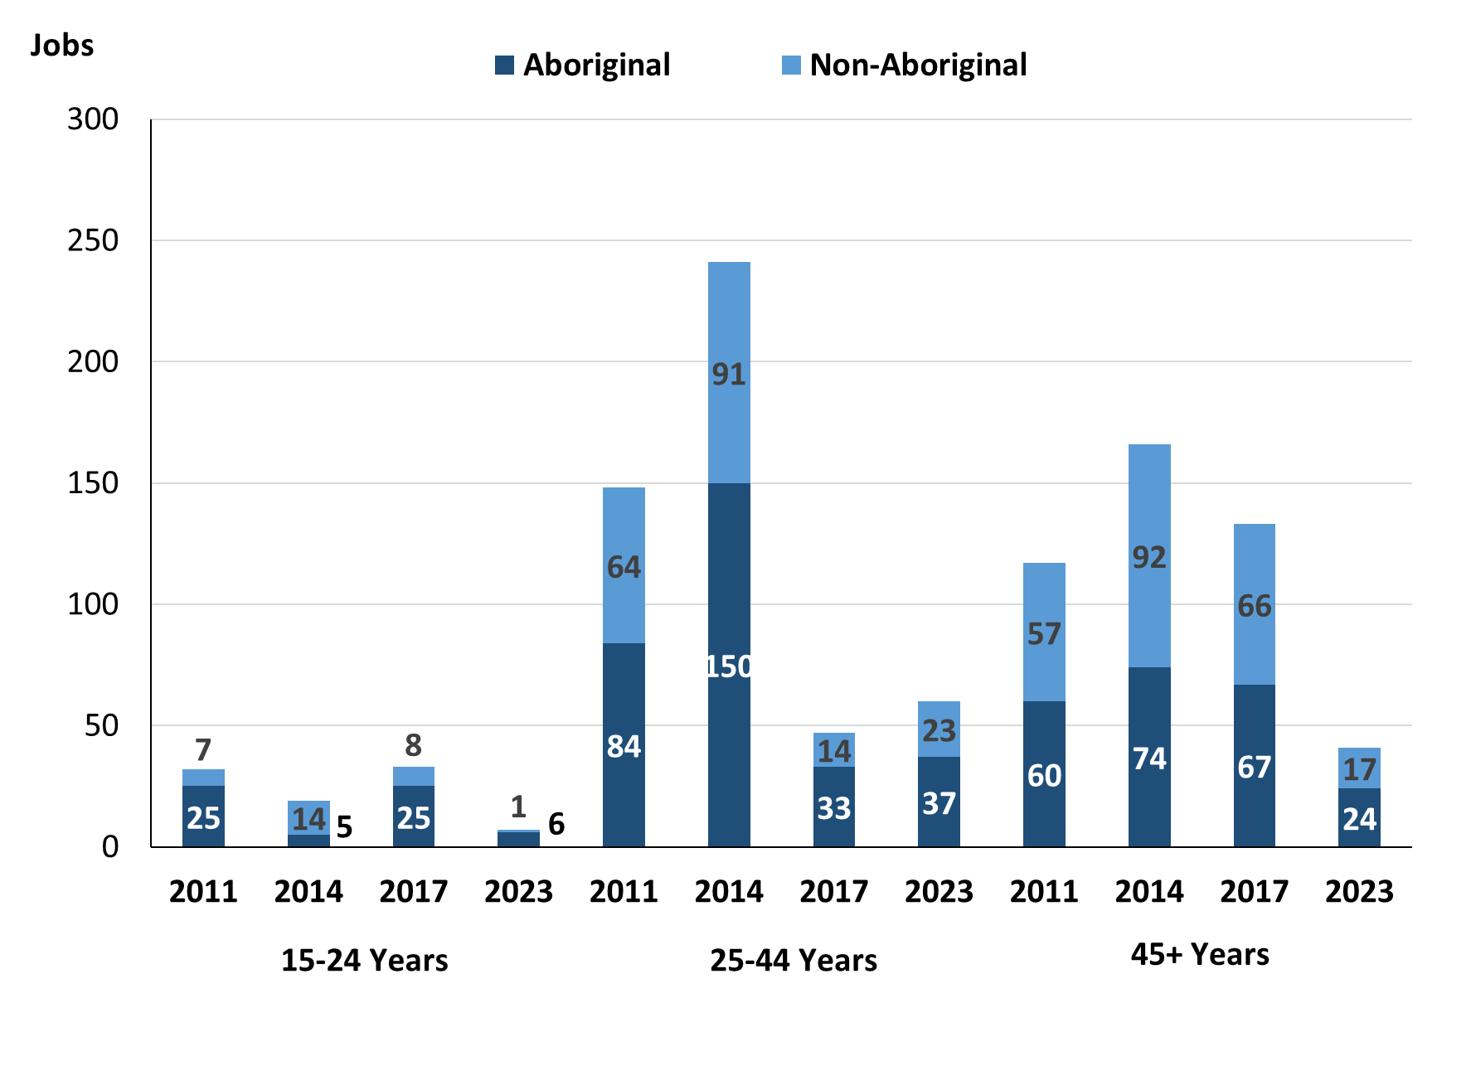

Source: Northern Territory Department of Industry, Tourism and Trade

In 2023 in Wadeye:

* there were 7 **jobs** filled by people aged **15-24 years,** a decrease of 26 jobs from 2017 and a decrease of 12 jobs from 2014. Of these:
* **Aboriginal** people filled 6 jobs, a decrease of 19 jobs from 2017 and an increase of 1 job from 2014
* a **non-Aboriginal** person filled 1 job, a decrease of 7 jobs from 2017 and a decrease of 13 jobs from 2014
* there were 60 **jobs** **filled** by people aged **25-44 years**, a decrease of 274 jobs from 2017 and a decrease of 181 jobs from 2014. Of these:
* **Aboriginal** people filled 37 jobs, a decrease of 162 jobs from 2017 and a decrease of 113 jobs from 2014
* **non-Aboriginal** people filled 23 jobs, a decrease of 112 jobs from 2017 and a decrease of 68 jobs from 2014
* there were 41 **jobs** **filled** by people aged **45+ years**, a decrease of 92 jobs from 2017 and a decrease of 125 jobs from 2014. Of these:
* **Aboriginal** people filled 24 jobs, a decrease of 43 jobs from 2017 and a decrease of 50 jobs from 2014
* **non-Aboriginal** people filled 17 jobs, a decrease of 49 jobs from 2017 and a decrease of 75 jobs from 2014.

Table 28: Count of filled jobs by age, by full-time/part-time status, by job permanency and by sector June-July 2011 (a)(b)(c)(d)(e)(i)

|  |  |  |  |  |  |  |  |  |  |  |  |  |  |
| --- | --- | --- | --- | --- | --- | --- | --- | --- | --- | --- | --- | --- | --- |
| **2011** | | | | | | | | | | | | | |
| **Indicator** | **15-24 years** | | | **25-44 years** | | | **45+ years** | | | **Total** | | | |
| **Aboriginal** | **Non-Aboriginal** | **Total** | **Aboriginal** | **Non-Aboriginal** | **Total** | **Aboriginal** | **Non-Aboriginal** | **Total** | **Aboriginal** | **Non-Aboriginal** | **Total** |
| Full-time | 20 | 6 | **26** | 55 | 60 | **115** | 40 | 55 | **95** | 177 | 161 | **338** |
| Part-time | 5 | 1 | **6** | 29 | 4 | **33** | 20 | 2 | **22** | 79 | 7 | **86** |
| **Total** | **25** | **7** | **32** | **84** | **64** | **148** | **60** | **57** | **117** | **256** | **168** | **424** |
| Permanent | 23 | 5 | **28** | 62 | 56 | **118** | 51 | 44 | **95** | 198 | 145 | **343** |
| Temporary | 2 | 2 | **4** | 22 | 8 | **30** | 9 | 13 | **22** | 58 | 23 | **81** |
| **Total** | **25** | **7** | **32** | **84** | **64** | **148** | **60** | **57** | **117** | **256** | **168** | **424** |
| Public Sector | 3 | 5 | **8** | 40 | 14 | **54** | 35 | 18 | **53** | 78 | 37 | **115** |
| Private Sector | 22 | 2 | **24** | 44 | 50 | **94** | 25 | 39 | **64** | 178 | 131 | **309** |
| **Total** | **25** | **7** | **32** | **84** | **64** | **148** | **60** | **57** | **117** | **256** | **168** | **424** |

Source: Northern Territory Department of Industry, Tourism and Trade

Table 29: Count of filled jobs by age, by full-time/part-time status, by job permanency and by sector June-July 2014 (a)(b)(c)(d)(e)(i)

|  |  |  |  |  |  |  |  |  |  |  |  |  |  |
| --- | --- | --- | --- | --- | --- | --- | --- | --- | --- | --- | --- | --- | --- |
| **2014** | | | | | | | | | | | | | |
| **Indicator** | **15-24 years** | | | **25-44 years** | | | **45+ years** | | | **Total** | | | |
| **Aboriginal** | **Non-Aboriginal** | **Total** | **Aboriginal** | **Non-Aboriginal** | **Total** | **Aboriginal** | **Non-Aboriginal** | **Total** | **Aboriginal** | **Non-Aboriginal** | **Total** |
| Full-time | 2 | 12 | **14** | 79 | 84 | **163** | 41 | 79 | **120** | 122 | 175 | **297** |
| Part-time | 3 | 2 | **5** | 71 | 7 | **78** | 33 | 13 | **46** | 107 | 22 | **129** |
| **Total** | **5** | **14** | **19** | **150** | **91** | **241** | **74** | **92** | **166** | **229** | **197** | **426** |
| Permanent | 2 | 9 | **11** | 51 | 39 | **90** | 44 | 33 | **77** | 97 | 81 | **178** |
| Temporary | 3 | 5 | **8** | 99 | 52 | **151** | 30 | 59 | **89** | 132 | 116 | **248** |
| **Total** | **5** | **14** | **19** | **150** | **91** | **241** | **74** | **92** | **166** | **229** | **197** | **426** |
| Public Sector | 1 | 1 | **2** | 34 | 26 | **60** | 24 | 25 | **49** | 59 | 52 | **111** |
| Private Sector | 4 | 13 | **17** | 116 | 65 | **181** | 50 | 67 | **117** | 170 | 145 | **315** |
| **Total** | **5** | **14** | **19** | **150** | **91** | **241** | **74** | **92** | **166** | **229** | **197** | **426** |

Source: Northern Territory Department of Industry, Tourism and Trade

Table 30: Count of filled jobs by age, by full-time/part-time status, by job permanency and by sector June-July 2017 (a)(b)(c)(d)(e)(i)

|  |  |  |  |  |  |  |  |  |  |  |  |  |  |
| --- | --- | --- | --- | --- | --- | --- | --- | --- | --- | --- | --- | --- | --- |
| **2017** | | | | | | | | | | | | | |
| **Indicator** | **15-24 years** | | | **25-44 years** | | | **45+ years** | | | **Total** | | |
| **Aboriginal** | **Non-Aboriginal** | **Total** | **Aboriginal** | **Non-Aboriginal** | **Total** | **Aboriginal** | **Non-Aboriginal** | **Total** | **Aboriginal** | **Non-Aboriginal** | **Total** |
| Full-time | 6 | 8 | **14** | 62 | 126 | **188** | 31 | 62 | **93** | 99 | 196 | **295** |
| Part-time | 19 | 0 | **19** | 137 | 9 | **146** | 36 | 4 | **40** | 192 | 13 | **205** |
| **Total** | **25** | **8** | **33** | **199** | **135** | **334** | **67** | **66** | **133** | **291** | **209** | **500** |
| Permanent | 5 | 5 | **10** | 82 | 73 | **155** | 15 | 26 | **41** | 102 | 104 | **206** |
| Temporary | 20 | 3 | **23** | 117 | 62 | **179** | 52 | 40 | **92** | 189 | 105 | **294** |
| **Total** | **25** | **8** | **33** | **199** | **135** | **334** | **67** | **66** | **133** | **291** | **209** | **500** |
| Public Sector | 3 | 0 | **3** | 28 | 20 | **48** | 16 | 23 | **39** | 47 | 43 | **90** |
| Private Sector | 22 | 8 | **30** | 171 | 115 | **286** | 51 | 43 | **94** | 244 | 166 | **410** |
| **Total** | **25** | **8** | **33** | **199** | **135** | **334** | **67** | **66** | **133** | **291** | **209** | **500** |

Source: Northern Territory Department of Industry, Tourism and Trade

Table 31: Count of filled jobs by age, by full-time/part-time status, by job permanency and by sector September 2023 (a)(b)(c)(d)(e)(i)

|  |  |  |  |  |  |  |  |  |  |  |  |  |
| --- | --- | --- | --- | --- | --- | --- | --- | --- | --- | --- | --- | --- |
| **2023** | | | | | | | | | | | | |
| **Indicator** | **15-24 years** | | | **25-44 years** | | | **45+ years** | | | **Total** | | |
| **Aboriginal** | **Non-Aboriginal** | **Total** | **Aboriginal** | **Non-Aboriginal** | **Total** | **Aboriginal** | **Non-Aboriginal** | **Total** | **Aboriginal** | **Non-Aboriginal** | **Total** |
| Full-time | 4 | 1 | **5** | 22 | 22 | **44** | 15 | 17 | **32** | 255 | 43 | **298** |
| Part-time | 2 | 0 | **2** | 15 | 1 | **16** | 9 | 0 | **9** | 26 | 1 | **27** |
| **Total** | **6** | **1** | **7** | **37** | **23** | **60** | **24** | **17** | **41** | **281** | **44** | **325** |
| Permanent | 5 | 1 | **6** | 19 | 20 | **39** | 13 | 14 | **27** | 167 | 38 | **205** |
| Temporary | 1 | 0 | **1** | 18 | 3 | **21** | 11 | 3 | **14** | 114 | 6 | **120** |
| **Total** | **6** | **1** | **7** | **37** | **23** | **60** | **24** | **17** | **41** | **281** | **44** | **325** |
| Public Sector | 2 | 1 | **3** | 14 | 9 | **23** | 5 | 9 | **14** | 234 | 22 | **256** |
| Private Sector | 4 | 0 | **4** | 23 | 14 | **37** | 19 | 8 | **27** | 47 | 22 | **69** |
| **Total** | **6** | **1** | **7** | **37** | **23** | **60** | **24** | **17** | **41** | **281** | **44** | **325** |

Source: Northern Territory Department of Industry, Tourism and Trade

In 2023 in Wadeye:

* of the 7 **jobs** **filled** by people aged **15-24 years**, there were:
* 6 jobs filled by **Aboriginal** people, of which
* 4 were full-time jobs, a decrease of 2 jobs from 2017 and an increase of 2 jobs from 2014
* 2 were part-time jobs, a decrease of 17 jobs from 2017 and a decrease of 1 job from 2014
* 5 were permanent jobs, unchanged from 2017 and an increase of 3 jobs from 2014
* 1 was a temporary job, a decrease of 19 jobs from 2017 and a decrease of 2 jobs from 2014
* 2 were Public Sector jobs, a decrease of 1 job from 2017 and an increase of 1 job from 2014
* 4 were Private Sector jobs, a decrease of 18 jobs from 2017 and unchanged from 2014
* 1 job filled by a **non-Aboriginal** person, of which:
* 1 was a full-time job, a decrease of 7 jobs from 2017 and a decrease of 11 jobs from 2014
* none were part-time jobs, unchanged from 2017 and a decrease of 2 jobs from 2014
* 1 was a permanent job, a decrease of 4 jobs from 2017 and a decrease of 8 jobs from 2014
* none were temporary jobs, a decrease of 3 jobs from 2017 and a decrease of 5 jobs from 2014
* 1 was a Public Sector job, an increase of 1 job from 2017 and unchanged from 2014
* none were Private Sector jobs, a decrease of 8 jobs from 2017 and a decrease of 13 jobs from 2014
* of the 60 **jobs** **filled** by people aged **25-44 years**, there were:
* 37 jobs filled by **Aboriginal** people, of which:
* 22 were full-time jobs, a decrease of 40 jobs from 2017 and a decrease of 57 jobs from 2014
* 15 were part-time jobs, a decrease of 122 jobs from 2017 and a decrease of 56 jobs from 2014
* 19 were permanent jobs, a decrease of 63 jobs from 2017 and a decrease of 32 jobs from 2014
* 18 were temporary jobs, a decrease of 99 jobs from 2017 and a decrease of 81 jobs from 2014
* 14 were Public Sector jobs, a decrease of 14 jobs from 2017 and a decrease of 20 jobs from 2014
* 23 were Private Sector jobs, a decrease of 148 jobs from 2017 and a decrease of 93 jobs from 2014
* 23 jobs filled by **non-Aboriginal** people, of which:
* 22 were full-time jobs, a decrease of 104 jobs from 2017 and a decrease of 62 jobs from 2014
* 1 was a part-time job, a decrease of 8 jobs from 2017 and a decrease of 6 jobs from 2014
* 20 were permanent jobs, a decrease of 53 jobs from 2017 and a decrease of 19 jobs from 2014
* 3 were temporary jobs, a decrease of 59 jobs from 2017 and a decrease of 49 jobs from 2014
* 9 were Public Sector jobs, a decrease of 11 jobs from 2017 and a decrease of 17 jobs from 2014
* 14 were Private Sector jobs, a decrease of 101 jobs from 2017 and a decrease of 51 jobs from 2014
* of the 41 **jobs** **filled** by people aged **45+ years**, there were:
* 24 jobs filled by **Aboriginal** people, of which:
* 15 were full-time jobs, a decrease of 16 jobs from 2017 and a decrease of 26 jobs from 2014
* 9 were part-time jobs, a decrease of 27 jobs from 2017 and a decrease of 24 jobs from 2014
* 13 were permanent jobs, a decrease of 2 jobs from 2017 and a decrease of 31 jobs from 2014
* 11 were temporary jobs, a decrease of 41 jobs from 2017 and a decrease of 19 jobs from 2014
* 5 were Public Sector jobs, a decrease of 11 jobs from 2017 and a decrease of 19 jobs from 2014
* 19 were Private Sector jobs, a decrease of 32 jobs from 2017 and a decrease of 31 jobs from 2014
* 17 jobs filled by **non-Aboriginal** people, of which:
* 17 were full-time jobs, a decrease of 45 jobs from 2017 and a decrease of 62 jobs from 2014
* none were part-time jobs, a decrease of 4 jobs from 2017 and a decrease of 13 jobs from 2014
* 14 were permanent jobs, a decrease of 12 jobs from 2017 and a decrease of 19 jobs from 2014
* 3 were temporary jobs, a decrease of 37 jobs from 2017 and a decrease of 56 jobs from 2014
* 9 were Public Sector jobs, a decrease of 14 jobs from 2017 and a decrease of 16 jobs from 2014
* 8 were Private Sector jobs, a decrease of 35 jobs from 2017 and a decrease of 59 jobs from 2014.

# Vocational Education and Training

Note: *The 2010 data is in accordance with the new, standardised reporting procedures that focus on all training activities conducted in the remote town, irrespective of funding source, as compared to earlier publications. As a result, the 2010 VET data values in this publication might not match those in earlier publications.*

*The impact of the Remote Jobs and Communities Program (RJCP), established in 2013, has played a significant role in the reduction of accredited training in many remote towns across the Territory.*

Table 32a: Northern Territory Vocational Education and Training (VET) students, 2010, 2013, 2016 and 2023 (k)

|  |  |  |  |  |  |  |  |  |
| --- | --- | --- | --- | --- | --- | --- | --- | --- |
| **VET Funding Group** | **2010** | | **2013** | | **2016** | | **2023** | |
| **No.** | **% of Total** | **No.** | **% of Total** | **No.** | **% of Total** | **No.** | **% of Total** |
| Arts, Entertainment, Sports and Recreation | 24 | 4% | 4 | 1% | 30 | 9% | 37 | 17% |
| Automotive | 11 | 2% | 36 | 12% | 14 | 4% | 9 | 4% |
| Building and Construction | 141 | 25% | 37 | 12% | 34 | 10% | 32 | 15% |
| Business and Clerical | 12 | 2% | 2 | 1% | 10 | 3% | 3 | 1% |
| Community Services, Health and Education | 57 | 10% | 58 | 19% | 91 | 28% | 65 | 30% |
| Engineering and Mining | 33 | 6% | 0 | 0% | 17 | 5% | 0 | 0% |
| Finance, Banking and Insurance | 3 | 1% | 3 | 1% | 4 | 1% | 0 | 0% |
| General Education and Training | 76 | 13% | 37 | 12% | 29 | 9% | 15 | 7% |
| Primary Industry | 149 | 26% | 85 | 28% | 62 | 19% | 36 | 17% |
| Sales and Personal Service | 43 | 8% | 20 | 7% | 12 | 4% | 0 | 0% |
| Textiles, Clothing, Footwear and Furnishings | 0 | 0% | 2 | 1% | 0 | 0% | 0 | 0% |
| Tourism and Hospitality | 11 | 2% | 4 | 1% | 3 | 1% | 0 | 0% |
| Transport and Storage | 9 | 2% | 14 | 5% | 20 | 6% | 4 | 2% |
| Utilities | 0 | 0% | 1 | 0% | 0 | 0% | 0 | 0% |
| Other | 0 | 0% | 0 | 0% | 0 | 0% | 15 | 7% |
| **Total** | **569** | **100%** | **303** | **100%** | **326** | **100%** | **182** | **100%** |

Source: Northern Territory Department of Industry, Tourism and Trade

Table 32b: Northern Territory Vocational Education and Training (VET) students, 2010-2013, 2013-2016 and 2016-2023 (k)

|  |  |  |  |
| --- | --- | --- | --- |
| **VET Funding Group** | **Change** | | |
| **2010-2013** | **2013-2016** | **2016-2023** |
| Arts, Entertainment, Sports and Recreation | - 20 | 26 | 7 |
| Automotive | 25 | - 22 | -5 |
| Building and Construction | - 104 | - 3 | -2 |
| Business and Clerical | - 10 | 8 | -7 |
| Community Services, Health and Education | 1 | 33 | -26 |
| Engineering and Mining | - 33 | 17 | -17 |
| Finance, Banking and Insurance | 0 | 1 | -4 |
| General Education and Training | - 39 | - 8 | -14 |
| Primary Industry | - 64 | - 23 | -26 |
| Sales and Personal Service | - 23 | - 8 | -12 |
| Textiles, Clothing, Footwear and Furnishings | 2 | - 2 | 0 |
| Tourism and Hospitality | - 7 | - 1 | -3 |
| Transport and Storage | 5 | 6 | -16 |
| Utilities | 1 | - 1 | 0 |
| Other | 0 | 0 | 15 |
| **Total** | **- 266** | **23** | **-144** |

Source: Northern Territory Department of Industry, Tourism and Trade

In 2023 in Wadeye:

* there were 182 **VET students**, a decrease of 144 students from 2016 and a decrease of 121 students from 2013,
* VET activity with the most students were Community Services, Health and Education with 65 students,
* Arts, Entertainment, Sports and Recreation had 37 students,
* Primary Industry had 36 students,
* Arts, Entertainment, Sports and Recreation reported the largest increase in students with 7 more students compared to 2016,
* Primary Industry and Community Services, Health and Education both reported the largest decrease in students with 26 less students over the same period.

Table 33a: Northern Territory Vocational Education and Training (VET) unit enrolments, 2010, 2013, 2016 and 2023 (l)

|  |  |  |  |  |  |  |  |  |  |
| --- | --- | --- | --- | --- | --- | --- | --- | --- | --- |
| **VET Funding Group** | **2010** | | **2013** | | **2016** | | | **2023** | |
| **No.** | **% of Total** | **No.** | **% of Total** | **No.** | **% of Total** | **No.** | | **% of Total** | |
| Arts, Entertainment, Sports and Recreation | 144 | 7% | 13 | 1% | 63 | 4% | 171 | | 17% | |
| Automotive | 82 | 4% | 184 | 12% | 56 | 3% | 74 | | 7% | |
| Building and Construction | 448 | 22% | 331 | 22% | 342 | 20% | 238 | | 23% | |
| Business and Clerical | 27 | 1% | 6 | 0% | 10 | 1% | 21 | | 2% | |
| Community Services, Health and Education | 238 | 12% | 232 | 16% | 445 | 26% | 284 | | 27% | |
| Engineering and Mining | 33 | 2% | 0 | 0% | 80 | 5% | 0 | | 0% | |
| Finance, Banking and Insurance | 11 | 1% | 8 | 1% | 28 | 2% | 0 | | 0% | |
| Food Processing | 0 | 0% | 0 | 0% | 0 | 0% | 0 | | 0% | |
| General Education and Training | 138 | 7% | 202 | 14% | 151 | 9% | 165 | | 16% | |
| Primary Industry | 450 | 22% | 240 | 16% | 323 | 19% | 63 | | 6% | |
| Sales and Personal Service | 265 | 13% | 118 | 8% | 52 | 3% | 0 | | 0% | |
| Textiles, Clothing, Footwear and Furnishings | 0 | 0% | 6 | 0% | 0 | 0% | 0 | | 0% | |
| Tourism and Hospitality | 110 | 5% | 8 | 1% | 3 | 0% | 0 | | 0% | |
| Transport and Storage | 106 | 5% | 125 | 8% | 152 | 9% | 4 | | 0% | |
| Utilities | 0 | 0% | 2 | 0% | 0 | 0% | 0 | | 0% | |
| Other | 0 | 0% | 0 | 0% | 0 | 0% | 15 | | 1% | |
| **Total** | **2,052** | **100%** | **1,475** | **100%** | **1,705** | **100%** | **1,035** | | **100%** | |

Source: Northern Territory Department of Industry, Tourism and Trade

Table 33b: Northern Territory Vocational Education and Training (VET) unit enrolments, 2010-2013, 2013-2016 and 2016-2023 (l)

|  |  |  |  |
| --- | --- | --- | --- |
| **VET Funding Group** | **Change** | | |
| **2010-2013** | **2013-2016** | **2016-2023** |
| Arts, Entertainment, Sports and Recreation | - 131 | 50 | 108 |
| Automotive | 102 | - 128 | 18 |
| Building and Construction | - 117 | 11 | -104 |
| Business and Clerical | - 21 | 4 | 11 |
| Community Services, Health and Education | - 6 | 213 | -161 |
| Engineering and Mining | - 33 | 80 | -80 |
| Finance, Banking and Insurance | - 3 | 20 | -28 |
| Food Processing | 0 | 0 | 0 |
| General Education and Training | 64 | - 51 | 14 |
| Primary Industry | - 210 | 83 | -260 |
| Sales and Personal Service | - 147 | - 66 | -52 |
| Textiles, Clothing, Footwear and Furnishings | 6 | - 6 | 0 |
| Tourism and Hospitality | - 102 | - 5 | -3 |
| Transport and Storage | 19 | 27 | -148 |
| Utilities | 2 | - 2 | 0 |
| Other | 0 | 0 | 15 |
| **Total** | **- 577** | **230** | **-670** |

Source: Northern Territory Department of Industry, Tourism and Trade

In 2023 in Wadeye:

* there were 1,035 **VET unit enrolments**, a decrease of 670-unit enrolments from 2016 and a decrease of 440-unit enrolments from 2013,
* VET activity with the most unit enrolments were Community Services, Health and Education with 284-unit enrolments,
* Building and Construction had 238-unit enrolments,
* Arts, Entertainment, Sports and Recreation had 171-unit enrolments,
* Arts, Entertainment, Sports and Recreation reported the largest increase in unit enrolments with 80 more-unit enrolments compared to 2016,
* Primary Industry reported the largest decrease in unit enrolments with 260 less unit enrolments over the same period.

Table 34a: Northern Territory Vocational Education and Training (VET) nominal hours, 2010, 2013, 2016 and 2023 (m)

|  |  |  |  |  |  |  |  |  |  |  |
| --- | --- | --- | --- | --- | --- | --- | --- | --- | --- | --- |
| **VET Funding Group** | **2010** | | **2013** | | **2016** | | | **2023** | | |
| **No.** | **% of Total** | **No.** | **% of Total** | **No.** | **% of Total** | **No.** | | **% of Total** |
| Arts, Entertainment, Sports and Recreation | 5,760 | 10% | 180 | 0% | 1,330 | 4% | 4,020 | | 15% |
| Automotive | 1,255 | 2% | 3,365 | 8% | 910 | 2% | 1,380 | | 5% |
| Building and Construction | 15,172 | 25% | 9,420 | 23% | 9,928 | 27% | 7,112 | | 26% |
| Business and Clerical | 615 | 1% | 295 | 1% | 200 | 1% | 585 | | 2% |
| Community Services, Health and Education | 5,085 | 9% | 7,689 | 19% | 9,017 | 24% | 8,497 | | 31% |
| Engineering and Mining | 660 | 1% | 0 | 0% | 2,212 | 6% | 0 | | 0% |
| Finance, Banking and Insurance | 330 | 1% | 195 | 0% | 800 | 2% | 0 | | 0% |
| General Education and Training | 9,370 | 16% | 5,490 | 13% | 1,470 | 4% | 2,175 | | 8% |
| Primary Industry | 10,080 | 17% | 7,800 | 19% | 7,730 | 21% | 3,090 | | 11% |
| Sales and Personal Service | 6,411 | 11% | 3,345 | 8% | 316 | 1% | 0 | | 0% |
| Textiles, Clothing, Footwear and Furnishings | 0 | 0% | 180 | 0% | 0 | 0% | 0 | | 0% |
| Tourism and Hospitality | 2,068 | 3% | 116 | 0% | 0 | 0% | 0 | | 0% |
| Transport and Storage | 2,825 | 5% | 2,795 | 7% | 3,275 | 9% | 160 | | 1% |
| Utilities | 0 | 0% | 140 | 0% | 0 | 0% | 0 | | 0% |
| Other | 0 | 0% | 0 | 0% | 0 | 0% | 600 | | 2% |
| **Total** | **59,631** | **100%** | **41,010** | **100%** | **37,188** | **100%** | **27,619** | | **100%** |

Source: Northern Territory Department of Industry, Tourism and Trade

Table 34b: Northern Territory Vocational Education and Training (VET) nominal hours, 2010-2013, 2013-2016 and 2016-2023 (m)

|  |  |  |  |
| --- | --- | --- | --- |
| **VET Funding Group** | **Change** | | |
| **2010-2013** | **2013-2016** | **2016-2023** |
| Arts, Entertainment, Sports and Recreation | -5,580 | 1,150 | 2,690 |
| Automotive | 2,110 | -2,455 | 470 |
| Building and Construction | -5,752 | 508 | -2,816 |
| Business and Clerical | - 320 | - 95 | 385 |
| Community Services, Health and Education | 2,604 | 1,328 | -520 |
| Engineering and Mining | - 660 | 2,212 | -2,212 |
| Finance, Banking and Insurance | - 135 | 605 | -800 |
| General Education and Training | -3,880 | -4,020 | 705 |
| Primary Industry | -2,280 | - 70 | -4,640 |
| Sales and Personal Service | -3,066 | -3,029 | -316 |
| Textiles, Clothing, Footwear and Furnishings | 180 | - 180 | 0 |
| Tourism and Hospitality | -1,952 | - 116 | 0 |
| Transport and Storage | - 30 | 480 | -3,115 |
| Utilities | 140 | - 140 | 0 |
| Other | 0 | 0 | 600 |
| **Total** | **-18,621** | **-3,822** | **-9,569** |

Source: Northern Territory Department of Industry, Tourism and Trade

In 2023 in Wadeye:

* there were 27,619 **VET nominal hours** delivered, a decrease of 9,569 nominal hours delivered from 2016 and a decrease of 13,391 nominal hours delivered from 2013,
* VET activity with the most nominal hours delivered were Community Services, Health and Education with 8,497 nominal hours,
* Building and Construction had 7,112 nominal hours,
* Arts, Entertainment, Sports and Recreation had 4,020 nominal hours,
* Arts, Entertainment, Sports and Recreation reported the largest increase in nominal hours delivered with 2,690 more nominal hours compared to 2016,
* Primary Industry reported the largest decrease in nominal hours delivered with 4,640 less nominal hours over the same period.

Caveat: *Nominal hours are based on the hours funded through Northern Territory Government contracts and fee for service. Students and units include delivery that may have been funded in a previous year. Because of these factors, a direct match cannot be made between hours and student/units.*

Table 35a: Northern Territory Vocational Education and Training (VET) unit completions, 2010, 2013, 2016 and 2023 (n)

|  |  |  |  |  |  |  |  |  |
| --- | --- | --- | --- | --- | --- | --- | --- | --- |
| **VET Funding Group** | **2010** | | **2013** | | **2016** | | **2023** | |
| **No.** | **% of Total** | **No.** | **% of Total** | **No.** | **% of Total** | **No.** | **% of Total** |
| Arts, Entertainment, Sports and Recreation | 0 | 0% | 13 | 3% | 40 | 3% | 44 | 7% |
| Automotive | 31 | 3% | 105 | 21% | 23 | 2% | 44 | 7% |
| Building and Construction | 291 | 28% | 69 | 14% | 215 | 18% | 65 | 10% |
| Business and Clerical | 6 | 1% | 4 | 1% | 0 | 0% | 9 | 1% |
| Community Services, Health and Education | 195 | 19% | 63 | 13% | 269 | 23% | 224 | 36% |
| Computing | 0 | 0% | 0 | 0% | 0 | 0% | 0 | 0% |
| Engineering and Mining | 33 | 3% | 0 | 0% | 64 | 5% | 0 | 0% |
| Finance, Banking and Insurance | 0 | 0% | 0 | 0% | 12 | 1% | 0 | 0% |
| General Education and Training | 37 | 4% | 20 | 4% | 57 | 5% | 159 | 25% |
| Primary Industry | 235 | 22% | 77 | 16% | 313 | 27% | 63 | 10% |
| Sales and Personal Services | 108 | 10% | 10 | 2% | 25 | 2% | 0 | 0% |
| Tourism and Hospitality | 11 | 1% | 8 | 2% | 3 | 0% | 0 | 0% |
| Transport and Storage | 106 | 10% | 125 | 25% | 152 | 13% | 4 | 1% |
| Utilities | 0 | 0% | 1 | 0% | 0 | 0% | 0 | 0% |
| Other | 0 | 0% | 0 | 0% | 0 | 0% | 15 | 2% |
| **Total** | **1,053** | **100%** | **495** | **100%** | **1,173** | **100%** | **627** | **100%** |

Source: Northern Territory Department of Industry, Tourism and Trade

Table 35b: Northern Territory Vocational Education and Training (VET) unit completions, 2010-2013, 2013-2016 and 2016-2023 (n)

|  |  |  |  |
| --- | --- | --- | --- |
| **VET Funding Group** | **Change** | | |
| **2010-2013** | **2013-2016** | **2016-2023** |
| Arts, Entertainment, Sports and Recreation | 13 | 27 | 4 |
| Automotive | 74 | - 82 | 21 |
| Building and Construction | - 222 | 146 | -150 |
| Business and Clerical | - 2 | - 4 | 9 |
| Community Services, Health and Education | - 132 | 206 | -45 |
| Computing | 0 | 0 | 0 |
| Engineering and Mining | - 33 | 64 | -64 |
| Finance, Banking and Insurance | 0 | 12 | -12 |
| General Education and Training | - 17 | 37 | 102 |
| Primary Industry | - 158 | 236 | -250 |
| Sales and Personal Services | - 98 | 15 | -25 |
| Tourism and Hospitality | - 3 | - 5 | -3 |
| Transport and Storage | 19 | 27 | -148 |
| Utilities | 1 | - 1 | 0 |
| Other | 0 | 0 | 15 |
| **Total** | **- 558** | **678** | **-546** |

Source: Northern Territory Department of Industry, Tourism and Trade

In 2023 in Wadeye:

* there were 627 **VET unit completions,** a decrease of 546-unit completions from 2016 and an increase of 132-unit completions from 2013,
* VET activity with the most unit completions were Community Services, Health and Education with 224-unit completions,
* General Education and Training had 159-unit completions,
* Building and Construction had 65-unit completions,
* General Education and Training reported the largest increase in unit completions with 102 more-unit completions compared to 2016,
* Primary Industry reported the largest decrease in unit completions with 250 less unit completions over the same period.

# Population

**Table 36: Population distribution by gender and age (p)(r)**

|  |  |  |  |  |  |  |  |  |  |
| --- | --- | --- | --- | --- | --- | --- | --- | --- | --- |
| **Indicator** | **2011** | | | **2021** | | | **Change (2011-2021)** | | |
| **Male** | **Female** | **Total** | **Male** | **Female** | **Total** | **Male** | **Female** | **Total** |
| **0-4 years** | 148 | 139 | **287** | 68 | 65 | **133** | -80 | -74 | **-154** |
| **5-14 years** | 248 | 240 | **488** | 201 | 174 | **375** | -47 | -66 | **-113** |
| **15-24 years** | 202 | 216 | **418** | 185 | 183 | **368** | -17 | -33 | **-50** |
| **25-44 years** | 300 | 299 | **599** | 305 | 363 | **668** | 5 | 64 | **69** |
| **45-64 years** | 124 | 145 | **269** | 142 | 168 | **310** | 18 | 23 | **41** |
| **65+ years** | 18 | 27 | **45** | 38 | 37 | **75** | 20 | 10 | **30** |
| **Total** | **1,041** | **1,071** | **2,112** | **938** | **989** | **1,927** | **-103** | **-82** | **-185** |

*Source: Australian Bureau of Statistics*

In 2021 in Wadeye:

* there were an estimated 1927 people, of which:
* 938 (49%) were male
* 989 (51%) were female
* between 2011 and 2021, the **overall population** in Wadeye decreased by 185 people from 2011, or an average of -0.9% per year compared to -0.5% across the 28 remote towns and 1.0% Territory wide
* the **male population** decreased by 103 people from 2011
* the **female population** decreased by 82 people from 2011
* in 2021, the **working age population** (15 years and over) in Wadeye was an estimated 1421 people (73.7% of the total population) compared with 1331 people (63.0% of the total population) in 2011. Of these:
* 368 (19.1%) were between 15 and 24 years of age
* 668 (34.7%) were between 25 and 44 years of age
* 310 (16.1%) were between 45 and 64 years of age
* 75 (3.9%) were over 65 years of age
* of the 1421 people of **working age:**
* 670 (47.1%) were male
* 751 (52.9%) were female.

There were 0.3 jobs in Wadeye per working age person compared to 0.3 jobs per working age person across the 28 remote towns in the Northern Territory.

**Chart 13: Population comparison (p)(q)**

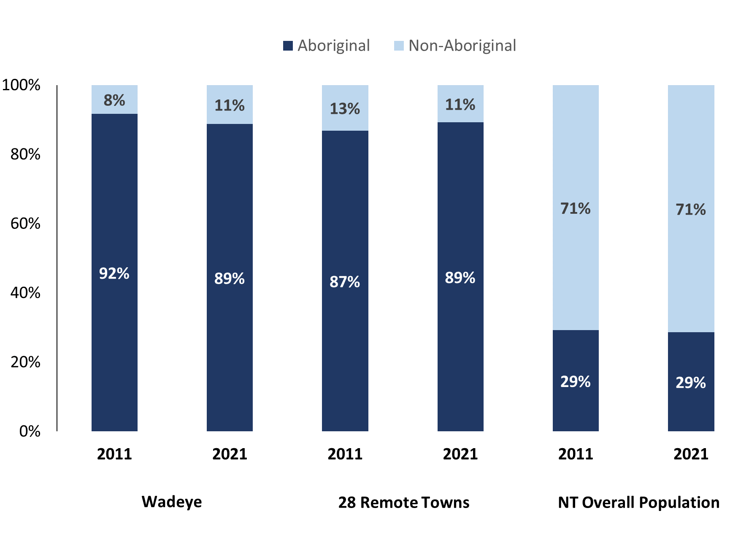

*Source: Australian Bureau of Statistics*

In 2021:

* 89.0% of the population in Wadeye were **Aboriginal**, compared to 92.0% in 2011
* 89.0% of the population across the 28 remote towns were **Aboriginal**
* 29.0% of the NT population were **Aboriginal**.

**Table 37: Unemployment and Aboriginal participation rates (q)**

|  |  |  |  |  |  |  |
| --- | --- | --- | --- | --- | --- | --- |
|  | **Wadeye** | | | **Northern Territory** | | |
| **Aboriginal** | **Non-Aboriginal** | **Total** | **Aboriginal** | **Non-Aboriginal** | **Total** |
| **Unemployment rate** | 24.3% | 0.0% | 12.6% | 20.8% | 3.2% | 5.6% |
| **Participation rate** | 15.6% | 96.1% | 28.6% | 35.4% | 78.3% | 64.9% |

*Source: Australian Bureau of Statistics*

In 2021 in Wadeye the:

* **total unemployment rate** was 12.6% compared to 5.6% for the total Northern Territory
* **Aboriginal** **unemployment rate** was 24.3% compared to 20.8% for the total Northern Territory
* **non-Aboriginal unemployment rate** was 0.0% compared to 3.2% for the total Northern Territory
* **total participation rate** was 28.6% compared to 64.9% for the total Northern Territory
* **Aboriginal participation rate** was 15.6% compared to 35.4% for the total Northern Territory
* **non-Aboriginal participation** rate was 96.1% compared to 78.3% for the total Northern Territory.

# Community Development Program

**Table 38: Community Development Program Aboriginal Job Seekers, 31 December 2023 (o)**

|  |  |  |
| --- | --- | --- |
| **Indicator** | **Aboriginal** | |
| **No.** | **%** |
| **Total Aboriginal Job Seekers** | 862 | N/A |
| **Age (years)** | | |
| 15-24 | 270 | 31.3% |
| 25-44 | 432 | 50.1% |
| 45+ | 160 | 18.6% |
| **Total** | 862 | 100.0% |
| **Gender** | | |
| Male | 406 | 47.1% |
| Female | 456 | 52.9% |
| **Total** | 862 | 100.0% |
| **Employment Outcome – 1 January 2023 to 31 December 2023** | | |
| 13 Weeks | 22 | N/A |
| 26 Weeks | <20 | N/A |

*Source: Department of Prime Minister and Cabinet*

**Chart 14: Community Development Program Aboriginal Job Seekers by Gender and Age Group, 31 December 2023 (o)**

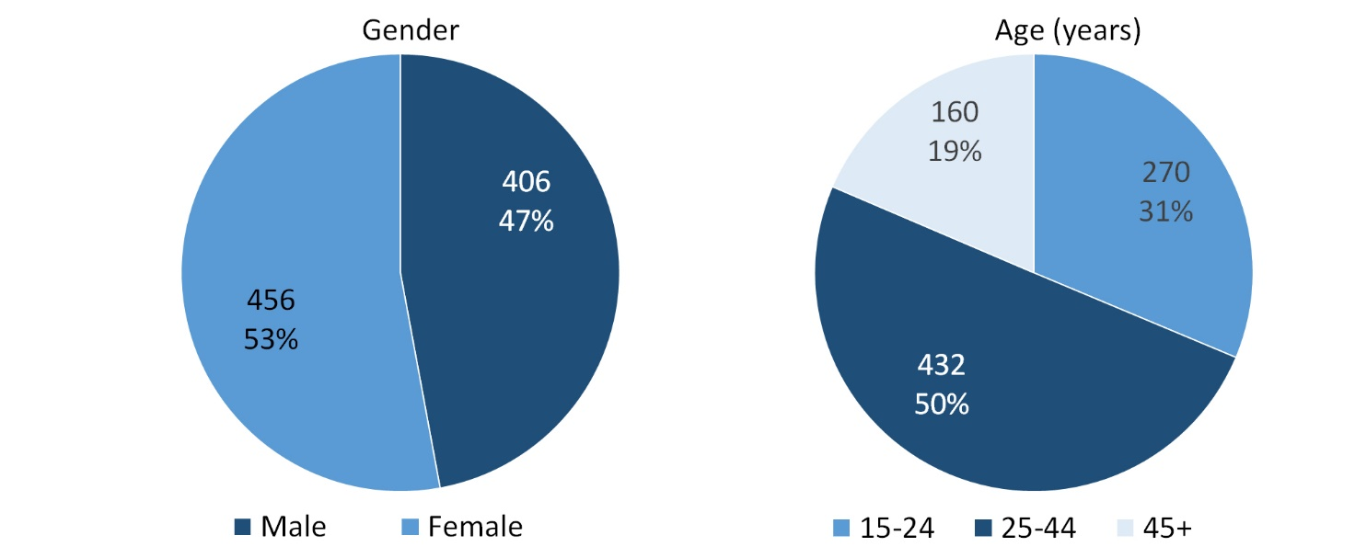

*Source: Department of Prime Minister and Cabinet*

As of 31 December 2023, in Wadeye, there were 862 CDP **Aboriginal** job seekers, of these:

* 406 (47.1%) were male and 456 (52.9%) were female
* 270 (31.3%) were aged 15-24 years, 432 (50.1%) were aged 25-44 years, and 160 (18.6%) were aged 45+ years
* between 1 January 2023 to 31 December 2023, 22 had reached the 13-week reporting milestone and less than 20 had reached the 26 week reporting milestone.

# Businesses

**Table 39: Businesses by sector (d)(s)**

|  |  |  |  |  |
| --- | --- | --- | --- | --- |
| **Business Name** | **Reported on in 2011** | **Reported on in 2014** | **Reported on in 2017** | **Reported on in 2023** |
| **PUBLIC SECTOR** | | | | |
| Aboriginal Hostels Limited | No | Yes | Yes | No |
| Department of Corrections | Yes | Yes | No | No |
| **Department of Health** | Yes | Yes | Yes | **Yes** |
| Department of Housing | Yes | Yes | No | No |
| Department of Human Services trading as Centrelink | Yes | Yes | Yes | No |
| Department of the Prime Minister and Cabinet | Yes | Yes | Yes | No |
| **National Indigenous Australians Agency** | No | No | No | **Yes** |
| **Northern Territory Police, Fire Emergency Services** | Yes | Yes | Yes | **Yes** |
| **Territory Families** | No | No | Yes | **Yes** |
| Victoria Daly Shire Council | Yes | No | No | No |
| **West Daly Regional Council** | No | Yes | Yes | **Yes** |
| **PRIVATE SECTOR** | | | | |
| Australian Football League Northern Territory (AFLNT) | Yes | No | No | No |
| Batchelor Institute of Indigenous Tertiary Education (BIITE) | Yes | Yes | Yes | No |
| Catholic Care NT | Yes | Yes | Yes | No |
| Catholic Church of the Diocese of Darwin | Yes | No | No | No |
| Dave Reddy Pty Ltd | Yes | No | No | No |
| DJ Air & Electrical Services Pty Ltd | No | Yes | Yes | No |
| Jobfind Centres Australia | Yes | No | No | No |
| Maninh Projects Pty Ltd trading as Werrk Store | No | Yes | Yes | No |
| Menzies School of Health Research | Yes | No | No | No |
| Mipatha Take Away | Yes | No | No | No |
| Murin Association Incorporated | Yes | Yes | No | No |
| Murrinhpatha Nimmipa Store | Yes | Yes | Yes | No |
| **Northern Land Council** | No | No | No | **Yes** |
| **One Tree Community Services Inc** | No | No | No | **Yes** |
| Our Lady of the Sacred Heart Thamurrurr Catholic School | Yes | Yes | Yes | No |
| **Palngun Wurnangat Aboriginal Corporation** | Yes | Yes | Yes | **Yes** |
| Palumpa Station Pty Ltd | Yes | No | No | No |
| Samjin Agriculture and Food Enterprise t/as Wadeye 24 Hour | No | No | Yes | No |
| Save the Children Australia | No | Yes | Yes | No |
| **Thamarrurr Development Corporation** | Yes | Yes | Yes | **Yes** |
| Thamurrurr Aged Care - D & R Community Services | Yes | Yes | No | No |
| Thathangathay Foundation | No | No | Yes | No |
| The Arnhem Land Progress Aboriginal Corporation (ALPA) | Yes | No | No | No |
| **Traditional Credit Union (TCU)** | Yes | Yes | Yes | **Yes** |
| Wadeye Creche - Children’s Services Support Unit | Yes | Yes | Yes | No |
| Wadeye Safe House - Children Services Support Unit | Yes | Yes | Yes | No |

*Source: Northern Territory Department of Industry, Tourism and Trade*

*Note: Business names captured across the four survey periods have been identified by the current 2023 Business ABN name listed as of 2023.*

In 2023 in Wadeye:

* there were 10 businesses reported on, of which:
* 5 businesses were from the Public Sector (50%)
* 5 businesses were from the Private Sector (50%)
* there were 3 businesses operating that were not operating in 2017.

# Notes

1. These counts represent numbers of filled jobs and not the number of people. As such the totals represent the total number of filled jobs, not the total number of employees. This count is not directly comparable to the total number of employed people as a person may have several jobs or one job may be shared by more than one person.
2. Full-time is defined as a job usually requiring 35 hours or more per week or that required 35 hours or more work during the reference week. Part-time is defined as a job usually requiring less than 35 hours per week or that required less than 35 hours work during the reference week. The reference week refers to the period that respondents were asked to provide information about. In most instances it would be the week prior to the week the questionnaire was completed. Questionnaires were predominantly conducted in June and July.
3. Care needs to be taken when analysing the counts of filled jobs by Aboriginal people. Aboriginality was reported by the business representative completing the questionnaire.
4. Sector was classified using the Standard Economic Sector of Classifications of Australia (SESCA), 2008.
5. Job permanency is classified according to what the business believes the level of job permanency is based on guidelines provided by data collectors. Those guidelines state a permanent job has paid annual and/or sick leave entitlements while a temporary job includes casual and fixed-term contract jobs.
6. Classified according to the Australian and New Zealand Standard Classification of Occupations (ANZSCO), 2006, major occupation level.
7. Other Occupations include jobs where occupation was not stated, not known or inadequately described.
8. Classified using the Australian and New Zealand Standard Industrial Classification (ANZSIC), 2006, division level.
9. Care needs to be taken when analysing the counts of filled jobs by the gender of people in the jobs. The gender of the person employed in a job is reported by the business representative completing the questionnaire.
10. Care needs to be taken when analysing the counts of filled jobs by the age of people in the jobs. The age of the person employed in a job is reported by the business representative completing the questionnaire.
11. Students represent the number of individual clients that enrolled in a Vocational Education and Training unit during the calendar year.
12. Unit enrolments represent the count of individual units that students enrolled in during the calendar year.
13. Nominal hours delivered is the sum of the nominal hours of the units commenced during the calendar year regardless of when the course enrolment commenced.
14. Unit completions are the count of all successfully completed units reported in the calendar year regardless of the year of commencement of the units.
15. The Community Development Program (CDP) supports job seekers in remote Australia to build skills, address barriers and contribute to their communities through a range of flexible activities. Under the CDP, job seekers with activity requirements are expected to do up to 25 hours per week of work-like activities that benefit their community. It should be noted that some CDP participants may be reported on within the profile if they are attached to a filled position with an employer captured in the survey. Due to confidentiality issues, data below 20 people is not published.
16. Population estimates for both 2011 and 2021 are taken from the estimated resident population (ERP) data produced by the Australian Bureau of Statistics (ABS) and based on Australian Statistical Geography Standard (ASGS) Statistical Area Level 1 (SA1) regions. ERP are official estimates of the Australian population, which link people to a place of usual residence with Australia. All ERP data sources, including the Census of Population and Housing (Census), are subject to error (including inaccuracies in collection, recording and processing data) and should be used with caution.
17. Indigenous population proportions, unemployment and workforce participation rates are based on ABS Census counts at ASGS Indigenous Locations (ILOCs) for each remote town.
18. Working-age population includes all residents aged 15 years and over (commonly referred to as the civilian population) and consists of people that are employed, unemployed or not in the labour force.
19. A ‘business’ has been defined as any organisation that has undertaken productive activities in the last year, including companies, non-profit organisations, government departments and enterprises operating within the designated remote geography (town), and has one or more employees in paid employment and an Australian Business Number (ABN).

# Abbreviations and Acronyms

ABN Australian Business Number

ABS Australian Bureau of Statistics

ANZSCO Australian and New Zealand Standard Classification of Occupations

ANZSIC Australian and New Zealand Standard Industrial Classification

ASGS Australian Statistical Geography Standard

CDP Community Development Program

ERP Estimated Resident Population

ILOC Indigenous Locations

nec Not Elsewhere Classified

No. Number

Perm Permanent

ppt Percentage point

RJCP Remote Jobs and Communities Program

Temp Temporary

SA1 Statistical Area Level 1

VET Vocational Education and Training

1. The number of filled jobs does not represent the number of people as a person may have several jobs or one job may be shared by more than one person.