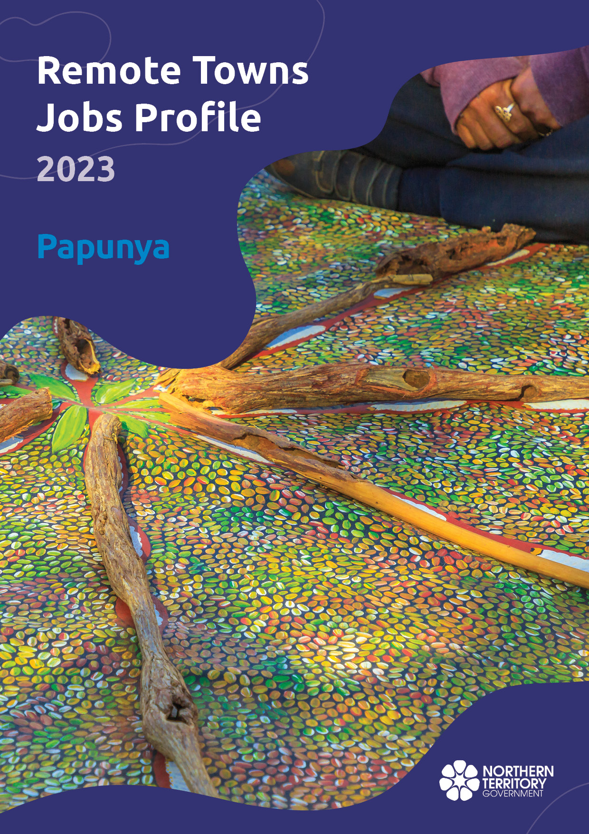

**© Northern Territory of Australia 2025**

**Preferred Reference:** Department of Trade, Business and Asian Relations, 2023 Remote Towns Jobs Profiles, Northern Territory Government, January 2025, Darwin.

**Front cover image:** Aboriginal bush painting at Karrke Aboriginal Cultural Experience.

**Disclaimer**

The data in this publication was collected by conducting a survey of businesses located in the 28 remote town boundaries. This body of work was completed in 2023 by the former Northern Territory Department of Industry, Tourism and Trade.

The collection methodology was created in accordance with Australian Bureau of Statistics data quality framework principles. Data in this publication is only reflective of those businesses reported on as operating in the town at the time of data collection (see table at the end of publication for list of businesses reported on). To comply with privacy legislation or where appropriate, some data in this publication may have been adjusted and will not reflect the actual data reported by businesses. As a result of this, combined with certain data not being reported by some businesses, some components may not add to totals. Changes over time may also reflect change in business propensity to report on certain data items rather than actual changes over time. Total figures have generally not been adjusted. Caution is advised when interpreting the comparisons made to the earlier 2011, 2014 and 2017 publications as the businesses identified and reported on and the corresponding jobs may differ between publications. The surveys have not always gathered data on training and jobs in the same years.

**Notes for each table and chart are ordered alphabetically and listed at the end of the publication.**

The Northern Territory of Australia exercised due care and skill to ensure that at the time of publication the information contained in this publication is true and correct. However, it is not intended to be relied on as professional advice or used for commercial purposes. The Territory gives no warranty or assurances as to the accuracy of the information contained in the publication and to the maximum extent permitted by law accepts no direct or indirect liability for reliance on its content.

Any use of this report for commercial purposes is not endorsed by the Department of Trade, Business and Asian Relations.

Contents

Papunya (Warumpi) 4

Introduction 5

Summary 6

Jobs Overview 7

Jobs filled by Aboriginality 8

Jobs by Sector: Private and Public 11

Job Status: Permanent and Temporary 18

Job Vacancies 22

Jobs by Industry 24

Jobs by Occupation 30

Jobs by Industry by Occupation 34

Jobs by Gender 37

Jobs by Age 43

Vocational Education and Training 50

Population 55

Community Development Program 57

Businesses 58

Notes 59

Abbreviations and Acronyms 60

# Papunya (Warumpi)

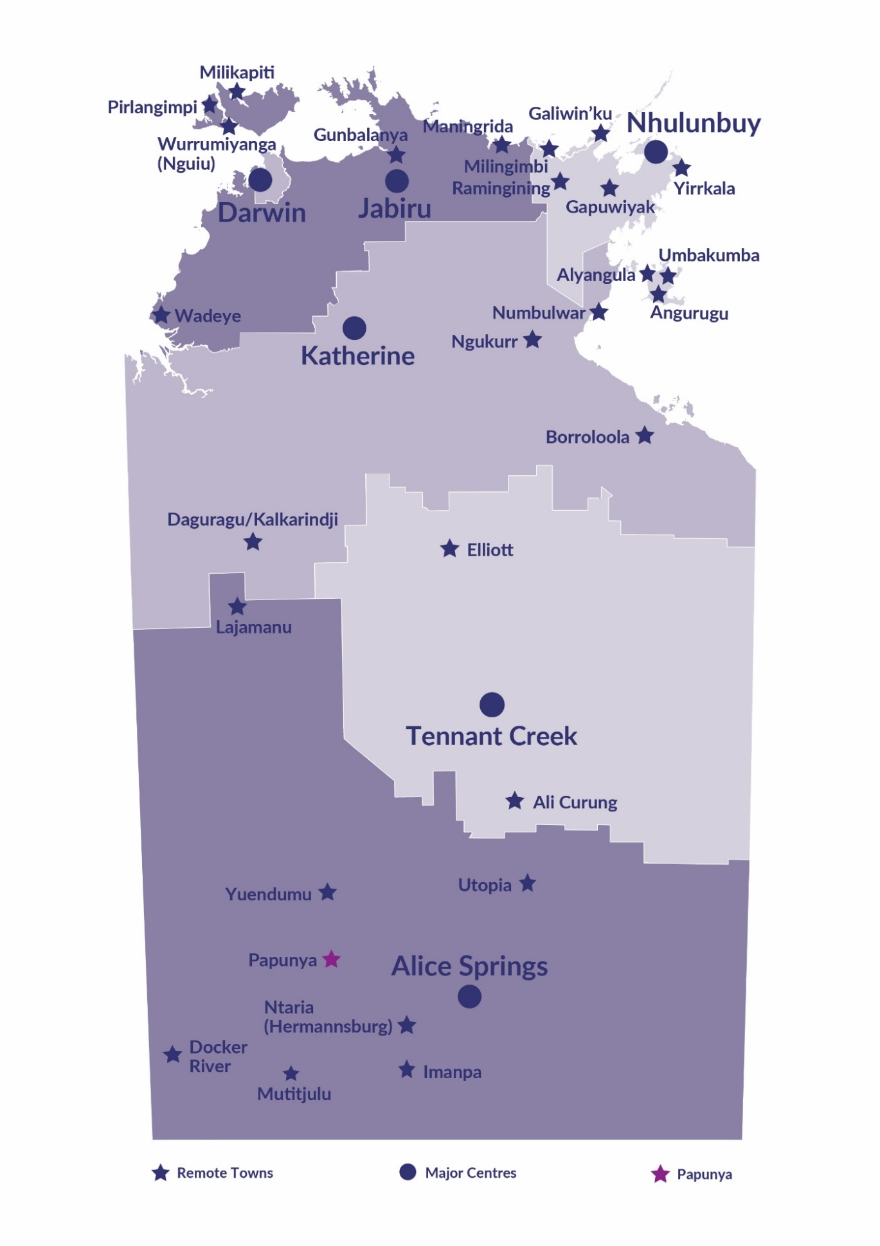Papunya (Warumpi) is located 250 kilometres west of Alice Springs along the McDonald Ranges. It is accessible by road from Alice Springs along the road to Kintore; with a population of 440 residents.

*Source: Northern Territory Department of Industry, Tourism and Trade*

# Introduction

This jobs profile provides a snapshot of jobs and the characteristics of job holders in Papunya (Warumpi) as of September 2023. Trends from the surveys conducted in 2011, 2014, and 2017 are also described. Additionally, it presents data on Community Development Program activity, Population, and Vocational Education and Training.

This job profile is one of 28 profiles developed for remote towns in the Northern Territory. It is anticipated these, and subsequent profiles will contribute to a robust evidence base to inform decision making in and relating to these remote Territory towns.

This profile contains information collected by the Northern Territory Department of Industry, Tourism and Trade from businesses operating within the town and is supplemented by other administrative data sets and information.

Each profile provides up-to-date information that is intended to inform the planning and design of current and future government programs and as an evidence base to inform decision making relating to workforce development, enterprise and job opportunities.

The profile may best be understood as a point-in-time tool. The number of business surveys from which the data was drawn is significantly less than in earlier surveys, and business participation has decreased with each survey. For Papunya (Warumpi), 20% fewer businesses than in 2017 are reported here.

The data collection methodology and corresponding questionnaire were created in partnership with the Australian Bureau of Statistics (ABS) and in accordance with ABS data quality framework and survey principles.

The Northern Territory Department of Industry, Tourism and Trades’ Territory Engagement and Delivery, Skills Initiative and VET data teams collaborated with the Northern Institute at Charles Darwin University to facilitate the surveys and reports.

The information collected and reported on represents a significant goodwill investment by those businesses and organisations that participated. Each business is listed at the end of this publication.

# Summary

The 2023 jobs profile was developed based on responses from 8 businesses operating within the Papunya (Warumpi) town boundary, 2 less than in the 2017 survey. Of these, there were:

* 2 businesses from the Private Sector, accounting for 21 filled jobs or 37.5% of total filled jobs
* 6 businesses from the Public Sector, accounting for 35 filled jobs or 62.5% of total filled jobs
* 5 businesses participated in all four surveys (completed in 2011, 2014, 2017 and 2023).

A total of 83 filled and vacant jobs in Papunya (Warumpi) were reported, a decrease of 16 jobs from 2017.[1]

The 2023 profile highlights:

* there were 56 filled jobs of which:
* 35 jobs (62.5%) were filled by Aboriginal people, an increase of 3 jobs from 2017
* 21 jobs (37.5%) were filled by non-Aboriginal people, a decrease of 4 jobs from 2017
* 34% of employed Aboriginal people are working in the Public Sector
* Aboriginal people accounted for 63% of job holders in the town compared to 56% in 2017
* Aboriginal females made up 69% of total Aboriginal filled jobs in the town compared to 72% in 2017
* there were 27 vacant jobs, of which:
* job vacancies as a percentage of jobs decreased to 32.5% in 2023 from 42.4% in 2017
* job vacancies equate to 1 in 3 jobs
* 16 of the vacancies were in Community and Personal Service Workers and Professionals areas
* Public Administration and Safety continues to be the largest industry employer over the four survey periods
* training had a decrease in student numbers of 42 between 2023 and 2016
* Community Services, Health and Education had the highest student numbers in 2023
* Primary Industry had the highest increase in student numbers of 12 between 2023 and 2016
* new training activities in 2023, Sales and Personal Service was delivered to 6 students; this training area was not delivered in 2016 and 2013.

The overall population in Papunya (Warumpi) increased by 21 people (5%) between 2011 and 2021 to 440 people.

In comparison, the overall Northern Territory population increased by 9.7% between 2011 and 2021.

In 2021, the working age population (15 years and over) in Papunya (Warumpi) was an estimated 319 people compared to 301 in 2011 an increase of 6%.

There were 0.3 jobs in Papunya (Warumpi) per working age person compared to 0.3 jobs per working age person across the 28 remote towns in the Northern Territory.

# Jobs Overview

Table 1: Count of filled jobs and vacancies, 2011, 2014, 2017 & 2023 (a)(b)

|  |  |  |  |  |  |  |  |
| --- | --- | --- | --- | --- | --- | --- | --- |
|  | **2011** | **2014** | **2017** | **2023** | **Change 2011-2014** | **Change 2014-2017** | **Change 2017-2023** |
| **Total All Jobs** | **114** | **121** | **99** | **83** | **7** | **-22** | **-16** |
| **Vacancies** | **30** | **29** | **42** | **27** | **-1** | **13** | **-15** |
| Vacancies as % of Total All Jobs | 26.3% | 24.0% | 42.4% | 32.5% | -2.3 ppt | 18.5 ppt | -9.9 ppt |
| **Filled Jobs** | **84** | **92** | **57** | **56** | **8** | **-35** | **-1** |
| Full-time | 46 | 42 | 27 | 40 | -4 | -15 | 13 |
| Part-time | 38 | 50 | 30 | 16 | 12 | -20 | -14 |

Source: Northern Territory Department of Industry, Tourism and Trade

Chart 1: Count of vacant jobs and filled jobs by full-time/part-time status, 2023, 2017, 2014 & 2011 (a)(b)

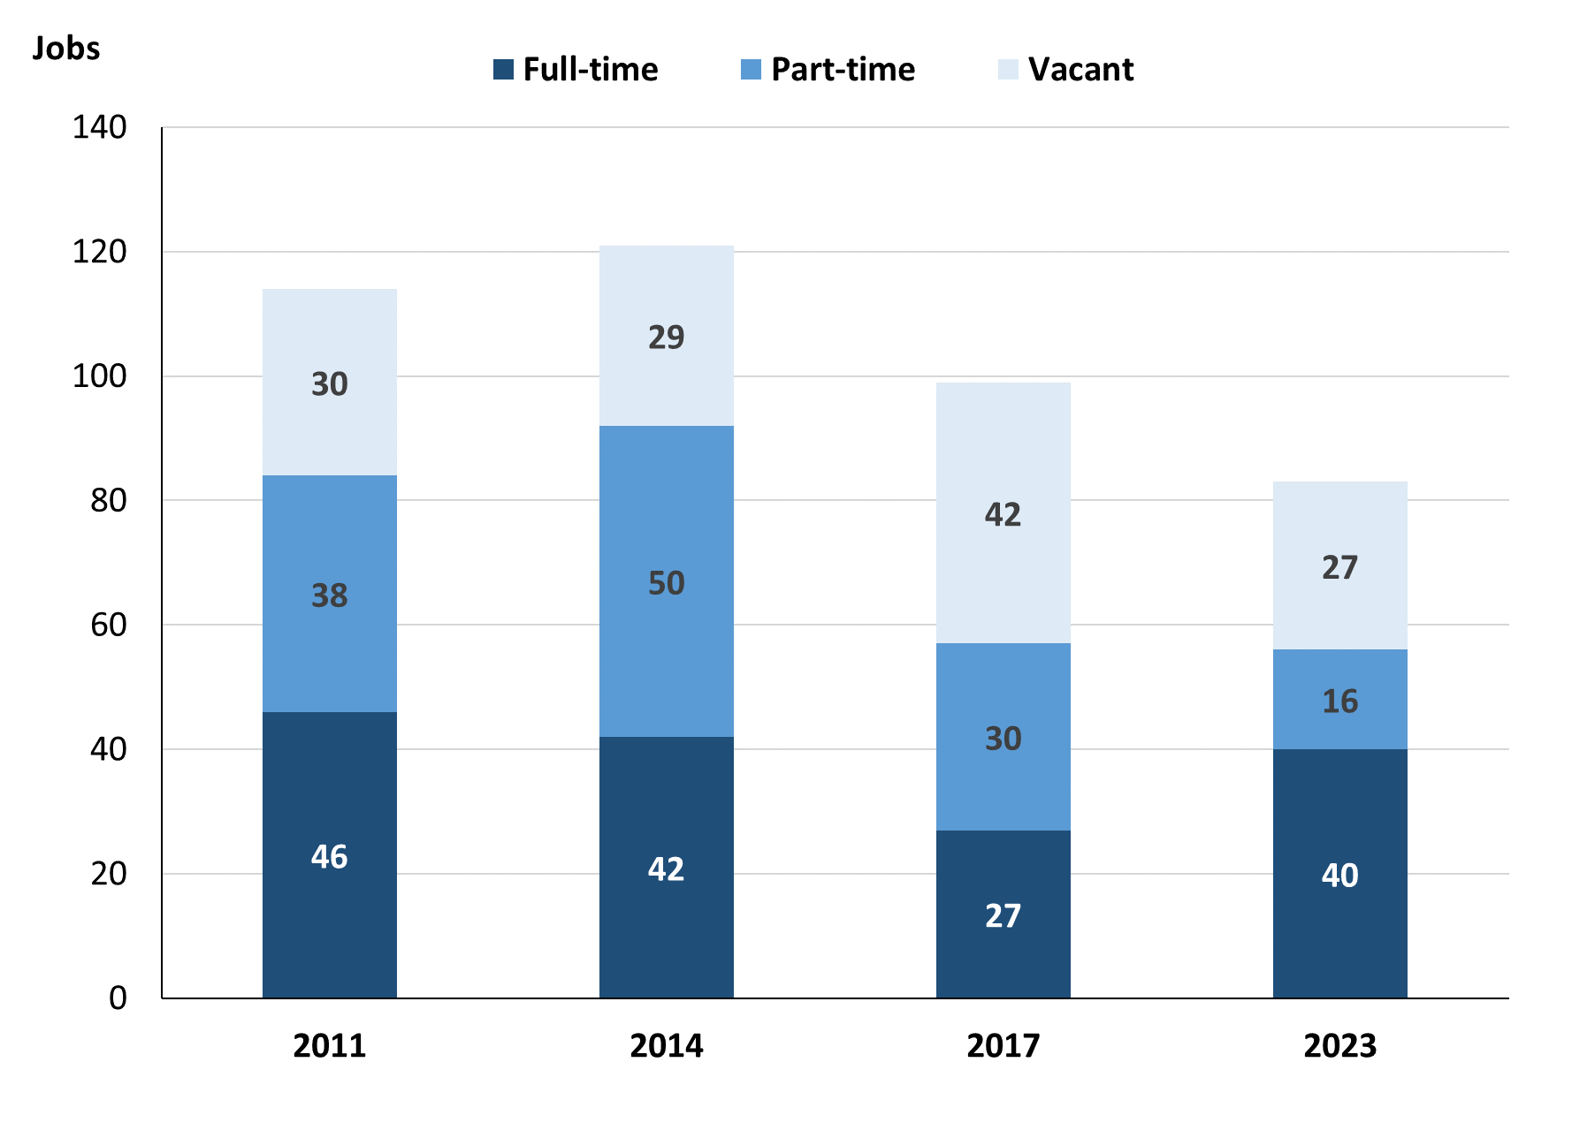

Source: Northern Territory Department of Industry, Tourism and Trade

In 2023 in Papunya (Warumpi):

* there was a total of 56 **filled jobs**, a decrease of 1 job from 2017 and a decrease of 36 jobs from 2014
* of the 56 **filled jobs** in 2023:
* 40 were full-time jobs, an increase of 13 jobs from 2017 and a decrease of 2 jobs from 2014
* 16 were part-time jobs, a decrease of 14 jobs from 2017 and a decrease of 34 jobs from 2014
* there were 27 total **job vacancies** in 2023, a decrease of 15 vacancies from 2017 and a decrease of 2 vacancies from 2014.

# Jobs filled by Aboriginality

Chart 2: Count of filled jobs by Aboriginality, 2011, 2014, 2017 & 2023 (a)(c)

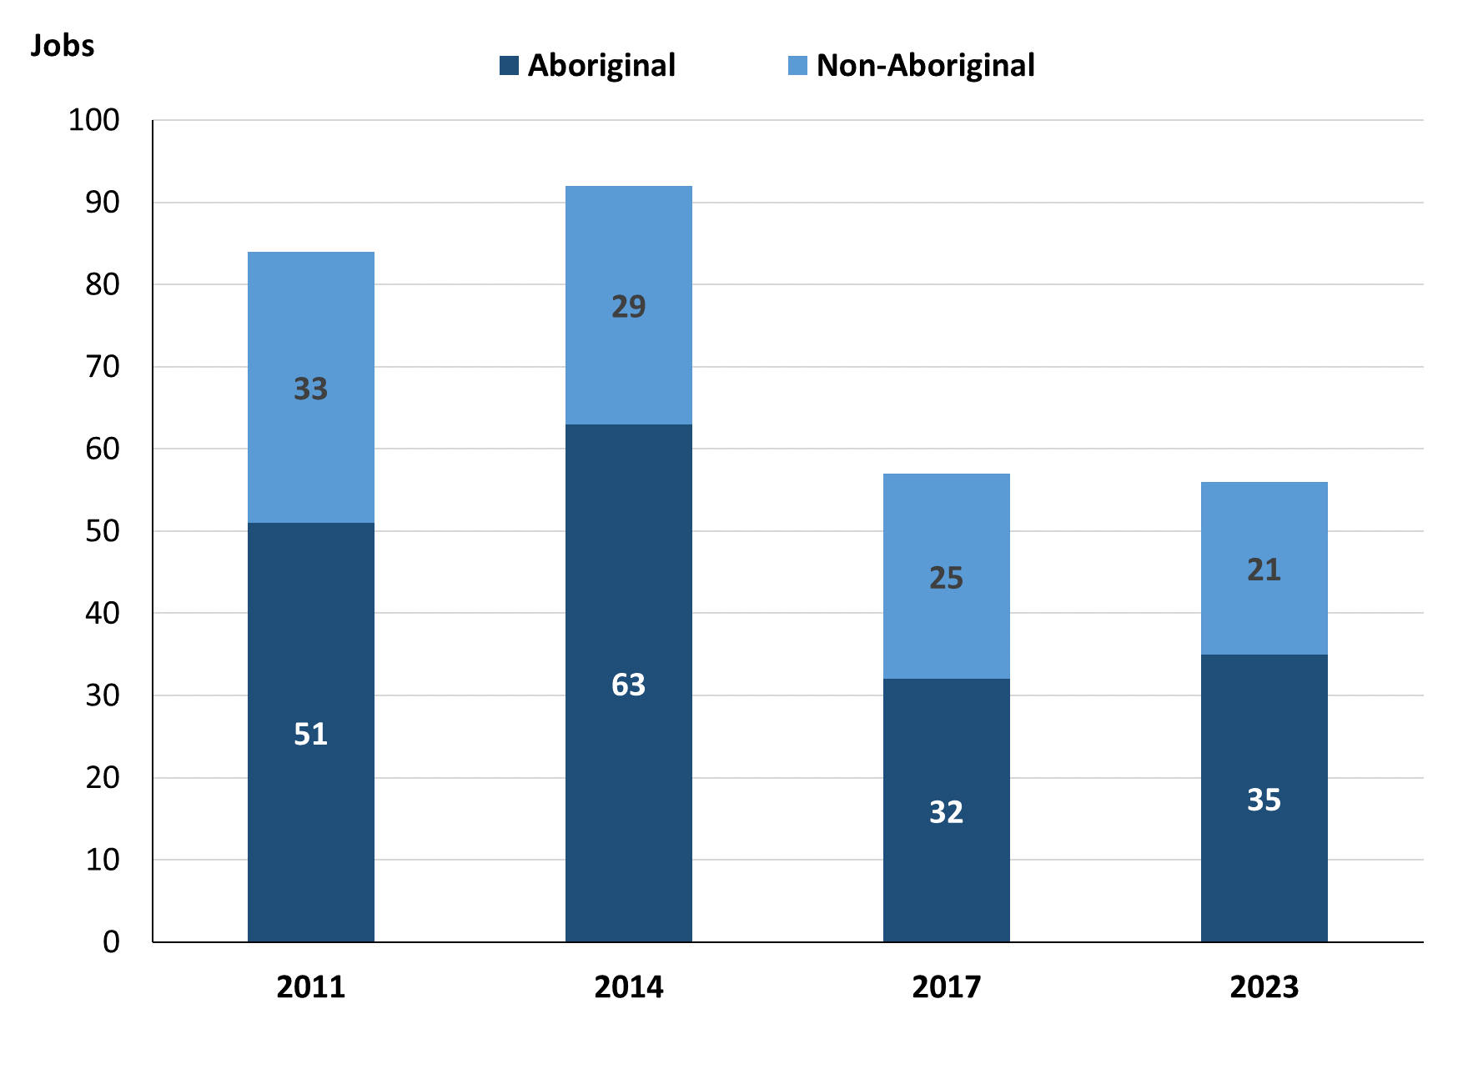

Source: Northern Territory Department of Industry, Tourism and Trade

In 2023 in Papunya (Warumpi):

* of the 56 **filled jobs**:
* **Aboriginal** people filled 35 jobs, an increase of 3 jobs from 2017 and a decrease of 28 jobs from 2014
* **non-Aboriginal** people filled 21 jobs, a decrease of 4 jobs from 2017 and a decrease of 8 jobs from 2014
* **Aboriginal** people accounted for 63% of job holders compared to 56% in 2017 and 68% in 2014.

Table 2a: Count of filled jobs by full-time/part-time status, 2011, 2014, 2017 & 2023 (a)(b)(c)

|  |  |  |  |  |  |  |  |  |  |  |  |  |  |
| --- | --- | --- | --- | --- | --- | --- | --- | --- | --- | --- | --- | --- | --- |
| **Indicator** | **2011** | | | **2014** | | | **2017** | | | **2023** | | | |
| **Aboriginal** | **Non-Aboriginal** | **Total** | **Aboriginal** | **Non-Aboriginal** | **Total** | **Aboriginal** | **Non-Aboriginal** | **Total** | **Aboriginal** | **Non-Aboriginal** | **Total** |
| Full-time | 19 | 27 | **46** | 14 | 28 | **42** | 4 | 23 | **27** | 19 | 21 | **40** |
| Part-time | 32 | 6 | **38** | 49 | 1 | **50** | 28 | 2 | **30** | 16 | 0 | **16** |
| **Total** | **51** | **33** | **84** | **63** | **29** | **92** | **32** | **25** | **57** | **35** | **21** | **56** |

Source: Northern Territory Department of Industry, Tourism and Trade

Table 2b: Count of filled jobs by full-time/part-time status, 2011-2014, 2014-2017 & 2017-2023 (a)(b)(c)

|  |  |  |  |  |  |  |  |  |  |
| --- | --- | --- | --- | --- | --- | --- | --- | --- | --- |
| **Indicator** | **Change 2011-2014** | | | **Change 2014-2017** | | | **Change 2017-2023** | | |
| **Aboriginal** | **Non-Aboriginal** | **Total** | **Aboriginal** | **Non-Aboriginal** | **Total** | **Aboriginal** | **Non-Aboriginal** | **Total** |
| Full-time | -5 | 1 | **-4** | -10 | -5 | **-15** | 15 | -2 | **13** |
| Part-time | 17 | -5 | **12** | -21 | 1 | **-20** | -12 | -2 | **-14** |
| **Total** | **12** | **-4** | **8** | **-31** | **-4** | **-35** | **3** | **-4** | **-1** |

Source: Northern Territory Department of Industry, Tourism and Trade

Chart 3: Count of filled jobs by full-time/part-time status, 2011, 2014, 2017 & 2023 (a)(b)(c)

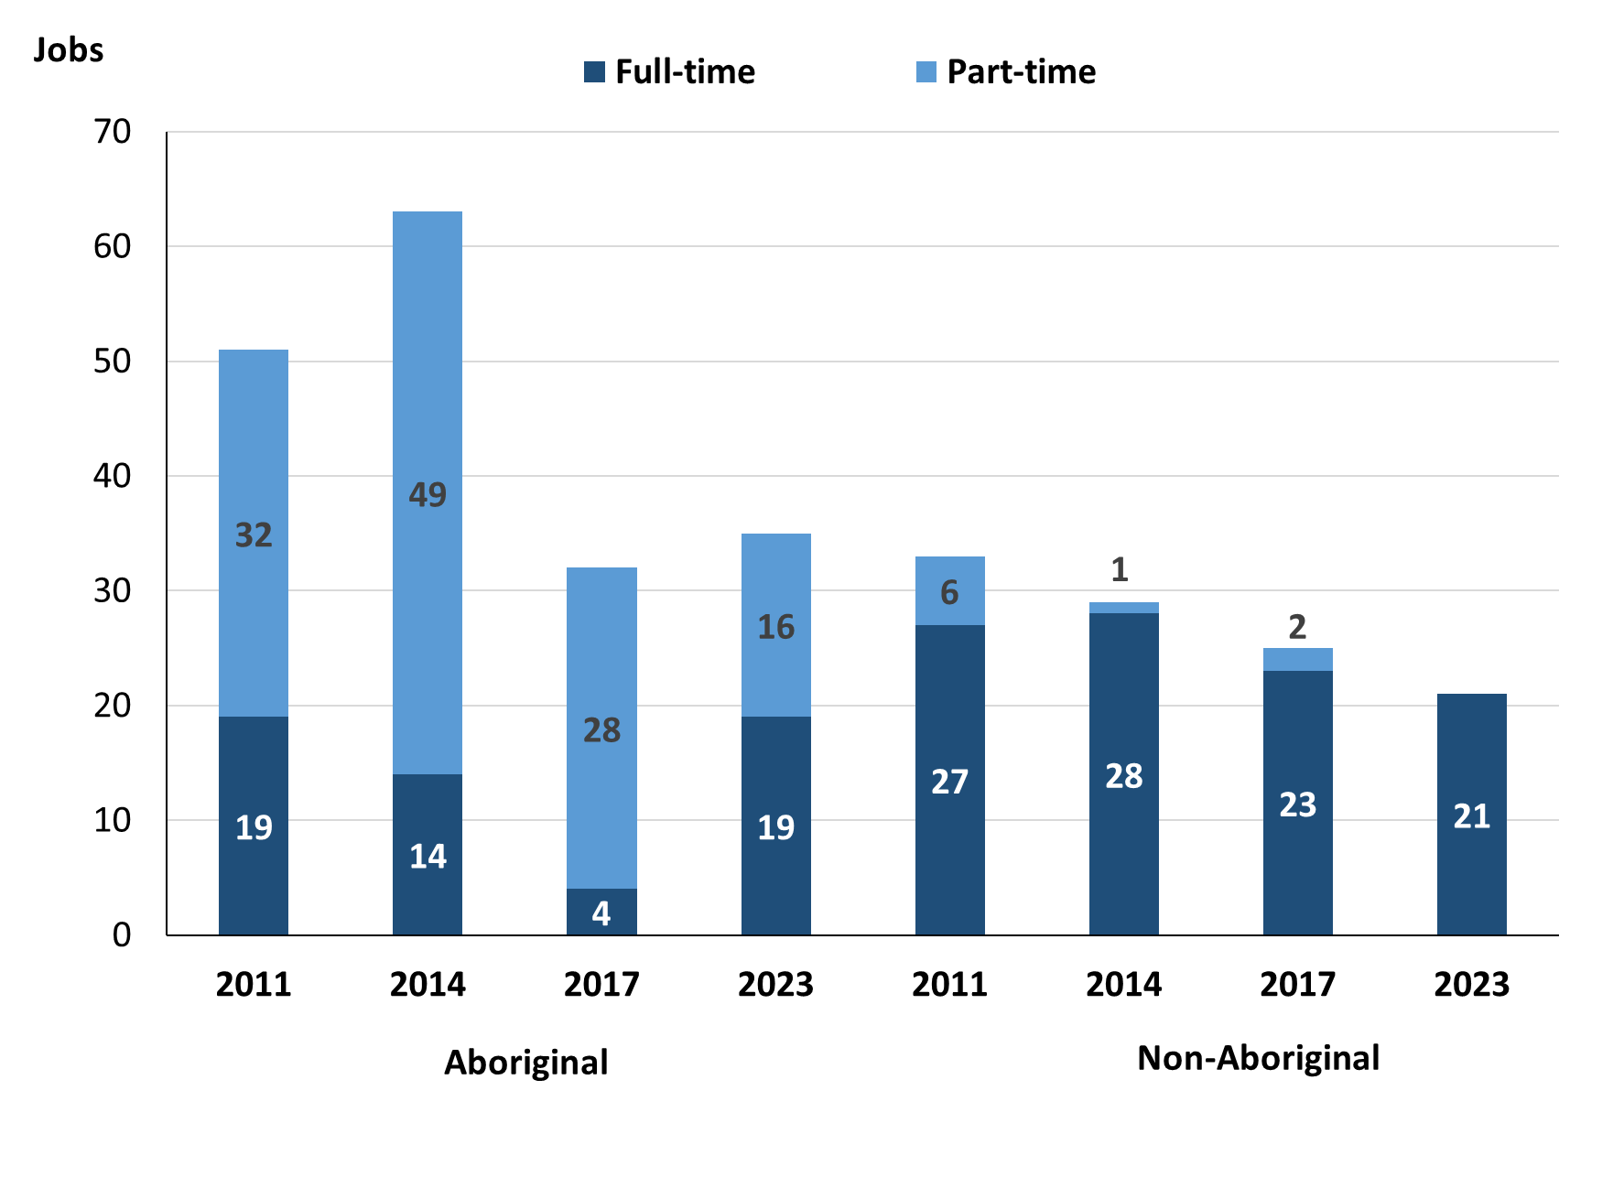

Source: Northern Territory Department of Industry, Tourism and Trade

In 2023 in Papunya (Warumpi):

* of the 56 **filled jobs**:
* 19 were **full-time** jobs filled by **Aboriginal** people, an increase of 15 jobs from 2017 and an increase of 5 jobs from 2014
* 16 were **part-time** jobs filled by **Aboriginal** people, a decrease of 12 jobs from 2017 and a decrease of 33 jobs from 2014
* 21 were **full-time** jobs filled by **non-Aboriginal** people, a decrease of 2 jobs from 2017 and a decrease of 7 jobs from 2014
* none were **part-time** jobs filled by **non-Aboriginal** people, a decrease of 2 jobs from 2017 and a decrease of 1 job from 2014.

# Jobs by Sector: Private and Public

Table 3a: Count of filled jobs by sector of business, 2011, 2014, 2017 & 2023 (a)(b)(c)

|  |  |  |  |  |  |  |  |  |  |  |  |  |
| --- | --- | --- | --- | --- | --- | --- | --- | --- | --- | --- | --- | --- |
| **Indicator** | **2011** | | | **2014** | | | **2017** | | | **2023** | | |
| **Aboriginal** | **Non-Aboriginal** | **Total** | **Aboriginal** | **Non-Aboriginal** | **Total** | **Aboriginal** | **Non-Aboriginal** | **Total** | **Aboriginal** | **Non-Aboriginal** | **Total** |
| **Public Sector** | 40 | 26 | **66** | 43 | 19 | **62** | 17 | 15 | **32** | 19 | 16 | **35** |
| Australian Government | 1 | 1 | **2** | 3 | 1 | **4** | 4 | 1 | **5** | 0 | 0 | **0** |
| Territory Government | 7 | 21 | **28** | 5 | 15 | **20** | 6 | 14 | **20** | 12 | 16 | **28** |
| Local Government | 32 | 4 | **36** | 35 | 3 | **38** | 7 | 0 | **7** | 7 | 0 | **7** |
| **Private Sector** | 11 | 7 | **18** | 20 | 10 | **30** | 15 | 10 | **25** | 16 | 5 | **21** |
| **Total** | **51** | **33** | **84** | **63** | **29** | **92** | **32** | **25** | **57** | **35** | **21** | **56** |

Source: Northern Territory Department of Industry, Tourism and Trade

Table 3b: Count of filled jobs by sector of business, 2011-2014, 2014-2017 & 2017-2023 (a)(b)(c)

|  |  |  |  |  |  |  |  |  |  |
| --- | --- | --- | --- | --- | --- | --- | --- | --- | --- |
| **Indicator** | **Change 2011-2014** | | | **Change 2014-2017** | | | **Change 2017-2023** | | |
| **Aboriginal** | **Non-Aboriginal** | **Total** | **Aboriginal** | **Non-Aboriginal** | **Total** | **Aboriginal** | **Non-Aboriginal** | **Total** |
| **Public Sector** | 3 | -7 | **-4** | -26 | -4 | **-30** | 2 | 1 | **3** |
| Australian Government | 2 | 0 | **2** | 1 | 0 | **1** | -4 | -1 | **-5** |
| Territory Government | -2 | -6 | **-8** | 1 | -1 | **0** | 6 | 2 | **8** |
| Local Government | 3 | -1 | **2** | -28 | -3 | **-31** | 0 | 0 | **0** |
| **Private Sector** | 9 | 3 | **12** | -5 | 0 | **-5** | 1 | -5 | **-4** |
| **Total** | **12** | **-4** | **8** | **-31** | **-4** | **-35** | **3** | **-4** | **-1** |

Source: Northern Territory Department of Industry, Tourism and Trade

**Chart 4: Count of filled jobs by sector of business, 2011, 2014, 2017 & 2023 (a)(d)**

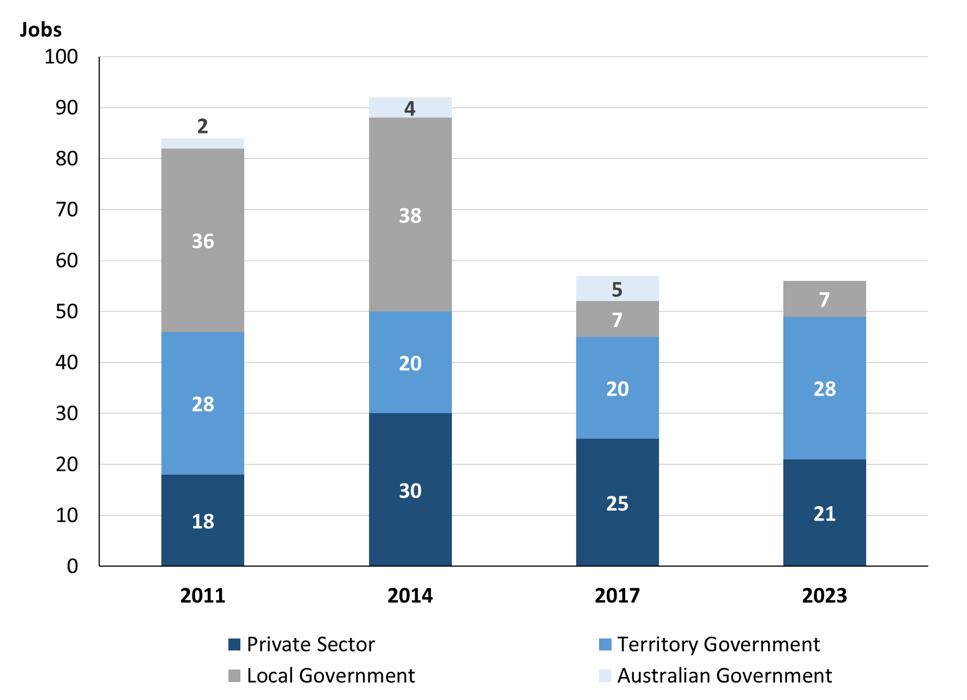

*Source: Northern Territory Department of Industry, Tourism and Trade*

Chart 5: Percentage of filled jobs by sector of business in 2023 (a)(d)

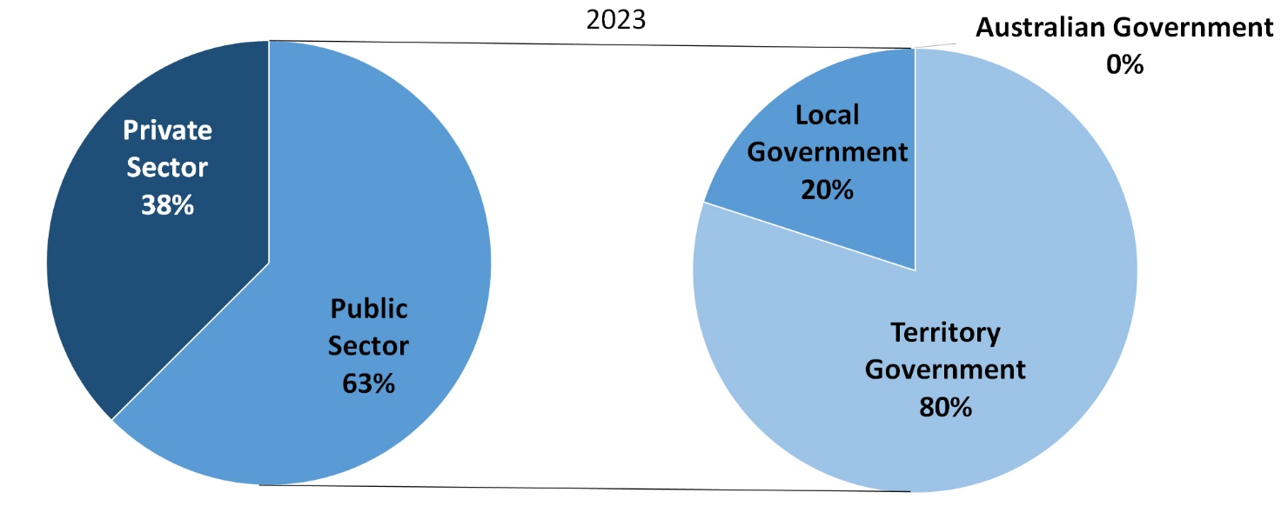

Source: Northern Territory Department of Industry, Tourism and Trade

In 2023 in Papunya (Warumpi):

* there were 35 jobs in the **Public Sector**, an increase of 3 jobs from 2017 and a decrease of 27 jobs from 2014
* of the 35 jobs in the **Public Sector**:
* none were in the Australian Government, a decrease of 5 jobs from 2017 and a decrease of 4 jobs from 2014
* 28 jobs were in the Territory Government, an increase of 8 jobs from 2017 and an increase of 8 jobs from 2014
* 7 jobs were in the Local Government, unchanged from 2017 and a decrease of 31 jobs from 2014
* there were 21 jobs in the **Private Sector**, a decrease of 4 jobs from 2017 and a decrease of 9 jobs from 2014.

Chart 6: Count of filled jobs by sector, 2011, 2014, 2017 & 2023 (a)(c)(d)

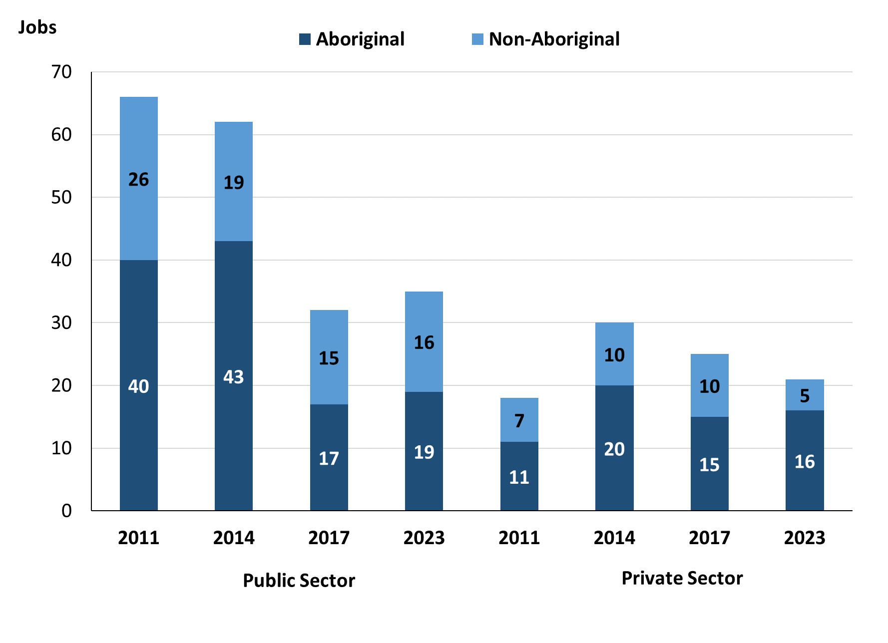

Source: Northern Territory Department of Industry, Tourism and Trade

In 2023 in Papunya (Warumpi):

* of the 35 jobs in the **Public Sector**:
* **Aboriginal** people filled 19 jobs, an increase of 2 jobs from 2017 and a decrease of 24 jobs from 2014
* **non-Aboriginal** people filled 16 jobs, an increase of 1 job from 2017 and a decrease of 3 jobs from 2014
* of the 21 jobs in the **Private Sector**:
* **Aboriginal** people filled 16 jobs, an increase of 1 job from 2017 and a decrease of 4 jobs from 2014
* **non-Aboriginal** people filled 5 jobs, a decrease of 5 jobs from 2017 and a decrease of 5 jobs from 2014.

Chart 7: Count of filled jobs by sector and full-time/part-time status, 2011, 2014, 2017 & 2023 (a)(b)(d)

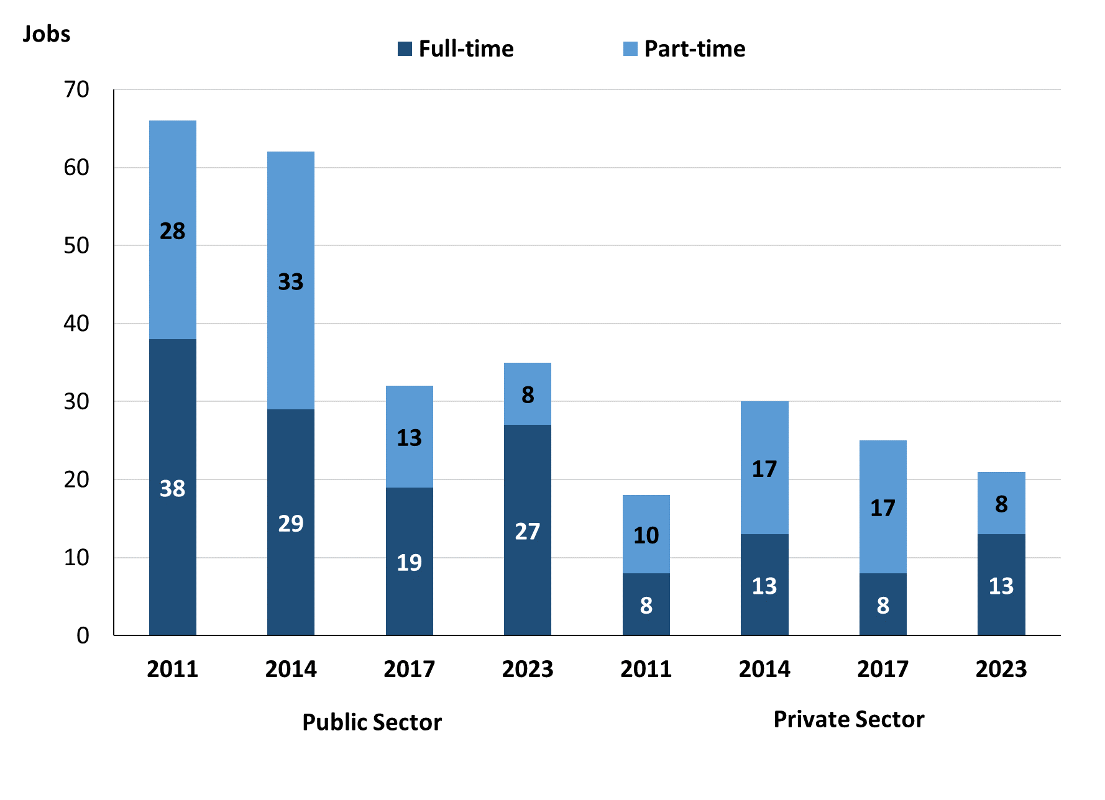

Source: Northern Territory Department of Industry, Tourism and Trade

In 2023 in Papunya (Warumpi):

* of the 35 jobs in the **Public Sector**:
* 27 were **full-time** jobs, an increase of 8 jobs from 2017 and a decrease of 2 jobs from 2014
* 8 were **part-time** jobs, a decrease of 5 jobs from 2017 and a decrease of 25 jobs from 2014
* of the 21 jobs in the **Private Sector:**
* 13 were **full-time** jobs, an increase of 5 jobs from 2017 and unchanged from 2014
* 8 were **part-time** jobs, a decrease of 9 jobs from 2017 and a decrease of 9 jobs from 2014.

Table 4: Count of filled jobs by full-time/part-time status by sector, 2011, 2014, 2017 & 2023 (a)(b)(c)(d)

|  |  |  |  |  |  |  |  |  |  |  |
| --- | --- | --- | --- | --- | --- | --- | --- | --- | --- | --- |
| **Indicator** | **2011** | | | | | | | | | |
| **Aboriginal** | | | **Non-Aboriginal** | | | **Total** | | | |
| **Full-time** | **Part-time** | **Total** | **Full-time** | **Part-time** | **Total** | **Full-time** | **Part-time** | **Total** |
| Public Sector | 15 | 25 | **40** | 23 | 4 | **27** | 38 | 29 | **67** |
| Private Sector | 4 | 7 | **11** | 4 | 2 | **6** | 8 | 9 | **17** |
| **Total** | **19** | **32** | **51** | **27** | **6** | **33** | **46** | **38** | **84** |

|  |  |  |  |  |  |  |  |  |  |  |
| --- | --- | --- | --- | --- | --- | --- | --- | --- | --- | --- |
| **Indicator** | **2014** | | | | | | | | | |
| **Aboriginal** | | | **Non-Aboriginal** | | | **Total** | | | |
| **Full-time** | **Part-time** | **Total** | **Full-time** | **Part-time** | **Total** | **Full-time** | **Part-time** | **Total** |
| Public Sector | 11 | 32 | **43** | 18 | 1 | **19** | 29 | 33 | **62** |
| Private Sector | 3 | 17 | **20** | 10 | 0 | **10** | 13 | 17 | **30** |
| **Total** | **14** | **49** | **63** | **28** | **1** | **29** | **42** | **50** | **92** |

|  |  |  |  |  |  |  |  |  |  |  |
| --- | --- | --- | --- | --- | --- | --- | --- | --- | --- | --- |
| **Indicator** | **2017** | | | | | | | | | |
| **Aboriginal** | | | **Non-Aboriginal** | | | **Total** | | | |
| **Full-time** | **Part-time** | **Total** | **Full-time** | **Part-time** | **Total** | **Full-time** | **Part-time** | **Total** |
| Public Sector | 4 | 13 | **17** | 15 | 0 | **15** | 19 | 13 | **32** |
| Private Sector | 0 | 15 | **15** | 8 | 2 | **10** | 8 | 17 | **25** |
| **Total** | **14** | **49** | **32** | **23** | **2** | **25** | **27** | **30** | **57** |

|  |  |  |  |  |  |  |  |  |  |  |
| --- | --- | --- | --- | --- | --- | --- | --- | --- | --- | --- |
| **Indicator** | **2023** | | | | | | | | | |
| **Aboriginal** | | | **Non-Aboriginal** | | | **Total** | | | |
| **Full-time** | **Part-time** | **Total** | **Full-time** | **Part-time** | **Total** | **Full-time** | **Part-time** | **Total** |
| Public Sector | 11 | 8 | **19** | 16 | 0 | **16** | 27 | 8 | **35** |
| Private Sector | 8 | 8 | **16** | 5 | 0 | **5** | 13 | 8 | **21** |
| **Total** | **19** | **16** | **35** | **21** | **0** | **21** | **40** | **16** | **56** |

Source: Northern Territory Department of Industry, Tourism and Trade

In 2023 in Papunya (Warumpi) there were:

* 19 jobs in the **Public Sector** filled by **Aboriginal** people, an increase of 2 jobs from 2017 and a decrease of 24 jobs from 2014, of which:
* 11 were **full-time** jobs, an increase of 7 jobs from 2017 and unchanged from 2014
* 8 were **part-time** jobs, a decrease of 5 jobs from 2017 and a decrease of 24 jobs from 2014
* 16 jobs in the **Private Sector** filled by **Aboriginal** people, an increase of 1 job from 2017 and a decrease of 4 jobs from 2014, of which:
* 8 were **full-time** jobs, an increase of 8 jobs from 2017 and an increase of 5 jobs from 2014
* 8 were **part-time** jobs, a decrease of 7 jobs from 2017 and a decrease of 9 jobs from 2014
* 16 jobs in the **Public Sector** filled by **non-Aboriginal** people, an increase of 1 job from 2017 and a decrease of 3 jobs from 2014, of which:
* 16 were **full-time** jobs, an increase of 1 job from 2017 and a decrease of 2 jobs from 2014
* none were **part-time** jobs, unchanged from 2017 and a decrease of 1 job from 2014
* 5 jobs in the **Private Sector** filled by **non-Aboriginal** people, a decrease of 5 jobs from 2017 and a decrease of 5 jobs from 2014, of which:
* 5 were **full-time** jobs, a decrease of 3 jobs from 2017 and a decrease of 5 jobs from 2014
* none were **part-time** jobs, a decrease of 2 jobs from 2017 and unchanged from 2014.

# Job Status: Permanent and Temporary

Table 5a: Count of filled jobs by employment status, 2011, 2014, 2017 & 2023 (a)(c)(e)

|  |  |  |  |  |  |  |  |  |  |  |  |  |
| --- | --- | --- | --- | --- | --- | --- | --- | --- | --- | --- | --- | --- |
| **Indicator** | **2011** | | | **2014** | | | **2017** | | | **2023** | | |
| **Aboriginal** | **Non-Aboriginal** | **Total** | **Aboriginal** | **Non-Aboriginal** | **Total** | **Aboriginal** | **Non-Aboriginal** | **Total** | **Aboriginal** | **Non-Aboriginal** | **Total** |
| Permanent | 7 | 12 | **19** | 43 | 24 | **67** | 10 | 16 | **26** | 7 | 14 | **21** |
| Temporary | 44 | 21 | **65** | 20 | 5 | **25** | 22 | 9 | **31** | 28 | 7 | **35** |
| **Total** | **51** | **33** | **84** | **63** | **29** | **92** | **32** | **25** | **57** | **35** | **21** | **56** |

Source: Northern Territory Department of Industry, Tourism and Trade

Table 5b: Count of filled jobs by employment status, 2011-2014, 2014-2017 & 2017-2023 (a)(c)(e)

|  |  |  |  |  |  |  |  |  |  |
| --- | --- | --- | --- | --- | --- | --- | --- | --- | --- |
| **Indicator** | **Change 2011-2014** | | | **Change 2014-2017** | | | **Change**  **2017-2023** | | |
| **Aboriginal** | **Non-Aboriginal** | **Total** | **Aboriginal** | **Non-Aboriginal** | **Total** | **Aboriginal** | **Non-Aboriginal** | **Total** |
| Permanent | 36 | 12 | **48** | -33 | -8 | **-41** | -3 | -2 | **-5** |
| Temporary | -24 | -16 | **-40** | 2 | 4 | **6** | 6 | -2 | **4** |
| **Total** | **12** | **-4** | **8** | **-31** | **-4** | **-35** | **3** | **-4** | **-1** |

Source: Northern Territory Department of Industry, Tourism and Trade

**Chart 8: Count of filled jobs by employment status, 2011, 2014, 2017 & 2023 (a)(c)(e)**

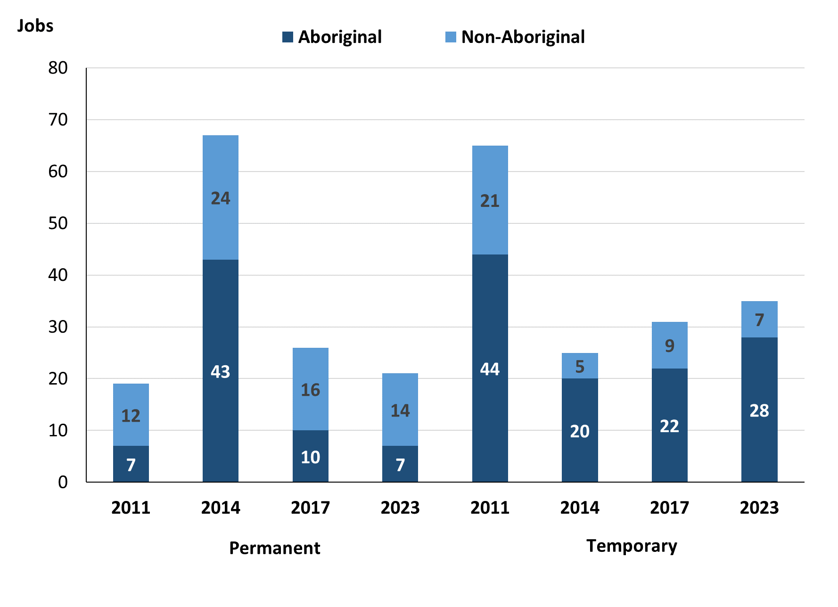

Source: Northern Territory Department of Industry, Tourism and Trade

In 2023 in Papunya (Warumpi):

* there were 21 **permanent** jobs, a decrease of 5 jobs from 2017, and a decrease of 46 jobs from 2014, of which:
* **Aboriginal** people filled 7 jobs, a decrease of 3 jobs from 2017 and a decrease of 36 jobs from 2014
* **non-Aboriginal** people filled 14 jobs, a decrease of 2 jobs from 2017 and a decrease of 10 jobs from 2014
* there were 35 **temporary** jobs, an increase of 4 jobs from 2017 and an increase of 10 jobs from 2014, of which:
* **Aboriginal** people filled 28 jobs, an increase of 6 jobs from 2017 and an increase of 8 jobs from 2014
* **non-Aboriginal** people filled 7 jobs, a decrease of 2 jobs from 2017 and an increase of 2 jobs from 2014.

Table 6: Count of filled jobs by sector and employment status, 2011, 2014, 2017 & 2023 (a)(c)(d)(e)

|  |  |  |  |  |  |  |  |  |  |
| --- | --- | --- | --- | --- | --- | --- | --- | --- | --- |
| **Indicator** | **2011** | | | | | | | | |
| **Aboriginal** | | | **Non-Aboriginal** | | | **Total** | | |
| **Perm** | **Temp** | **Total** | **Perm** | **Temp** | **Total** | **Perm** | **Temp** | **Total** |
| Public Sector | 2 | 38 | **40** | 7 | 20 | **27** | 9 | 58 | **67** |
| Private Sector | 5 | 6 | **11** | 5 | 1 | **6** | 10 | 7 | **17** |
| **Total** | **7** | **44** | **51** | **12** | **21** | **33** | **19** | **65** | **84** |

|  |  |  |  |  |  |  |  |  |  |
| --- | --- | --- | --- | --- | --- | --- | --- | --- | --- |
| **Indicator** | **2014** | | | | | | | | |
| **Aboriginal** | | | **Non-Aboriginal** | | | **Total** | | |
| **Perm** | **Temp** | **Total** | **Perm** | **Temp** | **Total** | **Perm** | **Temp** | **Total** |
| Public Sector | 31 | 12 | **43** | 15 | 4 | **19** | 46 | 16 | **62** |
| Private Sector | 12 | 8 | **20** | 9 | 1 | **10** | 21 | 9 | **30** |
| **Total** | **43** | **20** | **63** | **24** | **5** | **29** | **67** | **25** | **92** |

|  |  |  |  |  |  |  |  |  |  |
| --- | --- | --- | --- | --- | --- | --- | --- | --- | --- |
| **Indicator** | **2017** | | | | | | | | |
| **Aboriginal** | | | **Non-Aboriginal** | | | **Total** | | |
| **Perm** | **Temp** | **Total** | **Perm** | **Temp** | **Total** | **Perm** | **Temp** | **Total** |
| Public Sector | 2 | 15 | **17** | 8 | 7 | **15** | 10 | 22 | **32** |
| Private Sector | 8 | 7 | **15** | 8 | 2 | **10** | 16 | 9 | **25** |
| **Total** | **10** | **22** | **32** | **16** | **9** | **25** | **26** | **31** | **57** |

|  |  |  |  |  |  |  |  |  |  |
| --- | --- | --- | --- | --- | --- | --- | --- | --- | --- |
| **Indicator** | **2023** | | | | | | | | |
| **Aboriginal** | | | **Non-Aboriginal** | | | **Total** | | |
| **Perm** | **Temp** | **Total** | **Perm** | **Temp** | **Total** | **Perm** | **Temp** | **Total** |
| Public Sector | 3 | 16 | **19** | 9 | 7 | **16** | 12 | 23 | **35** |
| Private Sector | 4 | 12 | **16** | 5 | 0 | **5** | 9 | 12 | **21** |
| **Total** | **7** | **28** | **35** | **14** | **7** | **21** | **21** | **35** | **56** |

Source: Northern Territory Department of Industry, Tourism and Trade

In 2023 in Papunya (Warumpi) there were:

* 35 jobs in the **Public Sector**, an increase of 3 jobs from 2017 and a decrease of 27 jobs from 2014, of which:
* 12 jobs were **permanent**, an increase of 2 jobs from 2017 and a decrease of 34 jobs from 2014, of which:
* **Aboriginal** people filled 3 jobs, an increase of 1 job from 2017 and a decrease of 28 jobs from 2014
* **non-Aboriginal** people filled 9 jobs, an increase of 1 job from 2017 and a decrease of 6 jobs from 2014
* 23 jobs were **temporary**, an increase of 1 job from 2017 and an increase of 7 jobs from 2014, of which:
* **Aboriginal** people filled 16 jobs, an increase of 1 job from 2017 and an increase of 4 jobs from 2014
* **non-Aboriginal** people filled 7 jobs, unchanged from 2017 and an increase of 3 jobs from 2014
* 21 jobs in the **Private Sector**, a decrease of 4 jobs from 2017 and a decrease of 9 jobs from 2014, of which:
* 9 jobs were **permanent**, a decrease of 7 jobs from 2017 and a decrease of 12 jobs from 2014, of which:
* **Aboriginal** people filled 4 jobs, a decrease of 4 jobs from 2017 and a decrease of 8 jobs from 2014
* **non-Aboriginal** people filled 5 jobs, a decrease of 3 jobs from 2017 and a decrease of 4 jobs from 2014
* 12 jobs were **temporary**, an increase of 3 jobs from 2017 and an increase of 3 jobs from 2014, of which:
* **Aboriginal** people filled 12 jobs, an increase of 5 jobs from 2017 and an increase of 4 jobs from 2014
* **non-Aboriginal** people filled 0 jobs, a decrease of 2 jobs from 2017 and a decrease of 1 job from 2014.

# Job Vacancies

Table 7: Job vacancies, 2011, 2014, 2017 & 2023

|  |  |  |  |  |  |  |  |
| --- | --- | --- | --- | --- | --- | --- | --- |
| **Indicator** | **2011** | **2014** | **2017** | **2023** | **Change 2011-2014** | **Change 2014-2017** | **Change 2017-2023** |
| **Job vacancies** | **30** | **29** | **42** | **27** | **-1** | **13** | **-15** |

Source: Northern Territory Department of Industry, Tourism and Trade

Table 8a: Job vacancies by occupation, 2011, 2014, 2017 & 2023 (f)(g)

|  |  |  |  |  |
| --- | --- | --- | --- | --- |
| **Occupation (ANZSCO major group)** | **2011** | **2014** | **2017** | **2023** |
| Clerical and Administrative Workers | 5 | 0 | 2 | 2 |
| Community and Personal Service Workers | 10 | 14 | 15 | 6 |
| Labourers | 3 | 6 | 9 | 4 |
| Machinery Operators and Drivers | 0 | 0 | 1 | 0 |
| Managers | 1 | 0 | 2 | 1 |
| Professionals | 6 | 3 | 8 | 10 |
| Sales Workers | 4 | 6 | 4 | 2 |
| Technicians and Trades Workers | 0 | 0 | 1 | 2 |
| Other Occupations | 1 | 0 | 0 | 0 |
| **Total** | **30** | **29** | **42** | **27** |

Source: Northern Territory Department of Industry, Tourism and Trade

Table 8b: Job vacancies by occupation, 2011-2014, 2014-2017 & 2017-2023 (f)(g)

|  |  |  |  |
| --- | --- | --- | --- |
| **Occupation (ANZSCO major group)** | **Change 2011-2014** | **Change 2014-2017** | **Change 2017-2023** |
| Clerical and Administrative Workers | -5 | 2 | 0 |
| Community and Personal Service Workers | 4 | 1 | -9 |
| Labourers | 3 | 3 | -5 |
| Machinery Operators and Drivers | 0 | 1 | -1 |
| Managers | -1 | 2 | -1 |
| Professionals | -3 | 5 | 2 |
| Sales Workers | 2 | -2 | -2 |
| Technicians and Trades Workers | 0 | 1 | 1 |
| Other Occupations | -1 | 0 | 0 |
| **Total** | **-1** | **13** | **-15** |

Source: Northern Territory Department of Industry, Tourism and Trade

Table 9: Job vacancies by job title, 2023 profile (f)

|  |  |  |  |
| --- | --- | --- | --- |
| **Job Vacancy** | **No.** | **Job Vacancy** | **No.** |
| Aboriginal and Torres Strait Islander Education Worker | 3 | General Clerk | 2 |
| Aboriginal and Torres Strait Islander Health Worker | 2 | Handyperson | 3 |
| Aboriginal and Torres Strait Islander Land and Sea Ranger | 3 | Kitchen Hand | 1 |
| Checkout Operator and Office Cashier | 1 | Registered Nurse nec | 1 |
| Childcare Centre Manager | 1 | Retail Supervisor | 1 |
| Classroom Teacher | 4 | Senior Teacher | 1 |
| Cook | 1 | Special Education Teacher | 1 |
| Family Support Worker | 1 | Storeperson | 1 |
| **Total** | **27** |  |  |

Source: Northern Territory Department of Industry, Tourism and Trade

In 2023 in Papunya (Warumpi):

* there were 27 **vacancies** reported, a decrease of 15 vacancies from 2017 and a decrease of 2 vacancies from 2014
* of the 27 reported **vacancies**, the largest requirements were for:
* 10 Professionals, the majority of which are in the following jobs:
* Aboriginal and Torres Strait Islander Land and Sea Ranger
* Classroom Teacher
* 6 Community and Personal Service Workers, the majority of which are in the following jobs:
* Aboriginal and Torres Strait Islander Education Worker
* Aboriginal and Torres Strait Islander Health Worker
* 4 Labourers, the majority of which is in the following job:
* Handyperson.

# Jobs by Industry

Table 10: Count of filled jobs by industry of business, 2011, 2014, 2017, 2023 and change in count of filled jobs by industry 2011-2014, 2014-2017 & 2017-2023 (a)(h)

|  |  |  |  |  |  |  |  |  |  |  |  |
| --- | --- | --- | --- | --- | --- | --- | --- | --- | --- | --- | --- |
| **Industry (ANZSIC Division)** | **2011** | | **2014** | | **2017** | | **2023** | | **Change 2011-2014** | **Change 2014-2017** | **Change 2017-2023** |
| **Total** | **% of Total** | **Total** | **% of Total** | **Total** | **% of Total** | **Total** | **% of Total** | **Total** | **Total** | **Total** |
| Arts and Recreation Services | 6 | 7.1% | 15 | 16.3% | 15 | 26.3% | 0 | 0.0% | 9 | 0 | -15 |
| Construction | 0 | 0.0% | 0 | 0.0% | 0 | 0.0% | 0 | 0.0% | 0 | 0 | 0 |
| Education and Training | 18 | 21.4% | 11 | 12.0% | 11 | 19.3% | 17 | 30.4% | -7 | 0 | 6 |
| Health Care and Social Assistance | 6 | 7.1% | 6 | 6.5% | 5 | 8.8% | 12 | 21.4% | 0 | -1 | 7 |
| Public Administration and Safety | 45 | 53.6% | 53 | 57.6% | 16 | 28.1% | 18 | 32.1% | 8 | -37 | 2 |
| Retail Trade | 6 | 7.1% | 7 | 7.6% | 10 | 17.5% | 9 | 16.1% | 1 | 3 | -1 |
| **Total** | **84** | **100.0%** | **92** | **100.0%** | **57** | **100.0%** | **56** | **100.0%** | **8** | **-35** | **-1** |

Source: Northern Territory Department of Industry, Tourism and Trade

In 2023 in Papunya (Warumpi):

* the Public Administration and Safety industry was the **largest** **industry** **employer**, with 18 filled jobs or 32.1% of filled jobs, an increase of 2 jobs from 2017 and a decrease of 35 jobs from 2014
* **other** **significant** industry employers were:
* Education and Training with 17 jobs (or 30.4% of filled jobs), an increase of 6 jobs from 2017 and an increase of 6 jobs from 2014
* Health Care and Social Assistance with 12 jobs (or 21.4% of filled jobs), an increase of 7 jobs from 2017 and an increase of 6 jobs from 2014
* Retail Trade with 9 jobs (or 16.1% of filled jobs), a decrease of 1 job from 2017 and an increase of 2 jobs from 2014.

Table 11a: Count of filled jobs by industry of business, 2011, 2014, 2017 & 2023 (a)(c)(h)

|  |  |  |  |  |  |  |  |  |  |  |  |  |  |  |  |
| --- | --- | --- | --- | --- | --- | --- | --- | --- | --- | --- | --- | --- | --- | --- | --- |
| **Industry (ANZSIC division)** | **2011** | | | | **2014** | | | | **2017** | | | **2023** | | | |
| **Aboriginal** | **Non-Aboriginal** | **Total** | **Aboriginal** | | **Non-Aboriginal** | **Total** | **Aboriginal** | | **Non-Aboriginal** | **Total** | **Aboriginal** | **Non-Aboriginal** | **Total** |
| Arts and Recreation Services | 3 | 3 | **6** | 12 | | 3 | **15** | 11 | | 4 | **15** | 0 | 0 | **0** |
| Education and Training | 5 | 13 | **18** | 1 | | 10 | **11** | 4 | | 7 | **11** | 9 | 8 | **17** |
| Health Care and Social Assistance | 1 | 5 | **6** | 3 | | 3 | **6** | 1 | | 4 | **5** | 7 | 5 | **12** |
| Public Administration and Safety | 36 | 9 | **45** | 45 | | 8 | **53** | 12 | | 4 | **16** | 15 | 3 | **18** |
| Retail Trade | 3 | 3 | **6** | 2 | | 5 | **7** | 4 | | 6 | **10** | 4 | 5 | **9** |
| **Total** | **51** | **33** | **84** | **63** | | **29** | **92** | **32** | | **25** | **57** | **35** | **21** | **56** |

Source: Northern Territory Department of Industry, Tourism and Trade

Table 11b: Count of filled jobs by industry of business, 2011-2014, 2014-2017 & 2017-2023 (a)(c)(h)

|  |  |  |  |  |  |  |  |  |  |
| --- | --- | --- | --- | --- | --- | --- | --- | --- | --- |
| **Industry (ANZSIC division)** | **Change 2011-2014** | | | **Change  2014-2017** | | | **Change 2017-2023** | | |
| **Aboriginal** | **Non-Aboriginal** | **Total** | **Aboriginal** | **Non-Aboriginal** | **Total** | **Aboriginal** | **Non-Aboriginal** | **Total** |
| Arts and Recreation Services | 9 | 0 | **9** | -1 | 1 | **0** | -11 | -4 | **-15** |
| Education and Training | -4 | -3 | **-7** | 3 | -3 | **0** | 5 | 1 | **6** |
| Health Care and Social Assistance | 2 | -2 | **0** | -2 | 1 | **-1** | 6 | 1 | **7** |
| Public Administration and Safety | 9 | -1 | **8** | -33 | -4 | **-37** | 3 | -1 | **2** |
| Retail Trade | -1 | 2 | **1** | 2 | 1 | **3** | 0 | -1 | **-1** |
| **Total** | **12** | **-4** | **8** | **-31** | **-4** | **-35** | **3** | **-4** | **-1** |

Source: Northern Territory Department of Industry, Tourism and Trade

Chart 9: Count of filled jobs by industries, 2023 (a)(c)(h)

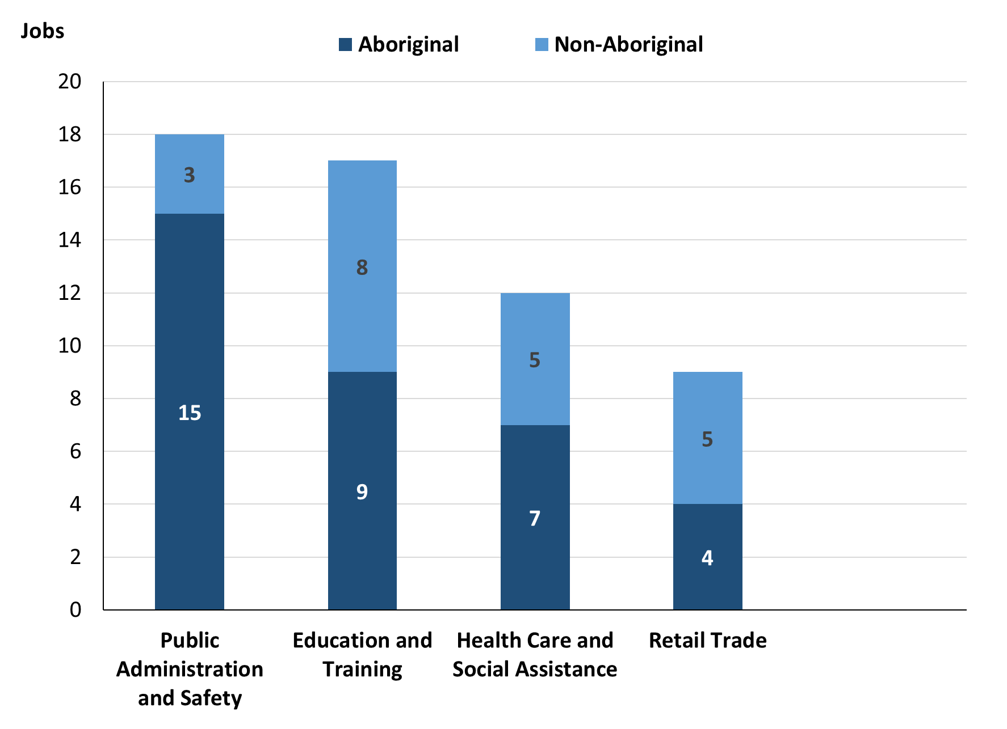

Source: Source: Northern Territory Department of Industry, Tourism and Trade

In 2023 in Papunya (Warumpi):

* of the 35 **jobs filled** by **Aboriginal** people, there were:
* 15 jobs in Public Administration and Safety, an increase of 3 jobs from 2017 and a decrease of 30 jobs from 2014
* 9 jobs in Education and Training, an increase of 5 jobs from 2017 and an increase of 8 jobs from 2014
* 7 jobs in Health Care and Social Assistance, an increase of 6 jobs from 2017 and an increase of 4 jobs from 2014
* of the 21 **jobs filled** by **non-Aboriginal** people, there were:
* 8 jobs in Education and Training, an increase of 1 job from 2017 and a decrease of 2 jobs from 2014
* 5 jobs in Health Care and Social Assistance, an increase of 1 job from 2017 and an increase of 2 jobs from 2014
* 5 jobs in Retail Trade, a decrease of 1 job from 2017 and unchanged from 2014.

Table 12: Count of filled jobs by industry and employment status, 2011 (a)(c)(e)(h)

|  |  |  |  |  |  |  |  |  |  |  |
| --- | --- | --- | --- | --- | --- | --- | --- | --- | --- | --- |
| **Industry (ANZSIC division)** | **2011** | | | | | | | | | |
| **Aboriginal** | | | **Non-Aboriginal** | | | **Total** | | | |
| **Perm** | **Temp** | **Total** | **Perm** | **Temp** | **Total** | **Perm** | **Temp** | **Total** |
| Arts and Recreation Services | 1 | 2 | **3** | 2 | 1 | **3** | 3 | 3 | **6** |
| Education and Training | 1 | 4 | **5** | 3 | 10 | **13** | 4 | 14 | **18** |
| Health Care and Social Assistance | 0 | 1 | **1** | 0 | 5 | **5** | 0 | 6 | **6** |
| Public Administration and Safety | 2 | 34 | **36** | 4 | 5 | **9** | 6 | 39 | **45** |
| Retail Trade | 3 | 0 | **3** | 3 | 0 | **3** | 6 | 0 | **6** |
| **Total** | **7** | **44** | **51** | **12** | **21** | **33** | **19** | **65** | **84** |

Source: Northern Territory Department of Industry, Tourism and Trade

Table 13: Count of filled jobs by industry and employment status, 2014 (a)(c)(e)(h)

|  |  |  |  |  |  |  |  |  |  |
| --- | --- | --- | --- | --- | --- | --- | --- | --- | --- |
| **Industry (ANZSIC division)** | **2014** | | | | | | | | |
| **Aboriginal** | | | **Non-Aboriginal** | | | **Total** | | |
| **Perm** | **Temp** | **Total** | **Perm** | **Temp** | **Total** | **Perm** | **Temp** | **Total** |
| Arts and Recreation Services | 4 | 8 | **12** | 2 | 1 | **3** | 6 | 9 | **15** |
| Education and Training | 0 | 1 | **1** | 6 | 4 | **10** | 6 | 5 | **11** |
| Health Care and Social Assistance | 3 | 0 | **3** | 3 | 0 | **3** | 6 | 0 | **6** |
| Public Administration and Safety | 34 | 11 | **45** | 8 | 0 | **8** | 42 | 11 | **53** |
| Retail Trade | 2 | 0 | **2** | 5 | 0 | **5** | 7 | 0 | **7** |
| **Total** | **43** | **20** | **63** | **24** | **5** | **29** | **67** | **25** | **92** |

Source: Northern Territory Department of Industry, Tourism and Trade

Table 14: Count of filled jobs by industry and employment status, 2017 (a)(c)(e)(h)

|  |  |  |  |  |  |  |  |  |  |
| --- | --- | --- | --- | --- | --- | --- | --- | --- | --- |
| **Industry (ANZSIC division)** | **2017** | | | | | | | | |
| **Aboriginal** | | | **Non-Aboriginal** | | | **Total** | | |
| **Perm** | **Temp** | **Total** | **Perm** | **Temp** | **Total** | **Perm** | **Temp** | **Total** |
| Arts and Recreation Services | 4 | 7 | **11** | 2 | 2 | **4** | 6 | 9 | **15** |
| Education and Training | 0 | 4 | **4** | 2 | 5 | **7** | 2 | 9 | **11** |
| Health Care and Social Assistance | 0 | 1 | **1** | 2 | 2 | **4** | 2 | 3 | **5** |
| Public Administration and Safety | 2 | 10 | **12** | 4 | 0 | **4** | 6 | 10 | **16** |
| Retail Trade | 4 | 0 | **4** | 6 | 0 | **6** | 10 | 0 | **10** |
| **Total** | **10** | **22** | **32** | **16** | **9** | **25** | **26** | **31** | **57** |

Source: Northern Territory Department of Industry, Tourism and Trade

Table 15: Count of filled jobs by industry and employment status, 2023 (a)(c)(e)(h)

|  |  |  |  |  |  |  |  |  |  |
| --- | --- | --- | --- | --- | --- | --- | --- | --- | --- |
| **Industry (ANZSIC division)** | **2023** | | | | | | | | |
| **Aboriginal** | | | **Non-Aboriginal** | | | **Total** | | |
| **Perm** | **Temp** | **Total** | **Perm** | **Temp** | **Total** | **Perm** | **Temp** | **Total** |
| Arts and Recreation Services | 0 | 0 | **0** | 0 | 0 | **0** | 0 | 0 | **0** |
| Education and Training | 0 | 9 | **9** | 4 | 4 | **8** | 4 | 13 | **17** |
| Health Care and Social Assistance | 0 | 7 | **7** | 2 | 3 | **5** | 2 | 10 | **12** |
| Public Administration and Safety | 3 | 12 | **15** | 3 | 0 | **3** | 6 | 12 | **18** |
| Retail Trade | 4 | 0 | **4** | 5 | 0 | **5** | 9 | 0 | **9** |
| **Total** | **7** | **28** | **35** | **14** | **7** | **21** | **21** | **35** | **56** |

Source: Northern Territory Department of Industry, Tourism and Trade

In 2023 in Papunya (Warumpi):

* of the 21 **permanent** jobs, there were:
* 9 jobs in Retail Trade, a decrease of 1 job from 2017 and an increase of 2 jobs from 2014, including:
* **Aboriginal** people filled 4 jobs, unchanged from 2017 and an increase of 2 jobs from 2014
* **non-Aboriginal** people filled 5 jobs, a decrease of 1 job from 2017 and unchanged from 2014
* 6 jobs in Public Administration and Safety, unchanged from 2017 and a decrease of 36 jobs from 2014, including:
* **Aboriginal** people filled 3 jobs, an increase of 1 job from 2017 and a decrease of 31 jobs from 2014
* **non-Aboriginal** people filled 3 jobs, a decrease of 1 job from 2017 and a decrease of 5 jobs from 2014
* 4 jobs in Education and Training, an increase of 2 jobs from 2017 and a decrease of 2 jobs from 2014, including:
* **Aboriginal** people filled 0 jobs, unchanged from 2017 and unchanged from 2014
* **non-Aboriginal** people filled 4 jobs, an increase of 2 jobs from 2017 and a decrease of 2 jobs from 2014
* of the 35 **temporary** jobs, there were:
* 13 jobs in Education and Training, an increase of 4 jobs from 2017 and an increase of 8 jobs from 2014, including
* **Aboriginal** people filled 9 jobs, an increase of 5 jobs from 2017 and an increase of 8 jobs from 2014

**non-Aboriginal** people filled 4 jobs, a decrease of 1 job from 2017 and unchanged from 2014

* 12 jobs in Public Administration and Safety, an increase of 2 jobs from 2017 and an increase of 1 job from 2014, including:
* **Aboriginal** people filled 12 jobs, an increase of 2 jobs from 2017 and an increase of 1 job from 2014
* **non-Aboriginal** people filled 0 jobs, unchanged from 2017 and unchanged from 2014
* 10 jobs in Health Care and Social Assistance, an increase of 7 jobs from 2017 and an increase of 10 jobs from 2014, including:
* **Aboriginal** people filled 7 jobs, an increase of 6 jobs from 2017 and an increase of 7 jobs from 2014
* **non-Aboriginal** people filled 3 jobs, an increase of 1 job from 2017 and an increase of 3 jobs from 2014.

# Jobs by Occupation

Table 16a: Count of filled jobs by occupation, 2011, 2014, 2017 & 2023 (a)(f)(g)

|  |  |  |  |  |  |  |  |  |
| --- | --- | --- | --- | --- | --- | --- | --- | --- |
| **Occupation (ANZSCO major group)** | **2011** | | **2014** | | **2017** | | **2023** | |
| **Total** | **% of Total** | **Total** | **% of Total** | **Total** | **% of Total** | **Total** | **% of Total** |
| Clerical and Administrative Workers | 8 | 9.5% | 9 | 9.8% | 8 | 14.0% | 4 | 7.1% |
| Community and Personal Service Workers | 30 | 35.7% | 32 | 34.8% | 11 | 19.3% | 24 | 42.9% |
| Labourers | 19 | 22.6% | 19 | 20.7% | 5 | 8.8% | 1 | 1.8% |
| Machinery Operators and Drivers | 0 | 0.0% | 3 | 3.3% | 1 | 1.8% | 1 | 1.8% |
| Managers | 6 | 7.1% | 6 | 6.5% | 8 | 14.0% | 4 | 7.1% |
| Professionals | 18 | 21.4% | 21 | 22.8% | 21 | 36.8% | 18 | 32.1% |
| Sales Workers | 3 | 3.6% | 0 | 0.0% | 2 | 3.5% | 0 | 0.0% |
| Technicians and Trades Workers | 0 | 0.0% | 2 | 2.2% | 1 | 1.8% | 4 | 7.1% |
| Other Occupations | 0 | 0.0% | 0 | 0.0% | 0 | 0.0% | 0 | 0.0% |
| **Total** | **84** | **100.0%** | **92** | **100.0%** | **57** | **100.0%** | **56** | **100.0%** |

Source: Northern Territory Department of Industry, Tourism and Trade

Table 16b: Count of filled jobs by occupation, 2011-2014, 2014-2017 & 2017-2023 (a)(f)(g)

|  |  |  |  |
| --- | --- | --- | --- |
| **Occupation (ANZSCO major group)** | **Change 2011-2014** | **Change 2014-2017** | **Change 2017-2023** |
| **Total** | **Total** | **Total** |
| Clerical and Administrative Workers | 1 | -1 | -4 |
| Community and Personal Service Workers | 2 | -21 | 13 |
| Labourers | 0 | -14 | -4 |
| Machinery Operators and Drivers | 3 | -2 | 0 |
| Managers | 0 | 2 | -4 |
| Professionals | 3 | 0 | -3 |
| Sales Workers | -3 | 2 | -2 |
| Technicians and Trades Workers | 2 | -1 | 3 |
| Other Occupations | 0 | 0 | 0 |
| **Total** | **8** | **-35** | **-1** |

Source: Northern Territory Department of Industry, Tourism and Trade

Chart 10: Percentage and count of top 6 filled jobs by occupation, 2011, 2014, 2017 & 2023 (a)(f)(g)

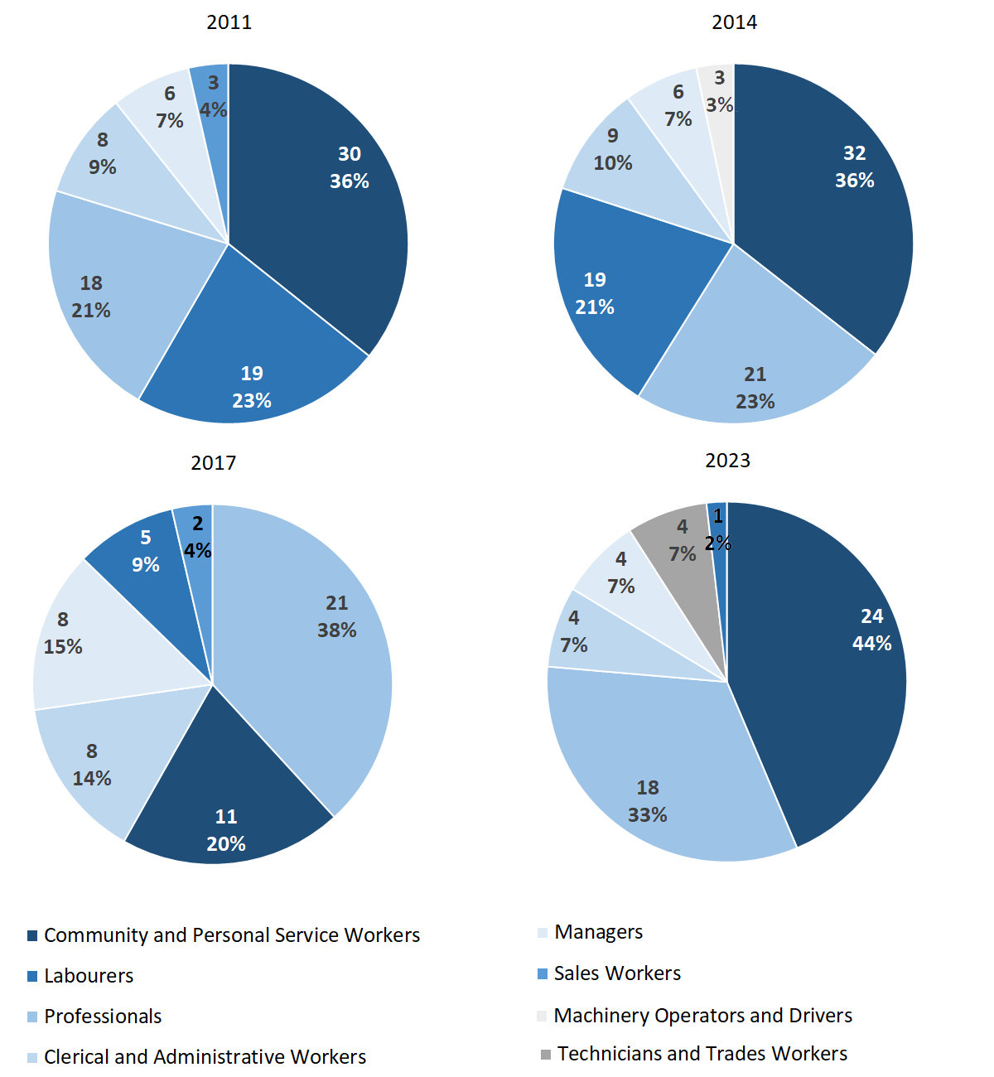Source: Northern Territory Department of Industry, Tourism and Trade

In 2023 in Papunya (Warumpi):

* Community and Personal Service Workers was the **largest occupation classification** in terms of filled jobs, accounting for 24 jobs (42.9% of total filled jobs), an increase of 13 jobs from 2017 and a decrease of 8 jobs from 2014
* **other significant** occupation classifications were:
* Professionals accounting for 18 jobs or 32.1% of total jobs, a decrease of 3 jobs from 2017 and a decrease of 3 jobs from 2014
* Clerical and Administrative Workers accounting for 4 jobs or 7.1% of total jobs, a decrease of 4 jobs from 2017 and a decrease of 5 jobs from 2014
* Managers accounting for 4 jobs or 7.1% of total jobs, a decrease of 4 jobs from 2017 and a decrease of 2 jobs from 2014
* Technicians and Trades Workers accounting for 4 jobs or 7.1% of total jobs, an increase of 3 jobs from 2017 and an increase of 2 jobs from 2014.

**Table 17a: Count of filled jobs by ANZSCO occupation, 2011, 2014, 2017 & 2023 (a)(c)(f)(g)**

|  |  |  |  |  |  |  |  |  |  |  |  |  |  |  |  |  |
| --- | --- | --- | --- | --- | --- | --- | --- | --- | --- | --- | --- | --- | --- | --- | --- | --- |
| **Occupation (ANZSCO major group)** | **2011** | | | | **2014** | | | | **2017** | | | | **2023** | | | |
| **Aboriginal** | **Non-Aboriginal** | **Total** | **Aboriginal** | | **Non-Aboriginal** | **Total** | **Aboriginal** | | **Non-Aboriginal** | **Total** | **Aboriginal** | | **Non-Aboriginal** | **Total** |
| Clerical and Administrative Workers | 6 | 2 | **8** | 8 | | 1 | **9** | 5 | | 3 | **8** | 3 | | 1 | **4** |
| Community and Personal Service Workers | 20 | 10 | **30** | 25 | | 7 | **32** | 8 | | 3 | **11** | 20 | | 4 | **24** |
| Labourers | 15 | 4 | **19** | 17 | | 2 | **19** | 5 | | 0 | **5** | 1 | | 0 | **1** |
| Machinery Operators and Drivers | 0 | 0 | **0** | 2 | | 1 | **3** | 1 | | 0 | **1** | 1 | | 0 | **1** |
| Managers | 0 | 6 | **6** | 0 | | 6 | **6** | 0 | | 8 | **8** | 0 | | 4 | **4** |
| Professionals | 7 | 11 | **18** | 10 | | 11 | **21** | 11 | | 10 | **21** | 7 | | 11 | **18** |
| Sales Workers | 3 | 0 | **3** | 0 | | 0 | **0** | 2 | | 0 | **2** | 0 | | 0 | **0** |
| Technicians and Trades Workers | 0 | 0 | **0** | 1 | | 1 | **2** | 0 | | 1 | **1** | 3 | | 1 | **4** |
| **Total** | **51** | **33** | **84** | **63** | | **29** | **92** | **32** | | **25** | **57** | **35** | | **21** | **56** |

Source: Northern Territory Department of Industry, Tourism and Trade

**Table 17b: Count of filled jobs by ANZSCO occupation, 2011-2014, 2014-2017 & 2017-2023 (a)(c)(f)(g)**

|  |  |  |  |  |  |  |  |  |  |  |
| --- | --- | --- | --- | --- | --- | --- | --- | --- | --- | --- |
| **Occupation (ANZSCO major group)** | **Change 2011-2014** | | | **Change 2014-2017** | | | | **Change 2017-2023** | | |
| **Aboriginal** | **Non-Aboriginal** | **Total** | **Aboriginal** | **Non-Aboriginal** | **Total** | **Aboriginal** | | **Non-Aboriginal** | **Total** |
| Clerical and Administrative Workers | 2 | -1 | **1** | -3 | 2 | **-1** | -2 | | -2 | **-4** |
| Community and Personal Service Workers | 5 | -3 | **2** | -17 | -4 | **-21** | 12 | | 1 | **13** |
| Labourers | 2 | -2 | **0** | -12 | -2 | **-14** | -4 | | 0 | **-4** |
| Machinery Operators and Drivers | 2 | 1 | **3** | -1 | -1 | **-2** | 0 | | 0 | **0** |
| Managers | 0 | 0 | **0** | 0 | 2 | **2** | 0 | | -4 | **-4** |
| Professionals | 3 | 0 | **3** | 1 | -1 | **0** | -4 | | 1 | **-3** |
| Sales Workers | -3 | 0 | **-3** | 2 | 0 | **2** | -2 | | 0 | **-2** |
| Technicians and Trades Workers | 1 | 1 | **2** | -1 | 0 | **-1** | 3 | | 0 | **3** |
| **Total** | **12** | **-4** | **8** | **-31** | **-4** | **-35** | **3** | | **-4** | **-1** |

Source: Northern Territory Department of Industry, Tourism and Trade

In 2023 in Papunya (Warumpi):

* of the 35 **jobs filled** by **Aboriginal** people, there were:
* 20 Community and Personal Service Workers, an increase of 12 jobs from 2017 and a decrease of 5 jobs from 2014
* 7 Professionals, a decrease of 4 jobs from 2017 and a decrease of 3 jobs from 2014
* 3 Clerical and Administrative Workers, a decrease of 2 jobs from 2017 and a decrease of 5 jobs from 2014
* of the 21 **jobs filled** by **non-Aboriginal** people, there were:
* 11 Professionals, an increase of 1 job from 2017 and unchanged from 2014
* 4 Community and Personal Service Workers, an increase of 1 job from 2017 and a decrease of 3 jobs from 2014
* 4 Managers, a decrease of 4 jobs from 2017 and a decrease of 2 jobs from 2014.

# Jobs by Industry by Occupation

Table 18: Count of filled jobs by industry by occupation, 2011 (a)(f)(g)(h)

|  |  |  |  |  |  |  |  |  |  |  |
| --- | --- | --- | --- | --- | --- | --- | --- | --- | --- | --- |
| **2011** | | | | | | | | | | |
| **Industry (ANZSIC Division)** |  | **Occupation (ANZSCO major group)** | | | | | | | | |
| **Clerical and Administrative Workers** | **Community and Personal Service Workers** | **Labourers** | **Machinery Operators and Drivers** | **Managers** | **Professionals** | **Sales Workers** | **Technicians and Trades Workers** | **Other Occupations** | **Total** |
| Arts and Recreation Services | 1 | 0 | 2 | 0 | 2 | 1 | 0 | 0 | 0 | **6** |
| Education and Training | 1 | 5 | 3 | 0 | 1 | 8 | 0 | 0 | 0 | **18** |
| Health Care and Social Assistance | 0 | 0 | 1 | 0 | 0 | 5 | 0 | 0 | 0 | **6** |
| Public Administration and Safety | 5 | 25 | 11 | 0 | 0 | 4 | 0 | 0 | 0 | **45** |
| Retail Trade | 0 | 0 | 0 | 0 | 3 | 0 | 3 | 0 | 0 | **6** |
| **Total** | **8** | **30** | **19** | **0** | **6** | **18** | **3** | **0** | **0** | **84** |

Source: Northern Territory Department of Industry, Tourism and Trade

Table 19: Count of filled jobs by industry by occupation, 2014 (a)(f)(g)(h)

|  |  |  |  |  |  |  |  |  |  |  |  |
| --- | --- | --- | --- | --- | --- | --- | --- | --- | --- | --- | --- |
| **2014** | | | | | | | | | | | |
| **Industry (ANZSIC Division)** |  | **Occupation (ANZSCO major group)** | | | | | | | | | |
| **Clerical and Administrative Workers** | **Community and Personal Service Workers** | **Labourers** | **Machinery Operators and Drivers** | **Managers** | **Professionals** | **Sales Workers** | **Technicians and Trades Workers** | **Other Occupations** | **Total** |
| Arts and Recreation Services | 1 | 0 | 2 | 0 | 1 | 11 | 0 | 0 | 0 | **15** |
| Education and Training | 0 | 5 | 0 | 0 | 1 | 5 | 0 | 0 | 0 | **11** |
| Health Care and Social Assistance | 1 | 1 | 1 | 0 | 1 | 2 | 0 | 0 | 0 | **6** |
| Public Administration and Safety | 7 | 26 | 14 | 2 | 1 | 3 | 0 | 0 | 0 | **53** |
| Retail Trade | 0 | 0 | 2 | 1 | 2 | 0 | 0 | 2 | 0 | **7** |
| **Total** | **9** | **32** | **19** | **3** | **6** | **21** | **0** | **2** | **0** | **92** |

Source: Northern Territory Department of Industry, Tourism and Trade

Table 20: Count of filled jobs by occupation and by industry, 2017(a)(f)(g)(h)

|  |  |  |  |  |  |  |  |  |  |  |  |
| --- | --- | --- | --- | --- | --- | --- | --- | --- | --- | --- | --- |
| **2017** | | | | | | | | | | | |
| **Industry (ANZSIC Division)** |  | **Occupation (ANZSCO major group)** | | | | | | | | | |
| **Clerical and Administrative Workers** | **Community and Personal Service Workers** | **Labourers** | **Machinery Operators and Drivers** | **Managers** | **Professionals** | **Sales Workers** | **Technicians and Trades Workers** | **Other Occupations** | **Total** |
| Arts and Recreation Services | 0 | 0 | 4 | 0 | 1 | 10 | 0 | 0 | 0 | **15** |
| Education and Training | 2 | 2 | 0 | 0 | 1 | 6 | 0 | 0 | 0 | **11** |
| Health Care and Social Assistance | 1 | 0 | 0 | 0 | 1 | 3 | 0 | 0 | 0 | **5** |
| Public Administration and Safety | 5 | 9 | 0 | 0 | 0 | 2 | 0 | 0 | 0 | **16** |
| Retail Trade | 0 | 0 | 1 | 1 | 5 | 0 | 2 | 1 | 0 | **10** |
| **Total** | **8** | **11** | **5** | **1** | **8** | **21** | **2** | **1** | **0** | **57** |

Source: Northern Territory Department of Industry, Tourism and Trade

Table 21: Count of filled jobs by occupation and by industry, 2023(a)(f)(g)(h)

|  |  |  |  |  |  |  |  |  |  |  |  |
| --- | --- | --- | --- | --- | --- | --- | --- | --- | --- | --- | --- |
| **2023** | | | | | | | | | | | |
| **Industry (ANZSIC Division)** |  | **Occupation (ANZSCO major group)** | | | | | | | | | |
| **Clerical and Administrative Workers** | **Community and Personal Service Workers** | **Labourers** | **Machinery Operators and Drivers** | **Managers** | **Professionals** | **Sales Workers** | **Technicians and Trades Workers** | **Other Occupations** | **Total** |
| Arts and Recreation Services | 0 | 0 | 0 | 0 | 0 | 0 | 0 | 0 | 0 | **0** |
| Education and Training | 2 | 7 | 1 | 0 | 0 | 7 | 0 | 0 | 0 | **17** |
| Health Care and Social Assistance | 1 | 0 | 0 | 0 | 0 | 11 | 0 | 0 | 0 | **12** |
| Public Administration and Safety | 1 | 17 | 0 | 0 | 0 | 0 | 0 | 0 | 0 | **18** |
| Retail Trade | 0 | 0 | 0 | 1 | 4 | 0 | 0 | 4 | 0 | **9** |
| **Total** | **4** | **24** | **1** | **1** | **4** | **18** | **0** | **4** | **0** | **56** |

Source: Northern Territory Department of Industry, Tourism and Trade

In 2023 in Papunya (Warumpi):

* Community and Personal Service Workers had the majority with 24 jobs (the largest occupation group) were shared across the Public Administration and Safety with 17 jobs and Education and Training industries with 7 jobs,
* Professionals had the majority 18 jobs (the 2nd largest occupation group) which were shared across the Health Care and Social Assistance with 11 jobs and Education and Training industries with 7 jobs,
* In Public Administration and Safety (the largest industry), there were 17 filled jobs for Community and Personal Service Workers, an increase of 8 filled jobs from 2017.
* Health Care and Social Assistance and Education and Training industries showed an increase of 7 and 6 filled jobs between 2023 and 2017, respectively.
* Arts and Recreation Services showed the largest decrease of 15 filled jobs between 2023 and 2017.

# Jobs by Gender

Table 22a: Count of filled jobs by gender, 2011, 2014, 2017 & 2023 (a)(c)(i)

|  |  |  |  |  |  |  |  |  |  |  |  |  |
| --- | --- | --- | --- | --- | --- | --- | --- | --- | --- | --- | --- | --- |
| **Indicator** | **2011** | | | **2014** | | | **2017** | | | **2023** | | |
| **Aboriginal** | **Non-Aboriginal** | **Total** | **Aboriginal** | **Non-Aboriginal** | **Total** | **Aboriginal** | **Non-Aboriginal** | **Total** | **Aboriginal** | **Non-Aboriginal** | **Total** |
| Male | 22 | 13 | **35** | 36 | 13 | **49** | 9 | 10 | **19** | 11 | 8 | **19** |
| Female | 29 | 20 | **49** | 27 | 16 | **43** | 23 | 15 | **38** | 24 | 13 | **37** |
| **Total** | **51** | **33** | **84** | **63** | **29** | **92** | **32** | **25** | **57** | **35** | **21** | **56** |

Source: Northern Territory Department of Industry, Tourism and Trade

Table 22b: Count of filled jobs by gender, 2011-2014, 2014-2017 & 2017-2023 (a)(c)(i)

|  |  |  |  |  |  |  |  |  |  |  |
| --- | --- | --- | --- | --- | --- | --- | --- | --- | --- | --- |
| **Indicator** | | **2011-2014 Change** | | | **2014-2017 Change** | | | **2017-2023 Change** | | |
| **Aboriginal** | **Non-Aboriginal** | **Total** | **Aboriginal** | **Non-Aboriginal** | **Total** | **Aboriginal** | **Non-Aboriginal** | **Total** |
| Male | 14 | 0 | **14** | -27 | -3 | **-30** | 2 | -2 | **0** |
| Female | -2 | -4 | **-6** | -4 | -1 | **-5** | 1 | -2 | **-1** |
| **Total** | **12** | **-4** | **8** | **-31** | **-4** | **-35** | **3** | **-4** | **-1** |

Source: Northern Territory Department of Industry, Tourism and Trade

**Chart 11: Count of filled jobs by gender, 2011, 2014, 2017 & 2023 (a)(b)(i)**

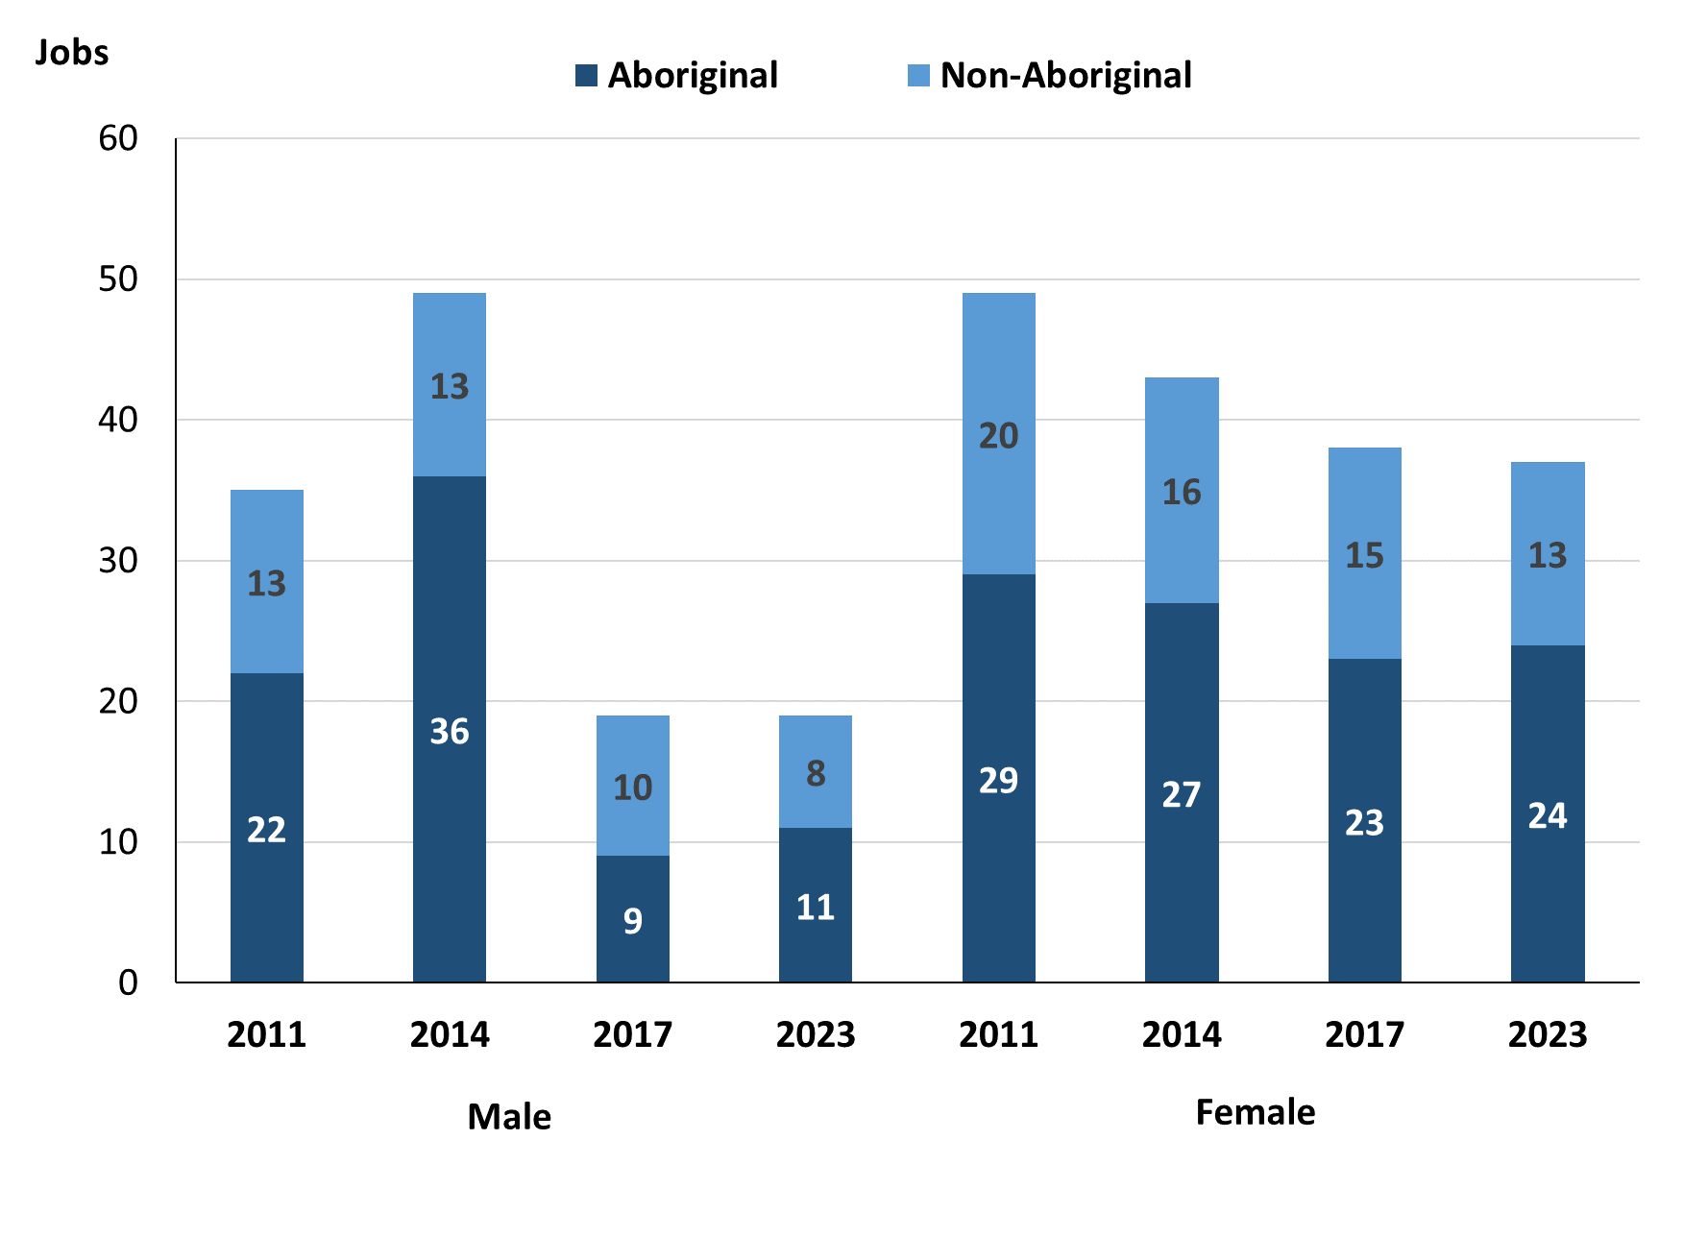

Source: Northern Territory Department of Industry, Tourism and Trade

In 2023 in Papunya (Warumpi):

* there were 19 **jobs** **filled** **by** **males**, unchanged from 2017 and a decrease of 30 jobs from 2014
* of the 19 **jobs filled by males**:
* 11 were **Aboriginal**, an increase of 2 jobs from 2017 and a decrease of 25 jobs from 2014
* 8 were **non-Aboriginal**, a decrease of 2 jobs from 2017 and a decrease of 5 jobs from 2014
* there were 37 **jobs** **filled** **by** **females**, a decrease of 1 job from 2017 and a decrease of 6 jobs from 2014
* of the 37 jobs **filled by females**:
* 24 were **Aboriginal**, an increase of 1 job from 2017 and a decrease of 3 jobs from 2014
* 13 were **non-Aboriginal**, a decrease of 2 jobs from 2017 and a decrease of 3 jobs from 2014.

Table 23: Count of filled jobs by gender, by full-time/part-time status, by job permanency and by sector 2011 (a)(b)(c)(d)(e)(i)

|  |  |  |  |  |  |  |  |  |  |
| --- | --- | --- | --- | --- | --- | --- | --- | --- | --- |
| **2011** | | | | | | | | | |
| **Indicator** | **Male** | | | **Female** | | | **Total** | | |
| **Aboriginal** | **Non-Aboriginal** | **Total** | **Aboriginal** | **Non-Aboriginal** | **Total** | **Aboriginal** | **Non-Aboriginal** | **Total** |
| Full-time | 10 | 11 | **21** | 9 | 16 | **25** | 19 | 27 | **46** |
| Part-time | 12 | 2 | **14** | 20 | 4 | **24** | 32 | 6 | **38** |
| **Total** | **22** | **13** | **35** | **29** | **20** | **49** | **51** | **33** | **84** |
| Permanent | 3 | 7 | **10** | 4 | 5 | **9** | 7 | 12 | **19** |
| Temporary | 19 | 6 | **25** | 25 | 15 | **40** | 44 | 21 | **65** |
| **Total** | **22** | **13** | **35** | **29** | **20** | **49** | **51** | **33** | **84** |
| Public Sector | 18 | 11 | **29** | 22 | 16 | **38** | 40 | 27 | **67** |
| Private Sector | 4 | 2 | **6** | 7 | 4 | **11** | 11 | 6 | **17** |
| **Total** | **22** | **13** | **35** | **29** | **20** | **49** | **51** | **33** | **84** |

Source: Northern Territory Department of Industry, Tourism and Trade

Table 24: Count of filled jobs by gender, by full-time/part-time status, by job permanency and by sector 2014 (a)(b)(c)(d)(e)(i)

|  |  |  |  |  |  |  |  |  |  |
| --- | --- | --- | --- | --- | --- | --- | --- | --- | --- |
| **2014** | | | | | | | | | |
| **Indicator** | **Male** | | | **Female** | | | **Total** | | |
| **Aboriginal** | **Non-Aboriginal** | **Total** | **Aboriginal** | **Non-Aboriginal** | **Total** | **Aboriginal** | **Non-Aboriginal** | **Total** |
| Full-time | 10 | 13 | **23** | 4 | 15 | **19** | 14 | 28 | **42** |
| Part-time | 26 | 0 | **26** | 23 | 1 | **24** | 49 | 1 | **50** |
| **Total** | **36** | **13** | **49** | **27** | **16** | **43** | **63** | **29** | **92** |
| Permanent | 25 | 12 | **37** | 18 | 12 | **30** | 43 | 24 | **67** |
| Temporary | 11 | 1 | **12** | 9 | 4 | **13** | 20 | 5 | **25** |
| **Total** | **36** | **13** | **49** | **27** | **16** | **43** | **63** | **29** | **92** |
| Public Sector | 24 | 6 | **30** | 19 | 13 | **32** | 43 | 19 | **62** |
| Private Sector | 12 | 7 | **19** | 8 | 3 | **11** | 20 | 10 | **30** |
| **Total** | **36** | **13** | **49** | **27** | **16** | **43** | **63** | **29** | **92** |

Source: Northern Territory Department of Industry, Tourism and Trade

Table 25: Count of filled jobs by gender, by full-time/part-time status, by job permanency and by sector 2017 (a)(b)(c)(d)(e)(i)

|  |  |  |  |  |  |  |  |  |  |
| --- | --- | --- | --- | --- | --- | --- | --- | --- | --- |
| **2017** | | | | | | | | | |
| **Indicator** | **Male** | | | **Female** | | | **Total** | | |
| **Aboriginal** | **Non-Aboriginal** | **Total** | **Aboriginal** | **Non-Aboriginal** | **Total** | **Aboriginal** | **Non-Aboriginal** | **Total** |
| Full-time | 1 | 9 | **10** | 3 | 14 | **17** | 4 | 23 | **27** |
| Part-time | 8 | 1 | **9** | 20 | 1 | **21** | 28 | 2 | **30** |
| **Total** | **9** | **10** | **19** | **23** | **15** | **38** | **32** | **25** | **57** |
| Permanent | 6 | 7 | **13** | 4 | 9 | **13** | 10 | 16 | **26** |
| Temporary | 3 | 3 | **6** | 19 | 6 | **25** | 22 | 9 | **31** |
| **Total** | **9** | **10** | **19** | **23** | **15** | **38** | **32** | **25** | **57** |
| Public Sector | 1 | 6 | **7** | 16 | 9 | **25** | 17 | 15 | **32** |
| Private Sector | 8 | 4 | **12** | 7 | 6 | **13** | 15 | 10 | **25** |
| **Total** | **9** | **10** | **19** | **23** | **15** | **38** | **32** | **25** | **57** |

Source: Northern Territory Department of Industry, Tourism and Trade

Table 26: Count of filled jobs by gender, by full-time/part-time status, by job permanency and by sector 2023 (a)(b)(c)(d)(e)(i)

|  |  |  |  |  |  |  |  |  |  |
| --- | --- | --- | --- | --- | --- | --- | --- | --- | --- |
| **2023** | | | | | | | | | |
| **Indicator** | **Male** | | | **Female** | | | **Total** | | |
| **Aboriginal** | **Non-Aboriginal** | **Total** | **Aboriginal** | **Non-Aboriginal** | **Total** | **Aboriginal** | **Non-Aboriginal** | **Total** |
| Full-time | 4 | 8 | **12** | 15 | 13 | **28** | 19 | 21 | **40** |
| Part-time | 7 | 0 | **7** | 9 | 0 | **9** | 16 | 0 | **16** |
| **Total** | **11** | **8** | **19** | **24** | **13** | **37** | **35** | **21** | **56** |
| Permanent | 3 | 7 | **10** | 4 | 7 | **11** | 7 | 14 | **21** |
| Temporary | 8 | 1 | **9** | 20 | 6 | **26** | 28 | 7 | **35** |
| **Total** | **11** | **8** | **19** | **24** | **13** | **37** | **35** | **21** | **56** |
| Public Sector | 4 | 5 | **9** | 15 | 11 | **26** | 19 | 16 | **35** |
| Private Sector | 7 | 3 | **10** | 9 | 2 | **11** | 16 | 5 | **21** |
| **Total** | **11** | **8** | **19** | **24** | **13** | **37** | **35** | **21** | **56** |

Source: Northern Territory Department of Industry, Tourism and Trade

In 2023 in Papunya (Warumpi):

* of the 19 **jobs filled by males**, there were:
* 11 jobs filled by **Aboriginal males**, an increase of 2 jobs from 2017 and a decrease of 25 jobs from 2014, including:
* 4 full-time jobs, an increase of 3 jobs from 2017 and a decrease of 6 jobs from 2014
* 7 part-time jobs, a decrease of 1 job from 2017 and a decrease of 19 jobs from 2014
* 3 permanent jobs, a decrease of 3 jobs from 2017 and a decrease of 22 jobs from 2014
* 8 temporary jobs, an increase of 5 jobs from 2017 and a decrease of 3 jobs from 2014
* 4 Public Sector jobs, an increase of 3 jobs from 2017 and a decrease of 20 jobs from 2014
* 7 Private Sector jobs, a decrease of 1 job from 2017 and a decrease of 5 jobs from 2014
* 8 jobs filled by **non-Aboriginal males**, a decrease of 2 jobs from 2017 and a decrease of 5 jobs from 2014, including:
* 8 full-time jobs, a decrease of 1 job from 2017 and a decrease of 5 jobs from 2014
* 0 part-time jobs, a decrease of 1 job from 2017 and unchanged from 2014
* 7 permanent jobs, unchanged from 2017 and a decrease of 5 jobs from 2014
* 1 temporary job, a decrease of 2 jobs from 2017 and unchanged from 2014
* 5 Public Sector jobs, a decrease of 1 job from 2017 and a decrease of 1 job from 2014
* 3 Private Sector jobs, a decrease of 1 job from 2017 and a decrease of 4 jobs from 2014
* of the 37 **jobs filled by females**, there were:
* 24 jobs filled by **Aboriginal females**, an increase of 1 job from 2017 and a decrease of 3 jobs from 2014, including:
* 15 full-time jobs, an increase of 12 jobs from 2017 and an increase of 11 jobs from 2014
* 9 part-time jobs, a decrease of 11 jobs from 2017 and a decrease of 14 jobs from 2014
* 4 permanent jobs, unchanged from 2017 and a decrease of 14 jobs from 2014
* 20 temporary jobs, an increase of 1 job from 2017 and an increase of 11 jobs from 2014
* 15 Public Sector jobs, a decrease of 1 job from 2017 and a decrease of 4 jobs from 2014
* 9 Private Sector jobs, an increase of 2 jobs from 2017 and an increase of 1 job from 2014
* 13 jobs filled by **non-Aboriginal females**, a decrease of 2 jobs from 2017 and a decrease of 3 jobs from 2014, including:
* 13 full-time jobs, a decrease of 1 job from 2017 and a decrease of 2 jobs from 2014
* 0 part-time jobs, a decrease of 1 job from 2017 and a decrease of 1 job from 2014
* 7 permanent jobs, a decrease of 2 jobs from 2017 and a decrease of 5 jobs from 2014
* 6 temporary jobs, unchanged from 2017 and an increase of 2 jobs from 2014
* 11 Public Sector jobs, an increase of 2 jobs from 2017 and a decrease of 2 jobs from 2014
* 2 Private Sector jobs, a decrease of 4 jobs from 2017 and a decrease of 1 job from 2014.

# Jobs by Age

Table 27a: Count of filled jobs by age, 2011, 2014, 2017 & 2023 (a)(c)(j)

|  |  |  |  |  |  |  |  |  |  |  |  |  |  |
| --- | --- | --- | --- | --- | --- | --- | --- | --- | --- | --- | --- | --- | --- |
| **Indicator** | **2011** | | | **2014** | | | **2017** | | | **2023** | | | |
| **Aboriginal** | **Non-Aboriginal** | **Total** | **Aboriginal** | **Non-Aboriginal** | **Total** | **Aboriginal** | **Non-Aboriginal** | **Total** | **Aboriginal** | **Non-Aboriginal** | **Total** |
| 15-24 years | 7 | 0 | **7** | 6 | 0 | **6** | 3 | 1 | **4** | 6 | 2 | **8** |
| 25-44 years | 33 | 16 | **49** | 40 | 12 | **52** | 23 | 13 | **36** | 21 | 7 | **28** |
| 45+ years | 11 | 17 | **28** | 17 | 17 | **34** | 6 | 11 | **17** | 8 | 12 | **20** |
| **Total** | **51** | **33** | **84** | **63** | **29** | **92** | **32** | **25** | **57** | **35** | **21** | **56** |

Source: Northern Territory Department of Industry, Tourism and Trade

Table 27b: Count of filled jobs by age and Aboriginal status of person employed in job, 2011-2014, 2014-2017 & 2017-2023 (a)(c)(j)

|  |  |  |  |  |  |  |  |  |  |
| --- | --- | --- | --- | --- | --- | --- | --- | --- | --- |
| **Indicator** | **Change 2011-2014** | | | **Change 2014-2017** | | | **Change 2017-2023** | | |
| **Aboriginal** | **Non-Aboriginal** | **Total** | **Aboriginal** | **Non-Aboriginal** | **Total** | **Aboriginal** | **Non-Aboriginal** | **Total** |
| 15-24 years | -1 | 0 | **-1** | -3 | 1 | **-2** | 3 | 1 | **4** |
| 25-44 years | 7 | -4 | **3** | -17 | 1 | **-16** | -2 | -6 | **-8** |
| 45+ years | 6 | 0 | **6** | -11 | -6 | **-17** | 2 | 1 | **3** |
| **Total** | **12** | **-4** | **8** | **-31** | **-4** | **-35** | **3** | **-4** | **-1** |

Source: Northern Territory Department of Industry, Tourism and Trade

**Chart 12: Count of filled jobs by age, 2011, 2014, 2017 & 2023 (a)(b)(j)**

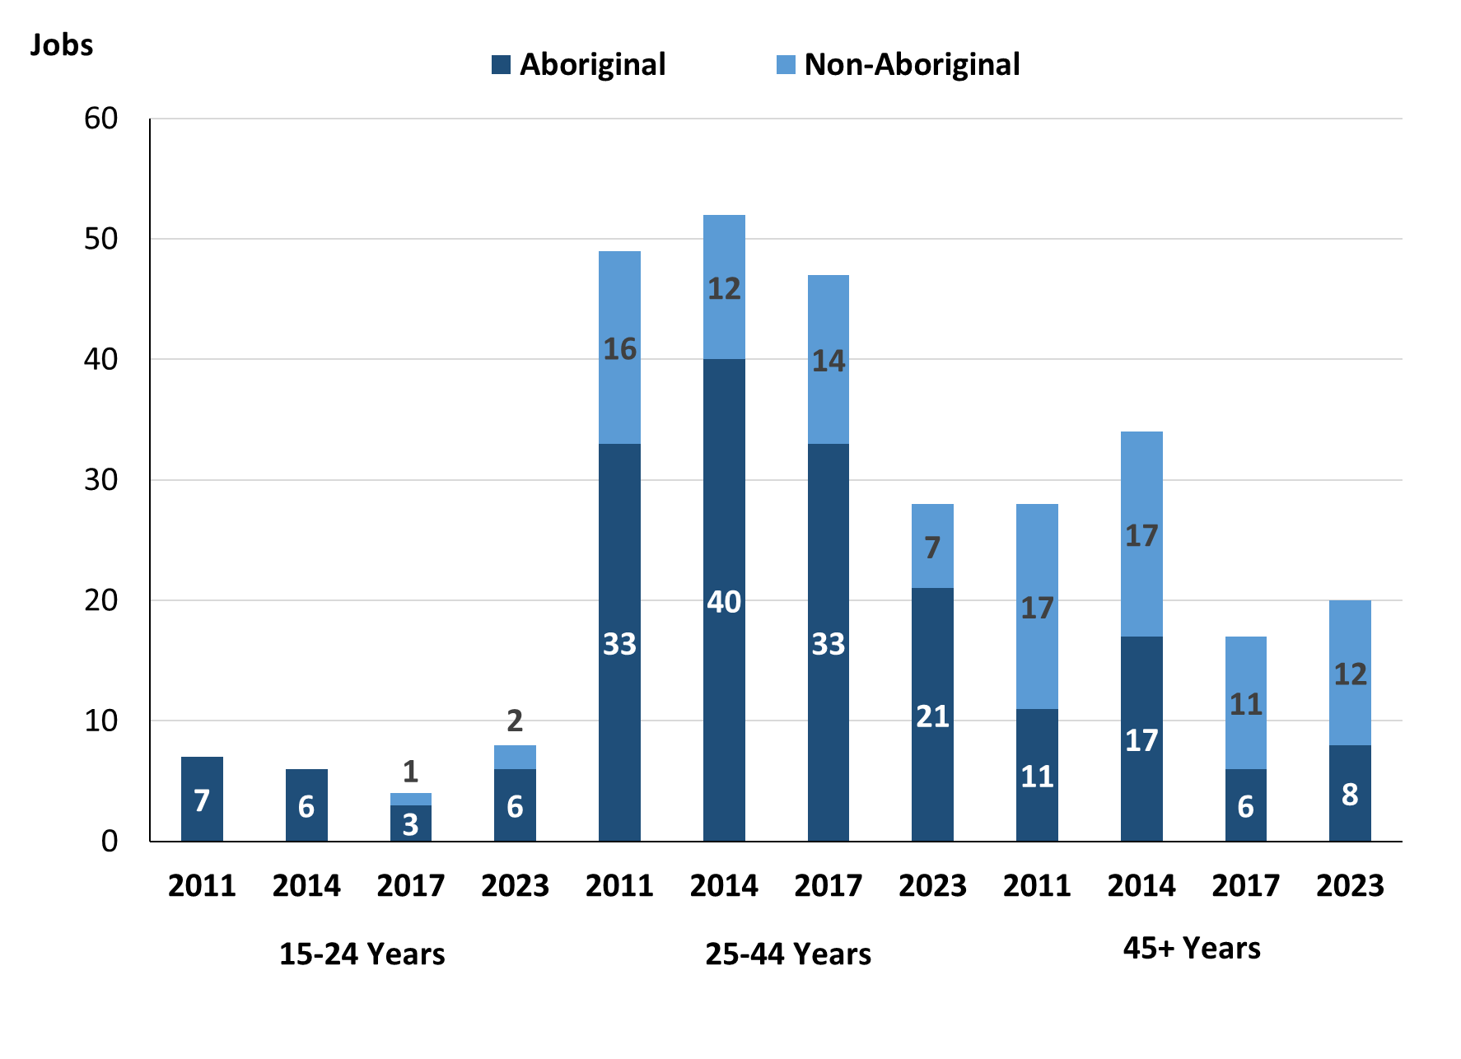

Source: Northern Territory Department of Industry, Tourism and Trade

In 2023 in Papunya (Warumpi):

* there were 8 **jobs** **filled** by people aged **15-24 years**, an increase of 4 jobs from 2017 and an increase of 2 jobs from 2014. Of these:
* **Aboriginal** people filled 6 jobs, an increase of 3 jobs from 2017 and unchanged from 2014
* by **Non-Aboriginal** people filled 2 jobs, an increase of 1 job from 2017 and an increase of 2 jobs from 2014
* there were 28 **jobs** **filled** by people aged **25-44 years**, a decrease of 8 jobs from 2017 and a decrease of 24 jobs from 2014. Of these:
* **Aboriginal** people filled 21 jobs, a decrease of 2 jobs from 2017 and a decrease of 19 jobs from 2014
* **non-Aboriginal** people filled 7 jobs, a decrease of 6 jobs from 2017 and a decrease of 5 jobs from 2014
* there were 20 **jobs** **filled** by people aged **45+ years**, an increase of 3 jobs from 2017 and a decrease of 14 jobs from 2014. Of these:
* **Aboriginal** people filled 8 jobs, an increase of 2 jobs from 2017 and a decrease of 9 jobs from 2014
* **non-Aboriginal** people filled 12 jobs, an increase of 1 job from 2017 and a decrease of 5 jobs from 2014.

Table 28: Count of filled jobs by age, by full-time/part-time status, by job permanency and by sector June-July 2011 (a)(b)(c)(d)(e)(i)

|  |  |  |  |  |  |  |  |  |  |  |  |  |
| --- | --- | --- | --- | --- | --- | --- | --- | --- | --- | --- | --- | --- |
| **2011** | | | | | | | | | | | | |
| **Indicator** | **15-24 years** | | | **25-44 years** | | | **45+ years** | | | **Total** | | |
| **Aboriginal** | **Non-Aboriginal** | **Total** | **Aboriginal** | **Non-Aboriginal** | **Total** | **Aboriginal** | **Non-Aboriginal** | **Total** | **Aboriginal** | **Non-Aboriginal** | **Total** |
| Full-time | 1 | 0 | **1** | 9 | 11 | **20** | 9 | 16 | **25** | 19 | 27 | **46** |
| Part-time | 6 | 0 | **6** | 24 | 5 | **29** | 2 | 1 | **3** | 32 | 6 | **38** |
| **Total** | **7** | **0** | **7** | **33** | **16** | **49** | **11** | **17** | **28** | **51** | **33** | **84** |
| Permanent | 1 | 0 | **1** | 4 | 7 | **11** | 2 | 5 | **7** | 7 | 12 | **19** |
| Temporary | 6 | 0 | **6** | 29 | 9 | **38** | 9 | 12 | **21** | 44 | 21 | **65** |
| **Total** | **7** | **0** | **7** | **33** | **16** | **49** | **11** | **17** | **28** | **51** | **33** | **84** |
| Public Sector | 5 | 0 | **5** | 25 | 13 | **38** | 10 | 14 | **24** | 40 | 27 | **67** |
| Private Sector | 2 | 0 | **2** | 8 | 3 | **11** | 1 | 3 | **4** | 11 | 6 | **17** |
| **Total** | **7** | **0** | **7** | **33** | **16** | **49** | **11** | **17** | **28** | **51** | **33** | **84** |

Source: Northern Territory Department of Industry, Tourism and Trade

Table 29: Count of filled jobs by age, by full-time/part-time status, by job permanency and by sector June-July 2014 (a)(b)(c)(d)(e)(i)

|  |  |  |  |  |  |  |  |  |  |  |  |  |
| --- | --- | --- | --- | --- | --- | --- | --- | --- | --- | --- | --- | --- |
| **2014** | | | | | | | | | | | | |
| **Indicator** | **15-24 years** | | | **25-44 years** | | | **45+ years** | | | **Total** | | |
| **Aboriginal** | **Non-Aboriginal** | **Total** | **Aboriginal** | **Non-Aboriginal** | **Total** | **Aboriginal** | **Non-Aboriginal** | **Total** | **Aboriginal** | **Non-Aboriginal** | **Total** |
| Full-time | 0 | 0 | **0** | 9 | 11 | **20** | 5 | 17 | **22** | 14 | 28 | **42** |
| Part-time | 6 | 0 | **6** | 31 | 1 | **32** | 12 | 0 | **12** | 49 | 1 | **50** |
| **Total** | **6** | **0** | **6** | **40** | **12** | **52** | **17** | **17** | **34** | **63** | **29** | **92** |
| Permanent | 4 | 0 | **4** | 27 | 9 | **36** | 12 | 15 | **27** | 43 | 24 | **67** |
| Temporary | 2 | 0 | **2** | 13 | 3 | **16** | 5 | 2 | **7** | 20 | 5 | **25** |
| **Total** | **6** | **0** | **6** | **40** | **12** | **52** | **17** | **17** | **34** | **63** | **29** | **92** |
| Public Sector | 2 | 0 | **2** | 28 | 9 | **37** | 13 | 10 | **23** | 43 | 19 | **62** |
| Private Sector | 4 | 0 | **4** | 12 | 3 | **15** | 4 | 7 | **11** | 20 | 10 | **30** |
| **Total** | **6** | **0** | **6** | **40** | **12** | **52** | **17** | **17** | **34** | **63** | **29** | **92** |

Source: Northern Territory Department of Industry, Tourism and Trade

Table 30: Count of filled jobs by age, by full-time/part-time status, by job permanency and by sector June-July 2017 (a)(b)(c)(d)(e)(i)

|  |  |  |  |  |  |  |  |  |  |  |  |  |  |
| --- | --- | --- | --- | --- | --- | --- | --- | --- | --- | --- | --- | --- | --- |
| **2017** | | | | | | | | | | | | | |
| **Indicator** | **15-24 years** | | | **25-44 years** | | | **45+ years** | | | **Total** | | | |
| **Aboriginal** | **Non-Aboriginal** | **Total** | **Aboriginal** | **Non-Aboriginal** | **Total** | **Aboriginal** | **Non-Aboriginal** | **Total** | **Aboriginal** | **Non-Aboriginal** | **Total** |
| Full-time | 1 | 1 | **2** | 1 | 11 | **12** | 2 | 11 | **13** | 4 | 23 | **27** |
| Part-time | 2 | 0 | **2** | 22 | 2 | **24** | 4 | 0 | **4** | 28 | 2 | **30** |
| **Total** | **3** | **1** | **4** | **23** | **13** | **36** | **6** | **11** | **17** | **32** | **25** | **57** |
| Permanent | 3 | 1 | **4** | 5 | 7 | **12** | 2 | 8 | **10** | 10 | 16 | **26** |
| Temporary | 0 | 0 | **0** | 18 | 6 | **24** | 4 | 3 | **7** | 22 | 9 | **31** |
| **Total** | **3** | **1** | **4** | **23** | **13** | **36** | **6** | **11** | **17** | **32** | **25** | **57** |
| Public Sector | 1 | 1 | **2** | 11 | 7 | **18** | 5 | 7 | **12** | 17 | 15 | **32** |
| Private Sector | 2 | 0 | **2** | 12 | 6 | **18** | 1 | 4 | **5** | 15 | 10 | **25** |
| **Total** | **3** | **1** | **4** | **23** | **13** | **36** | **6** | **11** | **17** | **32** | **25** | **57** |

Source: Northern Territory Department of Industry, Tourism and Trade

Table 31: Count of filled jobs by age, by full-time/part-time status, by job permanency and by sector September 2023 (a)(b)(c)(d)(e)(i)

|  |  |  |  |  |  |  |  |  |  |  |  |  |  |
| --- | --- | --- | --- | --- | --- | --- | --- | --- | --- | --- | --- | --- | --- |
| **2023** | | | | | | | | | | | | | |
| **Indicator** | **15-24 years** | | | **25-44 years** | | | **45+ years** | | | **Total** | | | |
| **Aboriginal** | **Non-Aboriginal** | **Total** | **Aboriginal** | **Non-Aboriginal** | **Total** | **Aboriginal** | **Non-Aboriginal** | **Total** | **Aboriginal** | **Non-Aboriginal** | **Total** |
| Full-time | 4 | 2 | **6** | 14 | 7 | **21** | 1 | 12 | **13** | 19 | 21 | **40** |
| Part-time | 2 | 0 | **2** | 7 | 0 | **7** | 7 | 0 | **7** | 16 | 0 | **16** |
| **Total** | **6** | **2** | **8** | **21** | **7** | **28** | **8** | **12** | **20** | **35** | **21** | **56** |
| Permanent | 1 | 1 | **2** | 5 | 6 | **11** | 1 | 7 | **8** | 7 | 14 | **21** |
| Temporary | 5 | 1 | **6** | 16 | 1 | **17** | 7 | 5 | **12** | 28 | 7 | **35** |
| **Total** | **6** | **2** | **8** | **21** | **7** | **28** | **8** | **12** | **20** | **35** | **21** | **56** |
| Public Sector | 3 | 2 | **5** | 11 | 5 | **16** | 5 | 9 | **14** | 19 | 16 | **35** |
| Private Sector | 3 | 0 | **3** | 10 | 2 | **12** | 3 | 3 | **6** | 16 | 5 | **21** |
| **Total** | **6** | **2** | **8** | **21** | **7** | **28** | **8** | **12** | **20** | **35** | **21** | **56** |

Source: Northern Territory Department of Industry, Tourism and Trade

In 2023 in Papunya (Warumpi):

* of the 8 jobs filled by people aged **15-24 years**, there were:
* 6 jobs filled by **Aboriginal** people, of which:
* 4 were full-time jobs, an increase of 3 jobs from 2017 and an increase of 4 jobs from 2014
* 2 were part-time jobs, unchanged from 2017 and a decrease of 4 jobs from 2014
* 1 was a permanent job, a decrease of 2 jobs from 2017 and a decrease of 3 jobs from 2014
* 5 were temporary jobs, an increase of 5 jobs from 2017 and an increase of 3 jobs from 2014
* 3 were Public Sector jobs, an increase of 2 jobs from 2017 and an increase of 1 job from 2014
* 3 were Private Sector jobs, an increase of 1 job from 2017 and a decrease of 1 job from 2014
* 2 jobs filled by **non-Aboriginal** people, of which:
* 2 were full-time jobs, an increase of 1 job from 2017 and an increase of 2 jobs from 2014
* none were part-time jobs, unchanged from 2017 and unchanged from 2014
* 1 was a permanent job, unchanged from 2017 and an increase of 1 job from 2014
* 1 was a temporary job, an increase of 1 job from 2017 and an increase of 1 job from 2014
* 2 were Public Sector jobs, an increase of 1 job from 2017 and an increase of 2 jobs from 2014
* none were Private Sector jobs, unchanged from 2017 and unchanged from 2014
* of the 28 jobs filled by people aged **25-44 years**, there were:
* 21 jobs filled by **Aboriginal** people, of which:
* 14 were full-time jobs, an increase of 13 jobs from 2017 and an increase of 5 jobs from 2014
* 7 were part-time jobs, a decrease of 15 jobs from 2017 and a decrease of 24 jobs from 2014
* 5 were permanent jobs, unchanged from 2017 and a decrease of 22 jobs from 2014
* 16 were temporary jobs, a decrease of 2 jobs from 2017 and an increase of 3 jobs from 2014
* 11 were Public Sector jobs, unchanged from 2017 and a decrease of 17 jobs from 2014
* 10 were Private Sector jobs, a decrease of 2 jobs from 2017 and a decrease of 2 jobs from 2014
* 7 jobs filled by **non-Aboriginal** people, of which:
* 7 were full-time jobs, a decrease of 4 jobs from 2017 and a decrease of 4 jobs from 2014
* none were part-time jobs, a decrease of 2 jobs from 2017 and a decrease of 1 job from 2014
* 6 were permanent jobs, a decrease of 1 job from 2017 and a decrease of 3 jobs from 2014
* 1 was a temporary job, a decrease of 5 jobs from 2017 and a decrease of 2 jobs from 2014
* 5 were Public Sector jobs, a decrease of 2 jobs from 2017 and a decrease of 4 jobs from 2014
* 2 were Private Sector jobs, a decrease of 4 jobs from 2017 and a decrease of 1 job from 2014
* of the 20 jobs filled by people aged **45+ years**, there were:
* 8 jobs filled by **Aboriginal** people, of which:
* 1 was a full-time job, a decrease of 1 job from 2017 and a decrease of 4 jobs from 2014
* 7 were part-time jobs, an increase of 3 jobs from 2017 and a decrease of 5 jobs from 2014
* 1 was a permanent job, a decrease of 1 job from 2017 and a decrease of 11 jobs from 2014
* 7 were temporary jobs, an increase of 3 jobs from 2017 and an increase of 2 jobs from 2014
* 5 were Public Sector jobs, unchanged from 2017 and a decrease of 8 jobs from 2014
* 3 were Private Sector jobs, an increase of 2 jobs from 2017 and a decrease of 1 job from 2014
* 12 jobs filled by **non-Aboriginal** people, of which:
* 12 were full-time jobs, an increase of 1 job from 2017 and a decrease of 5 jobs from 2014
* none were part-time jobs, unchanged from 2017 and unchanged from 2014
* 7 were permanent jobs, a decrease of 1 job from 2017 and a decrease of 8 jobs from 2014
* 5 were temporary jobs, an increase of 2 jobs from 2017 and an increase of 3 jobs from 2014
* 9 were Public Sector jobs, an increase of 2 jobs from 2017 and a decrease of 1 job from 2014
* 3 were Private Sector jobs, a decrease of 1 job from 2017 and a decrease of 4 jobs from 2014.

# Vocational Education and Training

Note: *The 2010 data is in accordance with the new, standardised reporting procedures that focus on all training activities conducted in the remote town, irrespective of funding source, as compared to earlier publications. As a result, the 2010 VET data values in this publication might not match those in earlier publications.*

*The impact of the Remote Jobs and Communities Program (RJCP), established in 2013, has played a significant role in the reduction of accredited training in many remote towns across the Territory.*

Table 32a: Northern Territory Vocational Education and Training (VET) students, 2010, 2013, 2016 and 2023 (k)

|  |  |  |  |  |  |  |  |  |
| --- | --- | --- | --- | --- | --- | --- | --- | --- |
| **VET Funding Group** | **2010** | | **2013** | | **2016** | | **2023** | |
| **No.** | **% of Total** | **No.** | **% of Total** | **No.** | **% of Total** | **No.** | **% of Total** |
| Arts, Entertainment, Sports and Recreation | 0 | 0% | 15 | 33% | 0 | 0% | 6 | 10% |
| Building and Construction | 0 | 0% | 0 | 0% | 16 | 15% | 0 | 0% |
| Business and Clerical | 3 | 5% | 8 | 18% | 34 | 33% | 9 | 15% |
| Community Services, Health and Education | 8 | 13% | 21 | 47% | 32 | 31% | 22 | 35% |
| Food Processing | 0 | 0% | 0 | 0% | 9 | 9% | 0 | 0% |
| General Education and Training | 33 | 53% | 0 | 0% | 13 | 13% | 7 | 11% |
| Primary Industry | 18 | 29% | 1 | 2% | 0 | 0% | 12 | 19% |
| Sales and Personal Service | 0 | 0% | 0 | 0% | 0 | 0% | 6 | 10% |
| **Total** | **62** | **100%** | **45** | **100%** | **104** | **100%** | **62** | **100%** |

Source: Northern Territory Department of Industry, Tourism and Trade

Table 32b: Northern Territory Vocational Education and Training (VET) students, 2010-2013, 2013-2016 and 2016-2023 (k)

|  |  |  |  |
| --- | --- | --- | --- |
| **VET Funding Group** | **Change** | | |
| **2010-2013** | **2013-2016** | **2016-2023** |
| Arts, Entertainment, Sports and Recreation | 15 | - 15 | 6 |
| Building and Construction | 0 | 16 | -16 |
| Business and Clerical | 5 | 26 | -25 |
| Community Services, Health and Education | 13 | 11 | -10 |
| Food Processing | 0 | 9 | -9 |
| General Education and Training | - 33 | 13 | -6 |
| Primary Industry | - 17 | - 1 | 12 |
| Sales and Personal Service | 0 | 0 | 6 |
| **Total** | **- 17** | **59** | **-42** |

Source: Northern Territory Department of Industry, Tourism and Trade

In 2023 in Papunya (Warumpi):

* there were 62 **VET students**, a decrease of 42 students from 2016 and an increase of 17 students from 2013
* VET activity with the most students were Community Services, Health and Education with students,
* Primary Industry had 12 students,
* Business and Clerical had 9 students,
* Primary Industry reported the largest increase in students with 12 more students compared to 2016,
* Business and Clerical reported the largest decrease in students with 25 less students over the same period.

Table 33a: Northern Territory Vocational Education and Training (VET) unit enrolments, 2010, 2013, 2016 and 2023 (l)

|  |  |  |  |  |  |  |  |  |
| --- | --- | --- | --- | --- | --- | --- | --- | --- |
| **VET Funding Group** | **2010** | | **2013** | | **2016** | | **2023** | |
| **No.** | **% of Total** | **No.** | **% of Total** | **No.** | **% of Total** | **No.** | **% of Total** |
| Arts, Entertainment, Sports and Recreation | 0 | 0% | 120 | 66% | 0 | 0% | 0 | 0% |
| Building and Construction | 0 | 0% | 0 | 0% | 16 | 3% | 26 | 7% |
| Business and Clerical | 25 | 16% | 25 | 14% | 192 | 34% | 86 | 24% |
| Community Services, Health and Education | 16 | 10% | 37 | 20% | 114 | 20% | 52 | 14% |
| Food Processing | 0 | 0% | 0 | 0% | 171 | 31% | 0 | 0% |
| General Education and Training | 59 | 38% | 0 | 0% | 65 | 12% | 10 | 3% |
| Primary Industry | 57 | 36% | 1 | 1% | 0 | 0% | 135 | 37% |
| Sales and Personal Service | 0 | 0% | 0 | 0% | 0 | 0% | 53 | 15% |
| **Total** | **157** | **100%** | **183** | **100%** | **558** | **100%** | **362** | **100%** |

Source: Northern Territory Department of Industry, Tourism and Trade

Table 33b: Northern Territory Vocational Education and Training (VET) unit enrolments, 2010-2013, 2013-2016 and 2016-2023 (l)

|  |  |  |  |
| --- | --- | --- | --- |
| **VET Funding Group** | **Change** | | |
| **2010-2013** | **2013-2016** | **2016-2023** |
| Arts, Entertainment, Sports and Recreation | 120 | - 120 | 0 |
| Building and Construction | 0 | 16 | 10 |
| Business and Clerical | 0 | 167 | -106 |
| Community Services, Health and Education | 21 | 77 | -62 |
| Food Processing | 0 | 171 | -171 |
| General Education and Training | - 59 | 65 | -55 |
| Primary Industry | - 56 | - 1 | 135 |
| Sales and Personal Service | 0 | 0 | 53 |
| **Total** | **26** | **375** | **-196** |

Source: Northern Territory Department of Industry, Tourism and Trade

In 2023 in Papunya (Warumpi):

* there were 362 **VET student enrolments**, a decrease of 196-unit enrolments from 2016 and an increase of 179-unit enrolments from 2013,
* VET activity with the most unit enrolments were Primary Industry with 135 student enrolments,
* Business and Clerical had 86 student enrolments,
* Sales and Personal Service had 53 student enrolments,
* Primary Industry reported the largest increase in student enrolments with 135 more student enrolments compared to 2016,
* Food Processing reported the largest decrease in student enrolments with 171 less student enrolments over the same period.

Table 34a: Northern Territory Vocational Education and Training (VET) nominal hours, 2010, 2013, 2016 and 2023 (m)

|  |  |  |  |  |  |  |  |  |  |
| --- | --- | --- | --- | --- | --- | --- | --- | --- | --- |
| **VET Funding Group** | **2010** | | **2013** | | **2016** | | | **2023** | |
| **No.** | **% of Total** | **No.** | **% of Total** | **No.** | **% of Total** | **No.** | | **% of Total** |
| Arts, Entertainment, Sports and Recreation | 0 | 0% | 4,425 | 71% | 0 | 0% | 0 | | 0% |
| Building and Construction | 0 | 0% | 0 | 0% | 96 | 1% | 2,600 | | 19% |
| Business and Clerical | 750 | 18% | 690 | 11% | 2,845 | 25% | 3,260 | | 24% |
| Community Services, Health and Education | 580 | 14% | 1,059 | 17% | 2,525 | 22% | 1,198 | | 9% |
| Food Processing | 0 | 0% | 0 | 0% | 5,400 | 47% | 0 | | 0% |
| General Education and Training | 760 | 18% | 0 | 0% | 715 | 6% | 100 | | 1% |
| Primary Industry | 2,140 | 51% | 60 | 1% | 0 | 0% | 4,970 | | 36% |
| Sales and Personal Service | 0 | 0% | 0 | 0% | 0 | 0% | 1,660 | | 12% |
| **Total** | **4,230** | **100%** | **6,234** | **100%** | **11,581** | **100%** | **13,788** | | **100%** |

Source: Northern Territory Department of Industry, Tourism and Trade

Table 34b: Northern Territory Vocational Education and Training (VET) nominal hours, 2010-2013, 2013-2016 and 2016-2023 (m)

|  |  |  |  |
| --- | --- | --- | --- |
| **VET Funding Group** | **Change** | | |
| **2010-2013** | **2013-2016** | **2016-2023** |
| Arts, Entertainment, Sports and Recreation | 4,425 | -4,425 | 0 |
| Building and Construction | 0 | 96 | 2,504 |
| Business and Clerical | - 60 | 2,155 | 415 |
| Community Services, Health and Education | 479 | 1,466 | -1,327 |
| Food Processing | 0 | 5,400 | -5,400 |
| General Education and Training | - 760 | 715 | -615 |
| Primary Industry | -2,080 | - 60 | 4,970 |
| Sales and Personal Service | 0 | 0 | 1,660 |
| **Total** | **2,004** | **5,347** | **2,207** |

Source: Northern Territory Department of Industry, Tourism and Trade

In 2023 in Papunya (Warumpi):

* there were 13,788 **VET nominal hours** delivered, an increase of 2,207 nominal hours delivered from 2016 and an increase of 7,554 nominal hours delivered from 2013,
* VET activity with the most nominal hours delivered were Primary Industry with 4,970 nominal hours,
* Business and Clerical had 3,260 nominal hours,
* Building and Construction had 2,600 nominal hours,
* Primary Industry reported the largest increase in nominal hours delivered with 4,970 more nominal hours compared to 2016,
* Food Processing reported the largest decrease in nominal hours delivered with 5,400 less nominal hours over the same period.

Caveat: *Nominal hours are based on the hours funded through Northern Territory Government contracts and fee for service. Students and units include delivery that may have been funded in a previous year. Because of these factors, a direct match cannot be made between hours and student/units.*

Table 35a: Northern Territory Vocational Education and Training (VET) unit completions, 2010, 2013, 2016 and 2023 (n)

|  |  |  |  |  |  |  |  |  |  |
| --- | --- | --- | --- | --- | --- | --- | --- | --- | --- |
| **VET Funding Group** | **2010** | | **2013** | | **2016** | | **2023** | | |
| **No.** | **% of Total** | **No.** | **% of Total** | **No.** | **% of Total** | **No.** | **% of Total** |
| Building and Construction | 0 | 0% | 0 | 0% | 16 | 5% | 22 | 9% |
| Business and Clerical | 25 | 18% | 6 | 16% | 6 | 2% | 33 | 13% |
| Community Services, Health and Education | 10 | 7% | 30 | 81% | 100 | 28% | 43 | 17% |
| Food Processing | 0 | 0% | 0 | 0% | 171 | 48% | 0 | 0% |
| General Education and Training | 55 | 40% | 0 | 0% | 60 | 17% | 10 | 4% |
| Primary Industry | 49 | 35% | 1 | 3% | 0 | 0% | 104 | 42% |
| Sales and Personal Service | 0 | 0% | 0 | 0% | 0 | 0% | 37 | 15% |
| **Total** | **139** | **100%** | **37** | **100%** | **353** | **100%** | **249** | **100%** |

Source: Northern Territory Department of Industry, Tourism and Trade

Table 35b: Northern Territory Vocational Education and Training (VET) unit completions, 2010-2013, 2013-2016 and 2016-2023 (n)

|  |  |  |  |
| --- | --- | --- | --- |
| **VET Funding Group** | **Change** | | |
| **2010-2013** | **2013-2016** | **2016-2023** |
| Building and Construction | 0 | 16 | 6 |
| Business and Clerical | - 19 | 0 | 27 |
| Community Services, Health and Education | 20 | 70 | -57 |
| Food Processing | 0 | 171 | -171 |
| General Education and Training | - 55 | 60 | -50 |
| Primary Industry | - 48 | - 1 | 104 |
| Sales and Personal Service | 0 | 0 | 37 |
| **Total** | **- 102** | **316** | **-104** |

Source: Northern Territory Department of Industry, Tourism and Trade

In 2023 in Papunya (Warumpi):

* there were 249 **VET unit completions**, a decrease of 104-unit completions from 2016 and an increase of 212-unit completions from 2013,
* VET activity with the most unit completions were Primary Industry with 104-unit completions,
* Community Services, Health and Education had 43-unit completions,
* Sales and Personal Service had 37-unit completions,
* Primary Industry reported the largest increase in unit completions with 104 more-unit completions compared to 2016,
* Food Processing reported the largest decrease in unit completions with 171 less completions over the same period.

# Population

**Table 36: Population distribution by gender and age (p)(r)**

|  |  |  |  |  |  |  |  |  |  |
| --- | --- | --- | --- | --- | --- | --- | --- | --- | --- |
| **Indicator** | **2011** | | | **2021** | | | **Change (2011-2021)** | | |
| **Male** | **Female** | **Total** | **Male** | **Female** | **Total** | **Male** | **Female** | **Total** |
| **0-4 years** | 21 | 25 | **46** | 23 | 21 | **44** | 2 | -4 | **-2** |
| **5-14 years** | 43 | 35 | **78** | 41 | 38 | **79** | -2 | 3 | **1** |
| **15-24 years** | 39 | 45 | **84** | 47 | 39 | **86** | 8 | -6 | **2** |
| **25-44 years** | 54 | 75 | **129** | 60 | 92 | **152** | 6 | 17 | **23** |
| **45-64 years** | 26 | 42 | **68** | 31 | 31 | **62** | 5 | -11 | **-6** |
| **65+ years** | 7 | 13 | **20** | 3 | 16 | **19** | -4 | 3 | **-1** |
| **Total** | **193** | **226** | **419** | **205** | **235** | **440** | **12** | **9** | **21** |

*Source: Australian Bureau of Statistics*

In 2021 in Papunya (Warumpi):

* there were an estimated 440 people, of which:
* 205 (46.6%) were male
* 235 (53.4%) were female
* between 2011 and 2021, the overall population in Papunya (Warumpi) increased by 21 people from 2011, or an average of 0.5% per year compared to -0.5% across the 28 remote towns and 1.0% Territory wide
* the male population increased by 12 people from 2011
* The female population increased by 9 people from 2011
* in 2021, the working age population (15 years and over) in Papunya (Warumpi) was an estimated 319 people (72.5% of the total population) compared with 301 people (71.8% of the total population) in 2011. Of these:
* 86 (19.5%) were between 15 and 24 years of age
* 152 (34.5%) were between 25 and 44 years of age
* 62 (14.1%) were between 45 and 64 years of age
* 19 (4.3%) were over 65 years of age
* of the 319 people of working age:
* 141 (44.2%) were male
* 178 (55.8%) were female.

There were 0.3 jobs in Papunya (Warumpi) per working age person compared to 0.3 jobs per working age person across the 28 remote towns in the Northern Territory.

**Chart 13: Population comparison (p)(q)**

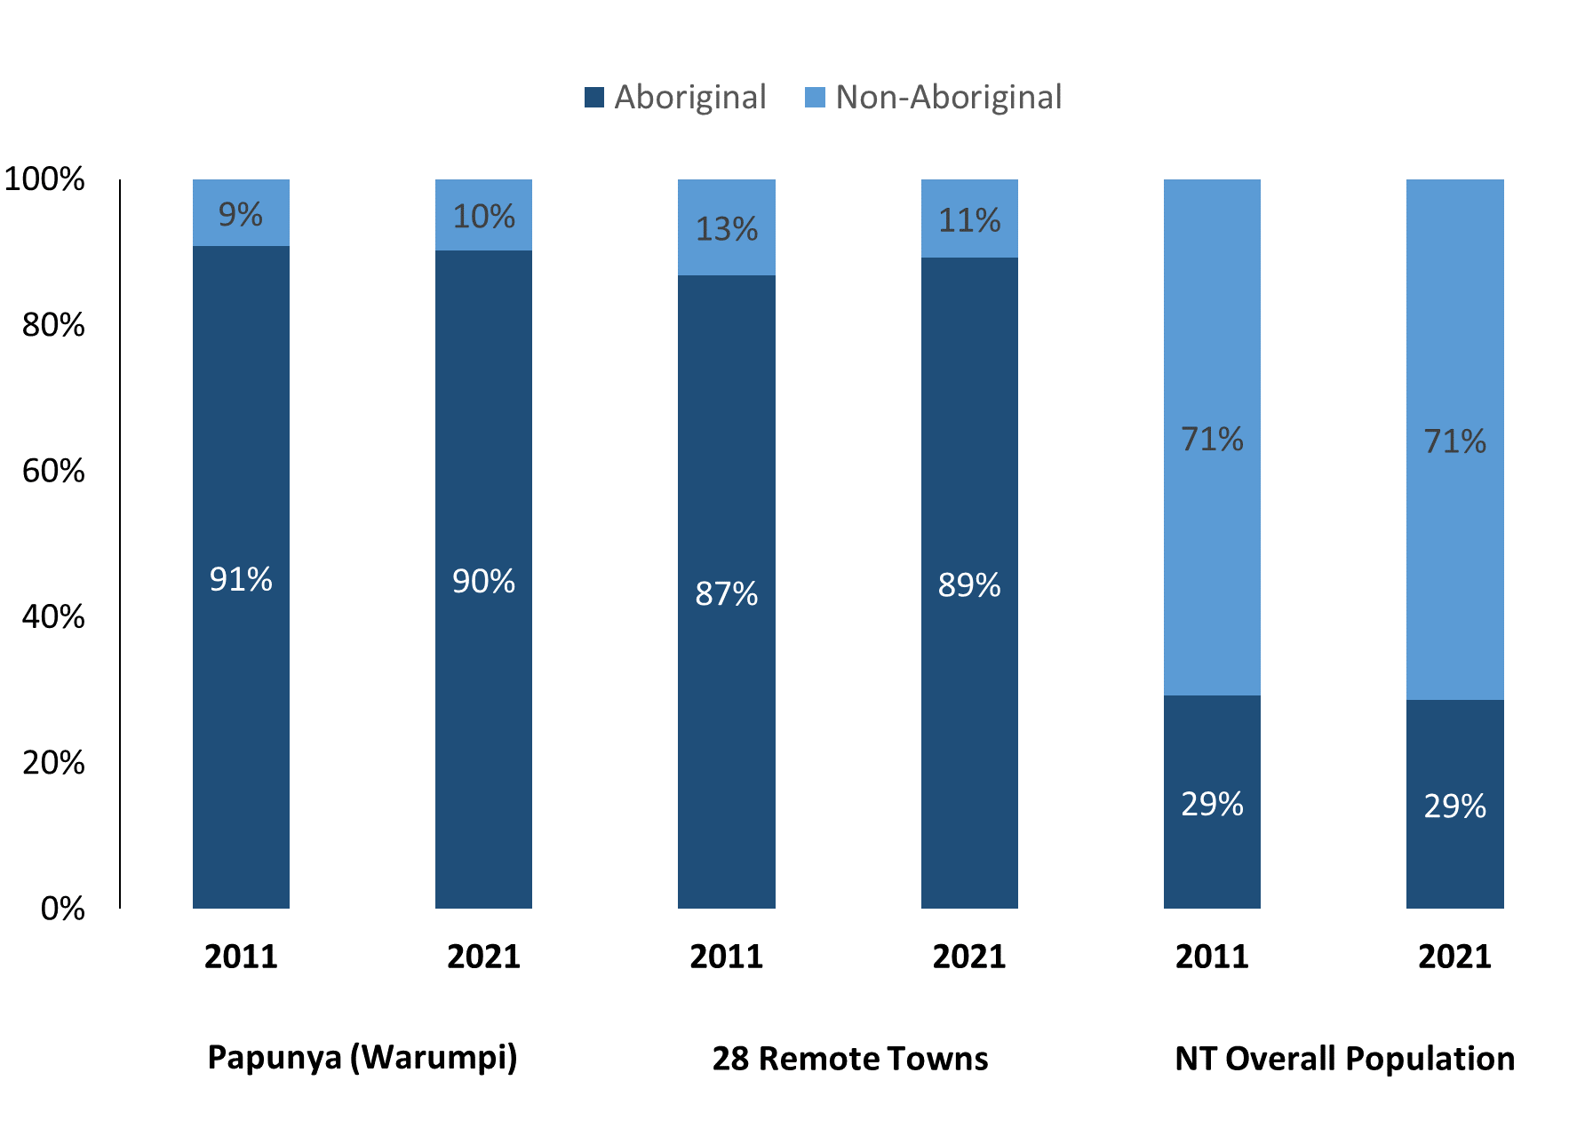

*Source: Australian Bureau of Statistics*

In 2021 in Papunya (Warumpi):

* 90% of the population in Papunya (Warumpi) were **Aboriginal**, compared to 91% in 2011
* 89% of the population across all 28 remote towns were **Aboriginal**
* 29% of the NT population were **Aboriginal**.

**Table 37: Unemployment and Aboriginal participation rates (q)**

|  |  |  |  |  |  |  |
| --- | --- | --- | --- | --- | --- | --- |
|  | **Papunya (Warumpi)** | | | **Northern Territory** | | |
| **Aboriginal** | **Non-Aboriginal** | **Total** | **Aboriginal** | **Non-Aboriginal** | **Total** |
| **Unemployment rate** | 16.1% | 0.0% | 10.4% | 20.8% | 3.2% | 5.6% |
| **Participation rate** | 22.7% | 100.0% | 33.4% | 35.4% | 78.3% | 64.9% |

*Source: Australian Bureau of Statistics*

In 2021 in Papunya (Warumpi) the:

* **total unemployment rate** was 10.4% compared to 5.6% for the total Northern Territory
* **Aboriginal** **unemployment rate** was 16.1% compared to 20.8% for the total Northern Territory
* **non-Aboriginal** **unemployment rate** was 0.0% compared to 3.2% for the total Northern Territory
* **total participation rate** was 33.4% compared to 64.9% for the total Northern Territory
* **Aboriginal participation rate** was 22.7% compared to 35.4% for the total Northern Territory
* **non-Aboriginal** **participation rate** was 100.0% compared to 78.3% for the total Northern Territory.

# Community Development Program

**Table 38: Community Development Program Aboriginal Job Seekers, 31 December 2023 (o)**

|  |  |  |
| --- | --- | --- |
| **Indicator** | **Aboriginal** | |
| **No.** | **%** |
| **Total Aboriginal Job Seekers** | 164 | N/A |
| **Age (years)** | | |
| 15-24 | 41 | 25.0% |
| 25-44 | 77 | 47.0% |
| 45+ | 46 | 28.0% |
| **Total** | 164 | 100.0% |
| **Gender** | | |
| Male | 79 | 48.2% |
| Female | 85 | 51.8% |
| **Total** | 164 | 100.0% |
| **Employment Outcome – 1 January 2023 to 31 December 2023** | | |
| 13 Weeks | <20 | N/A |
| 26 Weeks | <20 | N/A |

*Source: Department of Prime Minister and Cabinet*

**Chart 14: Community Development Program Aboriginal Job Seekers by Gender and Age Group, 31 December 2023 (o)**

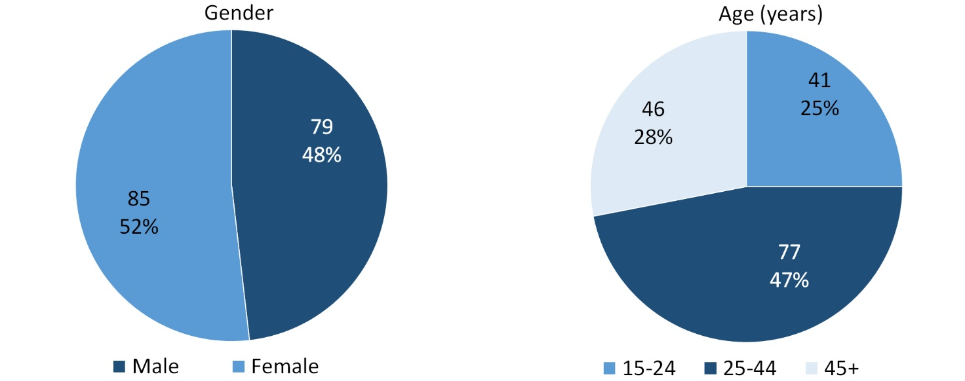

*Source: Department of Prime Minister and Cabinet*

As of 31 December 2023, in Papunya, there were 164 CDP **Aboriginal** job seekers of these:

* 79 (48.2%) were male and 85 (51.8%) were female
* 41 (25.0%) were aged 15-24 years, 77 (47.0%) were aged 25-44 years, and 46 (28.0%) were aged 45+ years
* between 1 January 2023 to 31 December 2023, less than 20 had reached the 13 week reporting milestone and less than 20 had reached the 26 week reporting milestone.

# Businesses

**Table 39: Businesses by sector (d)(s)**

|  |  |  |  |  |  |
| --- | --- | --- | --- | --- | --- |
| **Business Name** | **Reported on in 2011** | **Reported on in 2014** | **Reported on in 2017** | **Reported on in 2023** | |
| **PUBLIC SECTOR** | | | | |  | |
| Department of Children and Families | Yes | No | No | No | |
| **Department of Education** | Yes | Yes | Yes | **Yes** | |
| **Department of Health** | Yes | Yes | Yes | **Yes** | |
| Department of Human Services trading as Centrelink | Yes | Yes | Yes | No | |
| Department of the Prime Minister and Cabinet | Yes | Yes | Yes | No | |
| MacDonnell Regional Council | Yes | Yes | Yes | No | |
| **Northern Territory Police, Fire Emergency Services** | Yes | Yes | Yes | **Yes** | |
| **Papunya Aged Care** (under MacDonnell Regional Council) | No | No | No | **Yes** | |
| **Papunya Childcare** (under MacDonnell Regional Council) | No | No | No | **Yes** | |
| **Territory Families** | No | No | No | **Yes** | |
| **PRIVATE SECTOR** | | | | |  | |
| Batchelor Institute of Indigenous Tertiary Education (BIITE) | Yes | No | No | No | |
| **Central Land Council** | Yes | Yes | Yes | **Yes** | |
| Mission Australia | No | Yes | Yes | No | |
| Ngurratjuta Aboriginal Corporation | No | Yes | No | No | |
| **Papunya Community Store Aboriginal Association** | Yes | Yes | Yes | **Yes** | |
| Papunya Computer Room Program Manager | Yes | No | No | No | |
| Papunya Tjupi Art Centre Aboriginal Corporation | Yes | Yes | Yes | No | |

*Source: Northern Territory Department of Industry, Tourism and Trade*

*Note: Business names captured across the four survey periods have been identified by the current 2023 Business ABN name listed as of 2023.*

In 2023 in Papunya (Warumpi):

* there were 8 businesses reported on, of which:
* 6 businesses were from the Public Sector (75%)
* 2 businesses were from the Private Sector (25%)
* there were 3 businesses operating that were not operating in 2017.

# Notes

1. These counts represent numbers of filled jobs and not the number of people. As such the totals represent the total number of filled jobs, not the total number of employees. This count is not directly comparable to the total number of employed people as a person may have several jobs or one job may be shared by more than one person.
2. Full-time is defined as a job usually requiring 35 hours or more per week or that required 35 hours or more work during the reference week. Part-time is defined as a job usually requiring less than 35 hours per week or that required less than 35 hours work during the reference week. The reference week refers to the period that respondents were asked to provide information about. In most instances it would be the week prior to the week the questionnaire was completed. Questionnaires were predominantly conducted in June and July.
3. Care needs to be taken when analysing the counts of filled jobs by Aboriginal people. Aboriginality was reported by the business representative completing the questionnaire.
4. Sector was classified using the Standard Economic Sector of Classifications of Australia (SESCA), 2008.
5. Job permanency is classified according to what the business believes the level of job permanency is based on guidelines provided by data collectors. Those guidelines state a permanent job has paid annual and/or sick leave entitlements while a temporary job includes casual and fixed-term contract jobs.
6. Classified according to the Australian and New Zealand Standard Classification of Occupations (ANZSCO), 2006, major occupation level.
7. Other Occupations include jobs where occupation was not stated, not known or inadequately described.
8. Classified using the Australian and New Zealand Standard Industrial Classification (ANZSIC), 2006, division level.
9. Care needs to be taken when analysing the counts of filled jobs by the gender of people in the jobs. The gender of the person employed in a job is reported by the business representative completing the questionnaire.
10. Care needs to be taken when analysing the counts of filled jobs by the age of people in the jobs. The age of the person employed in a job is reported by the business representative completing the questionnaire.
11. Students represent the number of individual clients that enrolled in a Vocational Education and Training unit during the calendar year.
12. Unit enrolments represent the count of individual units that students enrolled in during the calendar year.
13. Nominal hours delivered is the sum of the nominal hours of the units commenced during the calendar year regardless of when the course enrolment commenced.
14. Unit completions are the count of all successfully completed units reported in the calendar year regardless of the year of commencement of the units.
15. The Community Development Program (CDP) supports job seekers in remote Australia to build skills, address barriers and contribute to their communities through a range of flexible activities. Under the CDP, job seekers with activity requirements are expected to do up to 25 hours per week of work-like activities that benefit their community. It should be noted that some CDP participants may be reported on within the profile if they are attached to a filled position with an employer captured in the survey. Due to confidentiality issues, data below 20 people is not published.
16. Population estimates for both 2011 and 2021 are taken from the estimated resident population (ERP) data produced by the Australian Bureau of Statistics (ABS) and based on Australian Statistical Geography Standard (ASGS) Statistical Area Level 1 (SA1) regions. ERP are official estimates of the Australian population, which link people to a place of usual residence with Australia. All ERP data sources, including the Census of Population and Housing (Census), are subject to error (including inaccuracies in collection, recording and processing data) and should be used with caution.
17. Indigenous population proportions, unemployment and workforce participation rates are based on ABS Census counts at ASGS Indigenous Locations (ILOCs) for each remote town.
18. Working-age population includes all residents aged 15 years and over (commonly referred to as the civilian population) and consists of people that are employed, unemployed or not in the labour force.
19. A ‘business’ has been defined as any organisation that has undertaken productive activities in the last year, including companies, non-profit organisations, government departments and enterprises operating within the designated remote geography (town), and has one or more employees in paid employment and an Australian Business Number (ABN).

# Abbreviations and Acronyms

ABN Australian Business Number

ABS Australian Bureau of Statistics

ANZSCO Australian and New Zealand Standard Classification of Occupations

ANZSIC Australian and New Zealand Standard Industrial Classification

ASGS Australian Statistical Geography Standard

CDP Community Development Program

ERP Estimated Resident Population

ILOC Indigenous Locations

nec Not Elsewhere Classified

No. Number

Perm Permanent

ppt Percentage point

RJCP Remote Jobs and Communities Program

Temp Temporary

SA1 Statistical Area Level 1

VET Vocational Education and Training

1. The number of filled jobs does not represent numbers of people as a person may have several jobs or one job may be shared by more than one person.