Mineral Titles Act 2010
NOTICE OF LAND CEASING TO BE A MINERAL TITLE AREA
Title Type and Number: | Exploration Licence 32159
Area Ceased on: | 03 February 2025
Area: | 110 Blocks, 360.20 km²
Locality: | BEETALOO
Name of Applicant(s)/Holder(s): | 100% BAUDIN RESOURCES PTY LTD [ACN. 618 455 593]
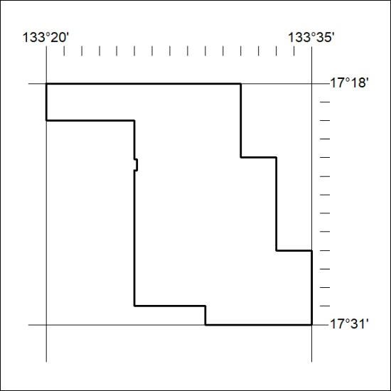

46/25

Mineral Titles Act 2010
NOTICE OF LAND CEASING TO BE A MINERAL TITLE AREA
Title Type and Number: | Exploration Licence 32419
Area Ceased on: | 03 February 2025
Area: | 40 Blocks, 127.08 km²
Locality: | ARAPUNGA
Name of Applicant(s)/Holder(s): | 100% TERRITORY LITHIUM PTY LTD [ACN. 610 691 033]
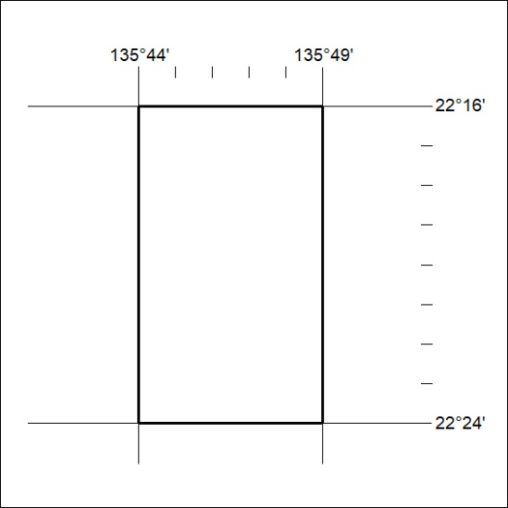

47/25

Mineral Titles Act 2010
NOTICE OF LAND CEASING TO BE A MINERAL TITLE AREA
Title Type and Number: | Exploration Licence 33346
Area Ceased on: | 03 February 2025
Area: | 1 Block, .89 km²
Locality: | BYNOE
Name of Applicant(s)/Holder(s): | 100% RED MOUNTAIN MINING LTD [ACN. 119 568 106]
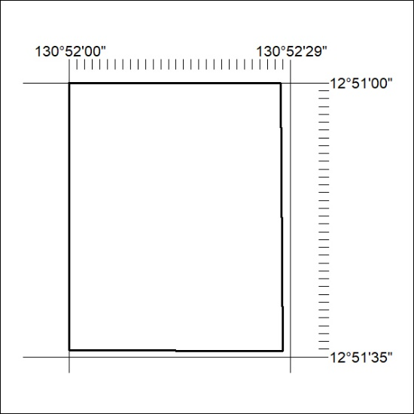

48/25

