# Barramundi Fishery Status Report 2024

## Fishing season: 1 February – 30 September 2024

# Catch

The total commercial catch of Barramundi for the 2024 fishing season was 101.2 tonnes and King Threadfin was 52 tonnes (Figure 1). Catch of both Barramundi and King Threadfin has decreased by 46% from the 2023 fishing season. This represents a continuation in the declining catch trend which has been observed across the fishery within the last two decades and coincides with declining effort within the fishery (Figure 2). The catch composition for the 2024 Barramundi Fishery season comprised of approximately 65% Barramundi, 33% King Threadfin, and <2% all other finfish species including Black Jewfish and Queenfish.

Figure 1. Catch composition of the Barramundi Fishery between 1983 and 2024.

# Effort

Effort for the 2024 fishing season was reported from seven active licences across six commercial vessels as 3417 Hundred Metre Net Days (HMND) (Figure 2). HMND refers to the length of net (measured in units of 100 m) used for each day of fishing by commercial fishers. This level of effort is approximately 68% lower than the previous fishing season and is the lowest level of effort recorded in the history of the commercial Barramundi Fishery.

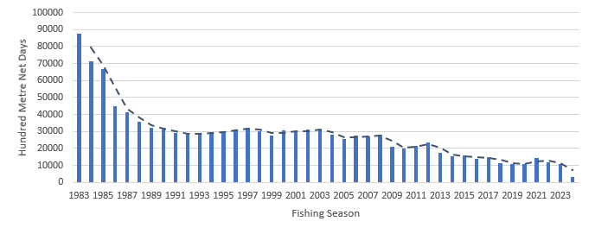

Figure 2. Effort levels in HMND by fishing season from 1983 to 2024.

# 2024 Interim Effort Controls

For the 2024 fishing season, interim commercial fishing effort limits were implemented in the Roper River, Anson Bay, and Moyle River catchments. These areas experience the highest overlap between recreational and commercial fishers. Limits were established in the three catchments to maintain commercial fishing effort within historical ranges from the past decade. For the season, fishing effort was 790 HMND in Anson Bay, 206 HMND in the Moyle River catchment, and 586 HMND in the Roper River catchment (Figure 3). This is approximately 28%, 16%, and 25% of the effort limits in Anson Bay, Moyle River, and Roper River, respectively.

Figure 3. Effort levels from the 2024 fishing season and interim effort limits across managed catchment areas.

# Catch per Unit of Effort

Catch per Unit Effort (CPUE) is based on total catch (kgs) divided by fishing effort (HMND). The CPUE was above the target reference point (RP) for each of the spatial management areas for Barramundi and King Threadfin outlined in the Harvest Strategy. High CPUE in the fishery for the 2024 season indicates stocks are healthy and is likely driven by strong rainfall during the previous wet season.

Table 1. Commercial CPUE for Barramundi in the 2024 fishing season (* very low of effort).

|  |  |  |  |  |
| --- | --- | --- | --- | --- |
| Catchment | Daly River/ Anson Bay | Mini mini/ Alligator Rivers | Buckingham/ Arnhem Bay | Roper River |
| CPUE (kg/HMND) | 19.02 | 39.13 | 40.9* | 40.40 |
| Target RP | 18.79 | 19.26 | 22.53 | 24.36 |
| Trigger RP | 14.09 | 14.44 | 16.90 | 18.27 |
| Limit RP | 9.39 | 9.63 | 11.23 | 12.18 |

Table 2. Commercial CPUE for King Threadfin in the 2024 fishing season (* very low of effort).

|  |  |  |  |  |
| --- | --- | --- | --- | --- |
| Catchment | Daly River /  Anson Bay | Mini mini/ Alligator Rivers | Buckingham/ Arnhem Bay | Roper River |
| CPUE (kg/HMND) | 17.66 | 15.38 | 48.06* | 23.52 |
| Target RP | 12.16 | 11.28 | 18.28 | 11.30 |
| Trigger RP | 9.12 | 8.46 | 13.71 | 8.48 |
| Limit RP | 6.08 | 5.64 | 9.14 | 5.65 |

# Interactions with Threatened Endangered and Protected Species (TEPS)

The 2024 fishing season was the first-year commercial fishers operated under the Barramundi Fishery Threatened Endangered and Protected Species Strategy 2024-2029. Monthly monitoring of interactions across the catchments detected no breaches of defined trigger or limit reference points. There was a total of 100 sawfish interactions, with 97 of these released alive at the point of capture (Table 3).

Table 3. Species group specific total reported number of interactions and number of individuals released alive (in brackets) for the Barramundi Fishery in 2024.

|  |  |  |  |  |  |
| --- | --- | --- | --- | --- | --- |
| Species Group | Coastal Dolphins | Dugong | Turtles | River Sharks | Sawfish |
| Number of interactions | 0 | 0 | 0 | 0 | 100 (97) |

# Data validation

In the 2024 fishing season, electronic monitoring (EM) solutions were fitted and trialled on three commercial fishing vessels over four trips within the Barramundi Fishery. The trial confirmed that the footage collected is fit for purpose and enables validation of Threatened, Endangered and Protected Species (TEPS) interactions reported in catch logs. Several practical challenges were identified regarding the EM configuration on vessels and modifications are currently being made with the intention of achieving 100% coverage by 1 July 2025. Two onboard observer trips were also conducted in the 2024 fishing season to gather biological data on Barramundi and King Threadfin including lengths, weights, sex and age, as well as verify reported logbook data.