Mineral Titles Act 2010
NOTICE OF LAND CEASING TO BE A MINERAL TITLE AREA
Title Type and Number: | Exploration Licence 31421
Area Ceased on: | 06 January 2025
Area: | 11 Blocks, 36.52 km²
Locality: | JINDUCKIN
Name of Applicant(s)/Holder(s): | 100% COPPEROZ PTY LTD [ACN. 603 957 124]
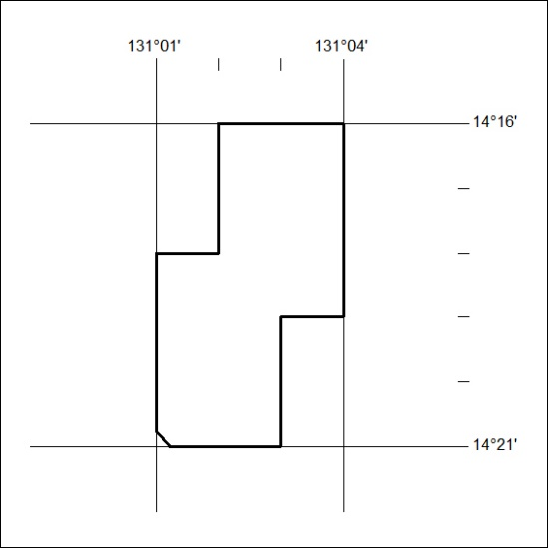
17/25

Mineral Titles Act
NOTICE OF GRANT OF A MINERAL TITLE
Title Type and Number: | Exploration Licence 33859
Granted: | 06 January 2025, for a period of 6 Years
Area: | 250 Blocks, 779.96 km²
Locality: | GREGORYS DEPOT
Name of Holder/s: | 100% G EX AUSTRALIA PTY LTD [ACN. 671951385]
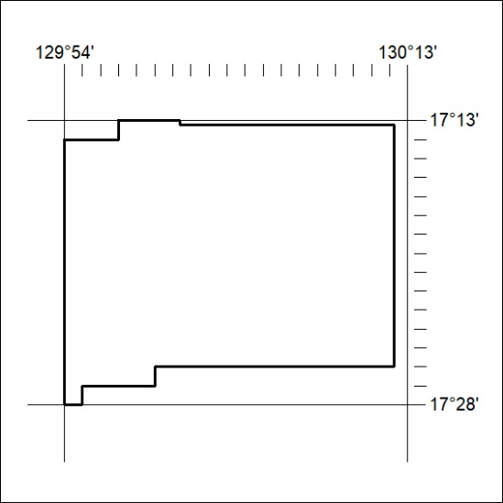
Area granted is indicated above. The titleholder is not permitted to exercise occupational rights on any land that is subject to a development title, or an application for a development title. Any land the subject of a Reserved Land gazettal under the Mineral Titles Act and all land vested in the Commonwealth of Australia is also excluded by description but not excised from the grant area.
18/25

Mineral Titles Act
NOTICE OF GRANT OF A MINERAL TITLE
Title Type and Number: | Exploration Licence 33860
Granted: | 06 January 2025, for a period of 6 Years
Area: | 250 Blocks, 800.41 km²
Locality: | MOUNT BARTON
Name of Holder/s: | 100% G EX AUSTRALIA PTY LTD [ACN. 671951385]
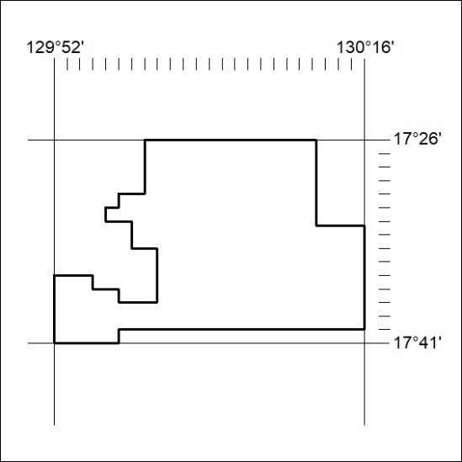
Area granted is indicated above. The titleholder is not permitted to exercise occupational rights on any land that is subject to a development title, or an application for a development title. Any land the subject of a Reserved Land gazettal under the Mineral Titles Act and all land vested in the Commonwealth of Australia is also excluded by description but not excised from the grant area.
19/25

Mineral Titles Act
NOTICE OF GRANT OF A MINERAL TITLE
Title Type and Number: | Exploration Licence 33861
Granted: | 06 January 2025, for a period of 6 Years
Area: | 250 Blocks, 817.42 km²
Locality: | INVERWAY
Name of Holder/s: | 100% G EX AUSTRALIA PTY LTD [ACN. 671951385]
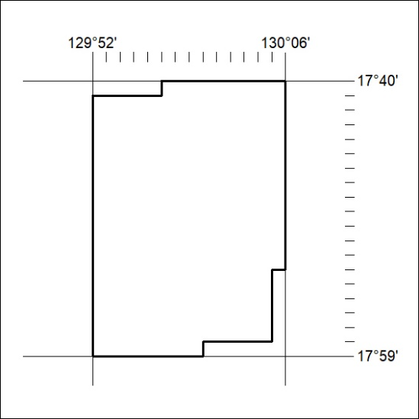
Area granted is indicated above. The titleholder is not permitted to exercise occupational rights on any land that is subject to a development title, or an application for a development title. Any land the subject of a Reserved Land gazettal under the Mineral Titles Act and all land vested in the Commonwealth of Australia is also excluded by description but not excised from the grant area.
20/25

Mineral Titles Act
NOTICE OF GRANT OF A MINERAL TITLE
Title Type and Number: | Exploration Licence 33862
Granted: | 06 January 2025, for a period of 6 Years
Area: | 177 Blocks, 568.92 km²
Locality: | MOUNT BARTON
Name of Holder/s: | 100% G EX AUSTRALIA PTY LTD [ACN. 671951385]
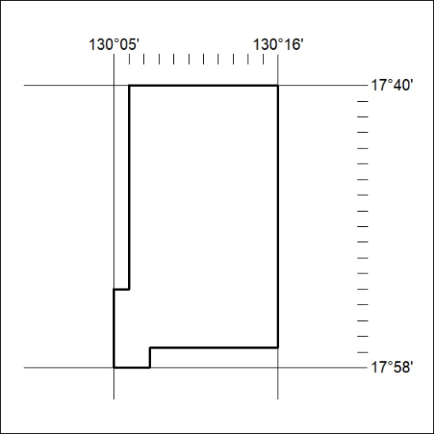
Area granted is indicated above. The titleholder is not permitted to exercise occupational rights on any land that is subject to a development title, or an application for a development title. Any land the subject of a Reserved Land gazettal under the Mineral Titles Act and all land vested in the Commonwealth of Australia is also excluded by description but not excised from the grant area.
21/25

Mineral Titles Act
NOTICE OF GRANT OF A MINERAL TITLE
Title Type and Number: | Exploration Licence 33890
Granted: | 03 January 2025, for a period of 6 Years
Area: | 23 Blocks, 71.56 km²
Locality: | CARRARA
Name of Holder/s: | 100% CERES INNOVATIONS PTY LTD [ACN. 677676167]
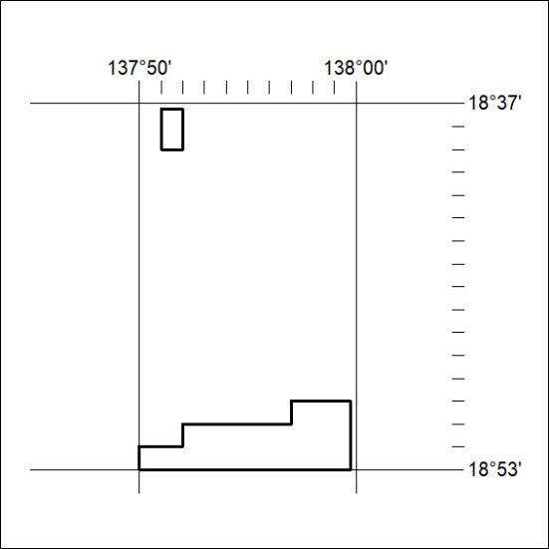
Area granted is indicated above. The titleholder is not permitted to exercise occupational rights on any land that is subject to a development title, or an application for a development title. Any land the subject of a Reserved Land gazettal under the Mineral Titles Act and all land vested in the Commonwealth of Australia is also excluded by description but not excised from the grant area.
22/25

