Mineral Titles Act 2010
NOTICE OF LAND CEASING TO BE A MINERAL TITLE AREA
Title Type and Number: | Exploration Licence 33204
Area Ceased on: | 13 December 2024
Area: | 113 Blocks, 357.35 km²
Locality: | NARWIETOOMA
Name of Applicant(s)/Holder(s): | 100% URO CORPORATION PTY LTD [ACN. 653 927 998]
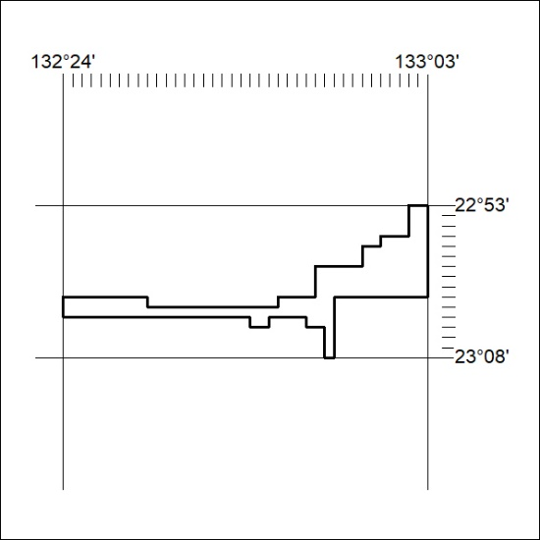

466/24

