Mineral Titles Act 2010
NOTICE OF LAND CEASING TO BE A MINERAL TITLE AREA
Title Type and Number: | Mineral Leases (Central) 366, 367, 368, 369, 370, 374, 375, 607, 608, 609, 611, 612, 613 & 614.
Area ceased on: | 06 December 2024
Area: | 160.00 Hectare
Locality: | TENNANT CREEK
Name of Applicants(s)Holder(s): | 100% SANTEXCO PTY LTD [ACN. 002 910 296]
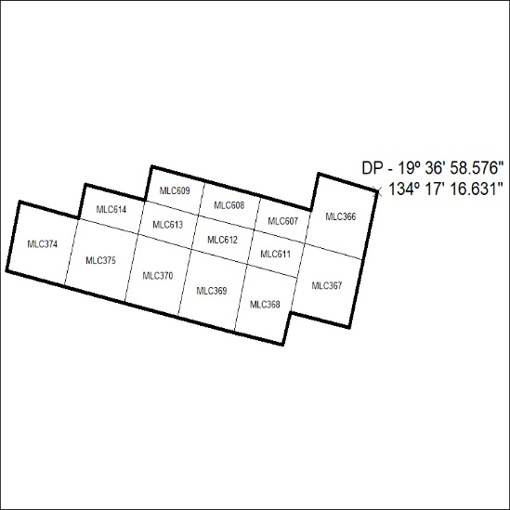
(Area now amalgamated into Mineral Lease 34032 under s102)
452/24

Mineral Titles Act 2010
NOTICE OF LAND CEASING TO BE A MINERAL TITLE AREA
Title Type and Number: | Mineral Lease (Central) 362
Area ceased on: | 06 December 2024
Area: | 15.00 Hectare
Locality: | TENNANT CREEK
Name of Applicants(s)Holder(s): | 100% SANTEXCO PTY LTD [ACN. 002 910 296]
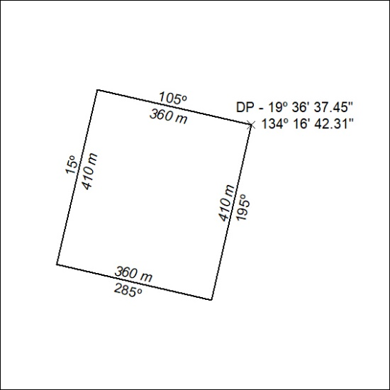
(Area now amalgamated into Mineral Lease 34031 under s102)
453/24

Mineral Titles Act 2010
NOTICE OF LAND CEASING TO BE A MINERAL TITLE AREA
Title Type and Number: | Mineral Lease (Central) 363
Area ceased on: | 06 December 2024
Area: | 14.00 Hectare
Locality: | TENNANT CREEK
Name of Applicants(s)Holder(s): | 100% SANTEXCO PTY LTD [ACN. 002 910 296]
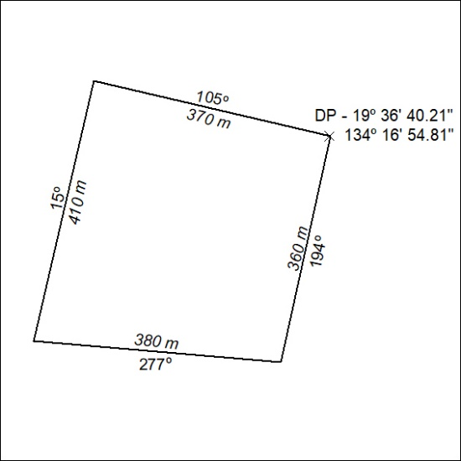
(Area now amalgamated into Mineral Lease 34031 under s102)
454/24

Mineral Titles Act 2010
NOTICE OF LAND CEASING TO BE A MINERAL TITLE AREA
Title Type and Number: | Mineral Lease (Central) 364
Area ceased on: | 06 December 2024
Area: | 13.00 Hectare
Locality: | TENNANT CREEK
Name of Applicants(s)Holder(s): | 100% SANTEXCO PTY LTD [ACN. 002 910 296]
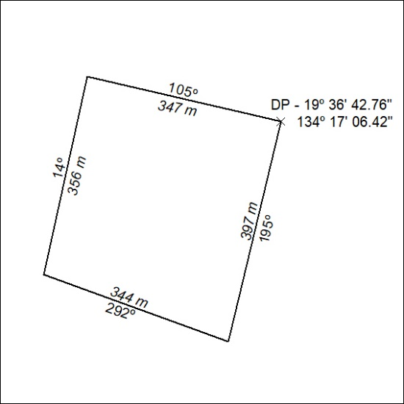
(Area now amalgamated into Mineral Lease 34035 under s102)
455/24

Mineral Titles Act 2010
NOTICE OF LAND CEASING TO BE A MINERAL TITLE AREA
Title Type and Number: | Mineral Lease (Central) 365
Area ceased on: | 06 December 2024
Area: | 16.00 Hectare
Locality: | TENNANT CREEK
Name of Applicants(s)Holder(s): | 100% SANTEXCO PTY LTD [ACN. 002 910 296]
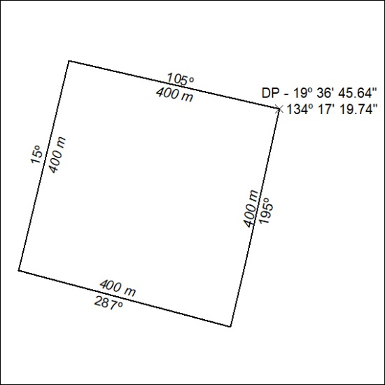
(Area now amalgamated into Mineral Lease 34035 under s102)
456/24

Mineral Titles Act 2010
NOTICE OF LAND CEASING TO BE A MINERAL TITLE AREA
Title Type and Number: | Mineral Lease (Central) 371
Area ceased on: | 06 December 2024
Area: | 16.00 Hectare
Locality: | TENNANT CREEK
Name of Applicants(s)Holder(s): | 100% SANTEXCO PTY LTD [ACN. 002 910 296]
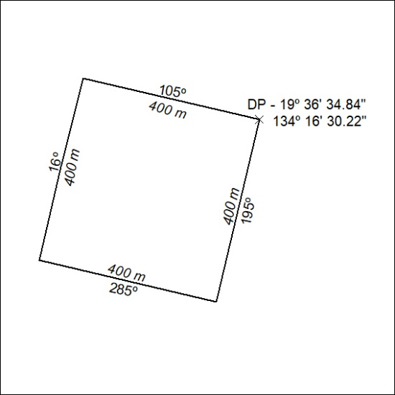
(Area now amalgamated into Mineral Lease 34031 under s102)
457/24

Mineral Titles Act 2010
NOTICE OF LAND CEASING TO BE A MINERAL TITLE AREA
Title Type and Number: | Mineral Lease (Central) 372
Area ceased on: | 06 December 2024
Area: | 16.00 Hectare
Locality: | TENNANT CREEK
Name of Applicants(s)Holder(s): | 100% SANTEXCO PTY LTD [ACN. 002 910 296]
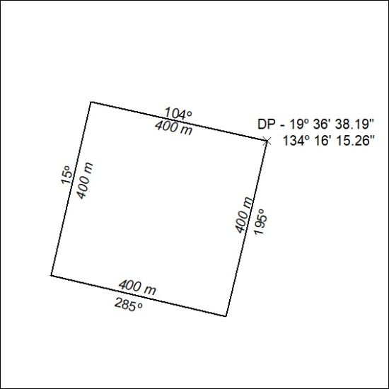
(Area now amalgamated into Mineral Lease 34031 under s102)
458/24

Mineral Titles Act 2010
NOTICE OF LAND CEASING TO BE A MINERAL TITLE AREA
Title Type and Number: | Mineral Lease (Central) 373
Area ceased on: | 06 December 2024
Area: | 16.00 Hectare
Locality: | TENNANT CREEK
Name of Applicants(s)Holder(s): | 100% SANTEXCO PTY LTD [ACN. 002 910 296]
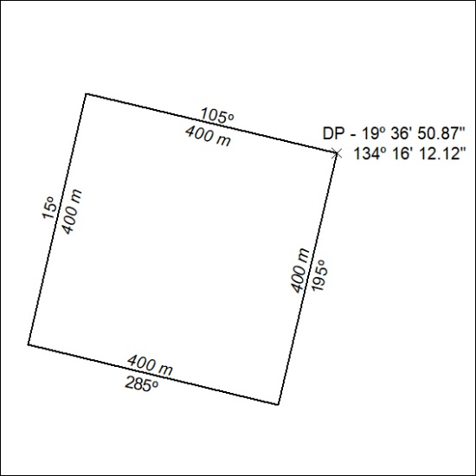
(Area now amalgamated into Mineral Lease 34035 under s102)
459/24

Mineral Titles Act 2010
NOTICE OF LAND CEASING TO BE A MINERAL TITLE AREA
Title Type and Number: | Mineral Lease (Central) 530
Area ceased on: | 06 December 2024
Area: | 8.00 Hectare
Locality: | TENNANT CREEK
Name of Applicants(s)Holder(s): | 100% SANTEXCO PTY LTD [ACN. 002 910 296]
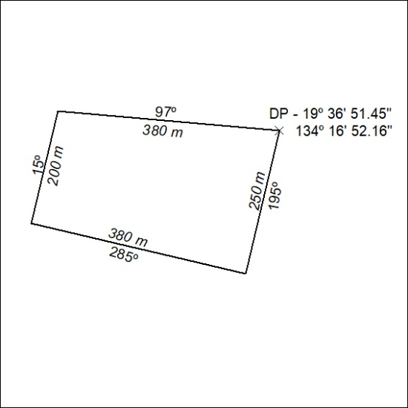
(Area now amalgamated into Mineral Lease 34035 under s102)
460/24

Mineral Titles Act 2010
NOTICE OF LAND CEASING TO BE A MINERAL TITLE AREA
Title Type and Number: | Mineral Lease (Central) 606
Area ceased on: | 06 December 2024
Area: | 8.00 Hectare
Locality: | TENNANT CREEK
Name of Applicants(s)Holder(s): | 100% SANTEXCO PTY LTD [ACN. 002 910 296]
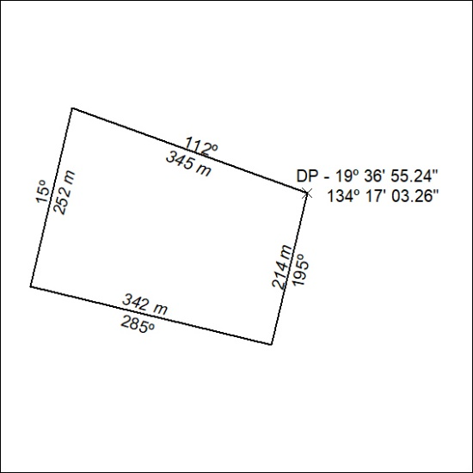
(Area now amalgamated into Mineral Lease 34035 under s102)
461/24

Mineral Titles Act 2010
NOTICE OF LAND CEASING TO BE A MINERAL TITLE AREA
Title Type and Number: | Mineral Lease (Central) 610
Area ceased on: | 06 December 2024
Area: | 7.00 Hectare
Locality: | TENNANT CREEK
Name of Applicants(s)Holder(s): | 100% SANTEXCO PTY LTD [ACN. 002 910 296]
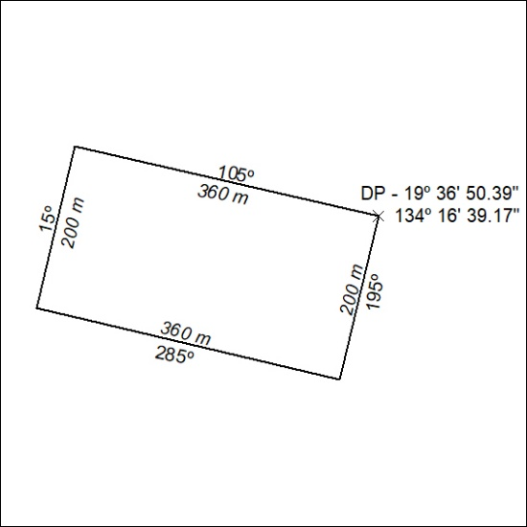
(Area now amalgamated into Mineral Lease 34035 under s102)
462/24

Mineral Titles Act 2010
NOTICE OF LAND CEASING TO BE A MINERAL TITLE AREA
Title Type and Number: | Mineral Lease (Central) 615
Area ceased on: | 06 December 2024
Area: | 8.00 Hectare
Locality: | TENNANT CREEK
Name of Applicants(s)Holder(s): | 100% SANTEXCO PTY LTD [ACN. 002 910 296]
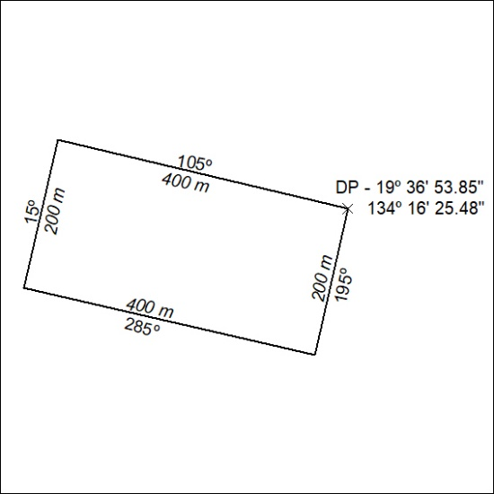
(Area now amalgamated into Mineral Lease 34035 under s102)
463/24

Mineral Titles Act 2010
NOTICE OF LAND CEASING TO BE A MINERAL TITLE AREA
Title Type and Number: | Mineral Lease (Central) 616
Area ceased on: | 06 December 2024
Area: | 8.00 Hectare
Locality: | TENNANT CREEK
Name of Applicants(s)Holder(s): | 100% SANTEXCO PTY LTD [ACN. 002 910 296]
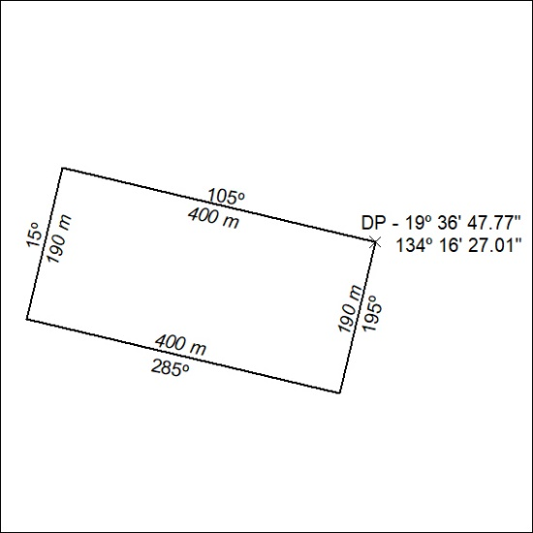
(Area now amalgamated into Mineral Lease 34035 under s102)
464/24

