Mineral Titles Act
NOTICE OF GRANT OF A MINERAL TITLE
Title Type and Number: | Exploration Licence 33810
Granted: | 14 November 2024, for a period of 6 Years
Area: | 11 Blocks, 35.12 km²
Locality: | ANNINGIE
Name of Holder/s: | 100% WA1 RESOURCES LTD [ACN. 646 878 631]
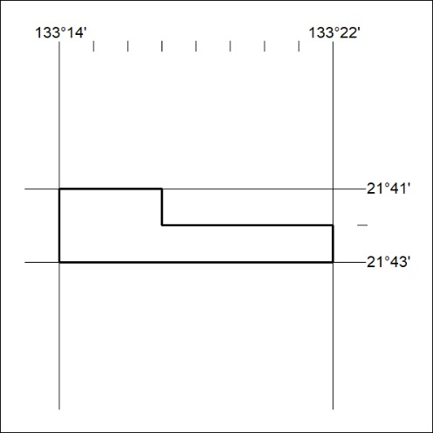
Area granted is indicated above. The titleholder is not permitted to exercise occupational rights on any land that is subject to a development title, or an application for a development title. Any land the subject of a Reserved Land gazettal under the Mineral Titles Act and all land vested in the Commonwealth of Australia is also excluded by description but not excised from the grant area.

406/24

Mineral Titles Act
NOTICE OF GRANT OF A MINERAL TITLE
Title Type and Number: | Exploration Licence 33811
Granted: | 14 November 2024, for a period of 6 Years
Area: | 6 Blocks, 19.12 km²
Locality: | GILES
Name of Holder/s: | 100% WA1 RESOURCES LTD [ACN. 646 878 631]
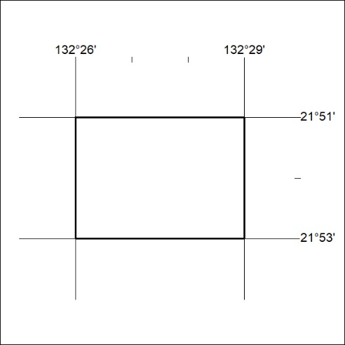
Area granted is indicated above. The titleholder is not permitted to exercise occupational rights on any land that is subject to a development title, or an application for a development title. Any land the subject of a Reserved Land gazettal under the Mineral Titles Act and all land vested in the Commonwealth of Australia is also excluded by description but not excised from the grant area.

407/24

Mineral Titles Act
NOTICE OF GRANT OF A MINERAL TITLE
Title Type and Number: | Exploration Licence 33812
Granted: | 14 November 2024, for a period of 6 Years
Area: | 168 Blocks, 531.14 km²
Locality: | AILERON
Name of Holder/s: | 100% WA1 RESOURCES LTD [ACN. 646 878 631]
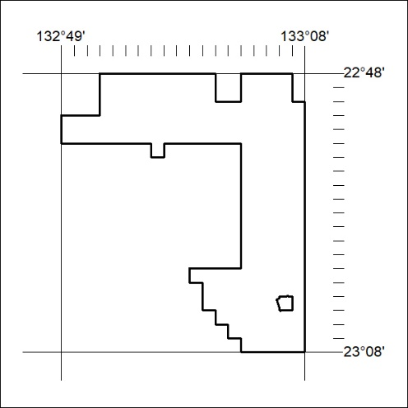
Area granted is indicated above. The titleholder is not permitted to exercise occupational rights on any land that is subject to a development title, or an application for a development title. Any land the subject of a Reserved Land gazettal under the Mineral Titles Act and all land vested in the Commonwealth of Australia is also excluded by description but not excised from the grant area.

408/24

Mineral Titles Act
NOTICE OF GRANT OF A MINERAL TITLE
Title Type and Number: | Exploration Licence 33813
Granted: | 14 November 2024, for a period of 6 Years
Area: | 25 Blocks, 79.06 km²
Locality: | AILERON
Name of Holder/s: | 100% WA1 RESOURCES LTD [ACN. 646 878 631]
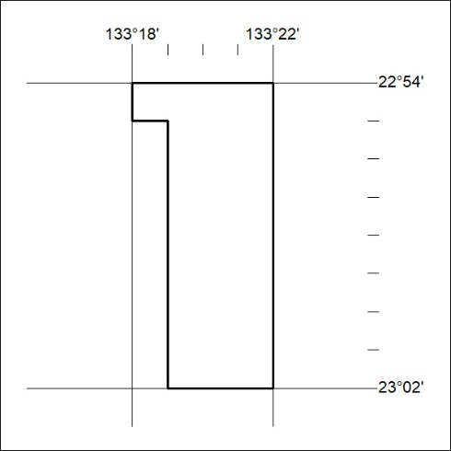
Area granted is indicated above. The titleholder is not permitted to exercise occupational rights on any land that is subject to a development title, or an application for a development title. Any land the subject of a Reserved Land gazettal under the Mineral Titles Act and all land vested in the Commonwealth of Australia is also excluded by description but not excised from the grant area.

409/24

Mineral Titles Act
NOTICE OF GRANT OF A MINERAL TITLE
Title Type and Number: | Exploration Licence 33820
Granted: | 14 November 2024, for a period of 6 Years
Area: | 24 Blocks, 44.74 km²
Locality: | TEA TREE
Name of Holder/s: | 100% WA1 RESOURCES LTD [ACN. 646 878 631]
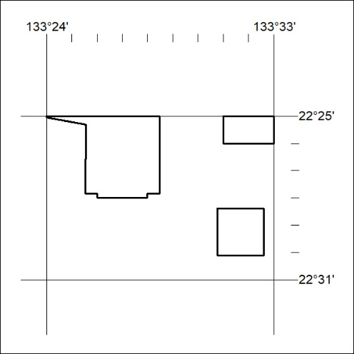
Area granted is indicated above. The titleholder is not permitted to exercise occupational rights on any land that is subject to a development title, or an application for a development title. Any land the subject of a Reserved Land gazettal under the Mineral Titles Act and all land vested in the Commonwealth of Australia is also excluded by description but not excised from the grant area.

410/24

Mineral Titles Act
NOTICE OF GRANT OF A MINERAL TITLE
Title Type and Number: | Exploration Licence 33822
Granted: | 14 November 2024, for a period of 6 Years
Area: | 37 Blocks, 60.23 km²
Locality: | WOOLLA
Name of Holder/s: | 100% WA1 RESOURCES LTD [ACN. 646 878 631]
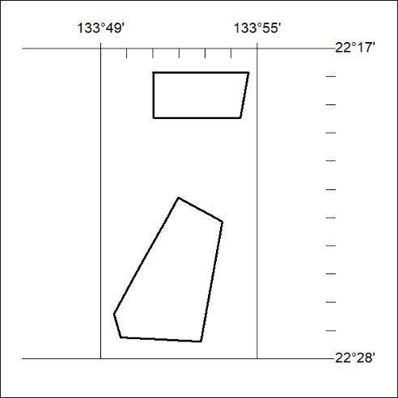
Area granted is indicated above. The titleholder is not permitted to exercise occupational rights on any land that is subject to a development title, or an application for a development title. Any land the subject of a Reserved Land gazettal under the Mineral Titles Act and all land vested in the Commonwealth of Australia is also excluded by description but not excised from the grant area.

411/24

Mineral Titles Act
NOTICE OF GRANT OF A MINERAL TITLE
Title Type and Number: | Exploration Licence 33823
Granted: | 14 November 2024, for a period of 6 Years
Area: | 18 Blocks, 24.94 km²
Locality: | BUSHY PARK
Name of Holder/s: | 100% WA1 RESOURCES LTD [ACN. 646 878 631]
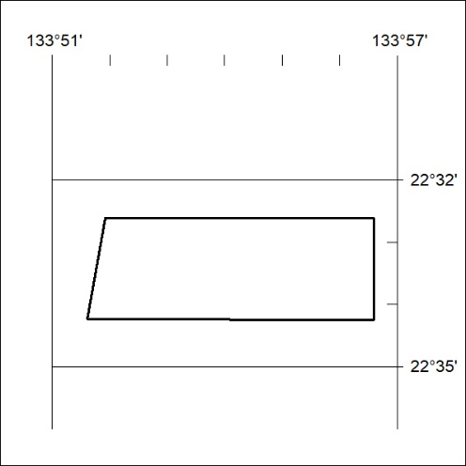
Area granted is indicated above. The titleholder is not permitted to exercise occupational rights on any land that is subject to a development title, or an application for a development title. Any land the subject of a Reserved Land gazettal under the Mineral Titles Act and all land vested in the Commonwealth of Australia is also excluded by description but not excised from the grant area.

412/24

Mineral Titles Act
NOTICE OF GRANT OF A MINERAL TITLE
Title Type and Number: | Exploration Licence 33825
Granted: | 14 November 2024, for a period of 6 Years
Area: | 9 Blocks, 28.53 km²
Locality: | AILERON
Name of Holder/s: | 100% WA1 RESOURCES LTD [ACN. 646 878 631]
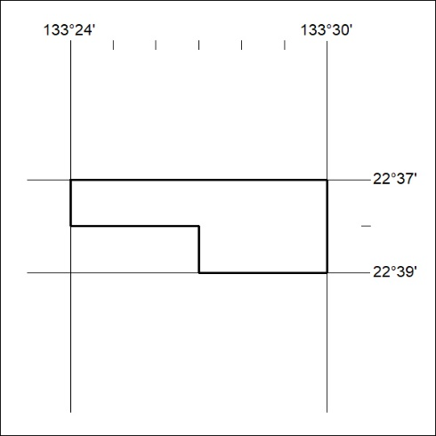
Area granted is indicated above. The titleholder is not permitted to exercise occupational rights on any land that is subject to a development title, or an application for a development title. Any land the subject of a Reserved Land gazettal under the Mineral Titles Act and all land vested in the Commonwealth of Australia is also excluded by description but not excised from the grant area.

413/24

