Mineral Titles Act 2010
NOTICE OF LAND CEASING TO BE A MINERAL TITLE AREA
Title Type and Number: | Exploration Licence 32917
Area Ceased on: | 27 October 2024
Area: | 41 Blocks, 128.48 km²
Locality: | PEACHY
Name of Applicant(s)/Holder(s): | 100% ORANGE CREEK RESOURCES PTY LTD [ACN. 665 078 857]
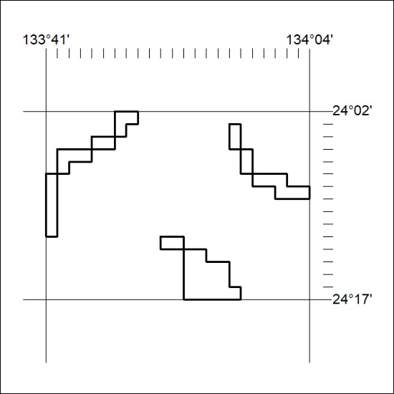

405/24

