Mineral Titles Act 2010
NOTICE OF LAND CEASING TO BE A MINERAL TITLE AREA
Title Type and Number: | Mineral Lease 30184
Area ceased on: | 23 October 2024
Area: | 36.00 Hectare
Locality: | QUARTZ
Name of Applicants(s)Holder(s): | 100% HANITRO PTY. LIMITED [ACN. 003 530 863]
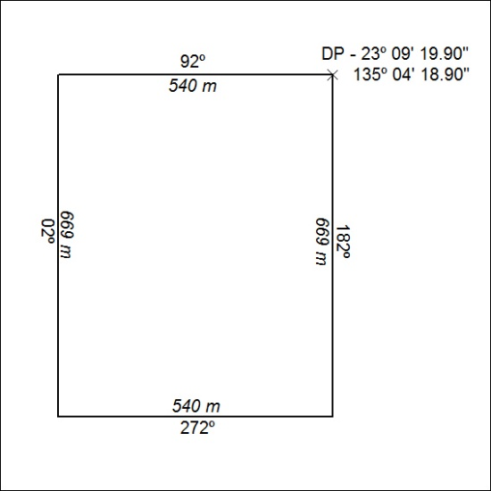

383/24

Mineral Titles Act 2010
NOTICE OF LAND CEASING TO BE A MINERAL TITLE AREA
Title Type and Number: | Exploration Licence 28967
Area Ceased on: | 23 October 2024
Area: | 14 Blocks, 44.29 km²
Locality: | NAPPERBY
Name of Applicant(s)/Holder(s): | 100% AUSTRALIA MINING & GEMSTONE CO. PTY LTD [ACN. 114 395 247]
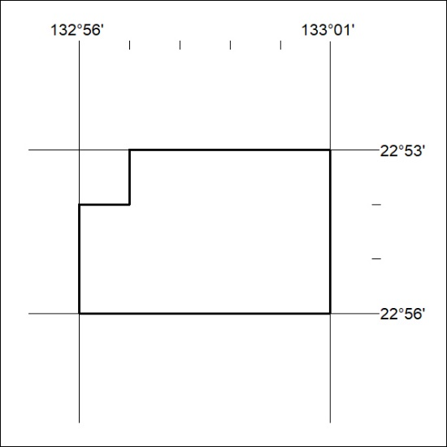

384/24

Mineral Titles Act 2010
NOTICE OF LAND CEASING TO BE A MINERAL TITLE AREA
Title Type and Number: | Exploration Licence 32476
Area Ceased on: | 23 October 2024
Area: | 49 Blocks, 159.08 km²
Locality: | CARRARA
Name of Applicant(s)/Holder(s): | 100% BAUDIN RESOURCES PTY LTD [ACN. 618 455 593]
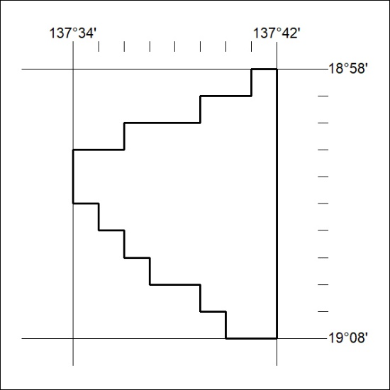

385/24

Mineral Titles Act 2010
NOTICE OF LAND CEASING TO BE A MINERAL TITLE AREA
Title Type and Number: | Exploration Licence 32477
Area Ceased on: | 23 October 2024
Area: | 78 Blocks, 253.24 km²
Locality: | GALLIPOLI
Name of Applicant(s)/Holder(s): | 100% BAUDIN RESOURCES PTY LTD [ACN. 618 455 593]
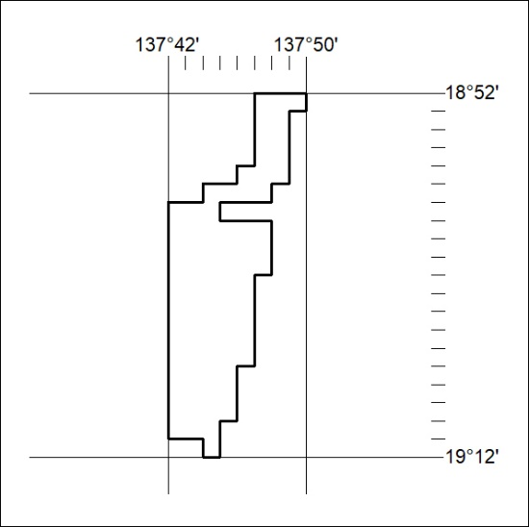

386/24

Mineral Titles Act 2010
NOTICE OF LAND CEASING TO BE A MINERAL TITLE AREA
Title Type and Number: | Exploration Licence 32701
Area Ceased on: | 23 October 2024
Area: | 108 Blocks, 346.26 km²
Locality: | CARRARA
Name of Applicant(s)/Holder(s): | 100% BAUDIN RESOURCES PTY LTD [ACN. 618 455 593]
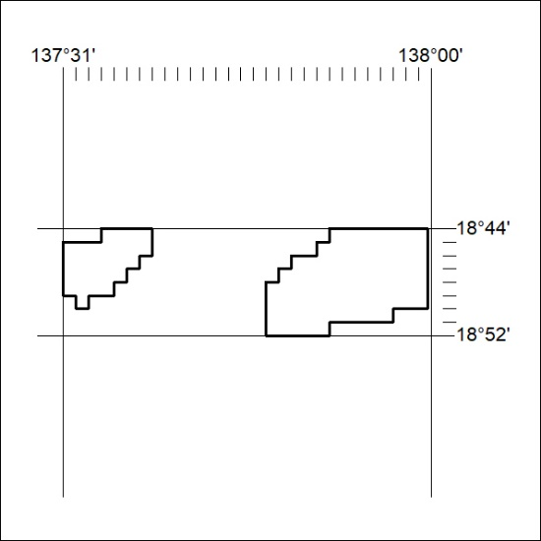

387/24

Mineral Titles Act 2010
NOTICE OF LAND CEASING TO BE A MINERAL TITLE APPLICATION AREA
Title Type and Number: | Exploration Licence 33616
Area Ceased on: | 23 October 2024
Area: | 249 Blocks, 821.83 km²
Locality: | BAUHINIA DOWNS
Name of Applicant(s)/Holder(s): | 100% BAUDIN RESOURCES PTY LTD [ACN. 618 455 593]
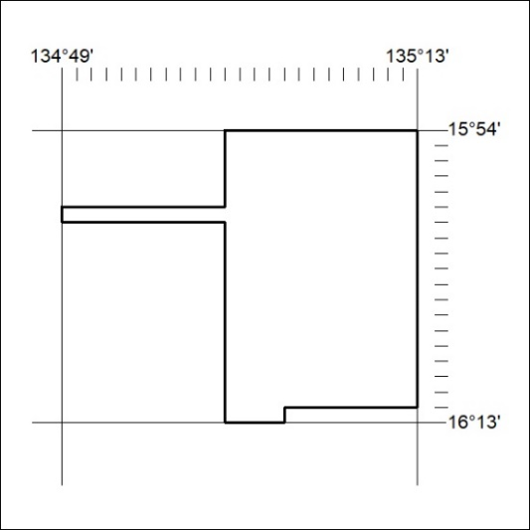

388/24

Mineral Titles Act 2010
NOTICE OF LAND CEASING TO BE A MINERAL TITLE APPLICATION AREA
Title Type and Number: | Exploration Licence 33733
Area Ceased on: | 19 October 2024
Area: | 201 Blocks, 626.93 km²
Locality: | LIMBLA
Name of Applicant(s)/Holder(s): | 100% SBR METALS (SA) PTY LTD [ACN. 674 331 170]
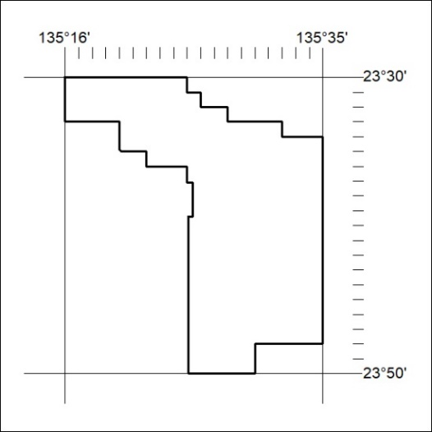

389/24

