Mineral Titles Act
NOTICE OF GRANT OF A MINERAL TITLE
Title Type and Number: | Exploration Licence 33765
Granted: | 26 September 2024, for a period of 6 Years
Area: | 78 Blocks, 247.39 km²
Locality: | BREADEN
Name of Holder/s: | 100% PURE EXPLORATION PTY LTD [ACN. 669 443 636]
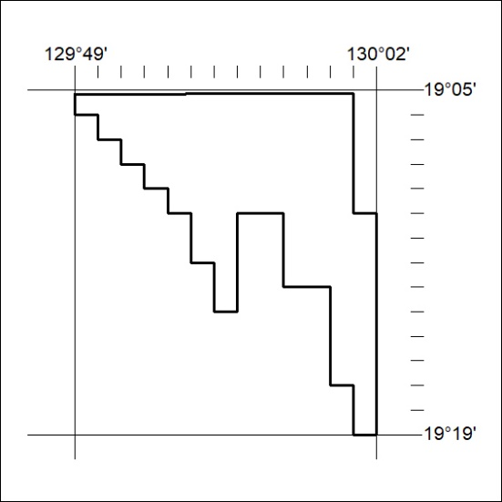
Area granted is indicated above. The titleholder is not permitted to exercise occupational rights on any land that is subject to a development title, or an application for a development title. Any land the subject of a Reserved Land gazettal under the Mineral Titles Act and all land vested in the Commonwealth of Australia is also excluded by description but not excised from the grant area.

325/24

Mineral Titles Act
NOTICE OF GRANT OF A MINERAL TITLE
Title Type and Number: | Exploration Licence 33766
Granted: | 26 September 2024, for a period of 6 Years
Area: | 217 Blocks, 699.36 km²
Locality: | BREADEN
Name of Holder/s: | 100% PURE EXPLORATION PTY LTD [ACN. 669 443 636]
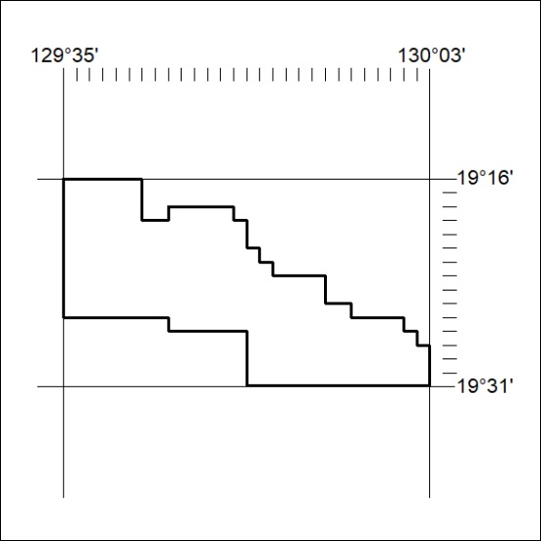
Area granted is indicated above. The titleholder is not permitted to exercise occupational rights on any land that is subject to a development title, or an application for a development title. Any land the subject of a Reserved Land gazettal under the Mineral Titles Act and all land vested in the Commonwealth of Australia is also excluded by description but not excised from the grant area.

326/24

Mineral Titles Act
NOTICE OF GRANT OF A MINERAL TITLE
Title Type and Number: | Exploration Licence 33767
Granted: | 26 September 2024, for a period of 6 Years
Area: | 231 Blocks, 744.71 km²
Locality: | BREADEN
Name of Holder/s: | 100% PURE EXPLORATION PTY LTD [ACN. 669 443 636]
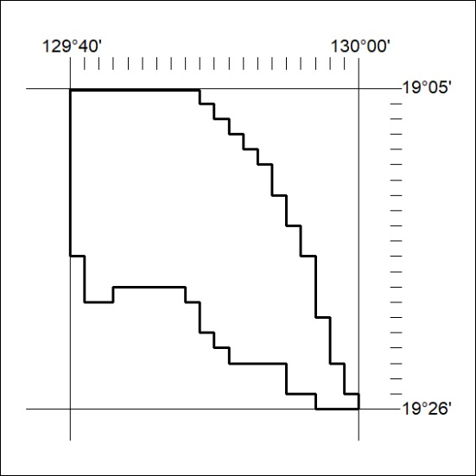
Area granted is indicated above. The titleholder is not permitted to exercise occupational rights on any land that is subject to a development title, or an application for a development title. Any land the subject of a Reserved Land gazettal under the Mineral Titles Act and all land vested in the Commonwealth of Australia is also excluded by description but not excised from the grant area.

327/24

Mineral Titles Act
NOTICE OF GRANT OF A MINERAL TITLE
Title Type and Number: | Exploration Licence 33768
Granted: | 26 September 2024, for a period of 6 Years
Area: | 250 Blocks, 766.73 km²
Locality: | BREADEN
Name of Holder/s: | 100% PURE EXPLORATION PTY LTD [ACN. 669 443 636]
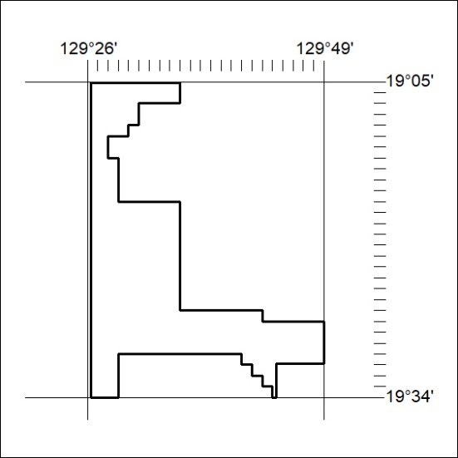
Area granted is indicated above. The titleholder is not permitted to exercise occupational rights on any land that is subject to a development title, or an application for a development title. Any land the subject of a Reserved Land gazettal under the Mineral Titles Act and all land vested in the Commonwealth of Australia is also excluded by description but not excised from the grant area.

328/24

