Mineral Titles Act 2010
NOTICE OF LAND CEASING TO BE A MINERAL TITLE AREA
Title Type and Number: | Mineral Lease (Northern) 63
Area ceased on: | 01 May 2024
Locality: | RANFORD HILL
Name of Applicants(s)Holder(s): | 100% OUTBACK METALS PROPRIETARY LIMITED* [ACN. 126 797 573]
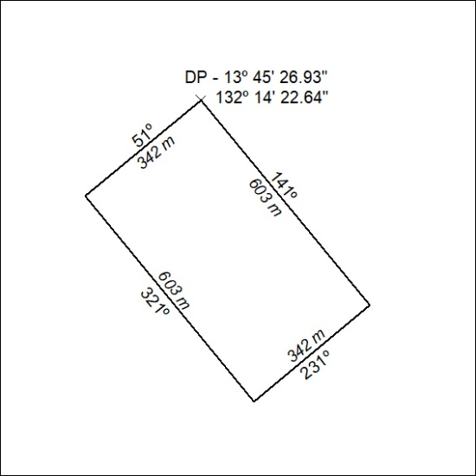
(Area now amalgamated into Mineral Lease 33850 under s102)

236/24

Mineral Titles Act 2010
NOTICE OF LAND CEASING TO BE A MINERAL TITLE AREA
Title Type and Number: | Mineral Lease (Northern) 64
Area ceased on: | 01 May 2024
Locality: | RANFORD HILL
Name of Applicants(s)Holder(s): | 100% OUTBACK METALS PROPRIETARY LIMITED* [ACN. 126 797 573]
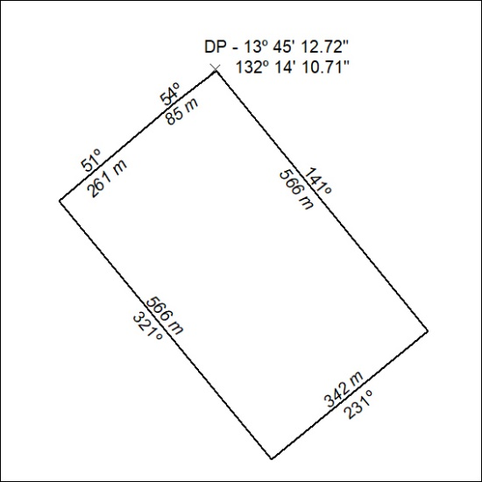
(Area now amalgamated into Mineral Lease 33850 under s102)

237/24

Mineral Titles Act 2010
NOTICE OF LAND CEASING TO BE A MINERAL TITLE AREA
Title Type and Number: | Mineral Lease (Northern) 65
Area ceased on: | 01 May 2024
Locality: | RANFORD HILL
Name of Applicants(s)Holder(s): | 100% OUTBACK METALS PROPRIETARY LIMITED* [ACN. 126 797 573]
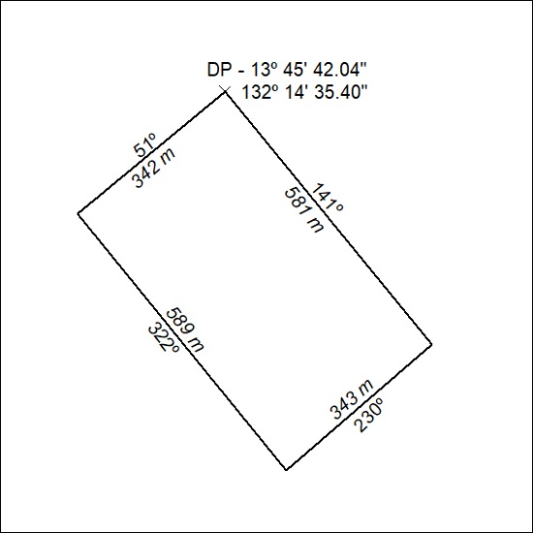
(Area now amalgamated into Mineral Lease 33850 under s102)

238/24

Mineral Titles Act 2010
NOTICE OF LAND CEASING TO BE A MINERAL TITLE AREA
Title Type and Number: | Mineral Lease (Northern) 697
Area ceased on: | 01 May 2024
Locality: | FLORA
Name of Applicants(s)Holder(s): | 100% MICRONISED MINERAL SOLUTIONS PTY LTD [ACN. 126 378 318]
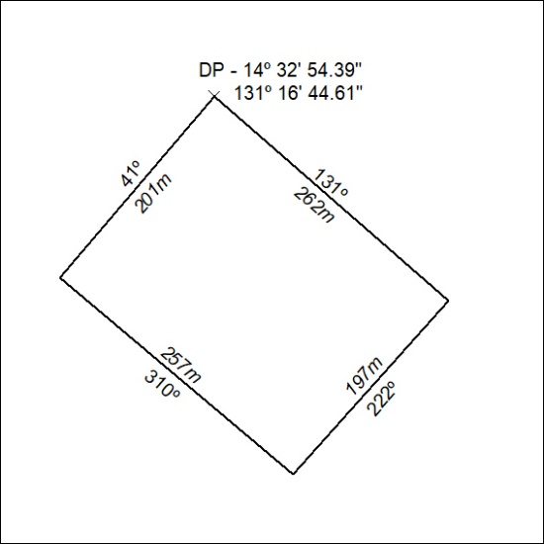
(Area now amalgamated into Mineral Lease 33759 under s102)

239/24

Mineral Titles Act 2010
NOTICE OF LAND CEASING TO BE A MINERAL TITLE AREA
Title Type and Number: | Mineral Lease (Northern) 698
Area ceased on: | 01 May 2024
Locality: | FLORA
Name of Applicants(s)Holder(s): | 100% MICRONISED MINERAL SOLUTIONS PTY LTD [ACN. 126 378 318]
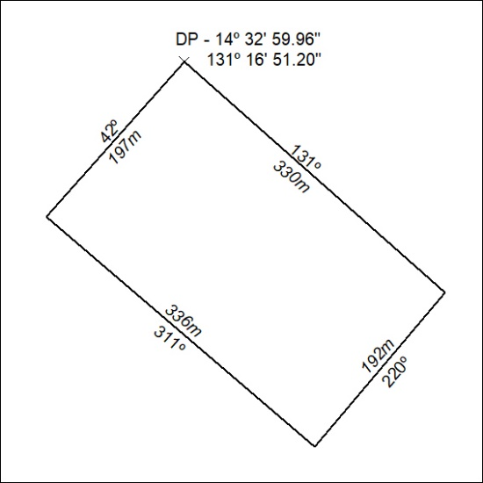
(Area now amalgamated into Mineral Lease 33759 under s102)

240/24

