Mineral Titles Act
NOTICE OF GRANT OF A MINERAL TITLE
Title Type and Number: | Exploration Licence 33596
Granted: | 05 April 2024, for a period of 6 Years
Area: | 42 Blocks, 130.19 km²
Locality: | VICTORY
Name of Holder/s: | 100% TERRALITH METALS PTY LTD [ACN. 669 527 360]
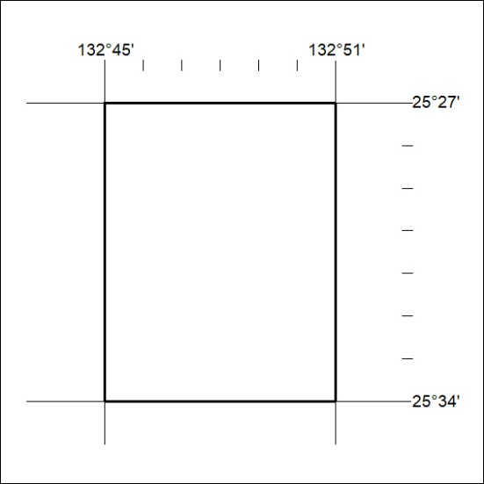
Area granted is indicated above. The titleholder is not permitted to exercise occupational rights on any land that is subject to a development title, or an application for a development title. Any land the subject of a Reserved Land gazettal under the Mineral Titles Act and all land vested in the Commonwealth of Australia is also excluded by description but not excised from the grant area.
92/24

Mineral Titles Act
NOTICE OF GRANT OF A MINERAL TITLE
Title Type and Number: | Exploration Licence 33597
Granted: | 05 April 2024, for a period of 6 Years
Area: | 24 Blocks, 74.69 km²
Locality: | EBENEZER
Name of Holder/s: | 100% TERRALITH METALS PTY LTD [ACN. 669 527 360]
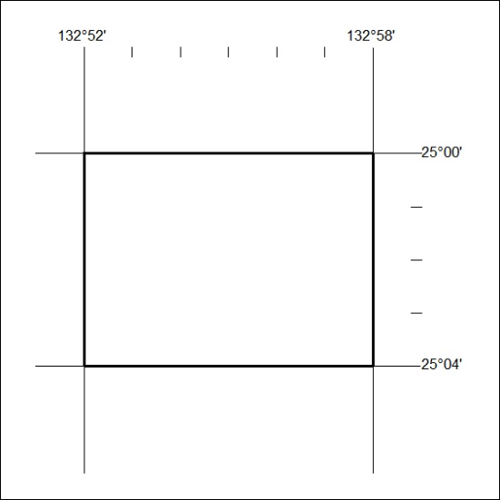
Area granted is indicated above. The titleholder is not permitted to exercise occupational rights on any land that is subject to a development title, or an application for a development title. Any land the subject of a Reserved Land gazettal under the Mineral Titles Act and all land vested in the Commonwealth of Australia is also excluded by description but not excised from the grant area.
93/24

Mineral Titles Act
NOTICE OF GRANT OF A MINERAL TITLE
Title Type and Number: | Exploration Licence 33598
Granted: | 04 April 2024, for a period of 6 Years
Area: | 32 Blocks, 97.51 km²
Locality: | PALM VALLEY
Name of Holder/s: | 100% TERRALITH METALS PTY LTD [ACN. 669 527 360]
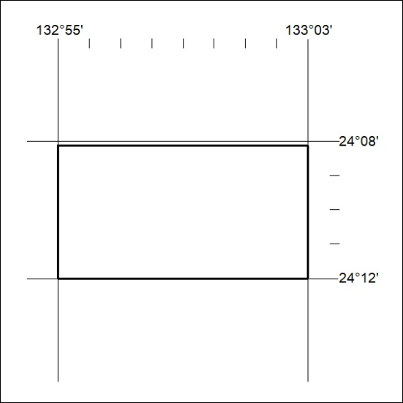
Area granted is indicated above. The titleholder is not permitted to exercise occupational rights on any land that is subject to a development title, or an application for a development title. Any land the subject of a Reserved Land gazettal under the Mineral Titles Act and all land vested in the Commonwealth of Australia is also excluded by description but not excised from the grant area.
94/24

Mineral Titles Act
NOTICE OF GRANT OF A MINERAL TITLE
Title Type and Number: | Exploration Licence 33599
Granted: | 05 April 2024, for a period of 6 Years
Area: | 18 Blocks, 56.37 km²
Locality: | PEACHY
Name of Holder/s: | 100% TERRALITH METALS PTY LTD [ACN. 669 527 360]
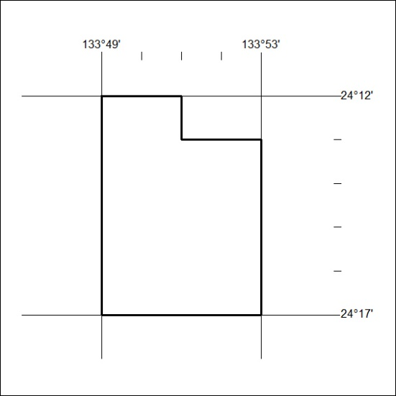
Area granted is indicated above. The titleholder is not permitted to exercise occupational rights on any land that is subject to a development title, or an application for a development title. Any land the subject of a Reserved Land gazettal under the Mineral Titles Act and all land vested in the Commonwealth of Australia is also excluded by description but not excised from the grant area.
95/24

Mineral Titles Act
NOTICE OF GRANT OF A MINERAL TITLE
Title Type and Number: | Exploration Licence 33600
Granted: | 05 April 2024, for a period of 6 Years
Area: | 25 Blocks, 78.44 km²
Locality: | SANTA TERESA
Name of Holder/s: | 100% TERRALITH METALS PTY LTD [ACN. 669 527 360]
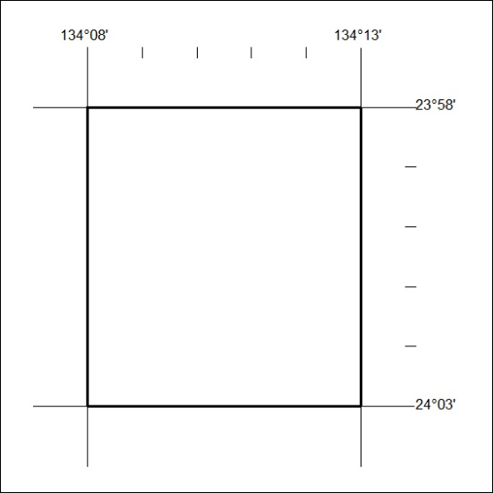
Area granted is indicated above. The titleholder is not permitted to exercise occupational rights on any land that is subject to a development title, or an application for a development title. Any land the subject of a Reserved Land gazettal under the Mineral Titles Act and all land vested in the Commonwealth of Australia is also excluded by description but not excised from the grant area.
96/24

