Mineral Titles Act 2010
NOTICE OF LAND CEASING TO BE A MINERAL TITLE AREA
Title Type and Number: | Extractive Mineral Permit (Southern) 146
Area ceased on: | 21 March 2024
Area: | 2.00 Hectare
Locality: | ALICE SPRINGS
Name of Applicants(s)Holder(s): | 100% BROWN Patrick
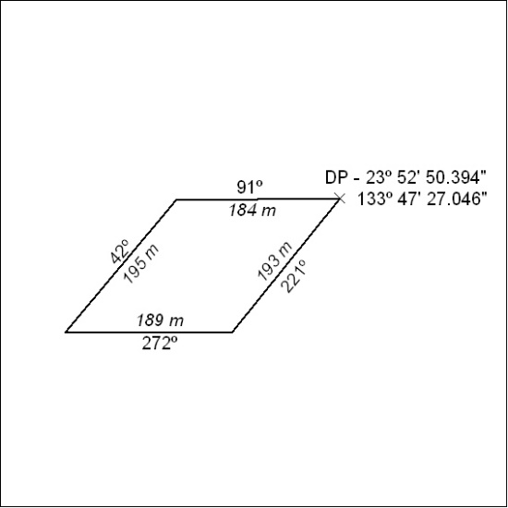

67/24

Mineral Titles Act 2010
NOTICE OF LAND CEASING TO BE A MINERAL TITLE APPLICATION AREA
Title Type and Number: | Exploration Licence 28695
Area Ceased on: | 21 March 2024
Area: | 38 Blocks, 108.90 km²
Locality: | KELLY
Name of Applicant(s)/Holder(s): | 100% RED METAL LIMITED [ACN. 103 367 684]
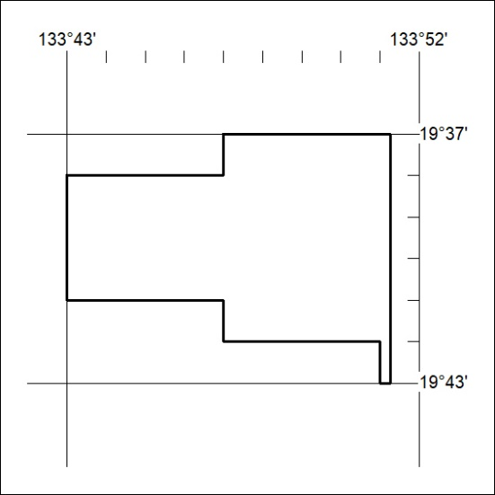

68/24

