Mineral Titles Act 2010
NOTICE OF LAND CEASING TO BE A MINERAL TITLE APPLICATION AREA
Title Type and Number: | Exploration Licence 33563
Area Ceased on: | 01 February 2024
Area: | 250 Blocks, 813.20 km²
Locality: | MITCHIEBO
Name of Applicant(s)/Holder(s): | 100% GIBB RIVER DIAMONDS LIMITED* [ACN. 129 158 550]
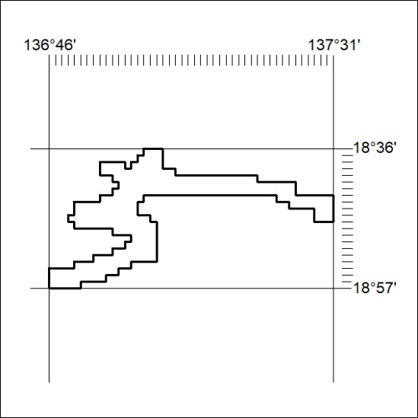

26/24

Mineral Titles Act
NOTICE OF GRANT OF A MINERAL TITLE
Title Type and Number: | Exploration Licence 28316
Granted: | 31 January 2024, for a period of 6 Years
Area: | 3 Blocks, 8.57 km²
Locality: | GOOMADEER
Name of Holder/s: | 100% G E RESOURCES PTY LTD [ACN. 096 473 737]
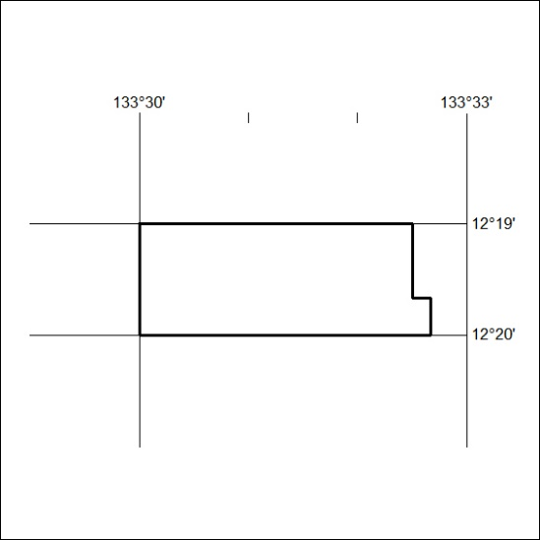
Area granted is indicated above. The titleholder is not permitted to exercise occupational rights on any land that is subject to a development title, or an application for a development title. Any land the subject of a Reserved Land gazettal under the Mineral Titles Act and all land vested in the Commonwealth of Australia is also excluded by description but not excised from the grant area.

27/24

