Mineral Titles Act 2010
NOTICE OF LAND CEASING TO BE A MINERAL TITLE APPLICATION AREA
Title Type and Number: | Extractive Mineral Permit 30626
Area ceased on: | 18 January 2024
Area: | 25.00 Hectare
Locality: | KOOLPINYAH
Name of Applicants(s)Holder(s): | 100% CECCON Suzanne Yoko
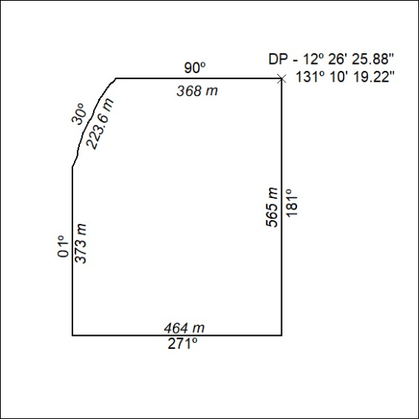

16/24

