Mineral Titles Act 2010
NOTICE OF LAND CEASING TO BE A MINERAL TITLE AREA
Title Type and Number: | Exploration Licence 32031
Area Ceased on: | 16 November 2023
Area: | 42 Blocks, 136.70 km²
Locality: | ROCKHAMPTON DOWNS
Name of Applicant(s)/Holder(s): | 100% PINNACLE GOLD PTY LTD [ACN. 151 778 424]
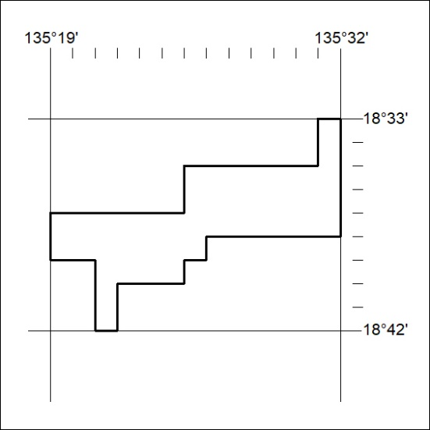

476/23

Mineral Titles Act 2010
NOTICE OF LAND CEASING TO BE A MINERAL TITLE AREA
Title Type and Number: | Exploration Licence 32032
Area Ceased on: | 16 November 2023
Area: | 40 Blocks, 130.59 km²
Locality: | MONMOONA
Name of Applicant(s)/Holder(s): | 100% PINNACLE GOLD PTY LTD [ACN. 151 778 424]
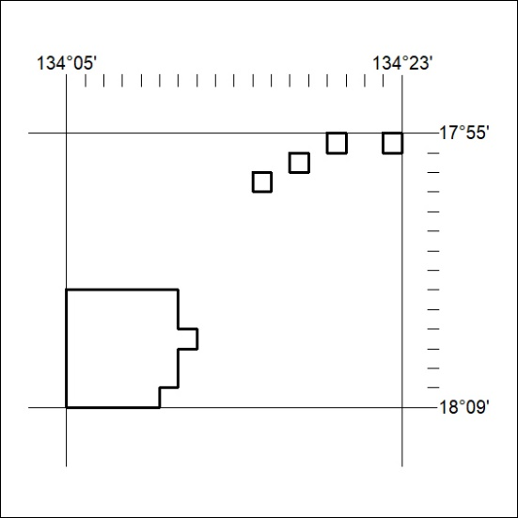

477/23

